

SCHOOL OF ADVANCED TECHNOLOGY

ICT - Applications & Programming

Computer Engineering Technology – Computing Science



A21
Model Definitions (RE/Automaton)

Lab Professor / Lab Session:
[Lab Prof Name / Lab Session]

Team:
[Student Name] - Id: [Student Id] / [Student Name] - Id: [Student Id]

Language Name [???]

This template is suggested (not mandatory) to answer A11 Specification.

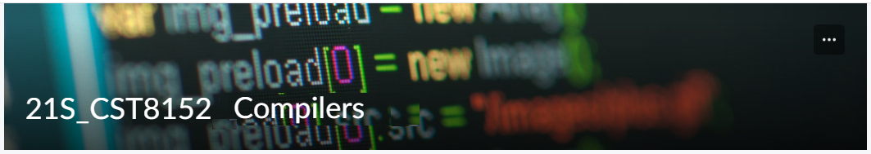

MODEL TASK FOR ASSIGNMENT 2.1 – YOUR LANGUAGE

- Note: This task is part of the Assignment 2 from Compilers Course. Any problem, contact your lab professor.

Task 1: Language Symbols (2.0 marks)

List examples: Define main symbols to be used:
- Special symbols (ex: “{“, “(“, “<=”, etc.)
- Comments
- Variables
- Functions
- Literals (numbers, strings)
- Keywords
- Datatypes

Answer:

Task 2: RE – Regular Expression (3.0 mark)

Lexeme Classes: Define the classes to be used in your regular expression:

Answer:

Define the RE to be used for: variables, literals and keywords:

Answer:
* Comments:
* Variables:
* Methods:
* Literals:
- Numbers
- Strings
* Keywords:

Task 3: TD – Transition Diagram (3.0 marks)

Activity: Starting from the previous lexeme classes and obeying the RE, it is possible to define the automata for your language:

Answer (draw / copy image of the automata):

Task 4: TT – Transition Table (2.0 marks)

Activity: Now, it is possible to define the TT for these lexemes:

Answer (Transition Table):

Update: Oct 10th 2023.

Adapted from resources developed by Prof. Svillen Ranev (Algonquin College, 2019)

