

SCHOOL OF ADVANCED TECHNOLOGY

ICT - Applications & Programming

Computer Engineering Technology – Computing Science



A21
Model Definitions (RE/Automaton)

Lab Professor / Lab Session:
[Paulo Saosa / 301]

Team:
[Yijia Xu] - Id: [041061204]

Language Name [Lana]

This template is suggested (not mandatory) to answer A11 Specification.

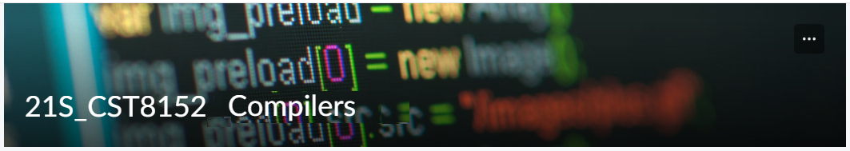

MODEL TASK FOR ASSIGNMENT 2.1 – YOUR LANGUAGE

- Note: This task is part of the Assignment 2 from Compilers Course. Any problem, contact your lab professor.

Task 1: Language Symbols (2.0 marks)

List examples: Define main symbols to be used:
- Special symbols (ex: “{“, “(“, “<=”, etc.)
- Comments
- Variables
- Functions
- Literals (numbers, strings)
- Keywords
- Datatypes

Answer:
Special symbols: ‘#’, ‘%’, ‘$’, ‘@’, ‘{‘, ‘}’, ‘&’, ‘;’, ‘,’, ‘++’, ‘--’, ‘+’, ‘-‘, ‘*’, ‘/’, ‘>’, ‘<’, ‘==’, ‘!=’, ‘=’, …
Comments: #some comments…#
Variables:
- Integer: var$
- Real: var%
- String: var#
Functions: func&
Literals (numbers, strings):
- Integers: 0, 1, -2, …
- Real: 0.1, -100.5, +3.14, …
- Strings: ‘Hello, world’, …
Keywords: data, code, int, real, string, if, then, else, break, while, do, const, return
Datatypes: int, real, string

Task 2: RE – Regular Expression (3.0 mark)

Lexeme Classes: Define the classes to be used in your regular expression:

Answer:

L (letters): [A-Za-z]
D (digits): [0-9]
H (hashtag): #
S (dollar): $
P (percentage): %
Z (dot): .
N (negative/positive): - | +
Q (single quotes): ‘
A (ampersand): &
O (others): [^LDHSPZNQA]

Define the RE to be used for: variables, literals and keywords:

Answer:
* Comments: H(^H)*H
* Variables:
- Integer : L(L|D)*S
- Real : L(L|D)*P
- String : L(L|D)*H
* Methods: MID = L(L|D)*A
* Literals:
- Integer: N?D+
- Real: N?D+ZD+
- Strings: SL = Q(^Q)*Q
* Keywords: L+ ∈ { data | code | int | real | string | if | then | else | break |while | do | const | return }

Task 3: TD – Transition Diagram (3.0 marks)

Activity: Starting from the previous lexeme classes and obeying the RE, it is possible to define the automata for your language:

Answer (draw / copy image of the automata):
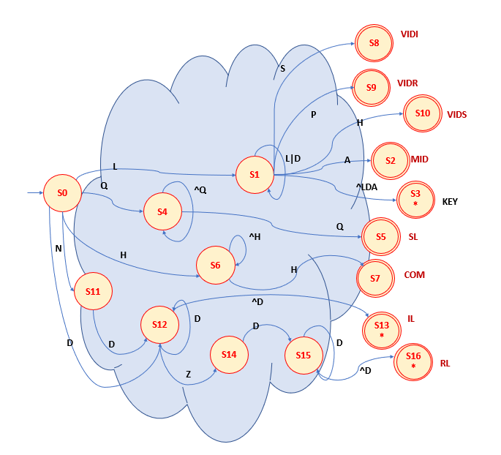

Task 4: TT – Transition Table (2.0 marks)

Activity: Now, it is possible to define the TT for these lexemes:

Answer (Transition Table):
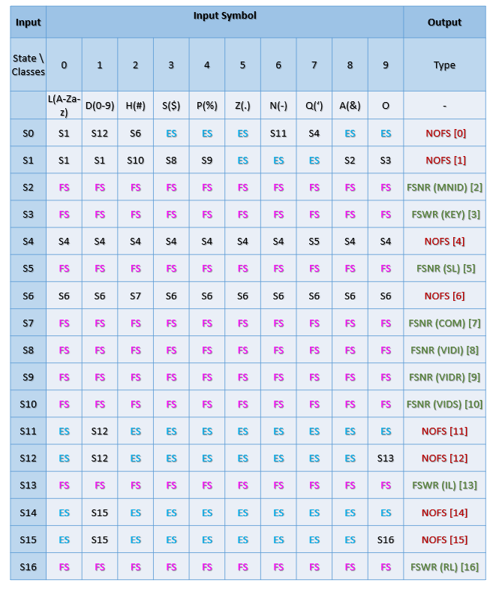

Update: Oct 10th 2023.

Adapted from resources developed by Prof. Svillen Ranev (Algonquin College, 2019)

