# Mysql5.7安装：

## 下载64位zip包，解压：

然后进入目录安装：

Mysqld.exe –initialize –user=mysql

Mysqld.exe –install mysql57

即安装成功



## 进入数据库修改密码：

Mysql在安装时间会初始化一个密码，找到登录mysql：

Mysql –u root –p

Set password for root@localhost=password(“123456”)

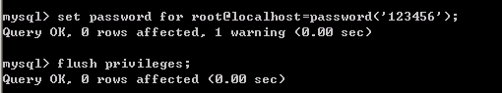

## 配置my.cnf

配置my.cnf，和主从

Master配置：

[mysqld]

port = 3306

basedir=D:\mysql57

datadir=D:\mysql57\data

max_connections=200

character-set-server=utf8

log-bin=mysql-bin

server-id=1

innodb_flush_log_at_trx_commit=1

sync_binlog=1

binlog_do_db=SB

default-storage-engine=INNODB

innodb_buffer_pool_size=2G

innodb_log_buffer_size=256M

innodb_log_file_size=256M

innodb_thread_concurrency=100

innodb_undo_directory=D:\mysql57\data\undolog

innodb_undo_tablespaces=4

innodb_undo_logs=128

innodb_max_undo_log_size=100M

innodb_purge_rseg_truncate_frequency

innodb_undo_log_truncate=1

tmp_table_size=1G

max_heap_table_size=512M

thread_cache_size=512

slave配置：

server-id=2

然后：

change master to master_host='10.225.13.41',master_user='slaveroot',master_password=123456,master_log_file='mysql-bin.000002',master_log_pos=154;

flush privileges;

start slave;