CONCORDIA UNIVERSITY

[Yijie Wang]

[40154119]

[yjyijiewang@gmail.com]

ASSIGNMENT 1

[CART 253](https://pippinbarr.github.io/cart253-2020/)

Pippin Barr

Nov.4th, 2020

Project summary

In Remembrance of the 2020 Global Confinement, is an interactive therapeutical programming project visualizing my personal experiences during the global pandemic, composed of smaller projects inspired by my personal emotions during the pandemic. The audiences are expected to move and interact, whether with a mouse and/or keyboard, engross in therapeutical power of colors and shapes.

Artistic vision

As the creative director and programmer of this project, I envision to infect the audiences with emotional comfort while being in confinement.

The project at large is composed of several small projects, each of them is inspired by a special emotion, invoked during the pandemic to me personally, and they meant to draw the feelings of intimacy and safety. The emotion vocabularies are unprepared, isolation, trapped, hope, depression, robotic, hostile, confusion, negative emotions but in order to communicate positivity, I want a lot of movement, such as human in bubbles representing us confining in our own space, and different shapes and colors that represent variety of emotions.

Plans for technical challenges

To communicate my message effectively in visual form is challenging because it is interwoven with technical abilities. There are 3 technical challenges. The first one is sound manipulation. I want some objects to react to the sound beat. the second one is customized shapes, or just make them as photos if they are way too complicated or time consuming. The third one is object-orient programming, because it is new concept for me to digest and trying to master, nevertheless I’ll reach out to my TA and professor.

Visual sketches

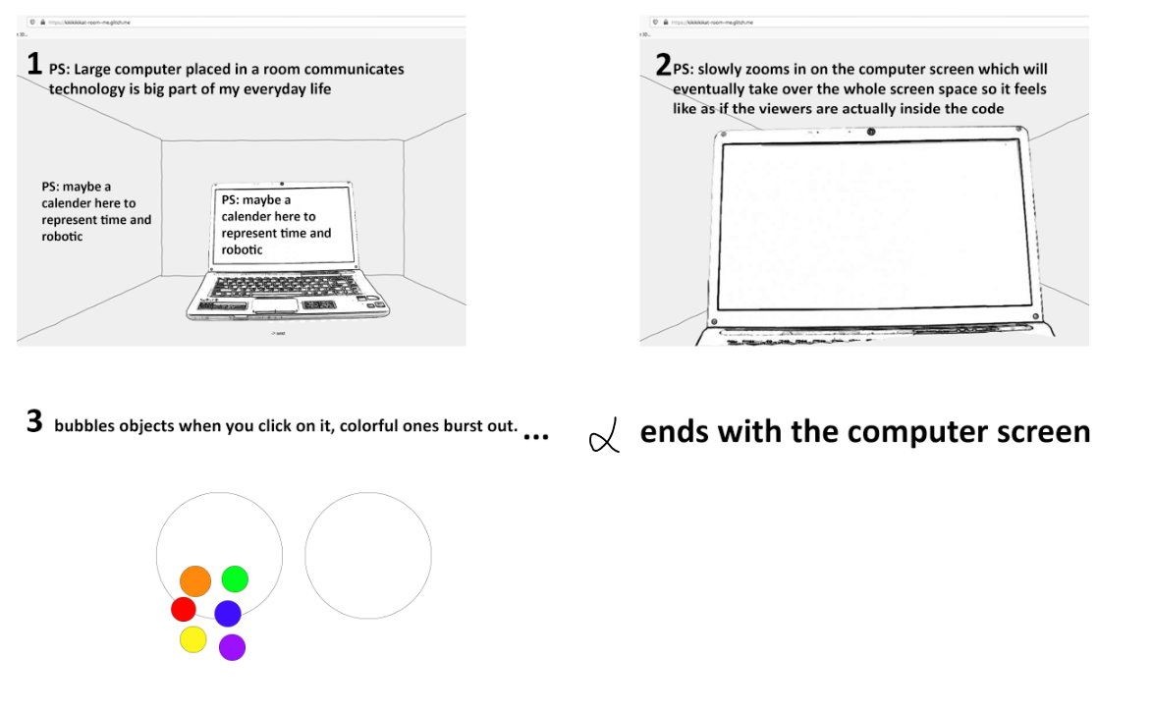

Inspiration

