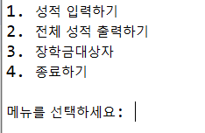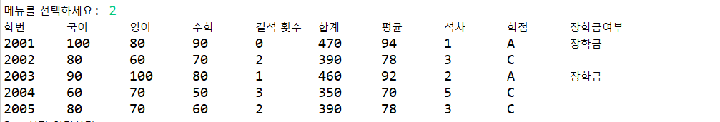

**package** ProgramTest;

**import** java.util.Scanner;

**public** **class** Score {

**public** **static** **void** main(String[] args) {

Scanner sc = **new** Scanner(System.***in***);

**int** act = 0;

**int**[][] stu = **new** **int**[5][8];

String[] hakjum = **new** String[5]; //학점

String[] janghak = **new** String[5]; //장학

**int**[] sum = **new** **int**[7]; //합계

**int**[] avg = **new** **int**[7]; //평균

**while**(**true**) {

System.***out***.println("1. 성적 입력하기\n2. 전체 성적 출력하기\n3. 장학금대상자\n4. 종료하기");

System.***out***.println();

System.***out***.print("메뉴를 선택하세요: ");

act = sc.nextInt();

**switch**(act) {

**case** 1: //성적, 결석 수 입력

**for** (**int** i = 0; i < stu.length; i++) {

stu[i][0] = 2001+i;

System.***out***.print(stu[i][0]+"학번 국어점수, 영어점수, 수학점수, 결석 수는?");

**for** (**int** j = 1; j <5; j++) {

stu[i][j] = sc.nextInt();

}

}

//합계, 평균

**for** (**int** i = 0; i < stu.length; i++) {

**double** chulsukRate = ((20-stu[i][4])/20.0);

**double** chulsukScore = 200 * chulsukRate;

stu[i][5] = stu[i][1]+stu[i][2]+stu[i][3]+(**int**)chulsukScore; //형변환 확인해봐

**int** tmp = stu[i][5];

stu[i][6] = tmp/5;

}

// 석차

**for** (**int** i = 0; i < stu.length; i++) {

stu[i][7] = 1;

**for** (**int** j = 0; j < stu.length; j++) {

**if**(stu[i][5]<stu[j][5]) {

stu[i][7]++;

}

}

}

//학점

**for** (**int** i = 0; i < stu.length; i++) {

**if**(stu[i][6]>=90 && stu[i][6]<=100) {

hakjum[i] = "A";

}**else** **if**(stu[i][6]>=80 && stu[i][6]<90) {

hakjum[i] = "B";

}**else** **if**(stu[i][6]>=70 && stu[i][6]<80) {

hakjum[i] = "C";

}**else** **if**(stu[i][6]>=60 && stu[i][6]<70) {

hakjum[i] = "D";

}**else** {

hakjum[i] = "F";

}

}

//장학금 여부

**for** (**int** i = 0; i < stu.length; i++) {

**if**(stu[i][6]>=85 && stu[i][4] <= 1) {

janghak[i] = "장학금";

}**else** {

janghak[i] = "";

}

}

// for (int i = 0; i < sum.length; i++) {

// sum[0] += stu[i][1];

// sum[1] += stu[i][2];

// sum[2] += stu[i][3];

// sum[4] += stu[i][5];

// sum[5] += stu[i][6];

// avg[0] += stu[i][1];

// avg[1] += stu[i][2];

// avg[2] += stu[i][3];

// avg[4] += stu[i][5];

// avg[5] += stu[i][6];

// }

**break**;

//전체출력

**case** 2:

System.***out***.printf("학번\t국어\t영어\t수학\t결석 횟수\t합계\t평균\t석차\t학점\t장학금여부\n");

**for** (**int** i = 0; i < stu.length; i++) {

System.***out***.printf(stu[i][0]+"\t"+stu[i][1]+"\t"+stu[i][2]+"\t"+stu[i][3]+"\t"+stu[i][4]+"\t"

+stu[i][5]+"\t"+stu[i][6]+"\t"+stu[i][7]+"\t"+hakjum[i]+"\t"+janghak[i]+"\n");

}

// System.out.println("합계"+sum[i]);

// System.out.println("평균"+avg[i]);

**break**;

**case** 3:

System.***out***.print("학번 ");

**for** (**int** i = 0; i < stu.length; i++) {

**if**(janghak[i].equals("장학금")) {

System.***out***.print(stu[i][0]+" ");

}

}

System.***out***.println();

**break**;

**case** 4:

System.***out***.println("좋은 하루입니다!!");

**break**;

}

}

}

}