Game Rules
The players’ objective is to navigate the map to get the character to the end tile. The bar at the top represents what action the players must take on each beat of the song. If the rhythm ticker is on a space with no action, the players are free to perform any action on the gameboard except standing idle. If the rhythm ticker is hovered over an action icon on the rhythm bar the players must take that action on the map to move onto the next action. If players miss a specified action, the players lose and restart from the starting tile. A picture of a sword indicates players must land on the same tile as an enemy to attack and defeat that enemy. A picture of the blue circle means that the players must land on the blue circle which completes the level.
The players have three actions they can take. First, they can move one tile in any cardinal direction. This action is available on all three levels. Second, players can jump. This allows them to move two tiles in any one cardinal direction. This action is only allowed on the medium and hard levels. Finally, the players can freeze enemies. Players are only allowed to freeze once per level and this action is only allowed on the hard level. When the players use freeze, all enemies on the board stop moving for the next three players’ actions and then resume movement as normal.

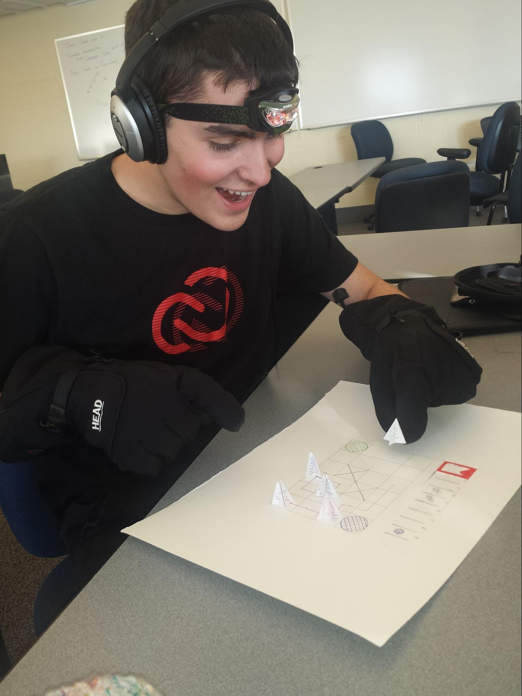
Andrew enjoying our nondigital prototype
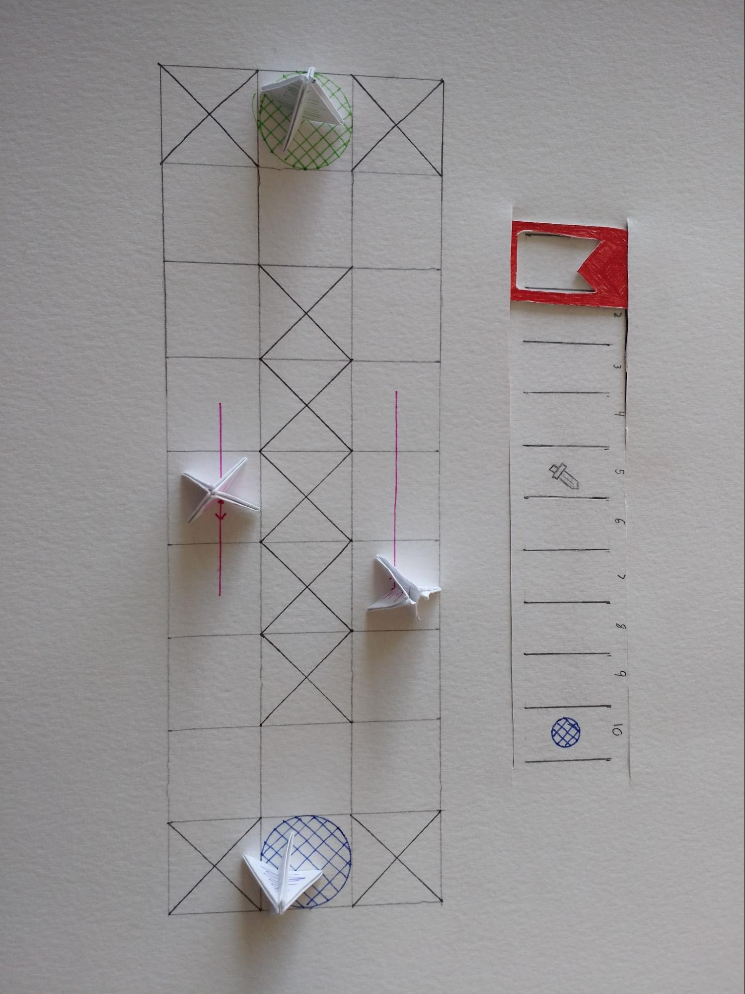
Easy Level

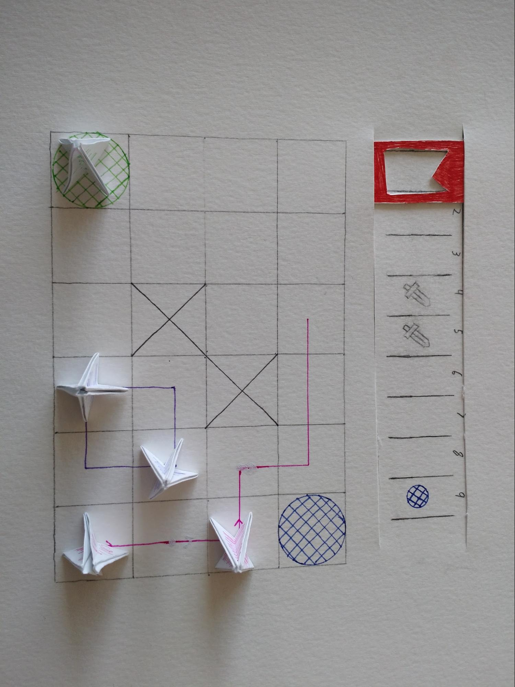
Medium Level

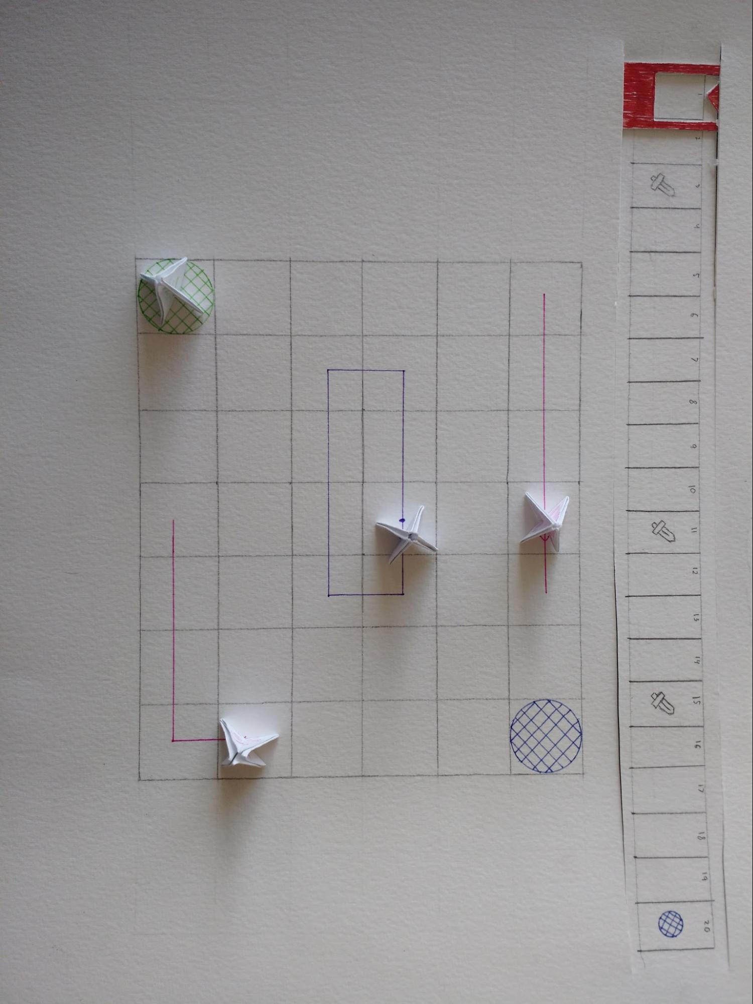
Hard Level

