This Python script can be used to check package loss between client and server. This script can be used to monitor on or many IP address via ICMP requests.
Features:
- It works with python 3.x
- IP list can be pull from Database
- IP list can be define from local file or variable
- Send alert function integrated for HP Operation Manager

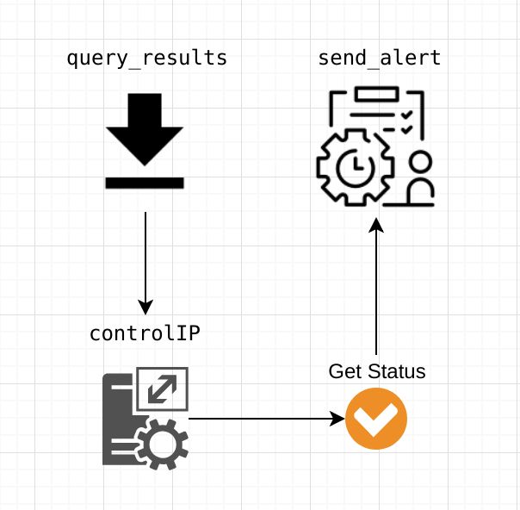

- Basic IP list can be defined like this example:

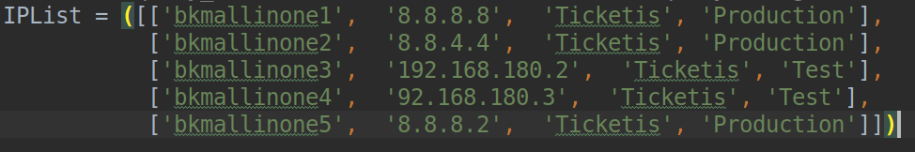
- Send alert function will create alert with some severity level like “Major”- “Critical”

