|  |
| --- |
| marmara university computer engineering ile ilgili gÃ¶rsel sonucu |
|  |

**COURSE DIARY**

**CSE3044 Software Engineering Project Report Part-2**

GROUP MEMBERS:

150115027 Burak ŞENKUŞ

150115050 Sergen YALÇIN

150114856 Özge YILDIRIM



# 1.

## 1.1.Timetable

*Application Link:* https://itunes.apple.com/tr/app/ders-program%C4%B1-timetable/id916497066?l=tr&mt=8

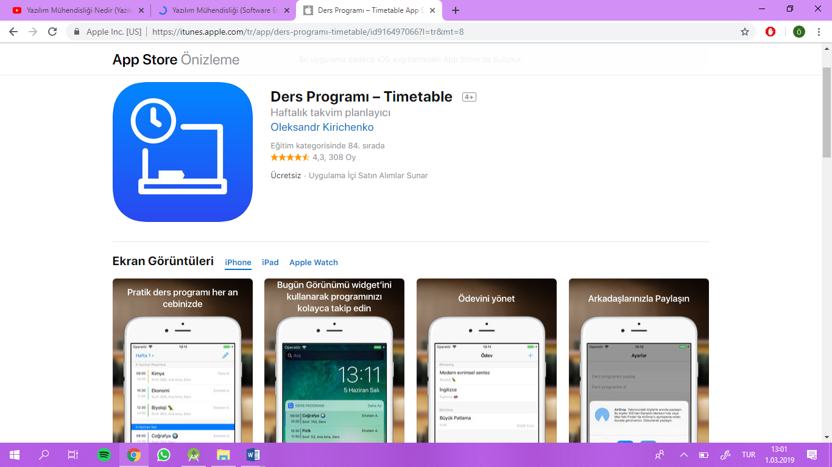

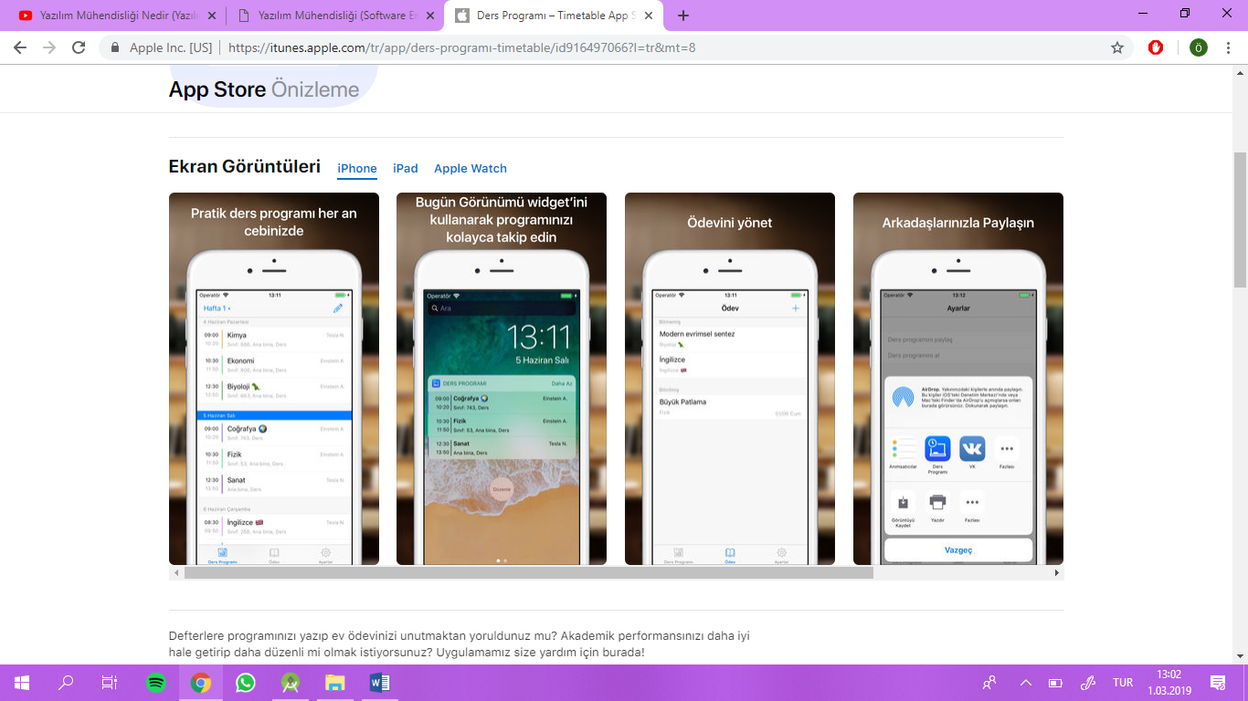



An application developed to make lessons more regular, keep all homework and course follow-up. At the opening of the application, once a week the program is filled and in the coming weeks it is always done on this ready program. You don't need to unlock the device when using this app that Apple Watch supports.

With our application, you can:

- Your program is always on hand

- You can control the program using the widget without unlocking the device

- You can edit your homework

- Receive reminders about your lessons and assignments

- You can use alternative weeks, for example, A / B

- Share your schedule with your friends

The application repeats only 4 weeks if the selection is not made. At the end of 4 weeks it is necessary to prepare the program again. You can add photos, new reminders can be added. The prepared program can be shared with different devices along with its contents.



## 1.2. Schedule Planner

*Application Link:*  [https://play.google.com/store/apps/details?id=com.lixiangdong.classschedule&hl=en](https://play.google.com/store/apps/details?id=com.lixiangdong.classschedule&hl=tr)

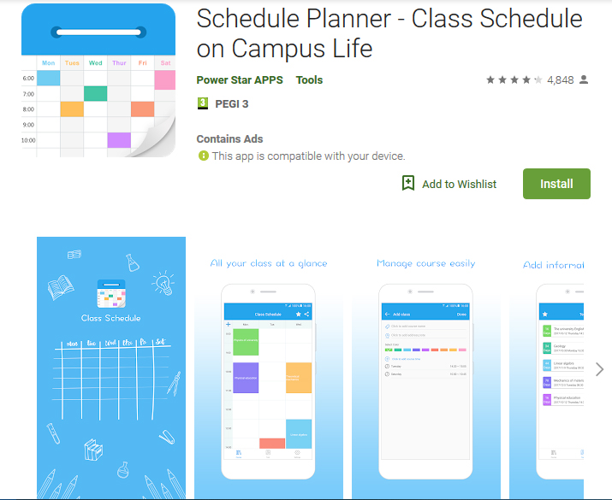



Schedule planner is a time management tool that helps to organize your campus life well. You can type your daily homework, assignments, exams into this app in order to remind yourself all those affairs.

Main function:

* Easy to record the details about the classes, teachers and exams
* Record time, class, location, course name setting
* Support for color labels to easily mark each type of schedule
* Notifications for upcoming homework, exams and classes

**Course Diary** - What differs in our project from these applications?

* Our application provides support to track our attendance and warns us when we are in critical situation.
* It is possible to add notes, photos and audio record for each course section.
* Easy attendance marking support on notification.

# 2.

We have chosen the Evolutionary Development Software Process by taking into account that there may be deficiencies in the progress of the application that we will develop based on the ideas we have in mind. At the beginning, there will be basic specifications to create an initial version of the application. The application will be much more usable and improved with new versions created by correcting errors in the application and adding new features.