COMPLETE CI/CD PROJECT DEVSECOPS

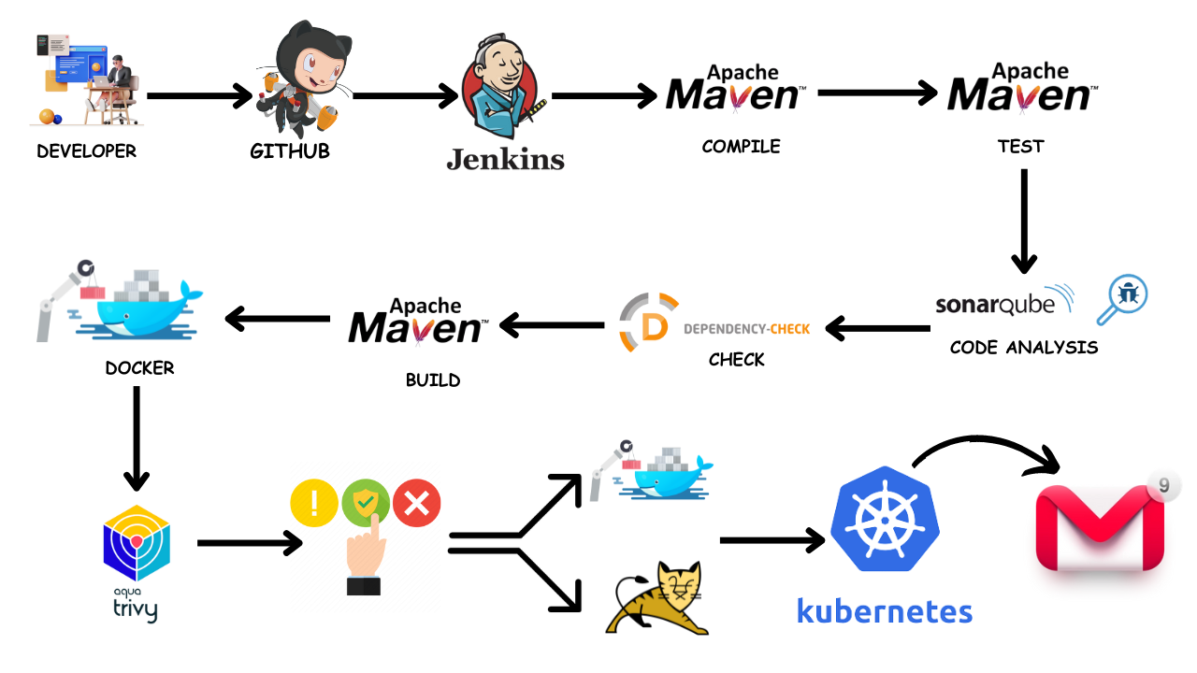

Hello friends, we will be deploying a Pet Clinic Java Based Application. This is an everyday use case scenario used by several organizations. We will be using Jenkins as a CICD tool and deploying our application on Tomcat Server. Hope this detailed blog is useful.

We will be deploying our application in two ways, using Docker Container and other is using Tomcat Server.And finally we will deploy it kubernetes Also.

And integrates manual approval also in this project.

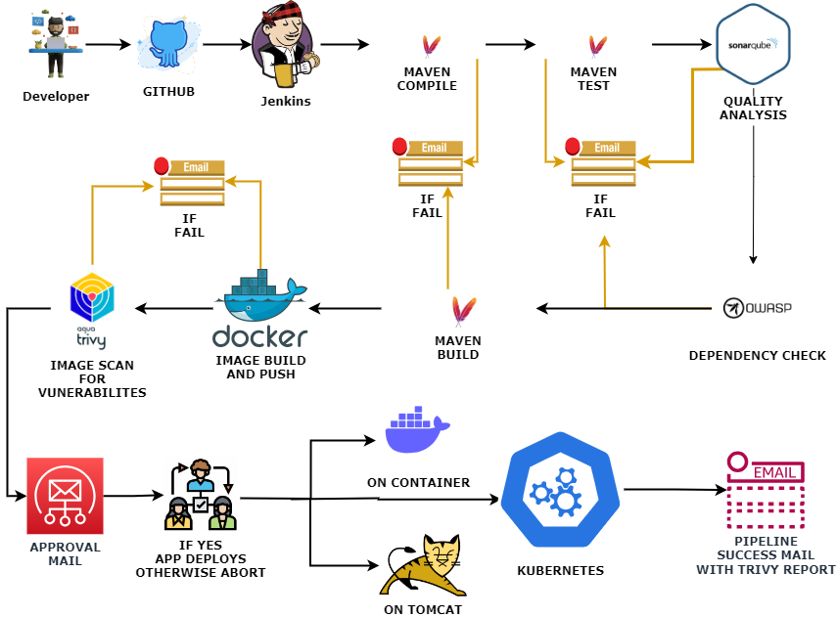

**Steps:-**

Step 1 — Create an Ubuntu T2 Large Instance

Step 2 — Install Jenkins, Docker and Trivy. Create a Sonarqube Container using Docker.

Step 3 — Install Plugins like JDK, Sonarqube Scanner, Maven, OWASP Dependency Check,

Step 4 — Create a Pipeline Project in Jenkins using Declarative Pipeline

Step 5 — Install OWASP Dependency Check Plugins

Step 6 — Docker Image Build and Push

Step 7 — Deploy image using Docker

Step 8 — Install Tomcat on Port 8083 and finally deploy on Apache Tomcat using groovy pipeline script mentioned

Step 9 — Access the Real World Application

Step 10 — Terminate the AWS EC2 Instance

**References**

**Now, lets get started and dig deeper into each of these steps :-**

**Step 1** — Launch an AWS T2 Large Instance. Use the image as Ubuntu. You can create a new key pair or use an existing one. Enable HTTP and HTTPS settings in the Security Group.

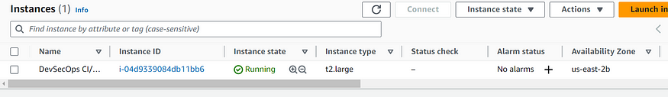

**Step 2** — Install Jenkins, Docker and Trivy

2A — To Install Jenkins

Connect to your console, and enter these commands to Install Jenkins

sudo apt-get update  
  
curl -fsSL https://pkg.jenkins.io/debian-stable/jenkins.io-2023.key | sudo tee \  
 /usr/share/keyrings/jenkins-keyring.asc > /dev/null  
echo deb [signed-by=/usr/share/keyrings/jenkins-keyring.asc] \  
 https://pkg.jenkins.io/debian-stable binary/ | sudo tee \  
 /etc/apt/sources.list.d/jenkins.list > /dev/null  
  
sudo apt update  
sudo apt install openjdk-17-jdk  
sudo apt install openjdk-17-jre  
  
sudo systemctl enable jenkins  
sudo systemctl start jenkins  
sudo systemctl status jenkins  
  
sudo cat /var/lib/jenkins/secrets/initialAdminPassword

Once Jenkins is installed, you will need to go to your AWS EC2 Security Group and open Inbound Port 8080, since Jenkins works on Port 8080.

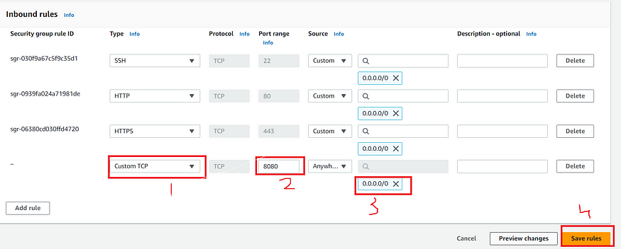

Now, grab your Public IP Address

<EC2 Public IP Address:8080>  
sudo cat /var/lib/jenkins/secrets/initialAdminPassword

Unlock Jenkins using an administrative password and install the required plugins.

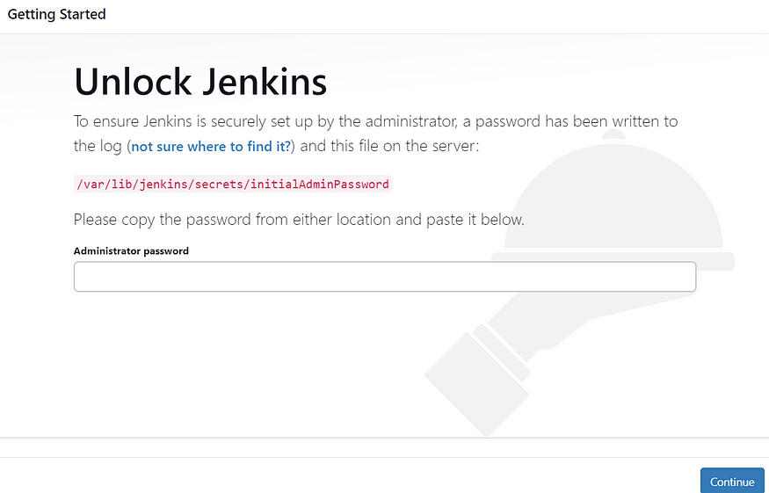

Jenkins will now get installed and install all the libraries.

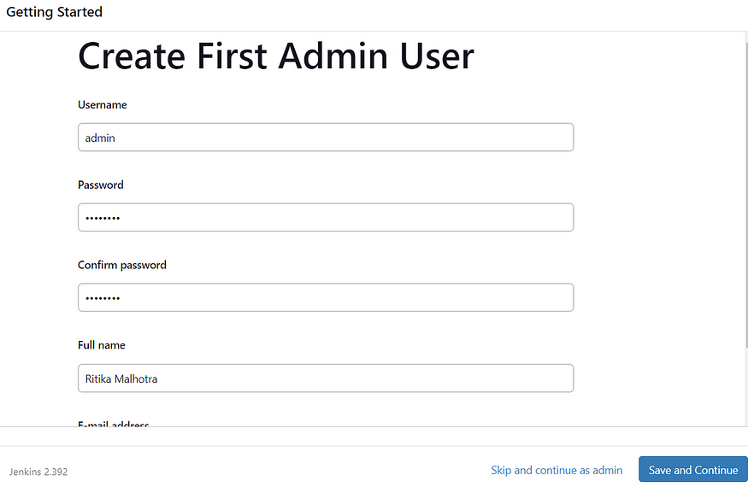

Jenkins Getting Started Screen

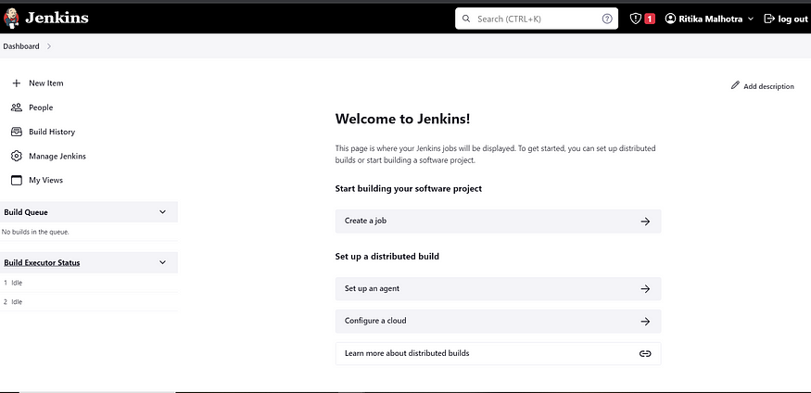

2B — Install Docker

sudo apt-get update  
sudo apt-get install docker.io -y  
sudo usermod -aG docker $USER  
sudo chmod 777 /var/run/docker.sock   
sudo docker ps

After the docker installation, we create a sonarqube container (Remember added 9000 port in the security group)

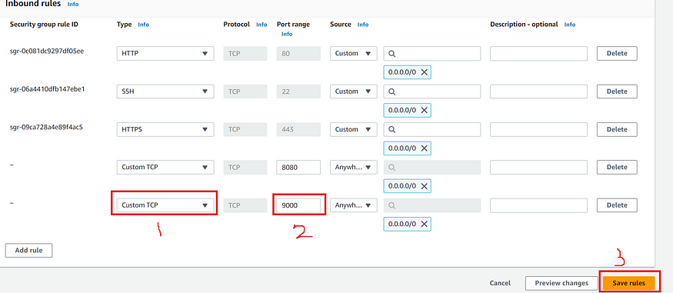

docker run -d --name sonar -p 9000:9000 sonarqube:lts-community

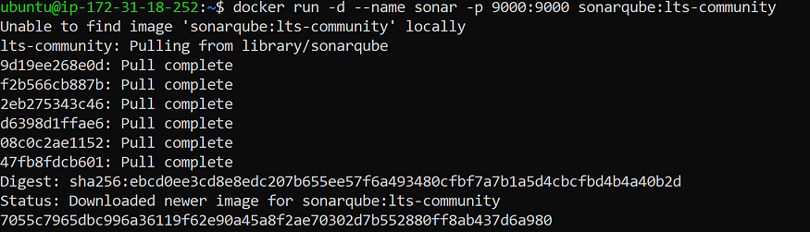

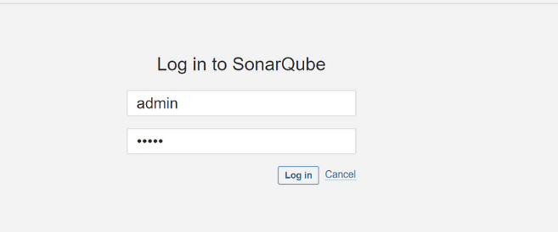

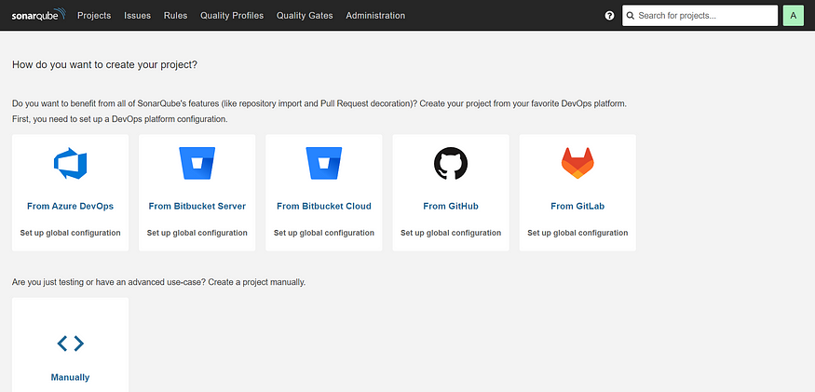

2C — Install Trivy

sudo apt-get install wget apt-transport-https gnupg lsb-release -y  
  
wget -qO - https://aquasecurity.github.io/trivy-repo/deb/public.key | gpg --dearmor | sudo tee /usr/share/keyrings/trivy.gpg > /dev/null  
  
echo "deb [signed-by=/usr/share/keyrings/trivy.gpg] https://aquasecurity.github.io/trivy-repo/deb $(lsb_release -sc) main" | sudo tee -a /etc/apt/sources.list.d/trivy.list  
  
sudo apt-get update  
  
sudo apt-get install trivy -y

Next, we will login to Jenkins and start to configure our Pipeline in Jenkins

**Step 3**— Install Plugins like JDK, Sonarqube Scanner, Maven, OWASP Dependency Check,

**3A — Install Plugin**

Goto Manage Jenkins →Plugins → Available Plugins →

Install below plugins

1 → Eclipse Temurin Installer (Install without restart)

2 → SonarQube Scanner (Install without restart)

**3B — Configure Java and Maven in Global Tool Configuration**

Goto Manage Jenkins → Tools → Install JDK and Maven3 → Click on Apply and Save

**3C — Create a Job**

Label it as Real-World CI-CD, click on Pipeline and Ok.

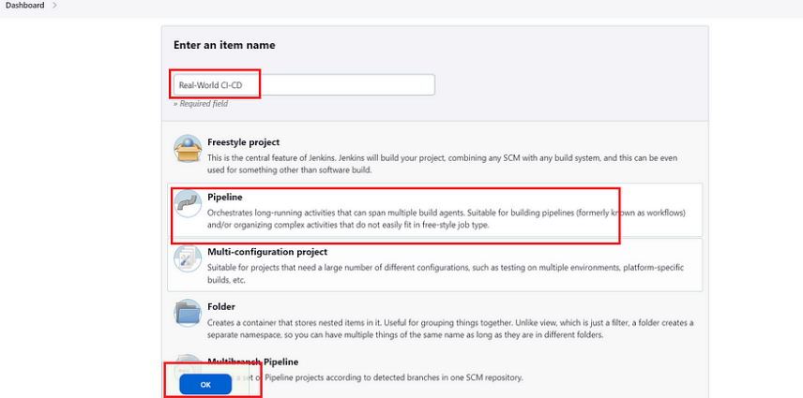

Enter this in Pipeline Script,

pipeline {  
 agent any   
   
 tools{  
 jdk 'jdk17'  
 maven 'maven3'  
 }  
   
 stages{  
   
 stage("Git Checkout"){  
 steps{  
 git branch: 'main', changelog: false, poll: false, url: 'https://github.com/Aj7Ay/Petclinic.git'  
 }  
 }  
   
 stage("Compile"){  
 steps{  
 sh "mvn clean compile"  
 }  
 }  
   
 stage("Test Cases"){  
 steps{  
 sh "mvn test"  
 }  
 }  
 }  
}

The stage view would look like this,

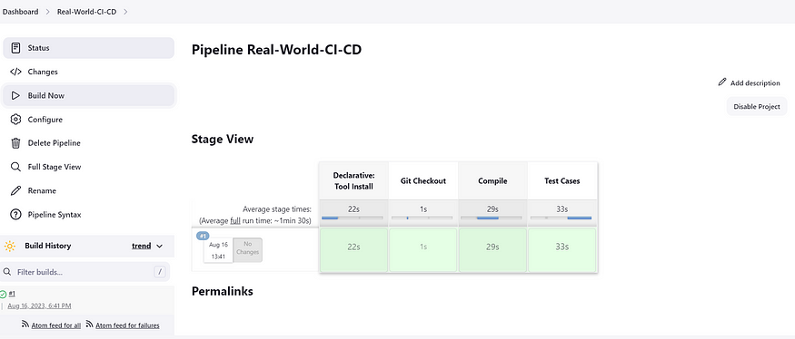

**Step 4 — Configure Sonar Server in Manage Jenkins**

Grab the Public IP Address of your EC2 Instance, Sonarqube works on Port 9000 , sp <Public IP>:9000. Goto your Sonarqube Server. Click on Administration → Security → Users → Click on Tokens and Update Token → Give it a name → and click on Generate Token

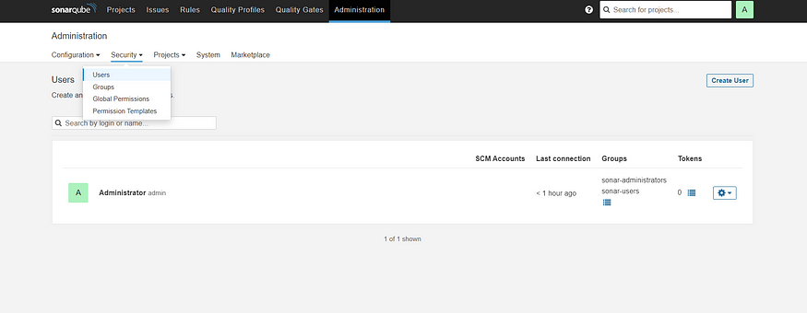

Click on Update Token

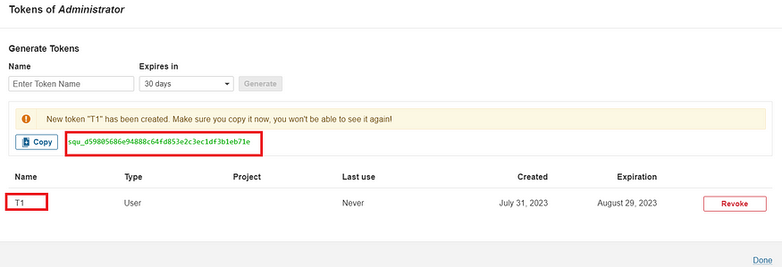

Copy this Token

Goto Dashboard → Manage Jenkins → Credentials → Add Secret Text. It should look like this

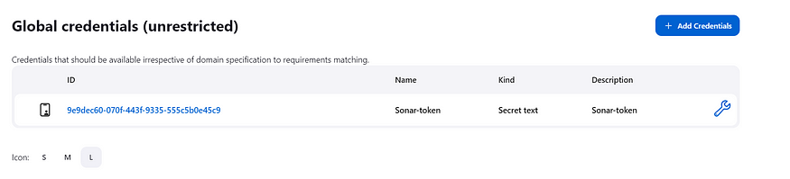

Now, goto Dashboard → Manage Jenkins → Configure System

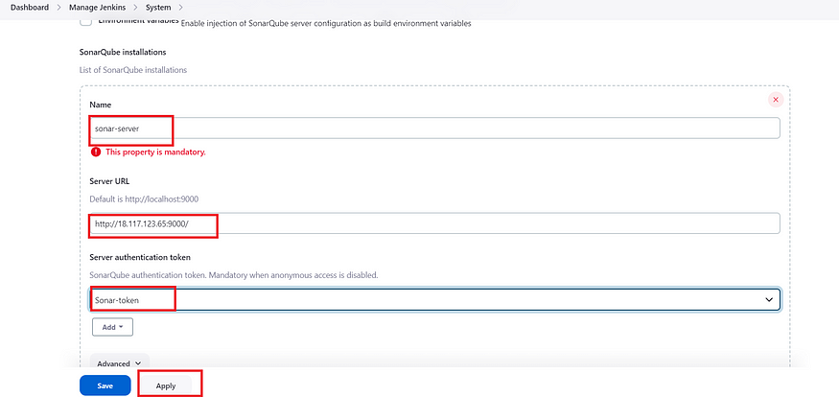

Click on Apply and Save

**Configure System option** is used in Jenkins to configure different server

**Global Tool Configuration** is used to configure different tools that we install using Plugins

We will install sonar-scanner in tools.

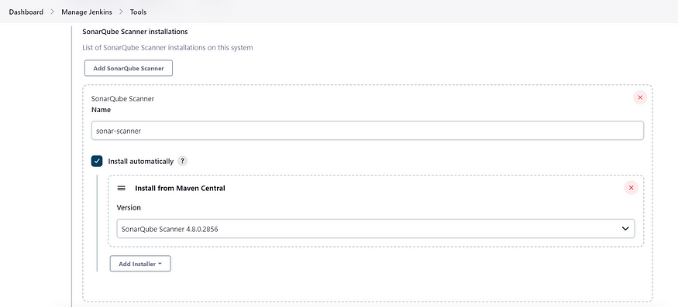

Lets goto our Pipeline and add Sonar-qube Stage in our Pipeline Script

pipeline {  
 agent any   
   
 tools{  
 jdk 'jdk17'  
 maven 'maven3'  
 }  
   
 environment {  
 SCANNER_HOME=tool 'sonar-scanner'  
 }  
   
 stages{  
   
 stage("Git Checkout"){  
 steps{  
 git branch: 'main', changelog: false, poll: false, url: 'https://github.com/Aj7Ay/Petclinic.git'  
 }  
 }  
   
 stage("Compile"){  
 steps{  
 sh "mvn clean compile"  
 }  
 }  
   
 stage("Test Cases"){  
 steps{  
 sh "mvn test"  
 }  
 }  
 stage("Sonarqube Analysis "){  
 steps{  
 withSonarQubeEnv('sonar-server') {  
 sh ''' $SCANNER_HOME/bin/sonar-scanner -Dsonar.projectName=Petclinic \  
 -Dsonar.java.binaries=. \  
 -Dsonar.projectKey=Petclinic '''  
   
 }  
 }  
 }

stage("quality gate"){

steps {

script {

waitForQualityGate abortPipeline: false, credentialsId: 'Sonar-token'

}

}

}

stage ('sonarqube Analysis'){

            steps{

                script{

                    withSonarQubeEnv(credentialsId: 'Sonar-token') {

                      sh 'mvn sonar:sonar'

                    }

                }

            }

        }  
 }  
}

Click on Build now, you will see the stage view like this

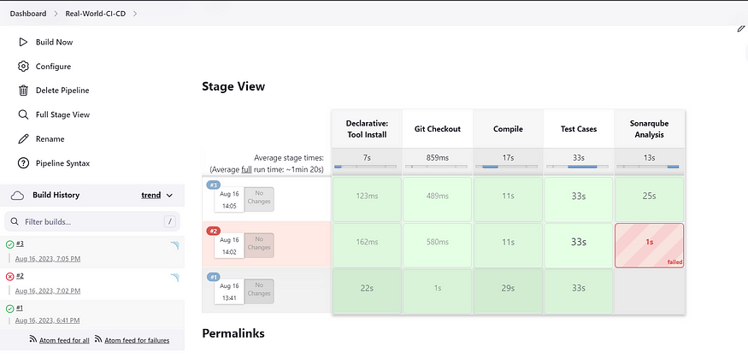

To see the report, you can goto Sonarqube Server and goto Projects.

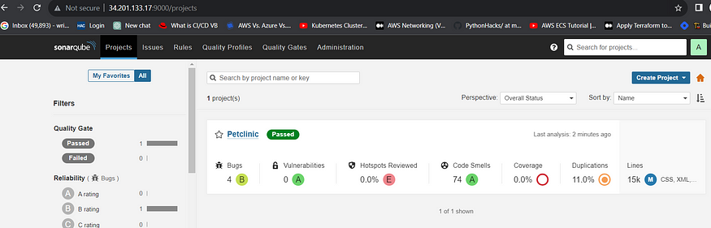

You can see the report has been generated and the status shows as passed. You can see that there are 15K lines. To see detailed report, you can go to issues.

**Step 5**— Install OWASP Dependency Check Plugins

GotoDashboard → Manage Jenkins → Plugins → OWASP Dependency-Check. Click on it and install without restart.

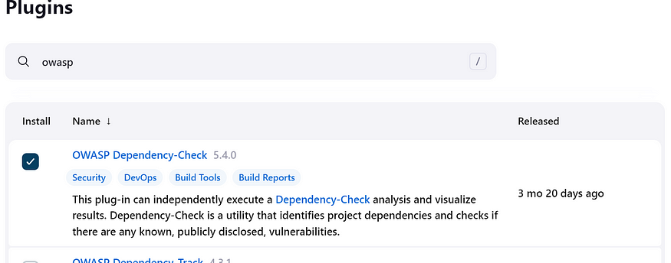

First, we configured Plugin and next we have to configure Tool

Goto Dashboard → Manage Jenkins → Tools →

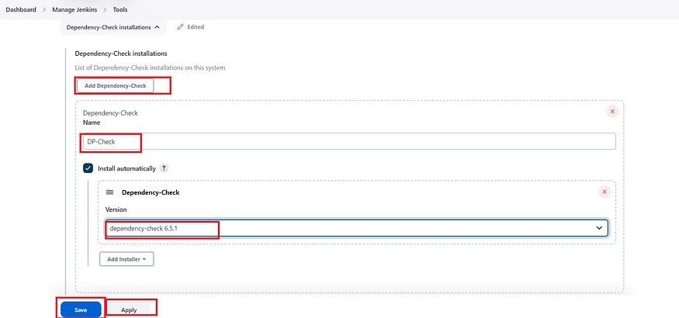

Click on apply and Save here.

Now goto configure → Pipeline and add this stage to your pipeline

stage("OWASP Dependency Check"){  
 steps{  
 dependencyCheck additionalArguments: '--scan ./ --format HTML ', odcInstallation: 'DP-Check'  
 dependencyCheckPublisher pattern: '**/dependency-check-report.html'  
 }  
 }  
stage("Build"){  
 steps{  
 sh " mvn clean install"  
 }  
 }

The final pipeline would look like this,

pipeline {  
 agent any   
   
 tools{  
 jdk 'jdk17'  
 maven 'maven3'  
 }  
   
 environment {  
 SCANNER_HOME=tool 'sonar-scanner'  
 }  
  
 stages{  
   
 stage("Git Checkout"){  
 steps{  
 git branch: 'main', changelog: false, poll: false, url: 'https://github.com/Aj7Ay/Petclinic.git'  
 }  
 }  
   
 stage("Compile"){  
 steps{  
 sh "mvn clean compile"  
 }  
 }  
   
 stage("Test Cases"){  
 steps{  
 sh "mvn test"  
 }  
 }  
   
 stage("Sonarqube Analysis "){  
 steps{  
 withSonarQubeEnv('sonar-server') {  
 sh ''' $SCANNER_HOME/bin/sonar-scanner -Dsonar.projectName=Petclinic \  
 -Dsonar.java.binaries=. \  
 -Dsonar.projectKey=Petclinic '''  
   
 }  
 }  
 }  
   
   
 stage("Build"){  
 steps{  
 sh " mvn clean install"  
 }  
 }  
   
 stage("OWASP Dependency Check"){  
 steps{  
 dependencyCheck additionalArguments: '--scan ./ --format HTML ' , odcInstallation: 'DP-Check'  
 dependencyCheckPublisher pattern: '**/dependency-check-report.html'  
 }  
 }  
   
 }  
}

The stage view would look like this,

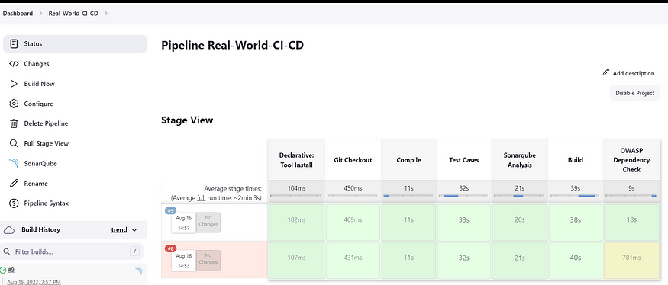

You will see that in status, a graph will also be generated

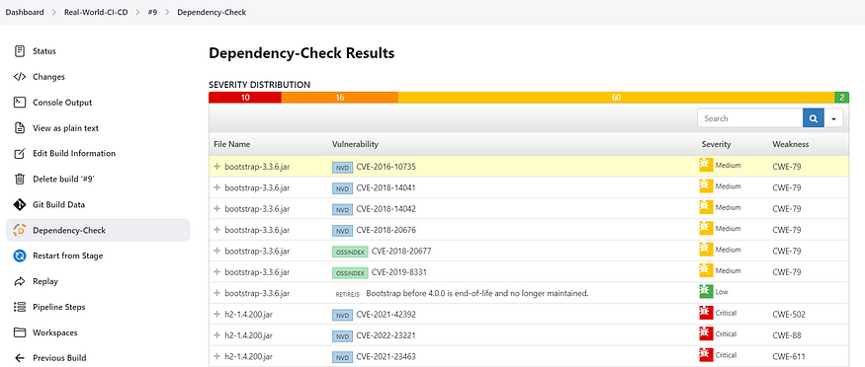

**Step 6** — Docker Image Build and Push

We need to install Docker tool in our system, Goto Dashboard → Manage Plugins → Available plugins → Search for Docker and install these plugins

* Docker
* Docker Commons
* Docker Pipeline
* Docker API
* docker-build-step

and click on install without restart

Now, goto Dashboard → Manage Jenkins → Tools →

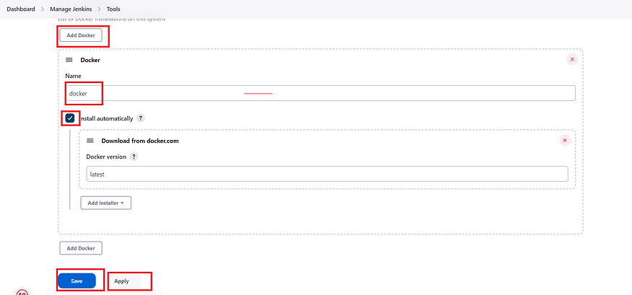

Add DockerHub Username and Password under Global Credentials

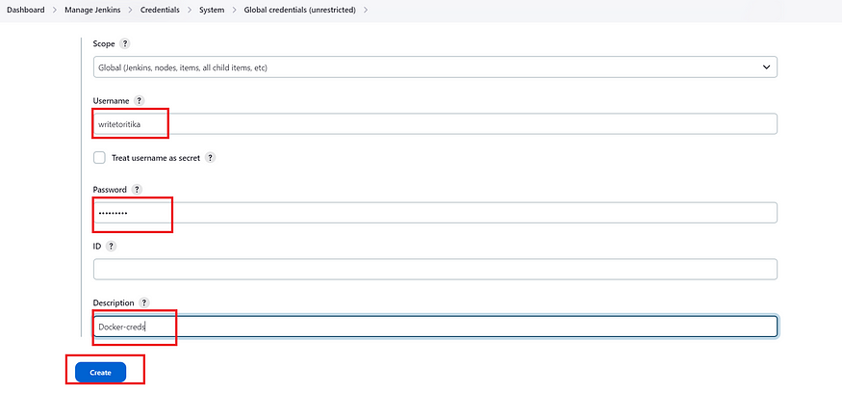

Add this stage in Pipeline Script

stage("Docker Build & Push"){  
 steps{  
 script{  
 withDockerRegistry(credentialsId: ‘docker', toolName: 'docker') {  
   
 sh "docker build -t petclinic1 ."  
 sh "docker tag petclinic1 Aj7Ay/pet-clinic123:latest "  
 sh "docker push Aj7Ay/pet-clinic123:latest "  
   
 }  
 }  
 }  
 }

You will see the output like below,

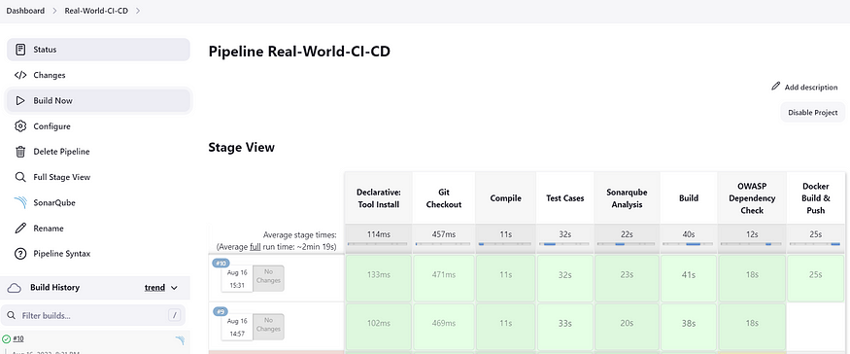

Now, when you do

docker images

You will see this output

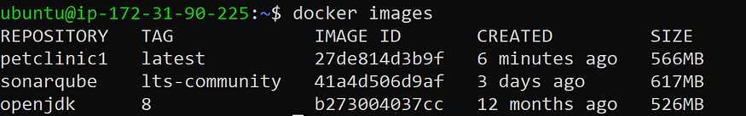

When you log in to Dockerhub, you will see a new image is created

**Step 7** — Deploy image using Docker

Add this stage to your pipeline syntax

stage("Deploy Using Docker"){  
 steps{  
 sh " docker run -d --name pet1 -p 8082:8082 Aj7Ay/pet-clinic123:latest "  
 }  
 }

You will see the Stage View like this,

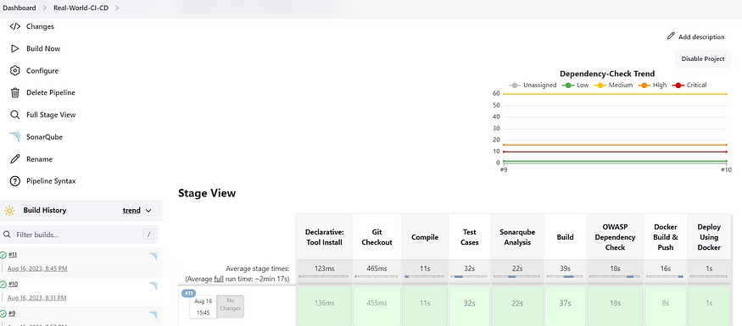

**Step 8** — Install Tomcat on Port 8083 and finally deploy on Apache Tomcat using groovy pipeline script mentioned

Before we add Pipeline Script, we need to install and configure Tomcat on our server.

Here are the steps to install Tomcat 9

##################----INSTALL TOMCAT----##################

Commands are in Yellow color

--> change to opt directory

cd /opt

--> Download tomcat file using wget command

sudo wget https://archive.apache.org/dist/tomcat/tomcat-9/v9.0.65/bin/apache-tomcat-9.0.65.tar.gz

sudo wget https://dlcdn.apache.org/tomcat/tomcat-9/v9.0.80/bin/apache-tomcat-9.0.80.tar.gz (Another link )

--> Unzip tar file

sudo tar -xvf apache-tomcat-9.0.65.tar.gz

--> move to conf directory and change port in tomcat server to another port from default port

cd /opt/apache-tomcat-9.0.65/conf

vi server.xml

--> update tomcat users xml file for manager app login.

cd /opt/apache-tomcat-9.0.65/conf

sudo vi tomcat-users.xml

# ---add-below-line at the end (2nd-last line)----

<user username="admin" password="admin1234" roles="admin-gui, manager-gui"/>

--> create a symbolic links for direct start and stop of tomcat

sudo ln -s /opt/apache-tomcat-9.0.65/bin/startup.sh /usr/bin/startTomcat

sudo ln -s /opt/apache-tomcat-9.0.65/bin/shutdown.sh /usr/bin/stopTomcat

sudo vi /opt/apache-tomcat-9.0.65/webapps/manager/META-INF/context.xml

comment:

<!-- Valve className="org.apache.catalina.valves.RemoteAddrValve"

allow="127\.\d+\.\d+\.\d+|::1|0:0:0:0:0:0:0:1" /> -->

sudo vi /opt/apache-tomcat-9.0.65/webapps/host-manager/META-INF/context.xml

comment:

<!-- Valve className="org.apache.catalina.valves.RemoteAddrValve"

allow="127\.\d+\.\d+\.\d+|::1|0:0:0:0:0:0:0:1" /> -->

sudo stopTomcat

sudo startTomcat

Certainly! To allow both the **ubuntu** and **jenkins** users to copy the **petclinic.war** file to the **/opt/apache-tomcat-9.0.65/webapps/** directory without entering passwords, you can add the appropriate entries to the **/etc/sudoers** file. Here's how you can do it:

Open a terminal.

Use the **sudo** command to edit the sudoers file using a text editor like **visudo**:

sudo visudo

Scroll down to an appropriate section (e.g., just below the line with **%sudo ALL=(ALL:ALL) ALL**) and add the following lines:

ubuntu ALL=(ALL) NOPASSWD: /bin/cp /var/lib/jenkins/workspace/petclinic/target/petclinic.war /opt/apache-tomcat-9.0.65/webapps/ jenkins ALL=(ALL) NOPASSWD: /bin/cp /var/lib/jenkins/workspace/petclinic/target/petclinic.war /opt/apache-tomcat-9.0.65/webapps/

Save the file and exit the text editor.

By adding these lines, you're allowing both the **ubuntu** user and the **jenkins** user to run the specified **cp** command without being prompted for a password.

After making these changes, both users should be able to run the Jenkins job that copies the **petclinic.war** file to the specified directory without encountering permission issues. Always ensure that you're cautious when editing the sudoers file and that you verify the paths and syntax before saving any changes.

SincePort 8080 is being used by Jenkins, we have used Port 8083 to host Tomcat Server

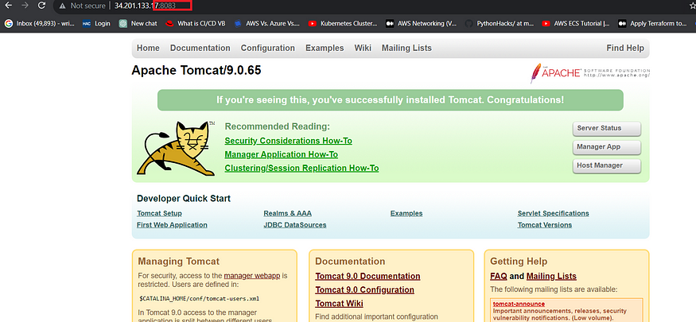

Add this stage to your Pipeline script

stage("Deploy To Tomcat"){  
 steps{  
 sh "cp /var/lib/jenkins/workspace/Real-World-CI-CD/target/petclinic.war /opt/apache-tomcat-9.0.65/webapps/ "  
 }  
 }

Kindly note that this application can be deployed via Docker and also via Tomcat Server. Here I have used Tomcat to deploy the application

The final script looks like this,

pipeline {  
 agent any   
   
 tools{  
 jdk 'jdk17'  
 maven 'maven3'  
 }  
   
 environment {  
 SCANNER_HOME=tool 'sonar-scanner'  
 }  
  
 stages{  
   
 stage("Git Checkout"){  
 steps{  
 git branch: 'main', changelog: false, poll: false, url: 'https://github.com/Aj7Ay/Petclinic.git'  
 }  
 }  
   
 stage("Compile"){  
 steps{  
 sh "mvn clean compile"  
 }  
 }  
   
 stage("Test Cases"){  
 steps{  
 sh "mvn test"  
 }  
 }  
   
   
   
   
 stage("Build"){  
 steps{  
 sh " mvn clean install"  
 }  
 }  
   
 stage("OWASP Dependency Check"){  
 steps{  
 dependencyCheck additionalArguments: '--scan ./ --format HTML ' , odcInstallation: 'DP-Check'  
 dependencyCheckPublisher pattern: '**/dependency-check-report.html'  
 }  
 }  
   
 stage("Docker Build & Push"){  
 steps{  
 script{  
 withDockerRegistry(credentialsId: 'docker’, toolName: 'docker') {  
   
   
 sh "docker build -t petclinic1 ."  
 sh "docker tag petclinic1 Aj7Ay/pet-clinic123:latest "  
 sh "docker push Aj7Ay/pet-clinic123:latest "  
   
 }  
 }  
 }  
 }  
   
 stage("Deploy Using Docker"){  
 steps{  
 sh " docker run -d --name pet12 -p 8082:8082 Aj7Ay/pet-clinic123:latest "  
 }  
 }  
   
 stage("Deploy To Tomcat"){  
 steps{  
 sh "cp target/petclinic.war /opt/apache-tomcat-9.0.65/webapps/ "  
 }  
 }  
 }  
}

And you can access your application on Port 8083. This is a Real World Application that has all Functional Tabs.

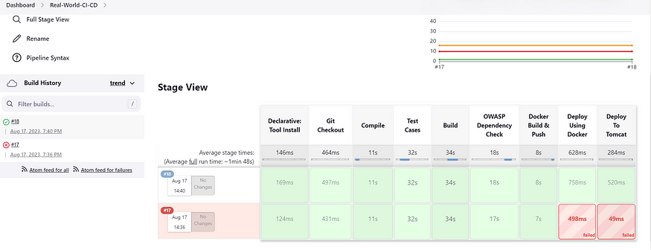

**Step 9**— Access the Real World Application

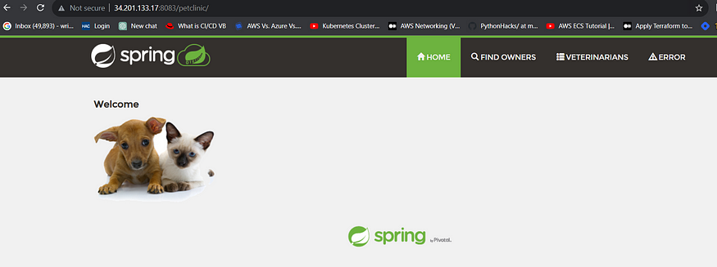

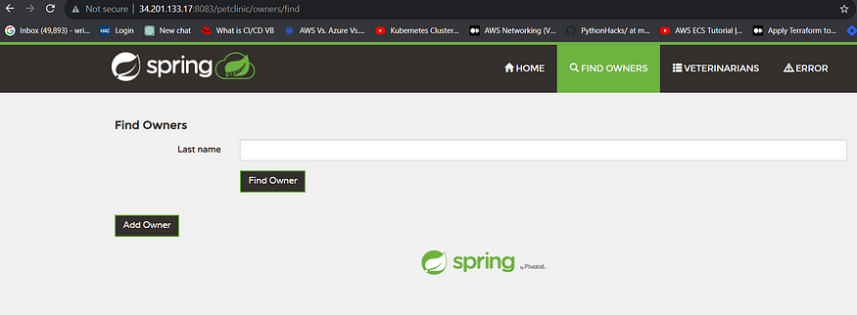

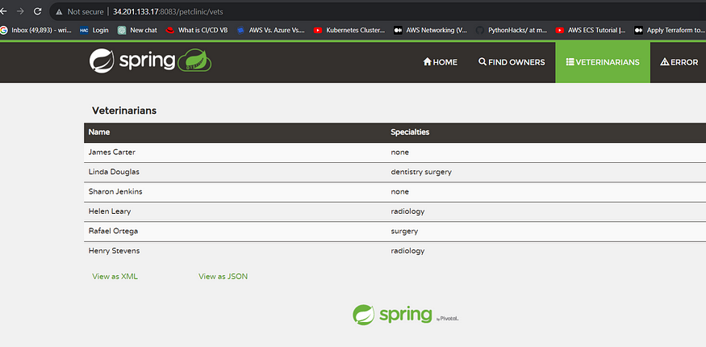

**STEP :10 Take Two Ubuntu 20.04 instances one for k8s master and other one for worker also install on Jenkins machine (only kubectl)**

**Kubectl on Jenkins to be installed**

**sudo apt update**

**sudo apt install curl**

**curl -LO** [**https://dl.k8s.io/release/$(curl -L -s https://dl.k8s.io/release/stable.txt)/bin/linux/amd64/kubectl**](https://dl.k8s.io/release/$(curl%20-L%20-s%20https://dl.k8s.io/release/stable.txt)/bin/linux/amd64/kubectl)

**sudo install -o root -g root -m 0755 kubectl /usr/local/bin/kubectl**

**kubectl version –client**

Part 1 ----------------------------Master ------------

sudo su

hostname master

bash

clear

Node --------------

sudo su

hostname master

bash

clear

Part 2 -----------------------------------------------------Both Master & Node -------------

sudo apt-get update && sudo apt-get upgrade -y

sudo apt-get install -y docker.io

sudo usermod –aG docker Ubuntu

newgrp docker

sudo chmod 777 /var/run/docker.sock

sudo curl -s https://packages.cloud.google.com/apt/doc/apt-key.gpg | sudo apt-key add -

sudo tee /etc/apt/sources.list.d/kubernetes.list <<EOF

deb https://apt.kubernetes.io/ kubernetes-xenial main

EOF

sudo apt-get update

sudo apt-get install -y kubelet kubeadm kubectl

snap install kube-apiserver

Part 3 ----------------------------------------------- Master ---------------

sudo kubeadm init --pod-network-cidr=10.244.0.0/16

mkdir -p $HOME/.kube

sudo cp -i /etc/kubernetes/admin.conf $HOME/.kube/config

sudo chown $(id -u):$(id -g) $HOME/.kube/config

kubectl apply -f https://raw.githubusercontent.com/coreos/flannel/master/Documentation/kube-flannel.yml

Node ----------

paster the kube adm join command which is in this format: sudo kubeadm join <master-node-ip>:<master-node-port> --token <token> --discovery-token-ca-cert-hash <hash>

Part 4 ----------------------------------------------------------------

Master -----------------

kubectl get nodes

---------------------------------------------------------------------------------------------------------------

CONGRATULATIONS FOR YOUR NEW KUBERNETES CLUSTER ON UBUNTU ON EC2

Copy config file to Jenkins master or to local file manager and save it

Install Kubernetes plugins

Install Kubernetes Plugin, once its installed successfully. goto manage jenkins --> manage credentials --> Click on jenkins global --> add credentials

# Configuring mail server in Jenkins ( Gmail )

Install Email Extension Plugin in Jenkins

Once plugin installed in jenkins, click on manage jenkins --> configure system there under E-mail Notification section configure the details as shown in below image

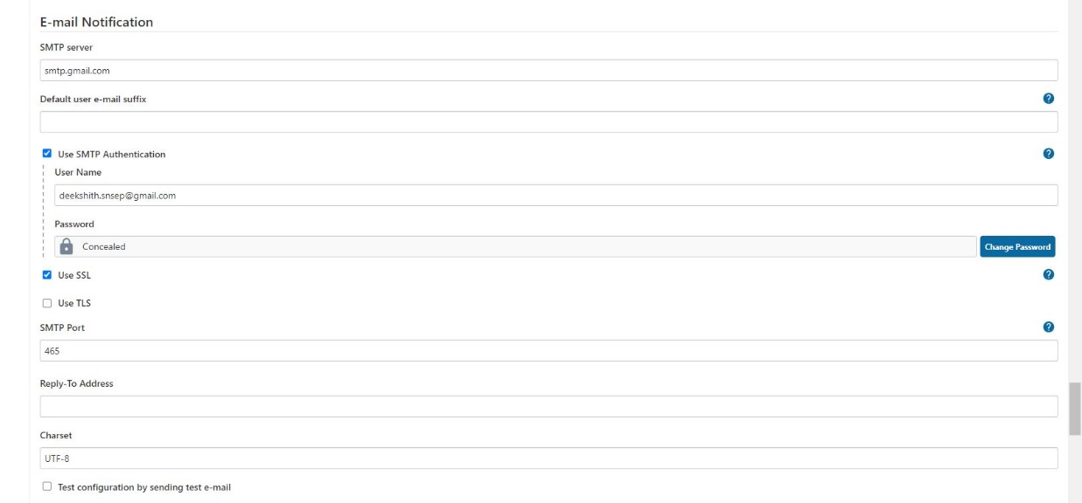

this is to just verify mail configuration

Now under Extended E-mail Notification section configure the details as shown in below images

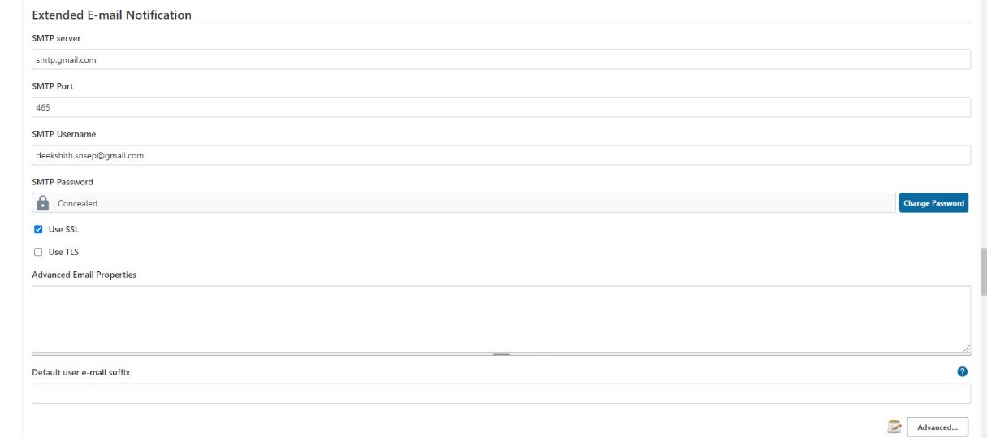 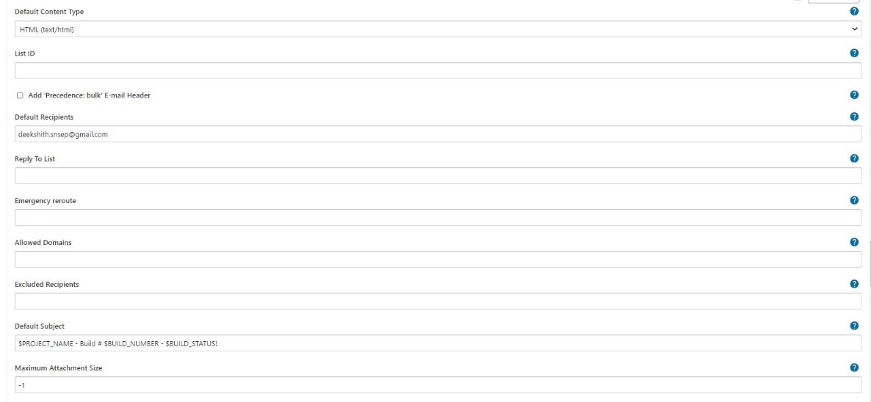 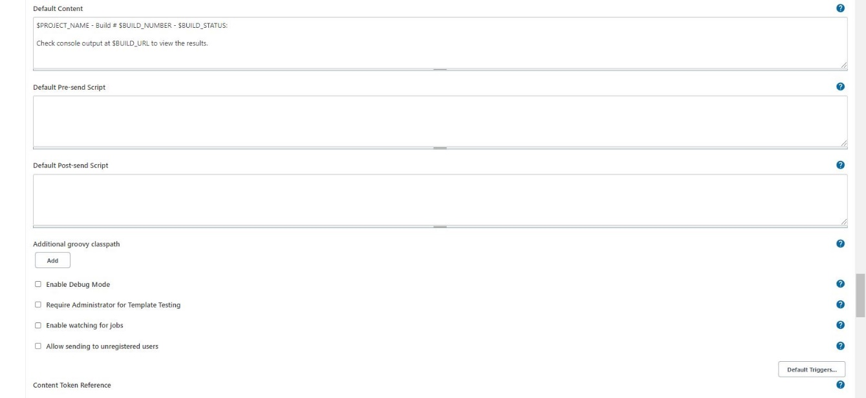

By using below code i can send customized mail

post {

always {

mail bcc: '', body: "<br>Project: ${env.JOB_NAME} <br>Build Number: ${env.BUILD_NUMBER} <br> URL de build: ${env.BUILD_URL}", cc: '', charset: 'UTF-8', from: '', mimeType: 'text/html', replyTo: '', subject: "${currentBuild.result} CI: Project name -> ${env.JOB_NAME}", to: "postbox.aj99@gmail.com";

}

}

also which ever the mail you use for authentication in that mail setting "Less secure apps access" should be enabled

**Step 11**— Terminate the AWS EC2 Instance

Lastly, do notS forget to terminate the AWS EC2 Instance.

pipeline{

    agent any

    tools{

        jdk 'jdk17'

        maven 'maven3'

    }

    environment {

        SCANNER_HOME=tool 'sonar-scanner'

    }

    stages {

        stage('clean workspace'){

            steps{

                cleanWs()

            }

        }

        stage('Checkout From Git'){

            steps{

                git branch: 'main', url: 'https://github.com/Aj7Ay/Petclinic-Real.git'

            }

        }

        stage('mvn compile'){

            steps{

                sh 'mvn clean compile'

            }

        }

        stage('mvn test'){

            steps{

                sh 'mvn test'

            }

        }

        stage("Sonarqube Analysis "){

            steps{

                withSonarQubeEnv('sonar-server') {

                    sh ''' $SCANNER_HOME/bin/sonar-scanner -Dsonar.projectName=Petclinic \

                    -Dsonar.java.binaries=. \

                    -Dsonar.projectKey=Petclinic '''

                }

            }

        }

        stage("quality gate"){

           steps {

                 script {

                     waitForQualityGate abortPipeline: false, credentialsId: 'Sonar-token'

                    }

                }

        }

        stage('mvn build'){

            steps{

                sh 'mvn clean install'

            }

        }

        stage("OWASP Dependency Check"){

            steps{

                dependencyCheck additionalArguments: '--scan ./ --format HTML ', odcInstallation: 'DP-Check'

                dependencyCheckPublisher pattern: '**/dependency-check-report.html'

            }

        }

        stage("Docker Build & Push"){

            steps{

                script{

                   withDockerRegistry(credentialsId: 'docker', toolName: 'docker'){

                       sh "docker build -t petclinic1 ."

                       sh "docker tag petclinic1 sevenajay/petclinic1:latest "

                       sh "docker push sevenajay/petclinic1:latest "

                    }

                }

            }

        }

        stage("TRIVY"){

            steps{

                sh "trivy image sevenajay/petclinic1:latest > trivy.txt"

            }

        }

        stage('Clean up containers') {   //if container runs it will stop and remove this block

          steps {

           script {

             try {

                sh 'docker stop pet1'

                sh 'docker rm pet1'

                } catch (Exception e) {

                  echo "Container pet1 not found, moving to next stage"

                }

            }

          }

        }

        stage ('Manual Approval'){

          steps {

           script {

             timeout(time: 10, unit: 'MINUTES') {

              def approvalMailContent = """

              Project: ${env.JOB_NAME}

              Build Number: ${env.BUILD_NUMBER}

              Go to build URL and approve the deployment request.

              URL de build: ${env.BUILD_URL}

              """

             mail(

             to: 'postbox.aj99@gmail.com',

             subject: "${currentBuild.result} CI: Project name -> ${env.JOB_NAME}",

             body: approvalMailContent,

             mimeType: 'text/plain'

             )

            input(

            id: "DeployGate",

            message: "Deploy ${params.project_name}?",

            submitter: "approver",

            parameters: [choice(name: 'action', choices: ['Deploy'], description: 'Approve deployment')]

            )

          }

         }

       }

    }

        stage('Deploy to conatiner'){

            steps{

                sh 'docker run -d --name pet1 -p 8082:8080 sevenajay/petclinic1:latest'

            }

        }

        stage("Deploy To Tomcat"){

            steps{

                sh "sudo cp  /var/lib/jenkins/workspace/petclinic/target/petclinic.war /opt/apache-tomcat-9.0.65/webapps/ "

            }

        }

        stage('Deploy to kubernets'){

            steps{

                script{

                    withKubeConfig(caCertificate: '', clusterName: '', contextName: '', credentialsId: 'k8s', namespace: '', restrictKubeConfigAccess: false, serverUrl: '') {

                       sh 'kubectl apply -f deployment.yaml'

                  }

                }

            }

        }

    }

    post {

     always {

        emailext attachLog: true,

            subject: "'${currentBuild.result}'",

            body: "Project: ${env.JOB_NAME}<br/>" +

                "Build Number: ${env.BUILD_NUMBER}<br/>" +

                "URL: ${env.BUILD_URL}<br/>",

            to: 'postbox.aj99@gmail.com',

            attachmentsPattern: 'trivy.txt'

        }

    }

}

// try this approval stage also

stage('Manual Approval') {

  timeout(time: 10, unit: 'MINUTES') {

    mail to: 'postbox.aj99@gmail.com',

         subject: "${currentBuild.result} CI: ${env.JOB_NAME}",

         body: "Project: ${env.JOB_NAME}\nBuild Number: ${env.BUILD_NUMBER}\nGo to ${env.BUILD_URL} and approve deployment"

    input message: "Deploy ${params.project_name}?",

           id: "DeployGate",

           submitter: "approver",

           parameters: [choice(name: 'action', choices: ['Deploy'], description: 'Approve deployment')]

  }

}