# MILESTONE 1

## Table of Contents

Table of Contents 1

Executive Summary 2

List and status of deliverables 3

Evaluation of the status of deliverables and its impact on your project plan 3

Evaluation of tools and processes that you have used to manage your team project 3

A summary of work done by each team member (in tabular format) 3

Deliverables 3

Scenarios and Mockups 3

Scenario 1 (Surfing) 3

Scenario 2 (Membership) 5

Scenario 3 (User Accounts) 6

Scenario 4 (Roles) 8

Scenario 5 (Spaces) 8

Scenario 6 (Blackboard) 11

Software Requirements Specification 12

Surfing 12

Membership 12

User Account 13

Rights 13

Roles 14

Spaces 14

Blackboard 16

Software design documents in UML 18

Use Case Diagram for the Platform 18

Sign-up Sign-in Sequence Diagram 19

Space Creation and Space Modes Sequence Diagram 20

Invitation and Participation Request Sequence Diagram 21

Rating Space Members Sequence Diagram 22

BlackBoard Process in flow Chart Diagram 23

Project plan 24

GitHub wiki pages 25

ToDo list for Github Repo 25

## Executive Summary

Within the scope of the project, a draft co-learning platform will establish within 14 weeks. Within the scope of this document (Milestone1), the progress over 5 weeks is summarized below;

* **Github page:** Github page was created and updated weekly.
* **Django framework example for platform setup:** A basic website was established using the Phyton Django framework.
* **Research:** A research was conducted on learning stages and co-learning applications.
* **Requirements:** Requirements set was roughly prepared.
* **Scenarios:** Scenarios were prepared so that requirements can be created.
* **Elicitation:** Requirements were elicitated.
* **Mock-ups:** Mock-ups were designed.
* **UML Diagrams:** Use Case and Activity diagrams were drawn.
* **Project Plan:** Project plan and timeline were prepared using Trello.

Implementation, UAT and some of the deployment phases will be completed in the remaining weeks. Due to the detailed preparation of the requirements for the co-learning platform and the low familiarity with the Django framework, the platform will be implemented as a draft, and the details will be completed with group work in the next semester. In addition, if there are requirements that will take too long to implement, these are removed from the prepared requirement set and the model will be simplified.

## List and status of deliverables

* Milestone1 report
* Github page (assignments were prepared in wiki page)
* Basic web site code (has been given in the Github code section)
* Requirement set of co-learning platform
* Draft mock-ups
* Draft project plan

## Evaluation of the status of deliverables and its impact on your project plan

Deliverables and completion stages are given in the “Project Plan” section of this document. Parts completed within 5 weeks are crucial for the rest of the project. An incorrect set of requirements may cause repetition of the work done so far and waste of time.

## Evaluation of tools and processes that you have used to manage your team project

Using the Gantt Chart plugin in the Trello application, project has been managed by determined project stages, ranking, prioritization and role assignments..

## A summary of work done by each team member (in tabular format)

In this semester, project phases will be implemented individually.

## Deliverables

### Scenarios and Mockups

#### Scenario 1 (Surfing)

* Since user Ahmet Yılmaz is not a member of the co-learning platform, he can only view the contents of About us, What do we offer, Spaces and Contact us.
* Ahmet Yılmaz can become a member with the sign-up button on the co-learning platform's home page, and view previously created and closed co-learning spaces with the search button.
* After Ahmet Yılmaz has become a member of co-learning platfrom, he can sign-in to his account with the sign-in button on the main page.

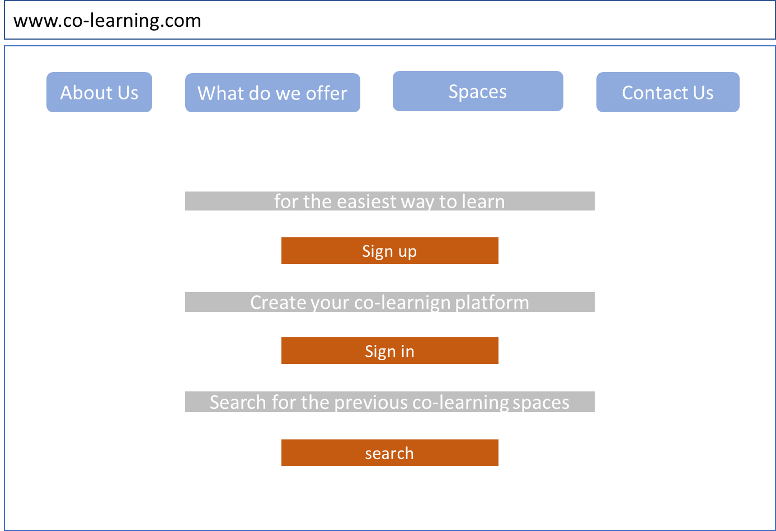

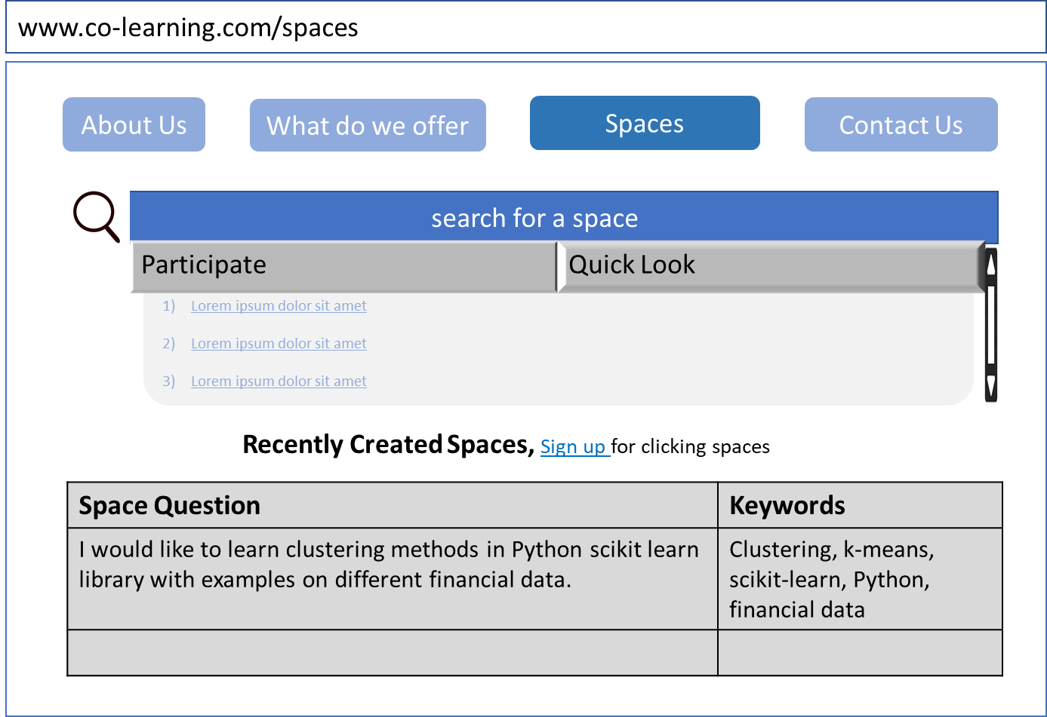

#### Scenario 2 (Membership)

* User Ahmet Yılmaz signs up with the e-mail address ahmet.yilmaz@gmail.com, the password Ahmet_Yilmaz34 and his interests in data science, artificial intelligence, deep learning, machine learning and python.
* A verification code link is automatically sent to Ahmet Yılmaz's e-mail address and Ahmet Yılmaz activates his account by clicking this link.
* Ahmet Yılmaz logs in to the Platform using the sign-in button, goes to his account, completes his information as XYZ A.Ş., Ph.D., 01.01.1990, İstanbul and uploads his photo into his account.

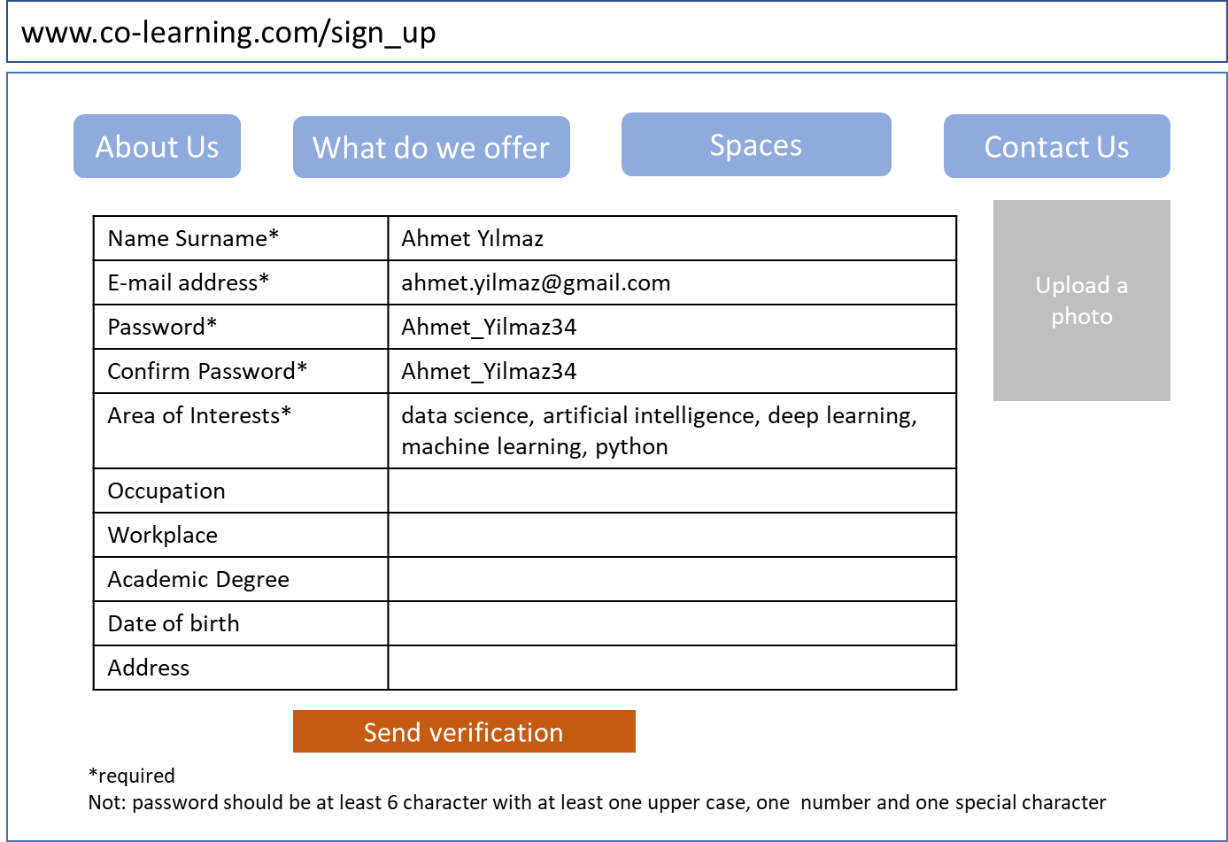

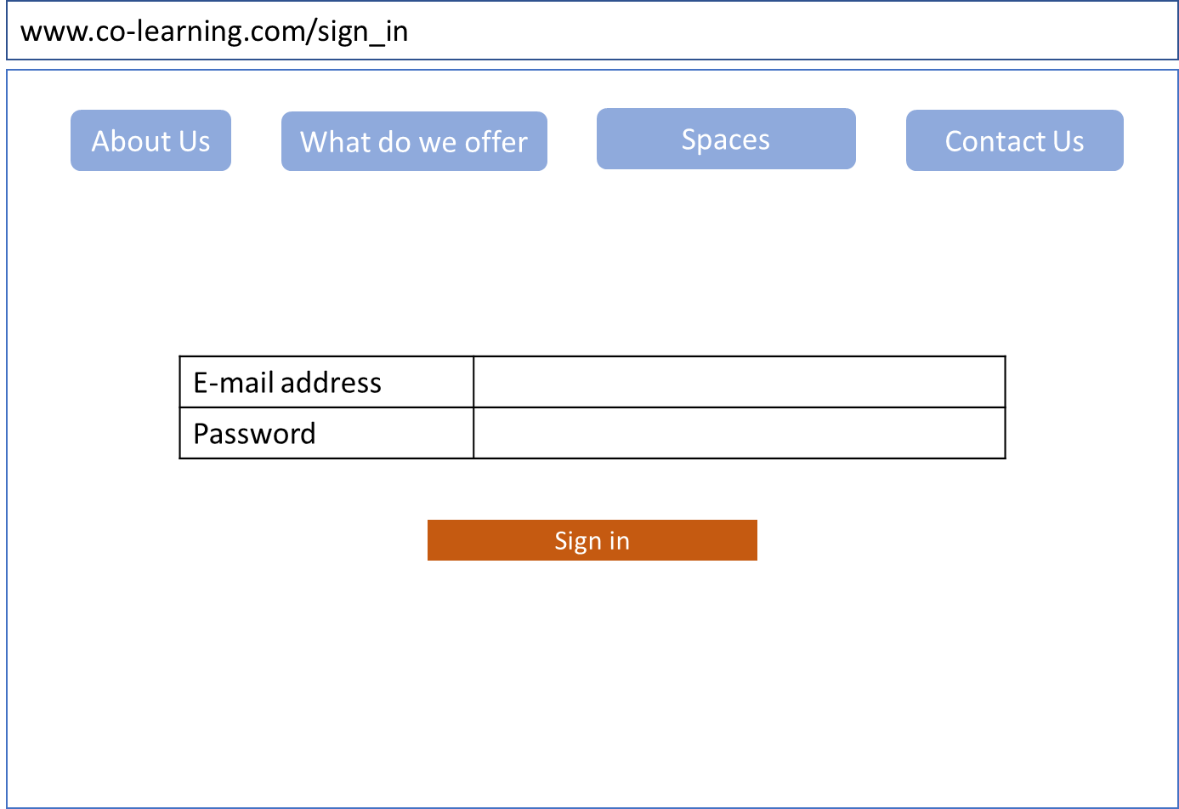

#### Scenario 3 (User Accounts)

Ahmet Yılmaz stated that he liked his work in co-learning space by giving 5 out of five to his space friend, Mustafa Yıldız. On the other hand, Ayşe Çalışkan, another friend of him in the same group, did not like Mustafa Yıldız's work very much, so she gave 3.5 to Mustafa Yıldız, who received a total of 32.76 points from the average of the previous 5 grades, is 4.68 out of five. The standard deviation of 7 grades is 0.64.

Since Mustafa Yıldız used 3 of the 10 space creating rights, by which he obtained due to his ratings, he has the right to create 7 spaces more for the current week. Since he sent 66 invitations for the spaces in which he took part, he had the right to send 34 invitations left. Out of a total of 5GB attachment right, 1.22GB was used and 3.64GB of file attachment right remained.

These values ​​can be accessed by clicking the User button on the top right of the page after Mustafa Yıldız sign-in. After clicking the User button, Mustafa Yıldız can view the rates he received in the user stats tab, the pages he created in the created space tab, and the previously participated spaces in the participated space tab. Mustafa Yıldız can enter into this active space and participate in studies by clicking the 74992 number space under the created space tab. In addition, by clicking on the closed spaces in the space tabs under the user account, he can examine the work done.

When he logs into his account, Mustafa Yıldız can view the invitations and messages by using the two buttons, which include the space invitations he receives and the messages from the spaces he is in, under the buttons located his name.

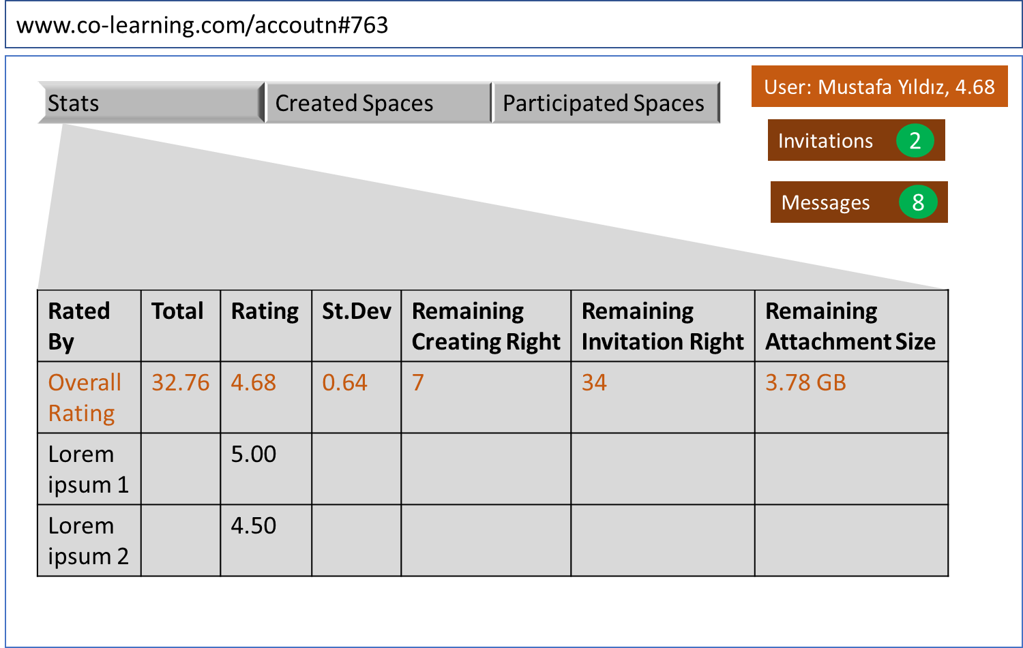

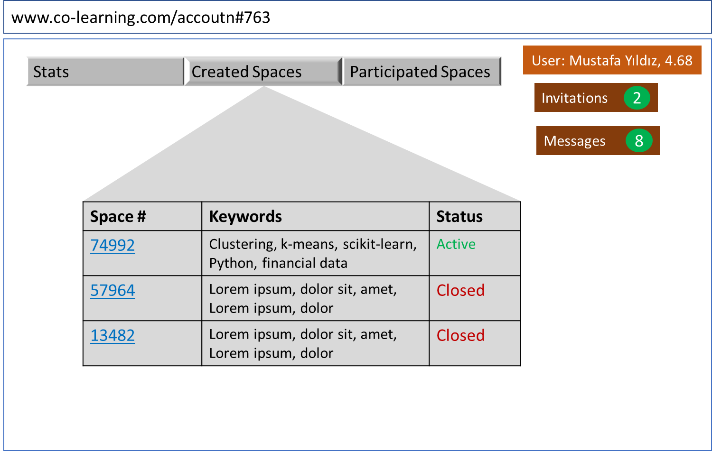

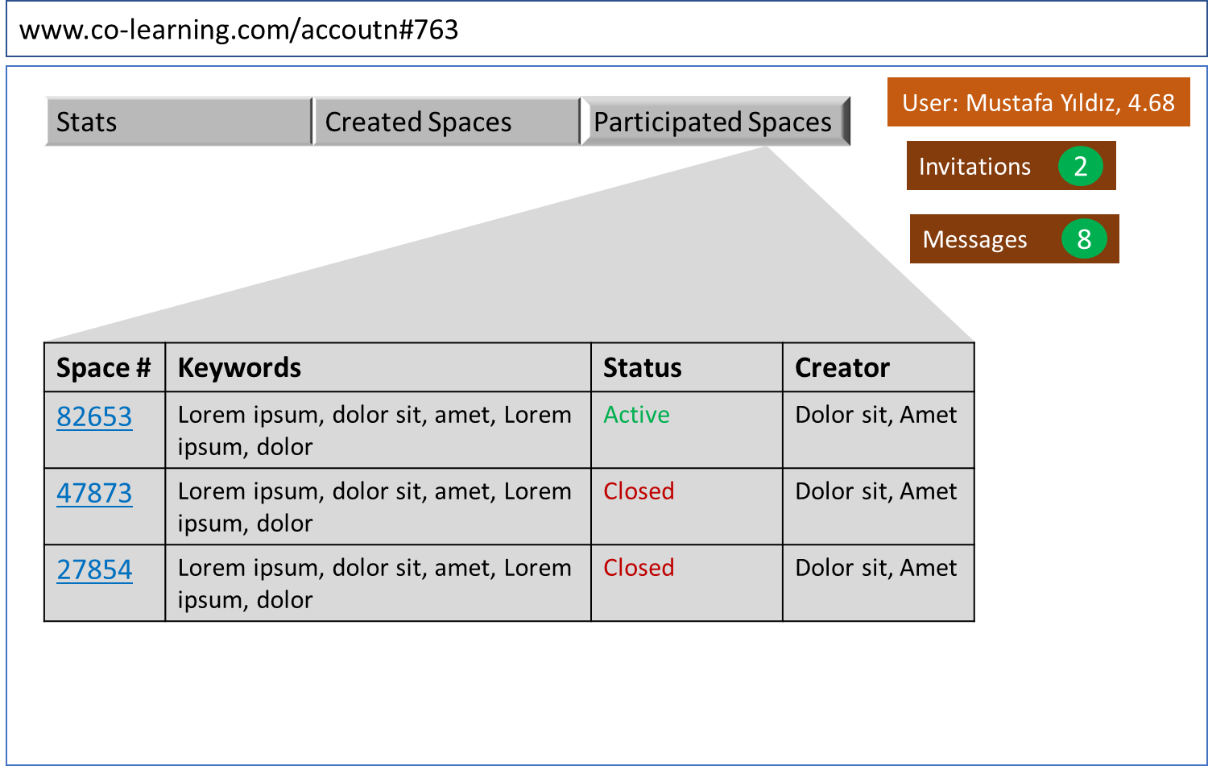

#### Scenario 4 (Roles)

Mustafa Yıldız has created space 74492 and started co-learning processes with the participation of a total of 4 users as a result of invitations. Since Mustafa Yıldız is the founder, he can change his space status, remove any member he wants and take into space any member he wants. Other space members, on the other hand, can invite members with the creator's approval and ask questions, participate in meetings, comment, like/dislike, send messages and chat.

#### Scenario 5 (Spaces)

There are 4 different modes/statues for Spaces.

**Creating the space:** After Mustafa Yıldız signs-in, he fills in the relevant required and optional fields to create a space.

* Subject (Required): I would like to learn clustering methods in Python scikit learn library with examples on different financial data.
* Keywords (Required): Clustering, k-means, scikit-learn, Python, financial data
* Duration for participation (Optional): 1 week
* Attachment (Optional): Clustering_methods.pdf

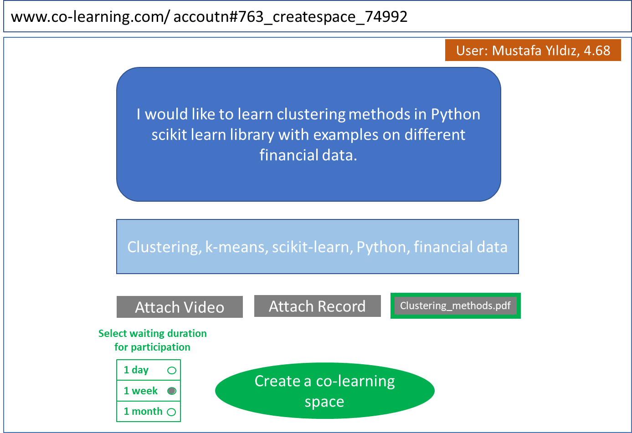

**Waiting for the participation**: Mustafa Yıldız sends a total of 3 invitations within his weekly invitation rights in the space where he is the creator. One of the invitees, Ahmet Yılmaz, accepts these invitations and becomes a space member.

Meanwhile, Ayşe Çalışkan also wants to learn something about clustering. After sign-in, she searches by typing "clustering" in the search line and filters the active spaces in the results. Space numbered 74992 created by Mustafa Yıldız comes first with the keywords "Clustering, k-means, scikit-learn, Python, financial data". Since Ayşe Çalışkan thinks that this space overlaps with the subject she wants to learn, she presses the join button and sends a request message to Mustafa Yıldız.

There are 2 unread messages in Mustafa Yıldız's account. In these messages, he sees Ayşe Çalışkan's request for joining. First, by clicking on Ayşe Çalışkan's name written in the message, he displays Ayşe Çalışkan's profile. Since Ayşe Çalışkan has 'Phyton' and 'Data Science' among her area of interests in her profile, he presses the Approve button under her name and accepts her into space.

Similar to this process, Mustafa Yıldız have taken into his space Zeynep Mert, Ali Bilir and Elif Su. Since there are 5 people in total, Mustafa Yıldız thinks that the sufficient number has been met, and switches the space mode from "waiting for participation" to "co-learning" mode without waiting at the end of the week which was selected by him at the beginning of the creation of the space.

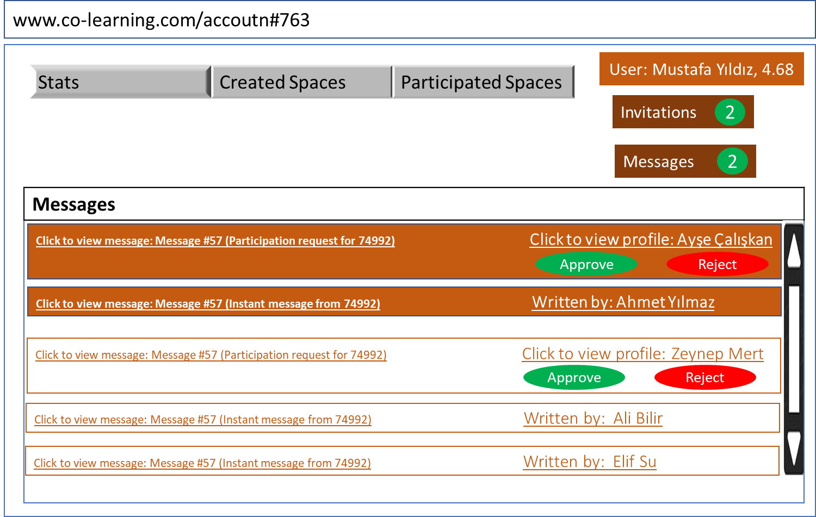

**Co-learning**: Ayşe Çalışkan and Ali Bilir write some instant message to Mustafa Yıldız's views on the subject. Ahmet Yılmaz and Ali Bilir, on the other hand, add their comments to these messages with the Comment button under the messages. In addition, space members indicate their ideas about whether they like these messages with the like and dislike buttons under the comments.

Ali Bilir and Ayşe Çalışkan upload the resources they obtained regarding clustering as Attachment Document>Browse>Clustering_methods.

Ahmet Yılmaz schedules a meeting with the “set meetings” button and the system sends an automatic e-mail to all participants for this meeting. Mustafa Yıldız and Ayşe Çalışkan attend the meeting. Ayşe Çalışkan prepares the meeting note and uploads it as Attachment Document>Browse>Meeting Note_04052022. Meeting video is automatically uploaded by the system.

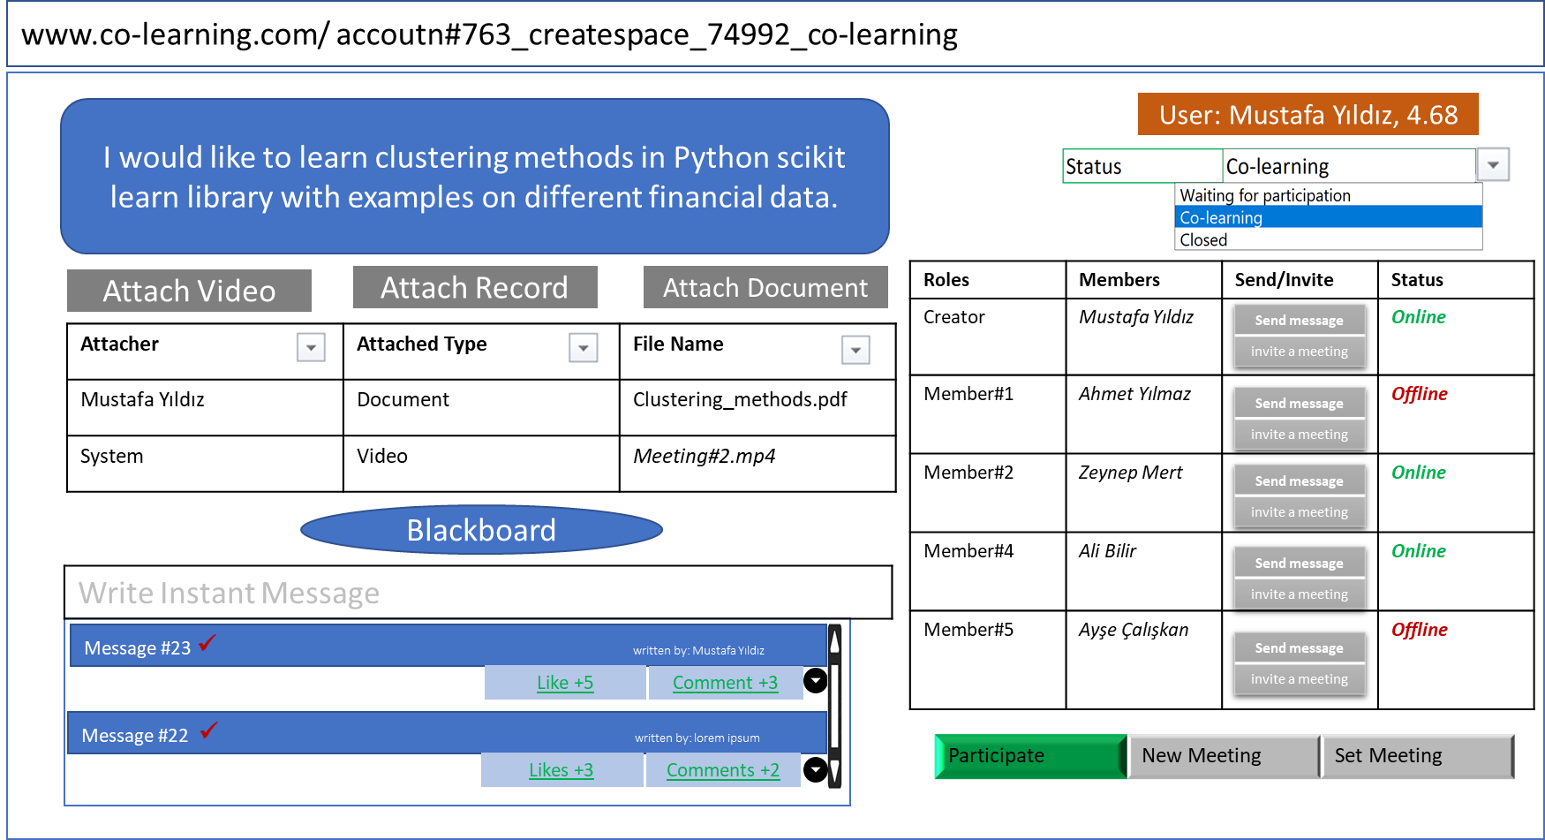

**Closing the space**: Mustafa Yıldız tells all space members that the learning process has been completed with an instant message and asks the members for their final opinions. All other members give their opinions on the completion of the learning process. Based on these views, Mustafa Yıldız chooses the space status as closed and the system saves the space 74992 with all its content to the database. This closed space is saved in a way that allows different users to be viewed later, this closed space can be accessed by searching.

#### Scenario 6 (Blackboard)

Mustafa Yıldız enters the blackboard page by pressing the Blackboard button in the space no 74992. He draws the learning program stages with the edit board button. Ali Bilir also enters the blackboard page by pressing the blackboard button. Mustafa Yıldız adds some of the files in the attachment to the learning program drawing that display on the screen. He makes this adding by dragging files from attachment and dropping them into board. He also comments on the stages in the blackboard. Zeynep Mert also makes changes on the drawing displayed on the screen after entering in, and adds new learning stages to the drawing.

When the edit button is clicked for drawing, pencil, eraser, shapes, text box, colors, arrows appear. Each of these can be edited separately. Namely, when the edit button is used by one member, the other member cannot use the edit button and cannot make any change in the drawing.

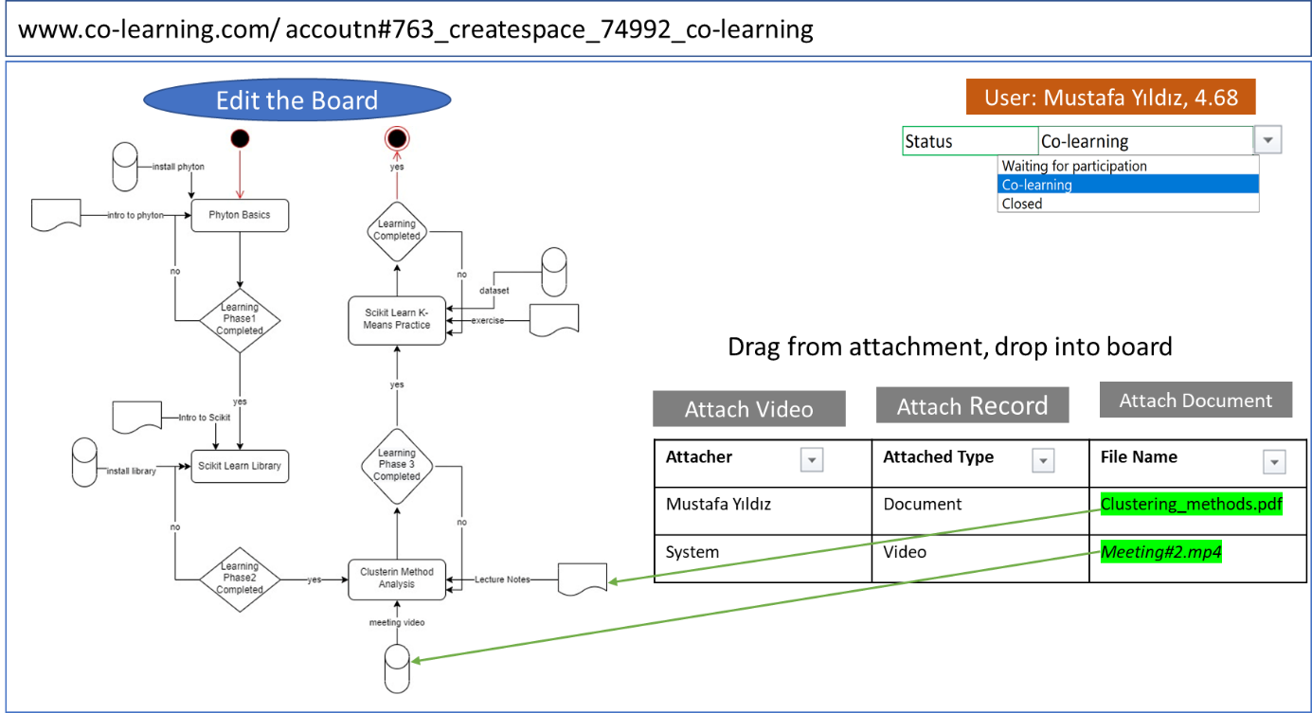

### Software Requirements Specification

#### Surfing

* System shall let users to view/display to the About us, What do we offer, Spaces and Contact us
* Users shall view previously created and closed co-learning spaces with the search button.
* Users shall sign-up or-sign-in by using buttons at the main page.

#### Membership

* User shall sign up with filling the mandatory fields as name-surname, e-mail address, password, confirm password and areas of interest.
* Areas of interest shall be at least 5 and maximum 20.
* Profile picture, year of birth, address, workplace and occupation information, academic degree fields shall be optional.
* When sign-up is completed, system shall send e-mail verification to user’s e-mail address in order to activate the user account.
* When activation is completed, user shall sign-in to the co-learning platform (Platform).
* System shall record the membership information, sign-in and sign-out times and unsuccessful sign-in attempts.
* Password shall include at least one special character, one number, one capital letter and 6 character.

#### User Account

* User shall have the right to rate the other users.
* Rates shall be between 0 and 5, with maximum two digits after point.
* User shall only rate other user once.
* System shall display the average, standard deviation and total value of rating in the account subpage of each user.
* System shall give users the rights obtained by rate level as follows:
* When user signs in, system shall display three buttons at the right top corner of the page which are user button, invitations button and message button.
* User shall reach its account by clicking user button.
* User shall view its stats, closed and created spaces tabs in its user account subpages.
* Spaces listed in the closed and created space shall have features as space number which is linked to the related space, active/closed status which are in green and red colors, creator info and keywords of the related space.
* When user click the space number, system shall open the related space.
* Unread invitation and messages quantities shall display nearby the related buttons with different color.
* When user click the invitations button, system shall open the invitation list sorted by time priority.
* When user click the messages button, system shall open the message list sorted by time priority.
* Unread invitations and messages shall display in bold structure.

#### Rights

* System shall give users the rights obtained by rate level as below:

**Table 1. Rights of the Co-Learning Platform Users According to Their Ratings**

|  |  |  |  |
| --- | --- | --- | --- |
| **Points (Stars)** | **Co-Learning Space Creating Right** | **Inivitation Sending Right** | **Attachment Size** |
| New User | 1 per week | 10 per week | 1 GB |
| < 3.0 | 1 per week | 10 per week | 1 GB |
| >=3.0 and < 4.0 | 5 per week | 50 per week | 2 GB |
| >=4.0 and < 5.0 | 10 per week | 100 per week | 5 GB |

#### Roles

* User that creates the space shall be the moderator/creator.
* Creator shall have the following right for the space that she/he creates.
  + Inviting the user to her/his space
  + Accepting the membership requests
  + Approving/Dening the invitation sending requests of the space members
  + Removing space member out of the space
  + Changing the status/mode of the space
* Users/Space memebers shall have the following right in his/her participated space.
  + Giving likes/dislikes
  + Inviting members with the creator's approval
  + Asking questions,
  + Answering the questions
  + Participating to space meetings
  + Commenting to answers,
  + Sending messages
  + Chating

#### Spaces

**Creating the space:**

* Number of space members shall be between 2-9.
* When users provide following fields, system shall create a co-learning space with a new number adding one to last created space number.
  + Subject (Required): This field shall have maximum 1000 characters.
  + Keywords (Required): This field shall have maximum 100 characters, at least 5 keywords.
  + Duration for participation (Optional): This field shall have 3 different choices: 1 day, 1 week, 1 month.
  + Attachment (Optional): the attachment sizes and structures for the each component of this field shall be as listed in Table 1 and 2:

**Table 2. Data Structures for the Platform**

|  |  |  |  |  |
| --- | --- | --- | --- | --- |
| **Materials** | **Place** | **Optional /Mandatory** | **Limitations** | **Formats** |
| Keywords | body of the page | M | Min. 5 keywords, max. 100 char. | - |
| Subject definition | body of the page | M | Max. 1000 char. | - |
| Documents | attached to the space | O | Maximum 1 MB | .txt, .doc, .xls, .pdf |
| Pictures | attached to the space | 0 | Maximum 10 MB | JPG, TIF, PNG, and GIF |
| Audio | attached to the space | O | Maximum 100 MB | Mp3, AAC, FLAC, OGG, or WMA |
| Videos | attached to the space | O | Maximum 1 GB | Mp4, mov, avi, wmv |

**Waiting for the participation**:

* Creator and the member of the co-learning space shall invite users to their space in their weekly invitation limits/rights.
* If a user click deny button in the message which comes due to the invitation, system automatically send the denial message to the inviter.
* When a user click accept button in the message which comes due to the invitation, system automatically send the acceptance message to the inviter, and system shall add this user to the space.
* When user searches and click for an active space, system automatically send a message to the creator of the space with approve and deny buttons.
* If the creator clicks the deny button, system automatically send a message to the user for denial.
* When the creator clicks the approve button, system automatically send a message to the user for approval.
* System shall display the unread messages with different colors than read messages and bold format.
* When a request comes from a user to a creator, system shall let the creator to view the profile of the user.
* System shall provide 3 modes for co-learning spaces: creating, waiting for participant, closed
* Creator shall switch among modes.
* While creator thinks that the enough users participate her/his space, creator shall switch the space mode from "waiting for participation" to "co-learning" mode.
* While creator thinks that the learning process is completed, creator shall switch the space mode from "co-learning" to “closed” mode.

**Co-learning**:

* A members of the spaces shall write instant messages in a spaces.
* A members of the spaces shall comment on the other members’ instant messages in a spaces.
* When a members of the spaces clicks the like button, he/she shall give like to the other members’ instant messages in the spaces.
* If a members of the spaces clicks the dislike button, he/she shall give dislike to the other members’ instant messages in the spaces.
* A members of the spaces shall attach any document, video or audio files to the attachment part of a space.
* When a members of the spaces clicks the attach button, system shall open browse window for member’s own desktop.
* A members of the spaces shall set or participate a meeting.
* When a members of the spaces clicks participate, new meeting, set meeting button system shall open a new page for meeting in which members can video talk each other, share their screens.
* When a space meeting or chat closed by a space members, system shall automatically create the records of chats’ audio files and videos of the meeting and save them into attachments

**Closing the space**:

* While creator thinks that the learning process is completed, creator shall switch the space mode from "co-learning" to “closed” mode.
* While creator switch the space mode from "co-learning" to “closed” mode, system shall save the space 74992 with all its content to the system database.
* When a user search for the keywords or the space number of a closed spaces, he/she shall view that space by clicking the related link of the space displayed at the results of the search.

#### Blackboard

* While user click the blacboard button, system shall open a subpage for drawing flow charts for co-learning process.
* While user click the edit board button, system shall display the tools such as drawing, pencil, eraser, shapes, text box, colors, arrows buttons for drawing flow charts.
* Each member of the space shall edit the flow chart prepared before by using drawing tools.
* While a member of the space is editing the flow chart, another member of the space shall not edit the flow chart at the same time.
* Each member of the space shall add document by dragging files from attachment part and dropping them into board or flow chart.

### Software design documents in UML

#### Use Case Diagram for the Platform

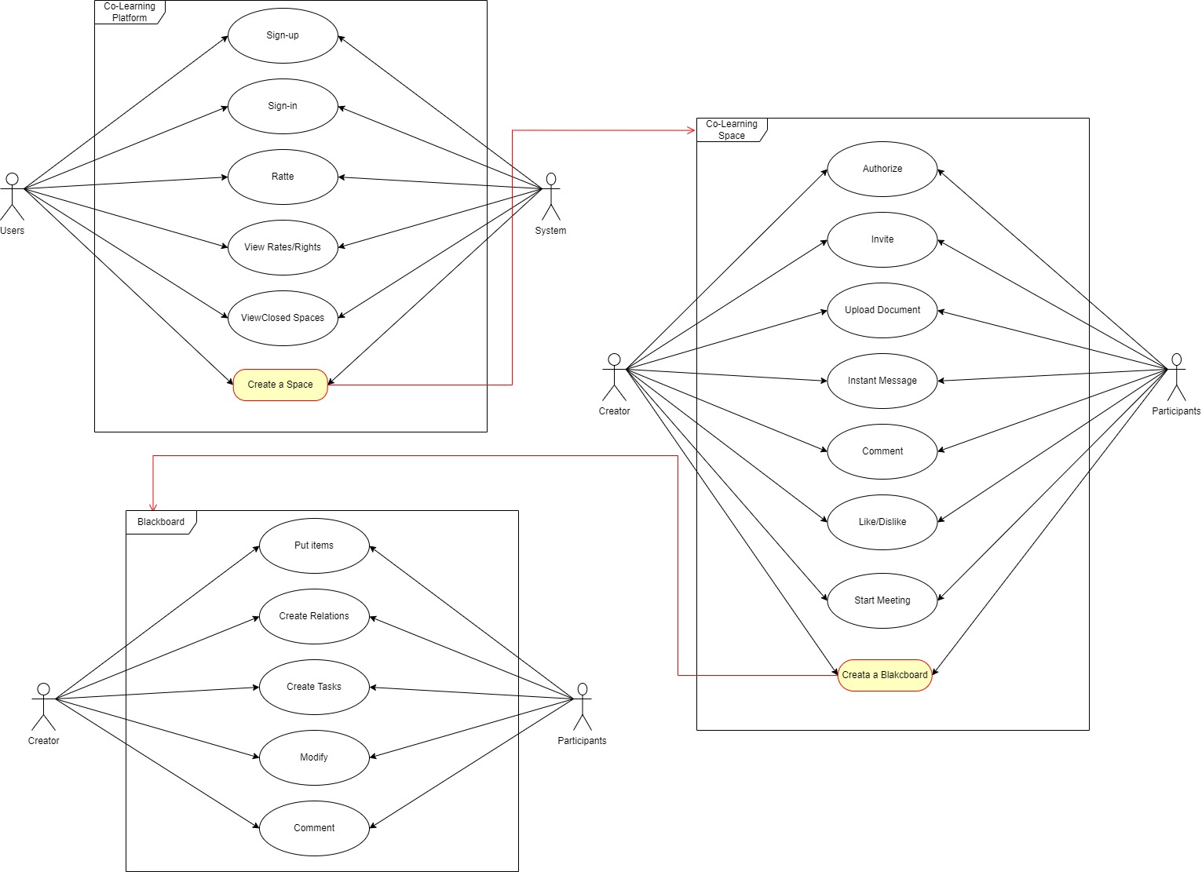

#### Sign-up Sign-in Sequence Diagram

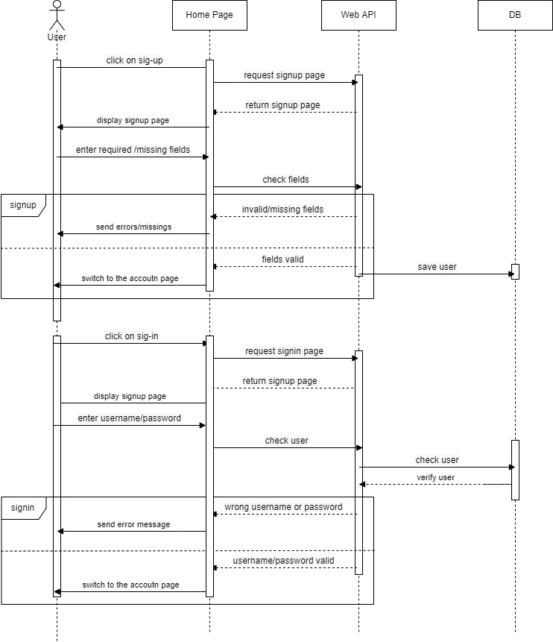

#### Space Creation and Space Modes Sequence Diagram

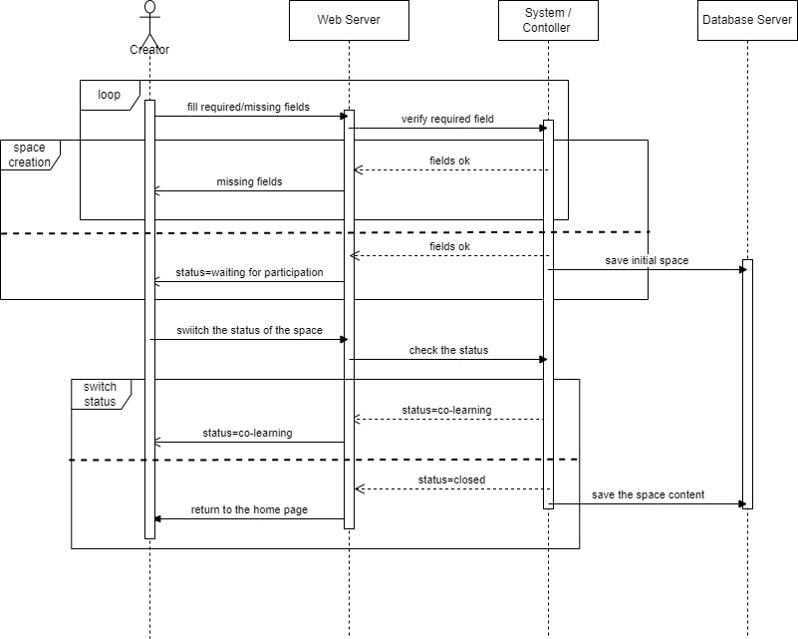

#### Invitation and Participation Request Sequence Diagram

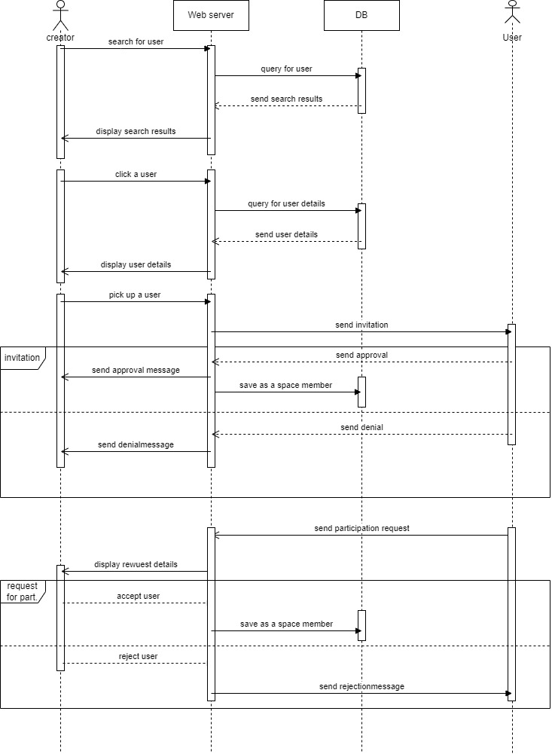

#### Rating Space Members Sequence Diagram

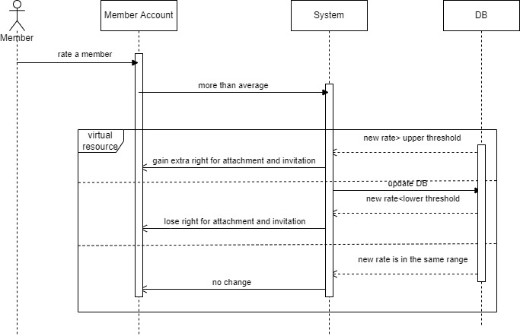

#### BlackBoard Process in flow Chart Diagram

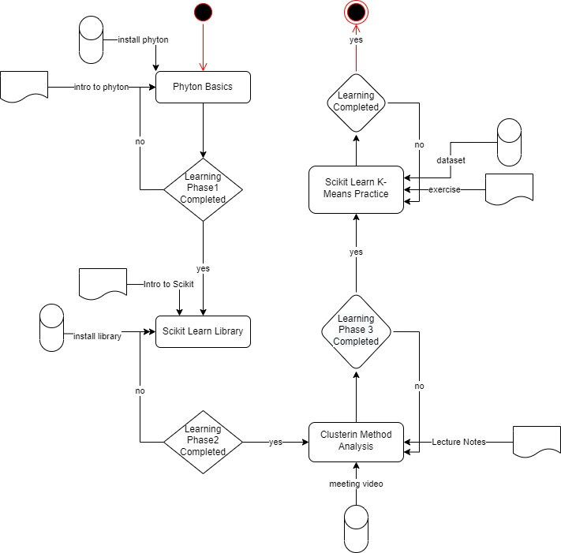

### Project plan

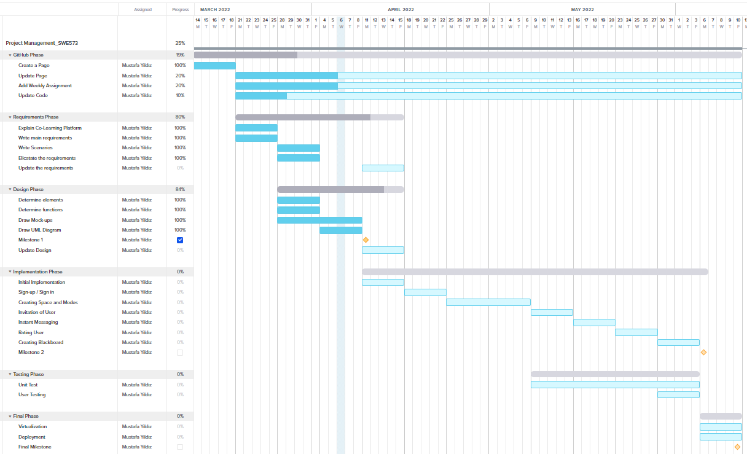

### GitHub wiki pages

* Assignments are uploaded weekly and displayed on the wiki pages.
* Under the Code section, there are main and master branches.
* Basic web application codes are installed under master branches.
* A login page has been created under Main branches.
* Entries regarding completed and ongoing works were added under Issues section.

#### ToDo list for Github Repo

* The gitignore file will be added to the master branch.
* Branches will be merged under main.
* Issues contents will be updated.
* The login page will be updated.
* Milestone pdf file will be added under wiki pages.