# PROCEDURE AND ALGORITHM

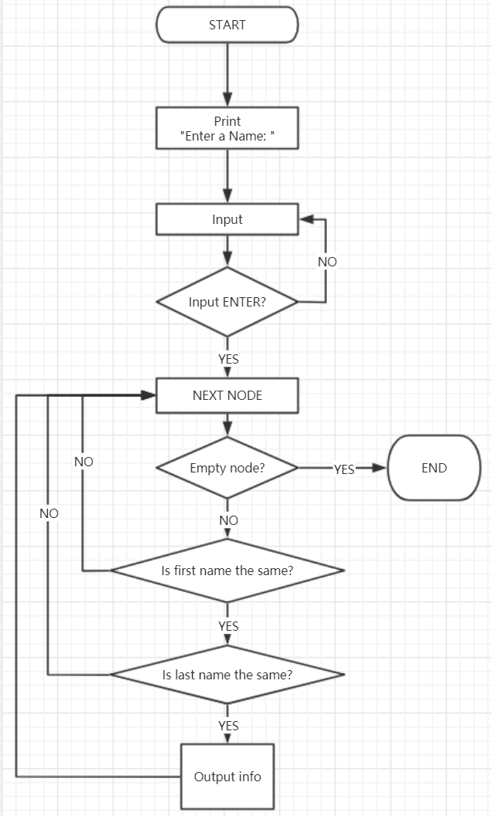

# MAIN CODE

CHECK_FN LEA R1, SAVENAME; R1 holds the ptr to SAVENAME

LDR R3, R2, #2; R3 holds the ptr to first name R2 refer to

LOOP_FN LDR R4, R1, #0

ADD R1, R1, #1; prepare for next letter

LDR R5, R3, #0

BRz SAME_FN; reach the end of name, tell whether they`re same or not

ADD R3, R3, #1; prepare for next letter

NOT R5, R5

ADD R5, R5, #1

ADD R5, R4, R5

BRnp CHECK_LN; not same

BRz LOOP_FN

SAME_FN ADD R4, R4, #0; tell whether str end at the same time

BRz OUTPUT; same

BRnp CHECK_LN; not same

Code above is to check whether two strings are the same or not.

# TA`S CHECK

Q1: How to traverse a linked list and how to tell you`ve reach the end?

A1: In my program, register 2 always point at the first memory address of current node. LDR R3, R2, #2 to store the first address of first name string into R3. Then you can start to compare two strings. So does the last name. After Comparing, LDR R2, R2, #0 to switch R2 to the next node. When R2 equals to x0000, we reach the end.

Q2: How to compare two strings?

A2: Load next char in two strings at the same time. If they are both 0, two stings are the same. If only one of them is 0, strings are not the same. If they are both not 0, subject one from another. If the result is not 0, they`re not the same. Otherwise, continue to load next char to check.