# Flowchart

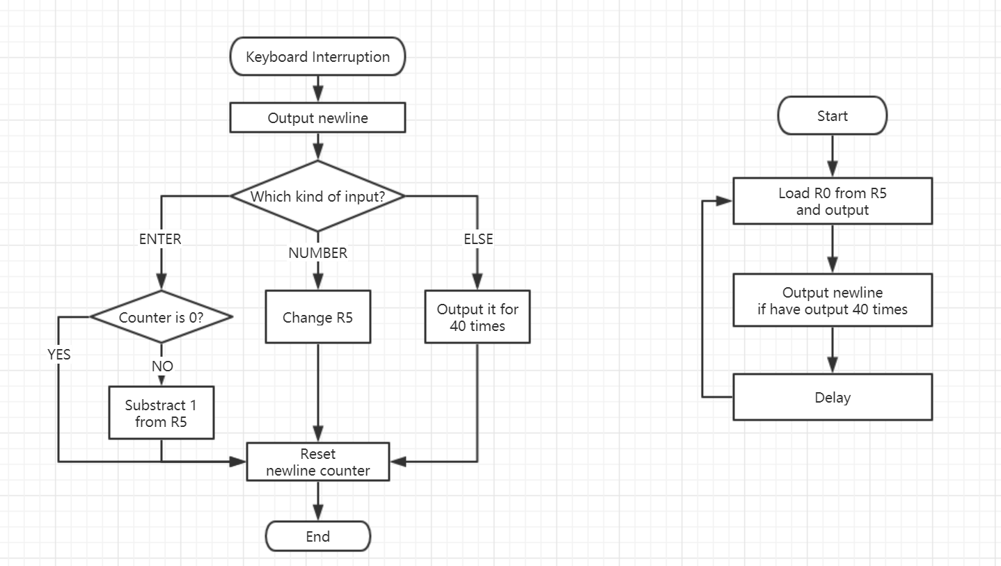

# Main Code and Algorithm

1. .orig x0800
2. LDI R0, KBDR
4. LD  R2, NASCII_NL
5. ADD R2, R0, R2
6. BRz INPUT_NL
7. LD  R2, NASCII_0
8. ADD R2, R0, R2
9. BRn INPUT_ELSE
10. LD  R2, NASCII_9
11. ADD R2, R0, R2
12. BRp INPUT_ELSE
14. INPUT_NUM   ……
15. INPUT_NL    ……
16. INPUT_ELSE    ……
17. END          AND R4, R4, #0
18. RTI
19. KBDR     .FILL xFE02
20. NASCII_0 .FILL xFFD0; negative x0030, ASCII of 0
21. NASCII_9 .FILL xFFC7; negative x0039, ASCII of 9
22. NASCII_NL .FILL xFFF6; negative x000A, ASCII of newline or called enter
23. .end

Code above shows how to tell which kind of input you struck and how to BR into respective solution.

1. OUTPUT_LOOP ADD R0, R5, #0
2. OUT
3. ADD R4, R4, #-1
4. JSR DELAY
5. ADD R4, R4, #0
6. BRz OUTPUT_NL
7. BRnp OUTPUT_LOOP

Code above shows how loop in user`s program works. NL means newline. R4 is the newline counter. R5 is the task counter, which stores the number in ASCII for the convenience of output. Each time you should load R0 form R5 before instruction OUT. Output newline also relies on R0.

# TA`s CHECK

Q1: I want to add a switch in this program. Keyboard interruption should be disabled once I strike Q on keyboard. How to realize that?

A1: Detect input in interrupt service routine. If it`s Q, set KBSR[14] as 0.

Q2: In question 1, why don`t you detect input and set KBSR in your user program part?

A2: KSBR needs privilege to visit. I can`t set it in user program or it`s an ACV error.

Q3: Where you store your previous PC when a keyboard interruption occurs? User stack, supervisor stack, R6, memory block SAVER_USP or somewhere else?

A3: In supervisor stack.