SELECT column, column from table.

SELECT* from mytable

**Constraints:**

Select column, column2 from mytable

Where condition

And

Or another_condition

Num_wheels >= 4 and doors <= 2

= != < <= > >=

Between … and…

In (2, 4, 6) numbers exist in a list

Not in (1,3,5) numbers does not exist in a list

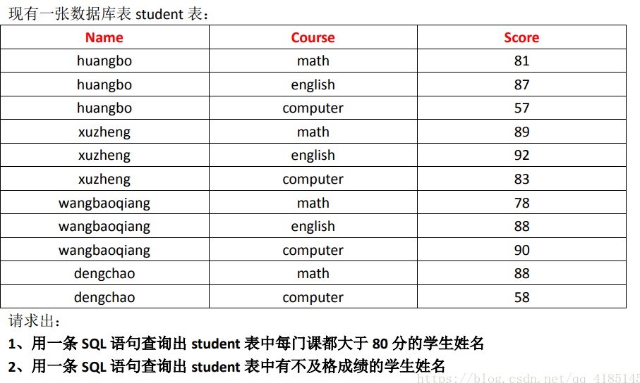

Select name from student

Group by student

Having min(score) >80;

Select name from student

Where score < 60

Group by name;

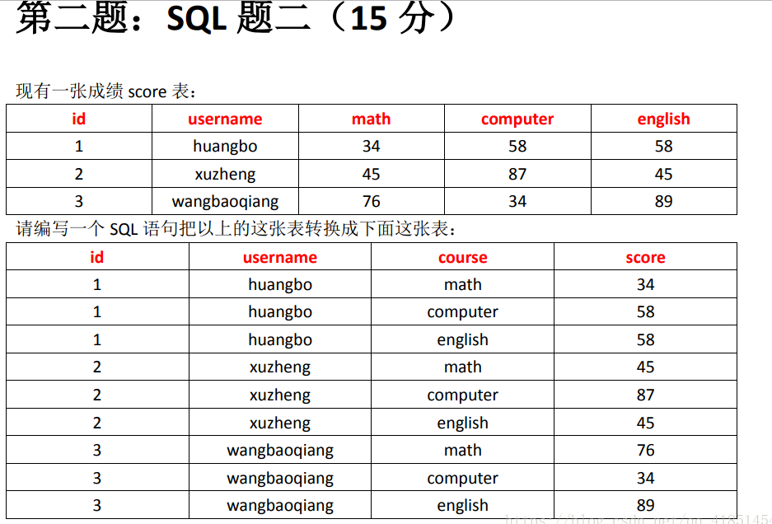

Select id, username, ‘math’ as course, math as score from hive2

Union select id, username, ‘computer’ as course, computer as score from hive2

Union select id, username, ‘English’ as course, English as score from hive2

Order by id, username;



Select store, count(distinct uid)

From visit

Group by store;

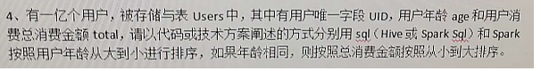

Select uid, age, total from Users

Order by age DESC, total;



Table lifestage

Select stage_someone, count(distinct uid) from lifestage lateral view Explode(stage) temptable as stage_someone group by stage some_one

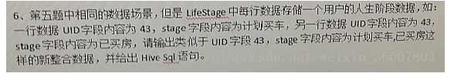

Select UID, contact_ws(‘,’, collect_set(stage)) as stages from lifestage group by UID.