Name Weiyi Zhang Name Yiliang Liu

Student Number: V00868237 Student Number: V00869672

a)

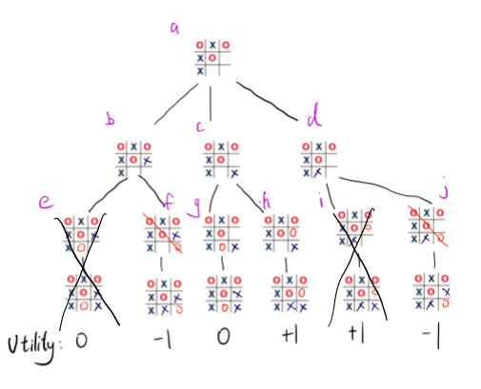

b)

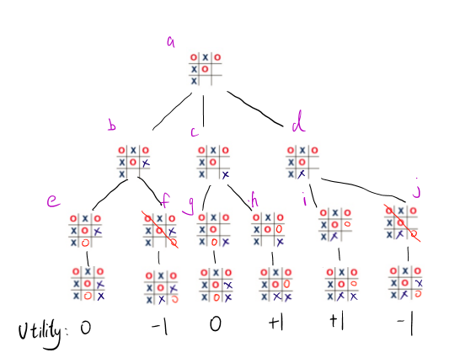

Node e and Node i would be pruned because when it’s the opponent’s turn, it will choose f and j



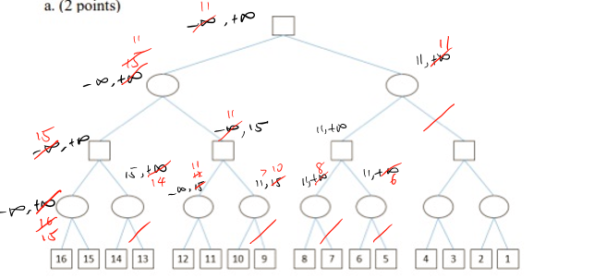

I agree with the majority of students in this forum, Canada should not build a national firewall. While I do believe such a firewall would be created with benevolent intentions, and may certainly have benefits to the general public, there are too many risks. Namely, the ability for the government to control what we see (or rather, to restrict the information we have available to only what the government wants us to see). Implementing any sort of a national firewall is a slippery slope, and that slope leads to a similar situation as China (with the Great Firewall) or North Korea (with Bright Star).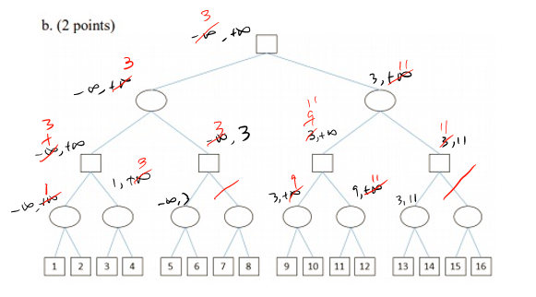

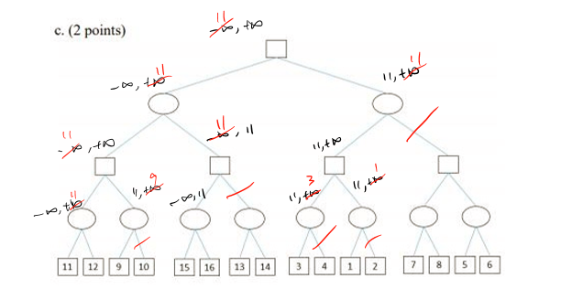

Variables: T, L, B, C, S, P, N

Domains: {1, 2, 3, 4}

Constraints:

1. B≠C≠N
2. L≠P≠N
3. S≠P
4. L≠C
5. T≠L≠N
6. C≠P
7. T=1

|  |  |  |  |  |  |  |  |  |
| --- | --- | --- | --- | --- | --- | --- | --- | --- |
| Depth | T | L | B | C | S | P | N | Algorithm |
| 1 | 1 | 234 | 1234 | 1234 | 1234 | 1234 | 234 | MRV/Forward Tracking |
| 2 | 1 | 34 | 134 | 134 | 1234 | 134 | 2 | D/Forward Tracking |
| 3 | 1 | 3 | 134 | 14 | 1234 | 14 | 2 | D/Forward Tracking |
| 4 | 1 | 3 | 134 | 4 | 234 | 1 | 2 | D/Forward Tracking |
| 5 | 1 | 3 | 13 | 4 | 234 | 1 | 2 | D/Forward Tracking |
| 6 | 1 | 3 | 1/3 | 4 | 2/3/4 | 1 | 2 | D/Forward Tracking |
| 6 | 1 | 3 | 1/3 | 4 | 2/3/4 | 1 | 2 | Back Tracking |



