Name Weiyi Zhang Name Yiliang Liu

Student Number: V00868237 Student Number: V00869672

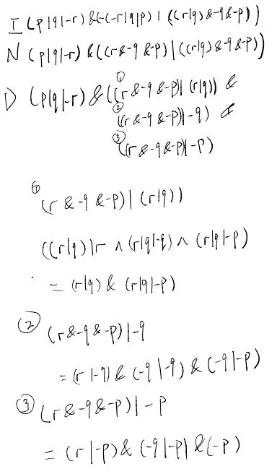

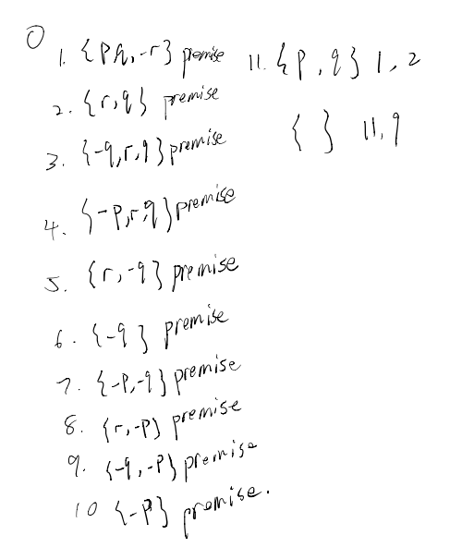



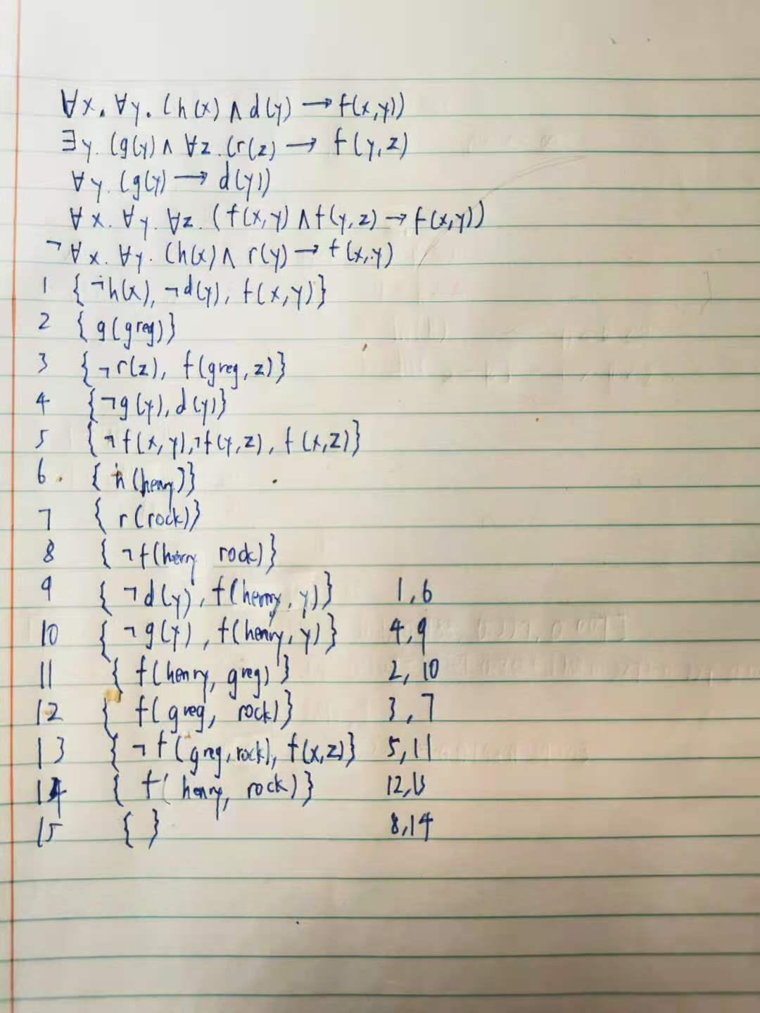



all x (hummingbird(x)->richly_colored(x)).

-(exists x (bird(x) & large(x) & lives_on_honey(x))).

all x (bird(x) & -lives_on_honey(x)->-richly_colored(x)).

all x (hummingbird(x)->bird(x)).

1 (all x (hummingbird(x) -> richly_colored(x))) # label(non_clause). [assumption].

2 -(exists x (bird(x) & large(x) & lives_on_honey(x))) # label(non_clause). [assumption].

3 (all x (bird(x) & -lives_on_honey(x) -> -richly_colored(x))) # label(non_clause). [assumption].

4 (all x (hummingbird(x) -> bird(x))) # label(non_clause). [assumption].

5 (all x (hummingbird(x) -> -large(x))) # label(non_clause) # label(goal). [goal].

6 hummingbird(c1). [deny(5)].

7 -hummingbird(x) | richly_colored(x). [clausify(1)].

8 -hummingbird(x) | bird(x). [clausify(4)].

9 bird(c1). [resolve(6,a,8,a)].

10 -bird(x) | -large(x) | -lives_on_honey(x). [clausify(2)].

11 -bird(x) | lives_on_honey(x) | -richly_colored(x). [clausify(3)].

12 -large(c1) | -lives_on_honey(c1). [resolve(9,a,10,a)].

13 large(c1). [deny(5)].

14 lives_on_honey(c1) | -richly_colored(c1). [resolve(9,a,11,a)].

15 richly_colored(c1). [resolve(6,a,7,a)].

16 lives_on_honey(c1). [resolve(14,b,15,a)].

17 -lives_on_honey(c1). [resolve(12,a,13,a)].

18 $F. [resolve(16,a,17,a)].



all x (gardner(My, x)->worth_listening(x)).

all x (remember(x, Waterloo)->old(x)).

-(exists x (worth_listening(x) & -remember(x, Waterloo))).

1 (all x (gardner(My,x) -> worth_listening(x))) # label(non_clause). [assumption].

2 (all x (remember(x,Waterloo) -> old(x))) # label(non_clause). [assumption].

3 -(exists x (worth_listening(x) & -remember(x,Waterloo))) # label(non_clause). [assumption].

4 (all x (gardner(My,x) -> old(x))) # label(non_clause) # label(goal). [goal].

5 gardner(My,c1). [deny(4)].

6 -gardner(My,x) | worth_listening(x). [clausify(1)].

7 -worth_listening(x) | remember(x,Waterloo). [clausify(3)].

8 -remember(x,Waterloo) | old(x). [clausify(2)].

9 -worth_listening(x) | old(x). [resolve(7,b,8,a)].

10 -old(c1). [deny(4)].

11 -worth_listening(c1). [resolve(9,b,10,a)].

12 worth_listening(c1). [resolve(5,a,6,a)].

13 $F. [resolve(11,a,12,a)].



.

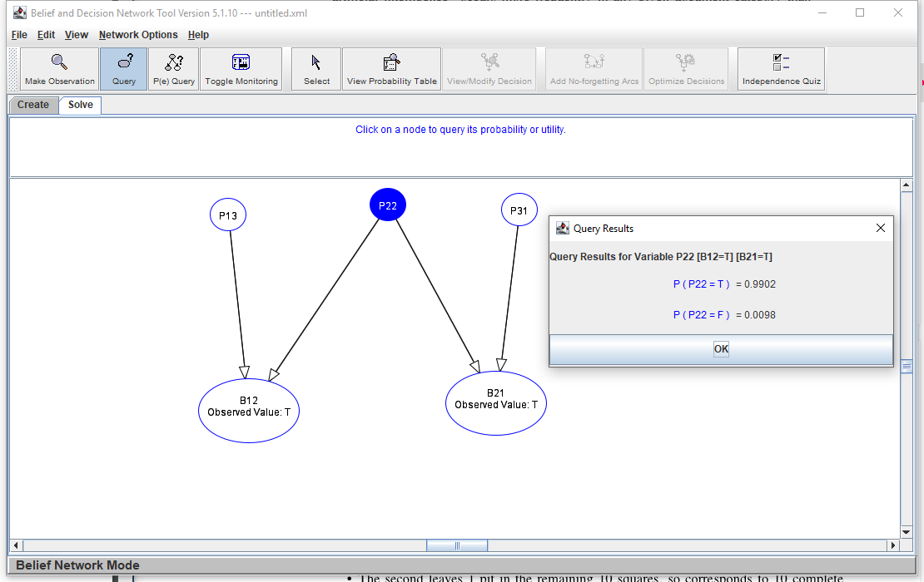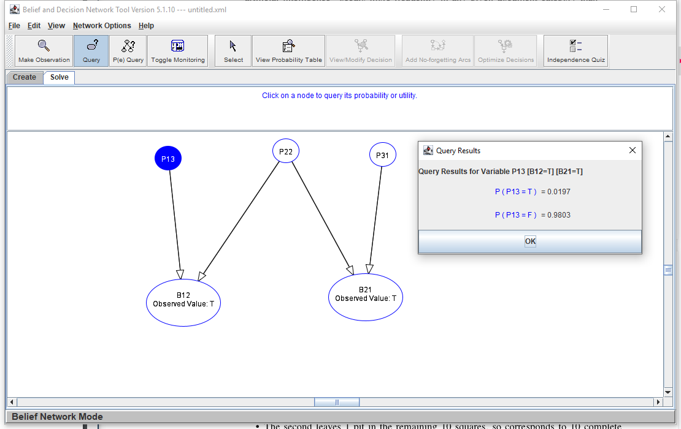

By using Belief and Decision Network Tool to calculate the 𝑃(𝑝13|𝑏12, 𝑏21), 𝑃(𝑝31|𝑏12, 𝑏21) and 𝑃(𝑝22|𝑏12, 𝑏21), we can see that the 𝑃(𝑝13|𝑏12, 𝑏21) = 𝑃(𝑝31|𝑏12, 𝑏21) = 1.97% which is quite low, 𝑃(𝑝22|𝑏12, 𝑏21)=99.02% which is quite high. Therefore, from this, we know that choosing [2,2] would be almost certain death. Also, The probability of each square contains a pit is 0.01, therefore we can infer the probability of [1,3] and [3,1] are both pits is almost 0. If we choose to use logical agent, the agent would randomly choose one from the 3 squares because it doesn’t know about the probability, so the chance it would die is 1/3.



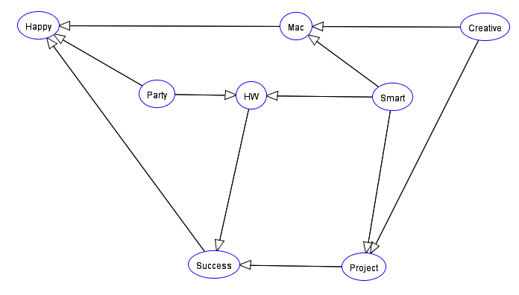



|  |  |  |
| --- | --- | --- |
| creative | smart | P(mac=T|creative, smart) |
| F | F | 0.121559633 |
| F | T | 0.413308341 |
| T | F | 0.897115385 |
| T | T | 0.685795686 |

|  |  |  |
| --- | --- | --- |
| project | hw | P(success=T|project, hw) |
| F | F | 0.049668874 |
| F | T | 0.306451613 |
| T | F | 0.20669746 |
| T | T | 0.896629213 |

|  |  |  |  |
| --- | --- | --- | --- |
| success | mac | party | P(happy=T|success, mac, party) |
| F | F | F | 0.093851133 |
| F | F | T | 0.420118343 |
| F | T | F | 0.204968944 |
| F | T | T | 0.492324561 |
| T | F | F | 0.306818182 |
| T | F | T | 0.721518987 |
| T | T | F | 0.357992074 |
| T | T | T | 0.959375 |

|  |  |  |
| --- | --- | --- |
| creative | smart | P(project=T|creative, smart) |
| F | F | 0.105504587 |
| F | T | 0.793814433 |
| T | F | 0.402884615 |
| T | T | 0.905168905 |

|  |  |  |
| --- | --- | --- |
| smart | party | P(hw=T|smart, party) |
| F | F | 0.304918033 |
| F | T | 0.093533487 |
| T | F | 0.898477157 |
| T | T | 0.802797203 |



