1. **Sign up for an account on GitHub.com.** Make sure you remember the user name and password.
2. **Accept the assignment.** Copy the assignment link given by the instructor and then paste to the address bar of your Chrome browser.
3. **Download the assignment to local folder.**

click to show all your repository

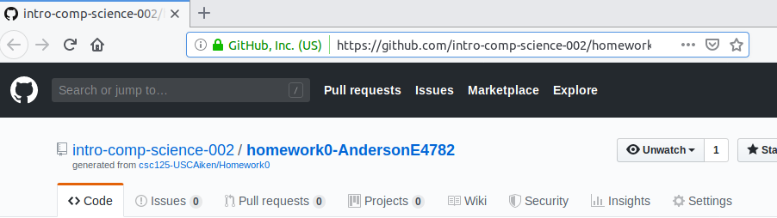

* 1. Use Command Line tools – PowerShell Window

**git clone** [**https://github.com/intro-comp-science-003/homework0-*USERNAME* homework0**](https://github.com/intro-comp-science-003/homework0-USERNAME%20homework0)

Please change to your username and use the right homework number (homework1, homework2,… etc)

* 1. Or use GIT GUI. Click clone repository

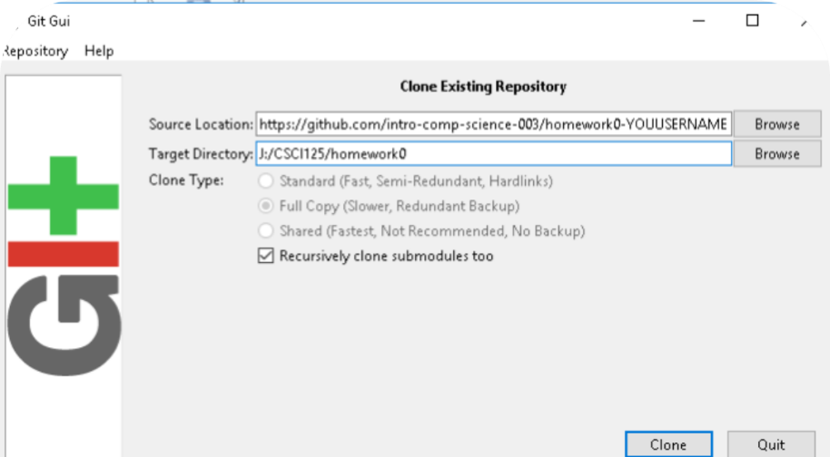

1. **Use Microsoft Visual Studio Code to work on the assignment and then upload back to github.**

|  |  |
| --- | --- |
| **Image result for visual studio code github source control menu** | **Step 1: Stage all Changes --- Ready to Commit**  **Step 2: Commit All ----- Commit, Save and update the version history**  **Step 3: Push to ---- Upload to remote server** |

What if ……….

Git is a great version control system but you are not good at command line tools.

Here is the shortcut.

