In Class Exercise 09/09 Name: __________________________

1. Security Mindset: Please explore [https://columbiacountytax.com/#/](https://columbiacountytax.com/) and answer the following questions.

Confidentiality:

* Who can access the data ?
* What can they access?
* When can they access?
* Are there any confidentiality failures?

Integrity

* Who can modify the record?
* How to modify the record?
* Are there any integrity failure?

Availability

* Is there a timely response?
* Is it present in a usable form?
* Are there faulty tolerance?

2. Create a easy to remember password that

* 8 character minimum
* And h­ave not been seen on website <https://haveibeenpwned.com/Passwords>

3. Survey on your security awareness.

* Please answer Yes or No .

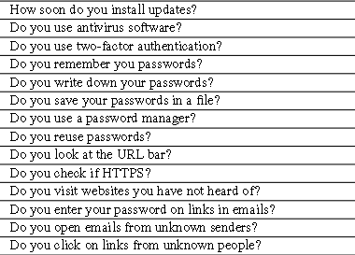

* Do you think the following security advices are effective? 0 – Not effective 5 – very effective.

