Forecasting Air Pollution with Machine Learning

Zhuorui Chai (z5619052) Yilin Ge (z5593916) Xuesen Luo (z5499050)

Yuhui Luo (z5565446)

1 Introduction
Air pollution represents a pressing environmental and public health challenge in urban environments. This project develops machine learning models to forecast pollutant concentrations using time-series sensor data from the UCI Machine Learning Repository. The dataset contains 9,358 hourly records (March 2004 to February 2005) from an air quality monitoring device in Italy, including five pollutants (CO, NMHC, $C_{6}H_{6}$, ${NO}_{X}$, ${NO}_{2}$) and meteorological variables (temperature, humidity).
The project aims to: (1) develop forecasting models for multiple horizons (1, 6, 12, 24 hours ahead), (2) compare regression and classification approaches, (3) evaluate against naïve baselines, (4) investigate temporal granularity effects (hourly vs. daily), and (5) identify anomalies in pollution patterns.

2 Data Analysis
The dataset contains 9,358 hourly records. After temporal splitting: training (6,736 samples, 80% of 2004), validation (749 samples, 10% of 2004), and test (1,872 samples, all 2005). NMHC(GT) was excluded from the regression targets because Figure 1 reveals prolonged gap, resulting in more than 50% missing data and making the variable unsuitable for reliable modelling.
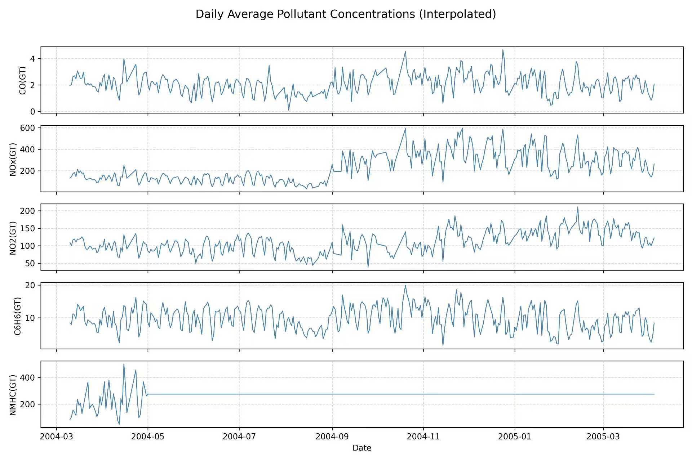
Figure 1. Daily average concentrations
Preprocessing: Missing values (sentinel -200) were replaced with NaN and handled via forward-fill/backward-fill. Date and Time fields were merged into DateTime. Data was normalized using StandardScaler (z-score). Approximately 5-10% missing values were observed, with missingness clustered in specific time periods, suggesting sensor malfunctions or maintenance periods.
Exploratory Analysis: The temporal behavior of pollutants is visualized in Figure 2. Figure 2(a) demonstrates strong hourly cycles, with pollutant concentrations peaking during typical traffic periods (7–9 AM and 5–7 PM). Figure 2(b) highlights substantial inter-pollutant correlations, especially between NOx and NO₂ (>0.8), consistent with their shared chemical origin. Meteorological variables show weaker associations.
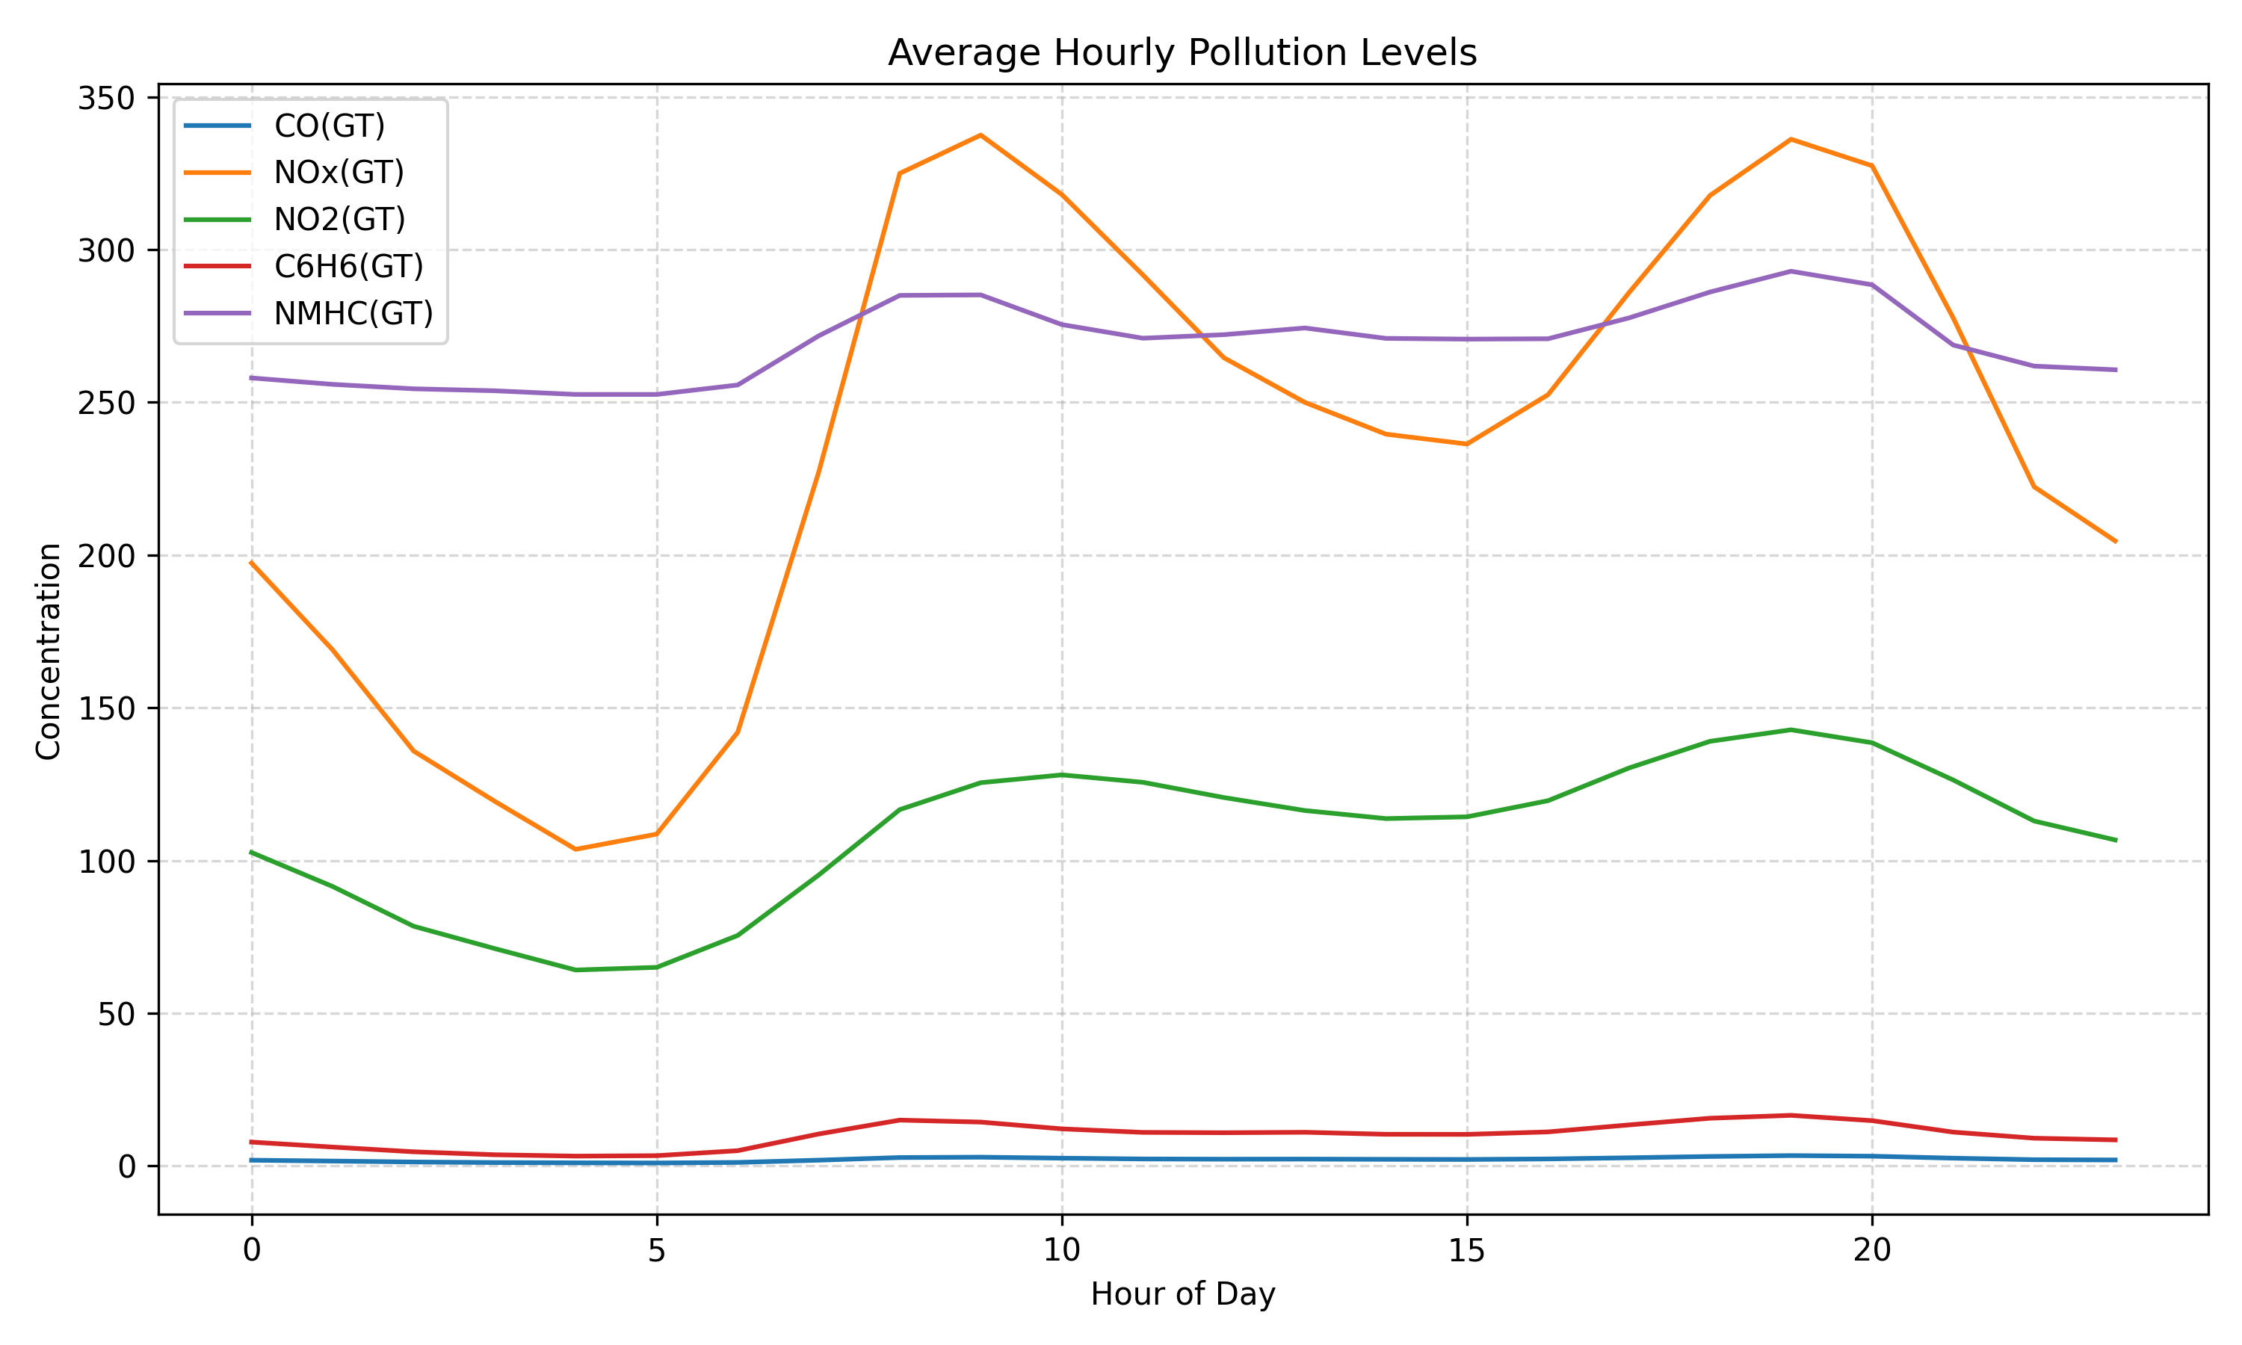
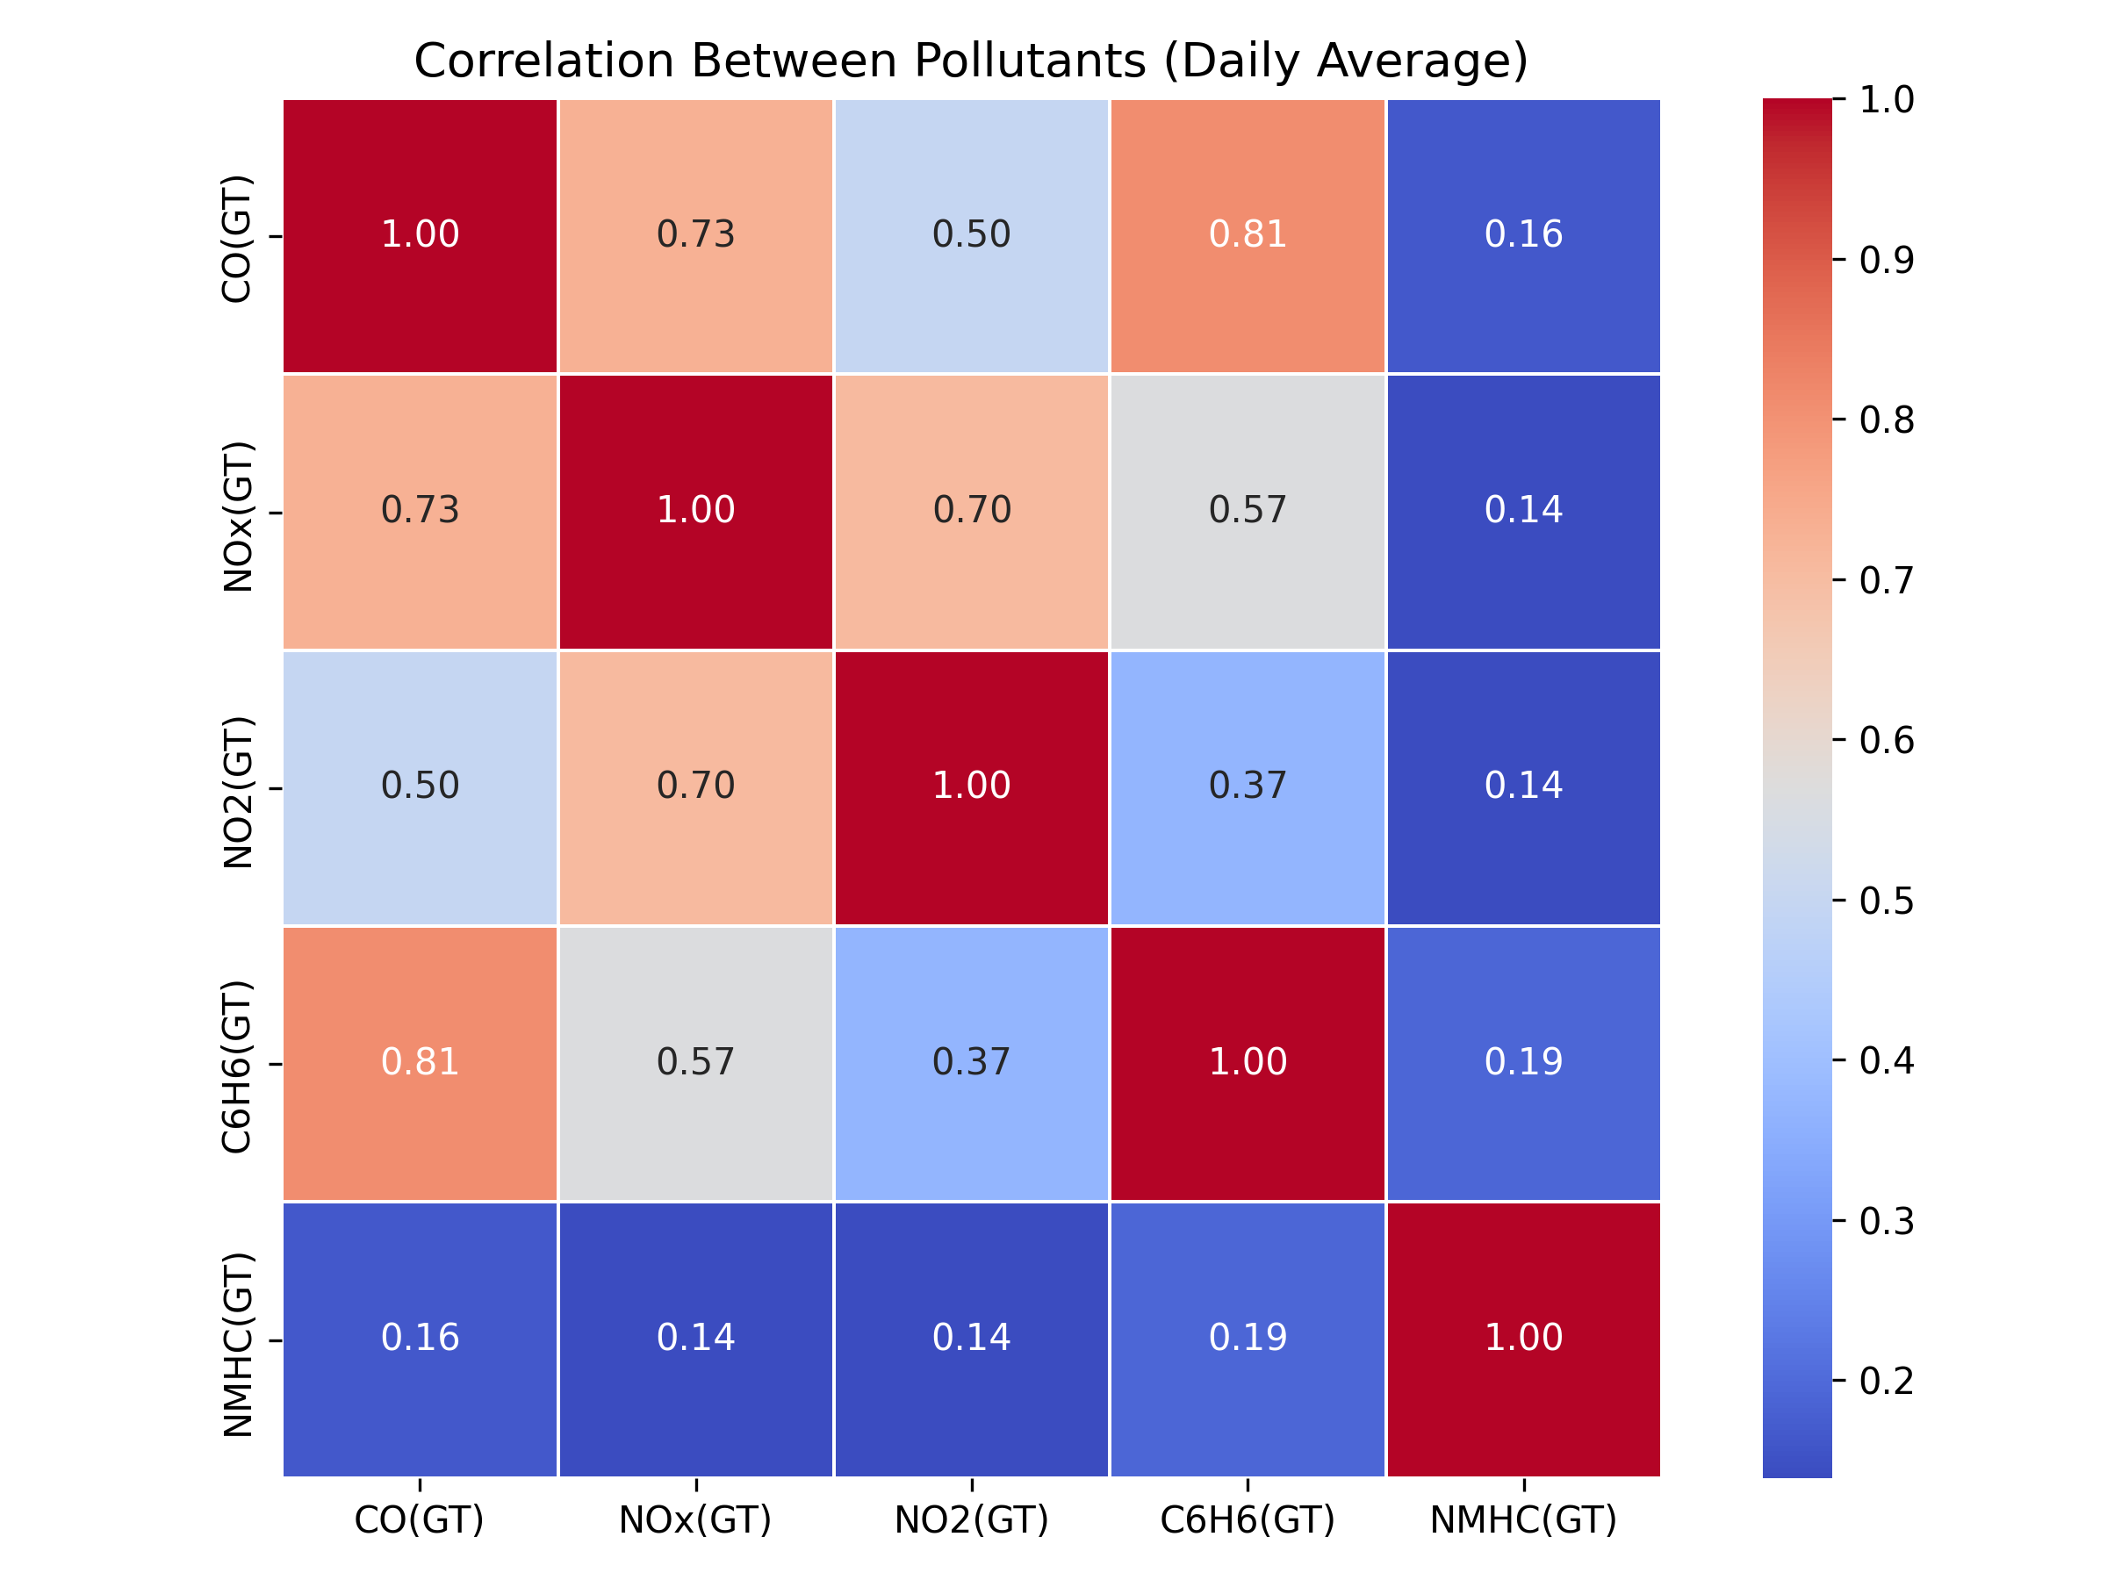
(a) Hourly patterns (b) correlation Pollutants
Figure 2. Temporal patterns and correlations
Anomaly Detection: Two different methods were used together to identify unusual pollution events. As shown in Figure 3(a), the Precision–Recall curve indicates only moderate anomaly-detection performance (precision around 0.3–0.5 and recall around 0.4–0.6).
To detect extreme prediction deviations, a residual-based method (‖residual − mean‖ > 3σ) was applied, while Isolation Forest (Liu et al., 2008) was used to identify unusual combinations of input features.
Figure 3(b) shows that detected anomalies align with sharp NOx(GT) spikes. Combined with the moderate Precision–Recall results, this suggests that the two methods capture complementary types of anomalies.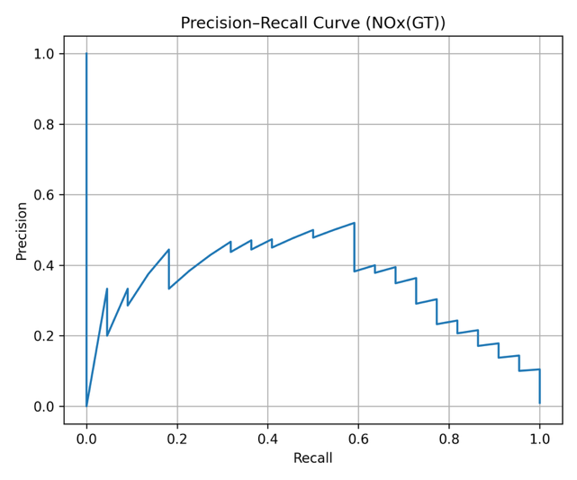 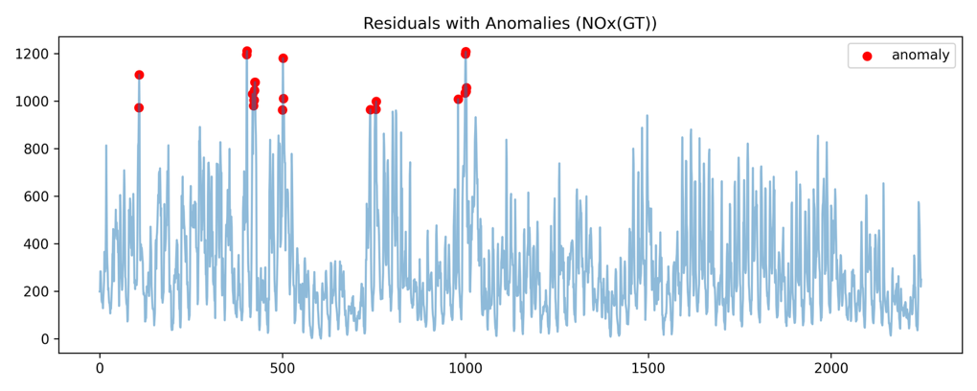
(a) Precision-Recall Curve (NO_{X}(GT)) (b) Residuals with Anomalies (NO_{X}(GT))
Figure 3. Anomaly detection results for NO_{X}(GT)

3 Methodology
Temporal Splitting: Chronological split (train on 2004, test on 2005) simulates realistic deployment. Validation set uses latest 10% of training data.
Feature Engineering: Created lag features (t-1, t-2, t-3), rolling statistics (3, 6, 12- hour windows), and time-based features (hour, weekday, month) with cyclical encoding (sine/cosine). Both hourly and daily aggregations were explored.
Models: The selection and theoretical understanding of these models were guided by foundational principles of statistical learning (Hastie et al., 2009). Regression: Linear Regression, Random Forest Regressor (Breiman, 2001), MLP Regressor. Classification: Logistic Regression, Random Forest Classifier (Breiman, 2001), MLP Classifier. For classification, CO(GT) was discretized into Low (<1.5), Mid (1.5-2.5), High (≥2.5) mg/m³ . Model selection covers different complexity levels: linear models provide interpretable baselines, Random For- est handles non-linearities and feature interactions, while MLP represents neural network approaches. All models and preprocessing steps were implemented using the Scikit-learn open-source library in Python (Pedregosa et al., 2011).
Hyperparameter Tuning: Grid search on validation sets. Random Forest: n estimators ∈ {100, 200}, max depth ∈ {None, 10}, min samples split ∈ {2, 5}. MLP: hidden layer sizes ∈ {(64,32), (128,64)}, learning rate init ∈ {0.001, 0.0005}. Logistic Regression: C ∈ {0.1, 1.0, 10.0}.
Baseline: Naive baseline uses concentration at time t as prediction for t+h (h ∈ {1, 6, 12, 24}).

4 Results

4.1 Regression Results
Table 1. Test set performance for regression models

Granularity | Model | MAE | RMSE | R2
Hourly | Linear Regression | 0.346 | 0.416 | 0.908
Hourly | Random Forest | 0.202 | 0.322 | 0.945
Hourly | MLP Regressor | 1.005 | 1.889 | -0.903
Daily | Linear Regression | 0.429 | 0.586 | 0.383
Daily | Random Forest | 0.288 | 0.414 | 0.691
Daily | MLP Regressor | 7.549 | 9.100 | -147.94
Random Forest (Breiman, 2001) achieved best performance: R2 = 0.945 (hourly) and 0.691 (daily). The performance gap (R2 difference of 0.254) indicates substantial information loss when aggregating to daily resolution. Linear Regression showed reasonable performance (R2 = 0.908 hourly), while MLP Regressor performed poorly (R2 = -0.903 hourly), indicating severe overfitting.
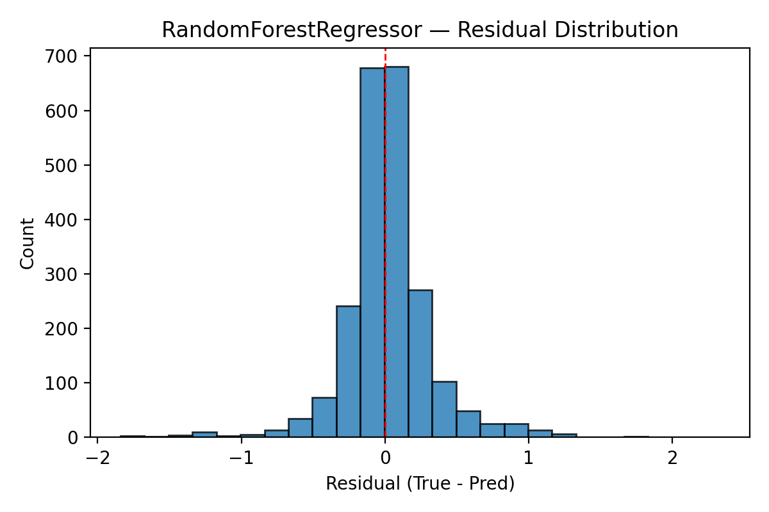
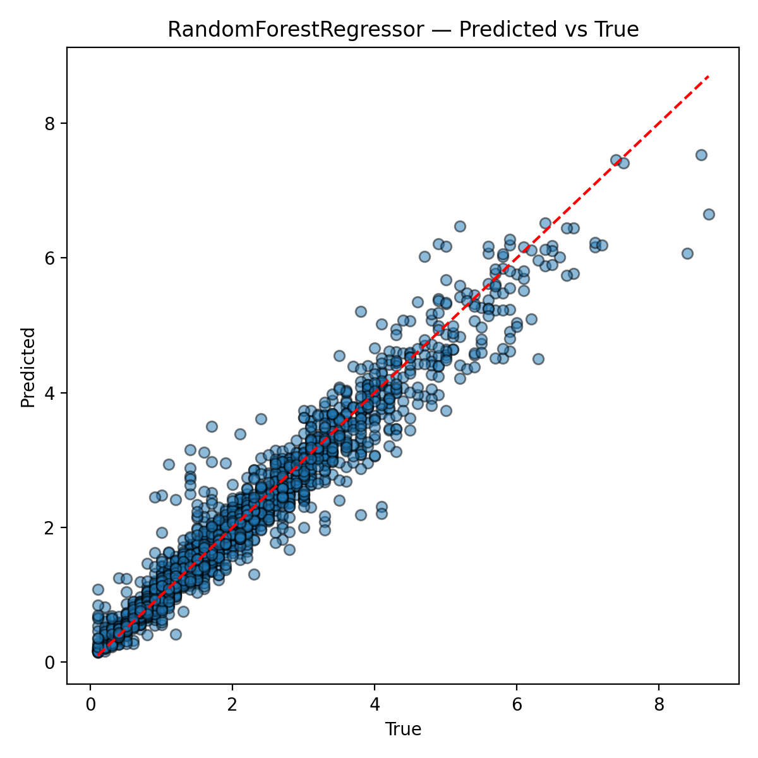
(a) Predicted vs true (b) Residual distribution
Figure 4. Hourly regression visualization (Random Forest)

4.2 Classification Results
Table 2. Test set classification performance

Model | Horizon | Accuracy | Precision | Recall | F1
Baseline | t+1 | 0.729 | 0.729 | 0.729 | 0.729
Logistic Regression | t+1 | 0.609 | 0.664 | 0.609 | 0.615
MLP | t+1 | 0.455 | 0.485 | 0.455 | 0.448
Random Forest | t+1 | 0.955 | 0.959 | 0.955 | 0.955
Baseline | t+24 | 0.561 | 0.562 | 0.561 | 0.561
Logistic Regression | t+24 | 0.503 | 0.573 | 0.503 | 0.499
MLP | t+24 | 0.500 | 0.670 | 0.500 | 0.502
Random Forest | t+24 | 0.946 | 0.950 | 0.946 | 0.945
Random Forest (Breiman, 2001) performs strongly at all forecast horizons. At t+1, it reaches 95.5% accuracy, clearly higher than the naive baseline of 72.9%, a gain of 22.6 percentage points. Accuracy stays high at later steps (t+6: 95.3%, t+12: 95.2%) and is still 94.6% at t+24, with 95.0% precision, so the drop from 95.5% to 94.6% is small. This shows good temporal generalization. The confusion matrices also show balanced performance across the three classes, with little confusion between neighboring classes.
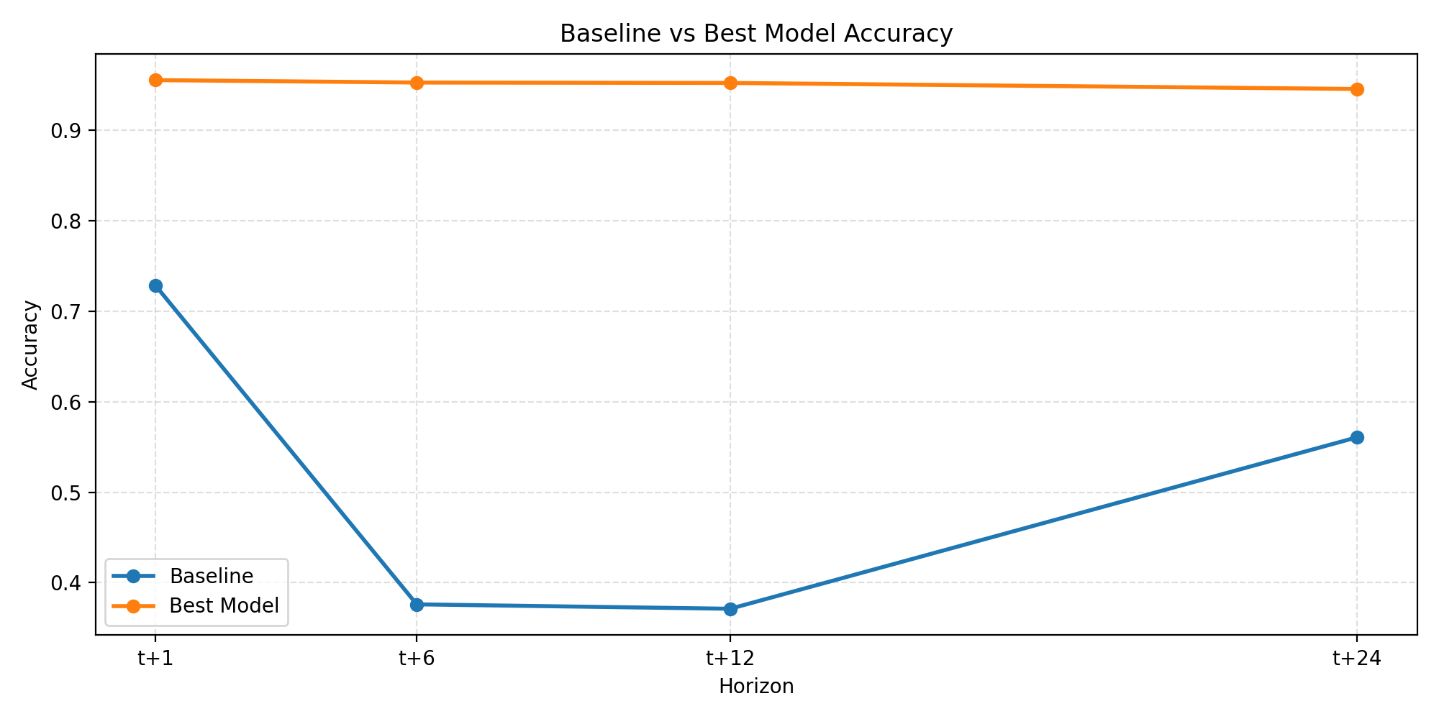
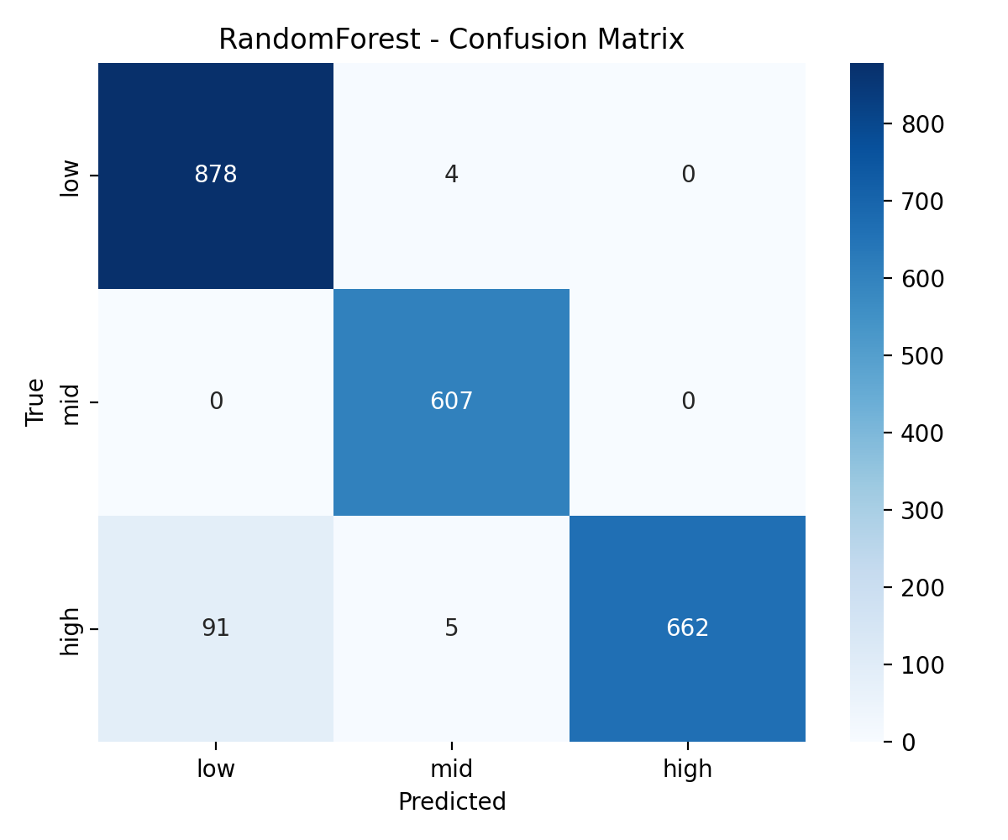
(a) Baseline vs best model (b) Confusion matrix (t+1)
Figure 5. Classification performance

5 Discussion
Interpretation of Results: The results show that time characteristics (such as lag terms and rolling statistics) are crucial on the hourly scale. They enable random forests to maintain a high accuracy rate in regression and multi-step classification (t+1, t+6, t+12, t+24), and the accuracy rate only decreases slightly as the time span increases. This shows that short-term historical data already contains powerful predictive signals. In contrast, the use of the daily average will weaken the short-term peak and reduce the overall performance. The model comparison further shows that the linear model cannot capture the nonlinear relationship well, and the multilayer sensor (MLP) is easy to overfitting on the data set, resulting in a negative value of R². However, the random forest achieves a better balance between accuracy and stability. For abnormal detection, residual threshold and isolation forest can detect some extreme events and sensor failures, but the detection capacity is limited, so it is more suitable as an auxiliary alarm tool.
Limitations: This study has several main limitations. The data come from a single site and cover a limited time period, so they cannot represent different cities or weather conditions well. Possible sensor drift and concept drift during long-term operation are not fully tested. Missing data appear in clusters, likely related to maintenance or extreme weather, which may introduce bias. In addition, NMHC has many missing values and is removed, so interactions between all pollutants cannot be fully described.
Improvement Strategies: Future work can extend the Random Forest baseline by adding time-series models such as LSTM and GRU, and compare their performance under long-term dependence and changing data patterns. At the same time, external data such as numerical weather prediction and traffic flow can be integrated to improve detection of extreme conditions and unusual events. For evaluation, besides R² and accuracy, metrics like the number of exceedances, peak error, and exposure-based risk scores can be included, so that model optimization better reflects the real needs of air quality management and health risk control.

6 Conclusion
This study compares several machine learning methods for short- and medium-term air pollution prediction using the UCI urban air quality dataset. With well-designed time features and hourly data, Random Forest clearly outperforms the naïve baseline, showing that tree-based ensemble models are a reliable choice for air quality prediction at a single monitoring station.
These findings suggest that, in single-station settings, it is better to use high-quality time features and robust tree models rather than start with complex deep networks. To support air quality management, models should also link performance to exceedance and health risk targets. Future work can add external data and time-series models on top of this Random Forest baseline to better match policy and health needs.

7 References
1. UCI Machine Learning Repository. Air Quality Data Set. https://archive.ics.uci. edu/ml/datasets/Air+Quality
2. Pedregosa, F., et al. (2011). Scikit-learn: Machine Learning in Python. Journal of Machine Learning Research, 12, 2825-2830.
3. Breiman, L. (2001). Random Forests. Machine Learning, 45(1), 5-32. https://doi . org/10.1023/A:1010933404324
4. Hastie, T., Tibshirani, R., & Friedman, J. (2009). The Elements of Statistical Learning: Data Mining, Inference, and Prediction (2nd ed.). Springer.
5. Liu, F. T., Ting, K. M., & Zhou, Z. H. (2008). Isolation Forest. In 2008 Eighth IEEE International Conference on Data Mining (pp. 413-422). IEEE.

