export JAVA_HOME=/usr/local/jdk

export CATALINA_HOME=/home/mingjunz/tomcat

/usr/local/jdk/bin/javac DatabaseControllerZ.java

./startup.sh

./shutdown.sh

lectura.cs.arizona.edu

27569

localhost:27569

mingjunz

cd ../webapps/ROOT/WEB-INF/classes/dbController

cd ../../../../../bin

cd tomcat/bin

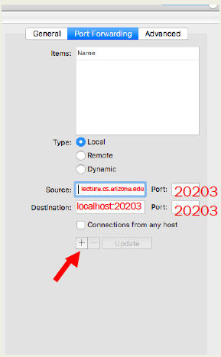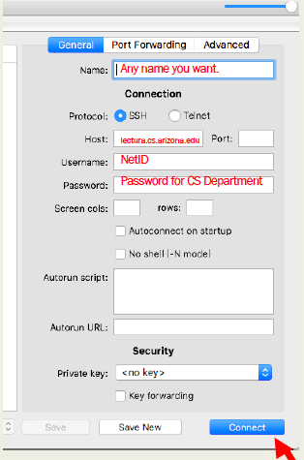

select * from yilingding.cart order by cid;