All HHA variables admitted

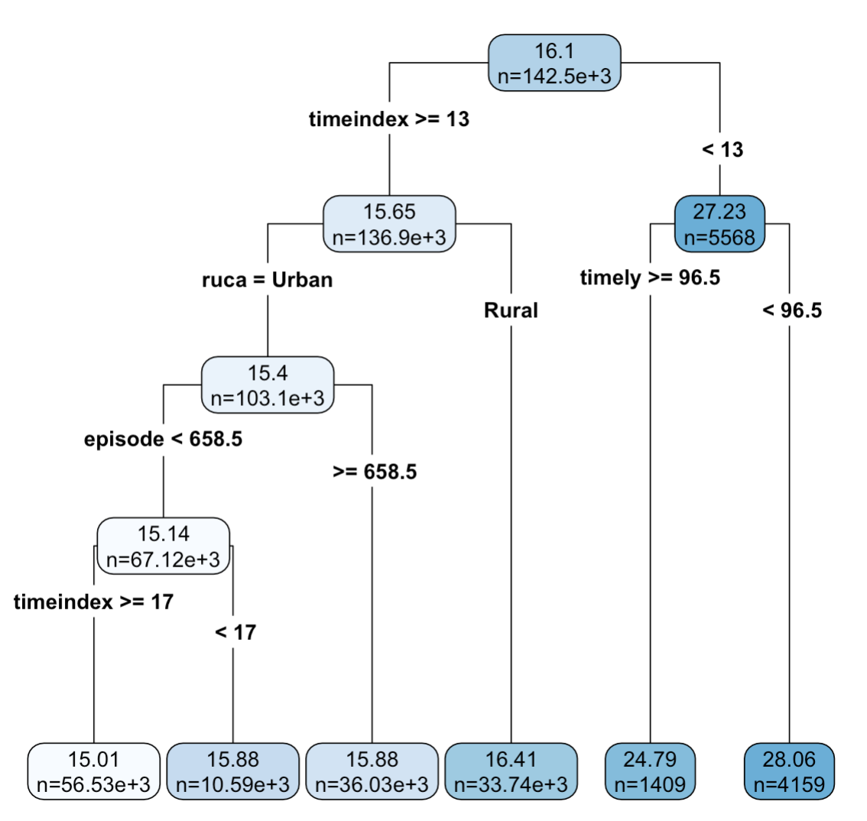

All HHA variables ER

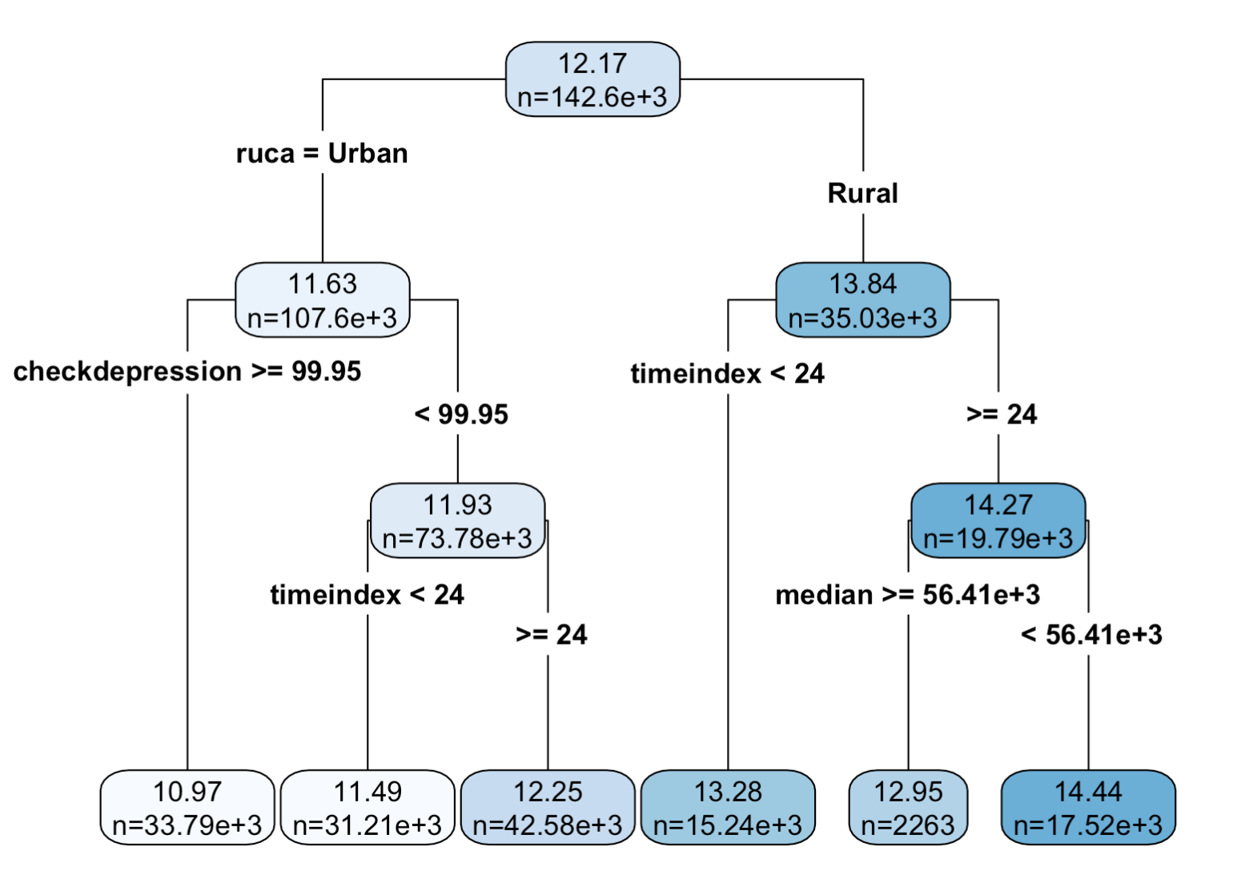

2010-2019 admitted

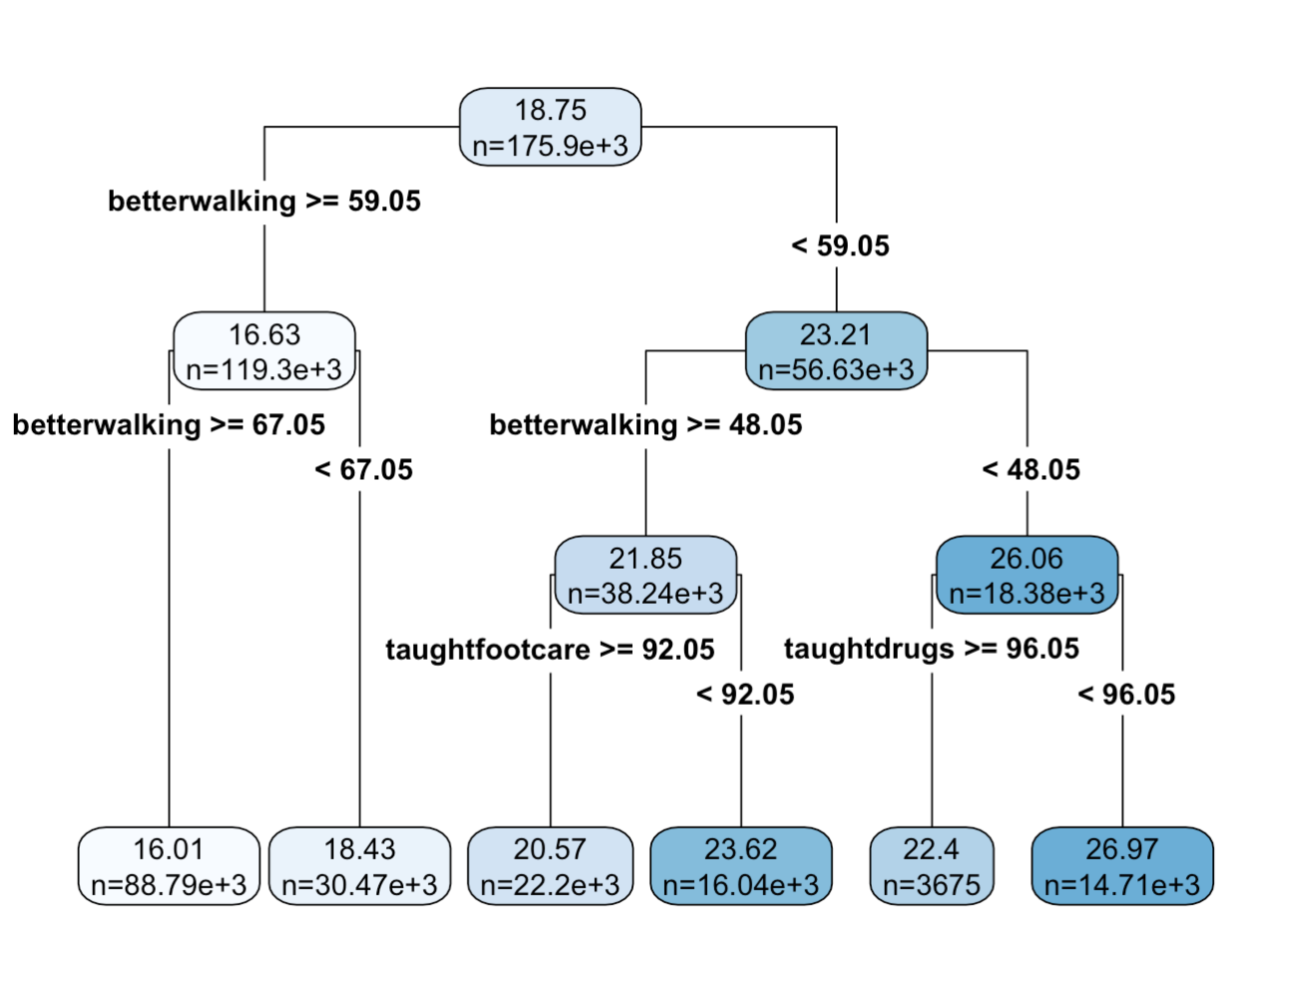

2010-2012 admitted

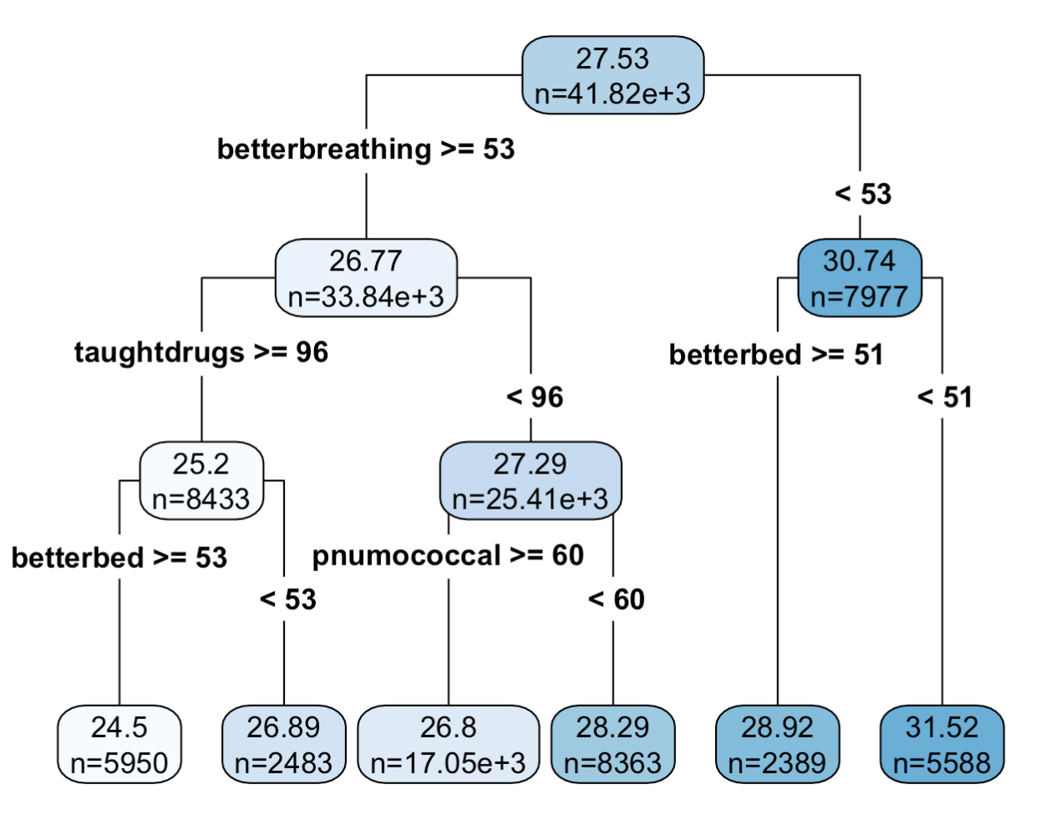

2013-2019 admitted

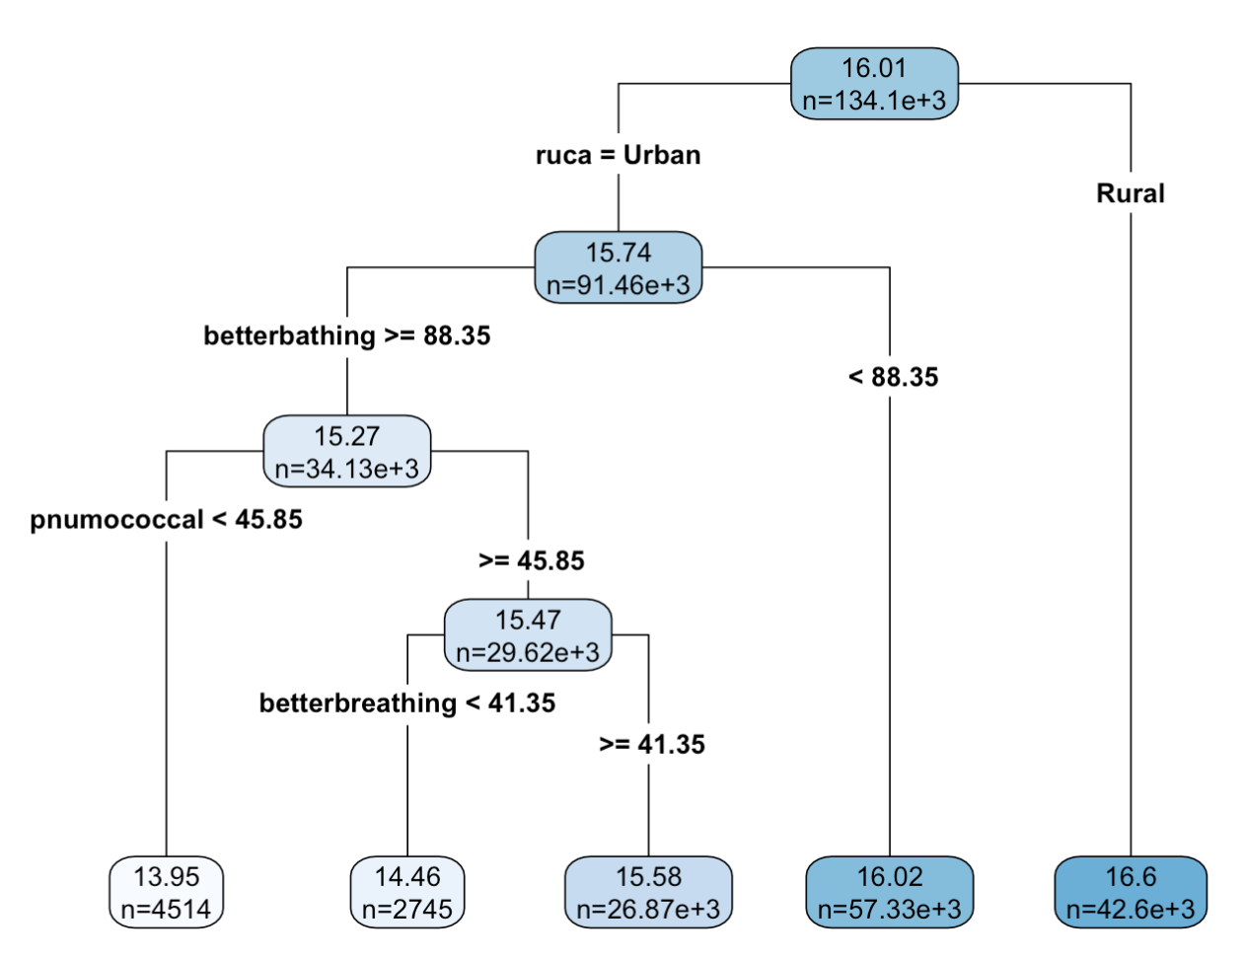

# of HHA in urban / # of HHA in rural over years

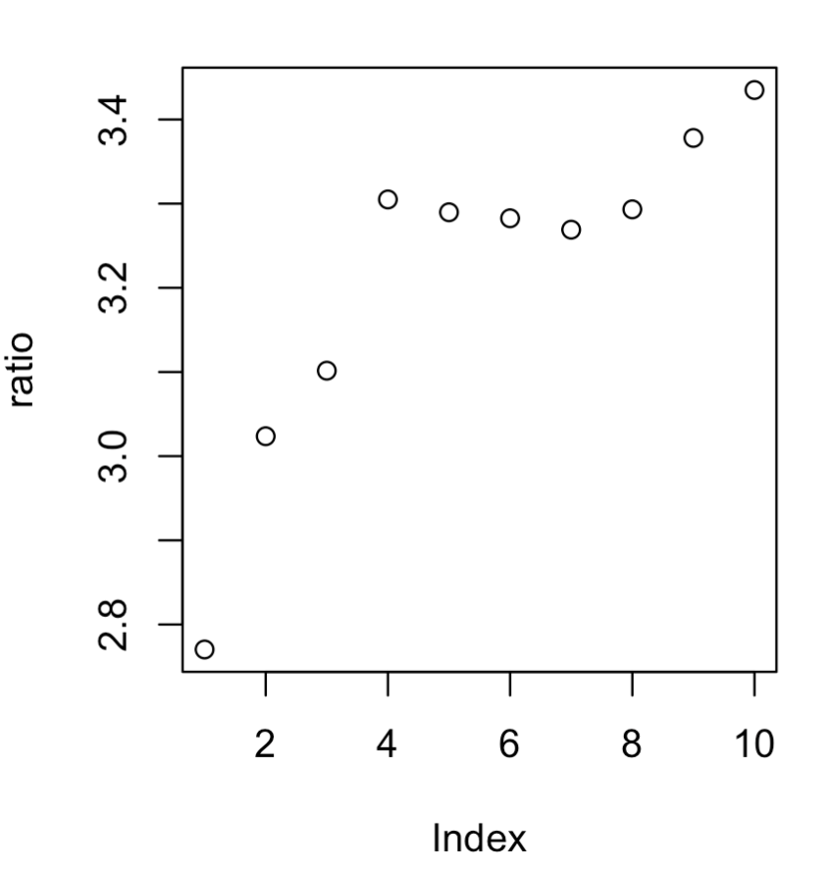

# of HHA in rural over years

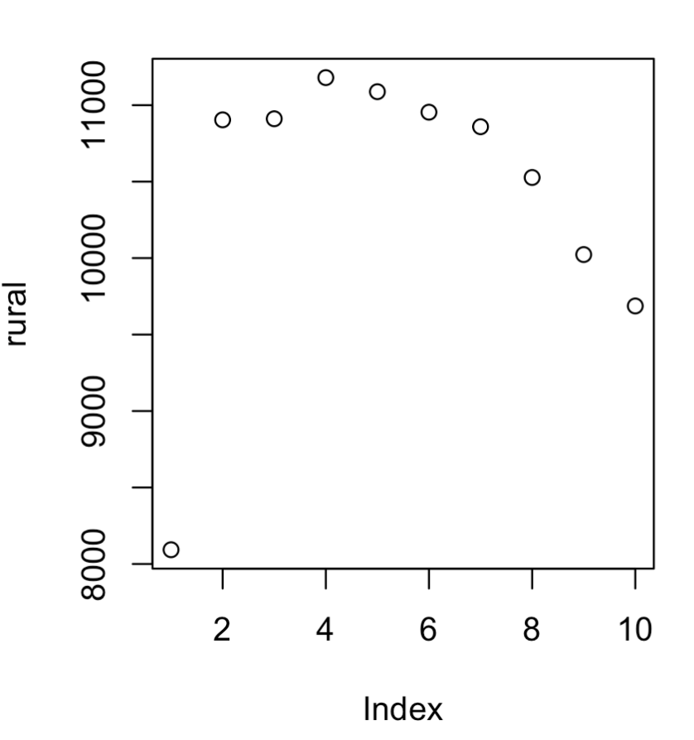

#of HHA in urban over years

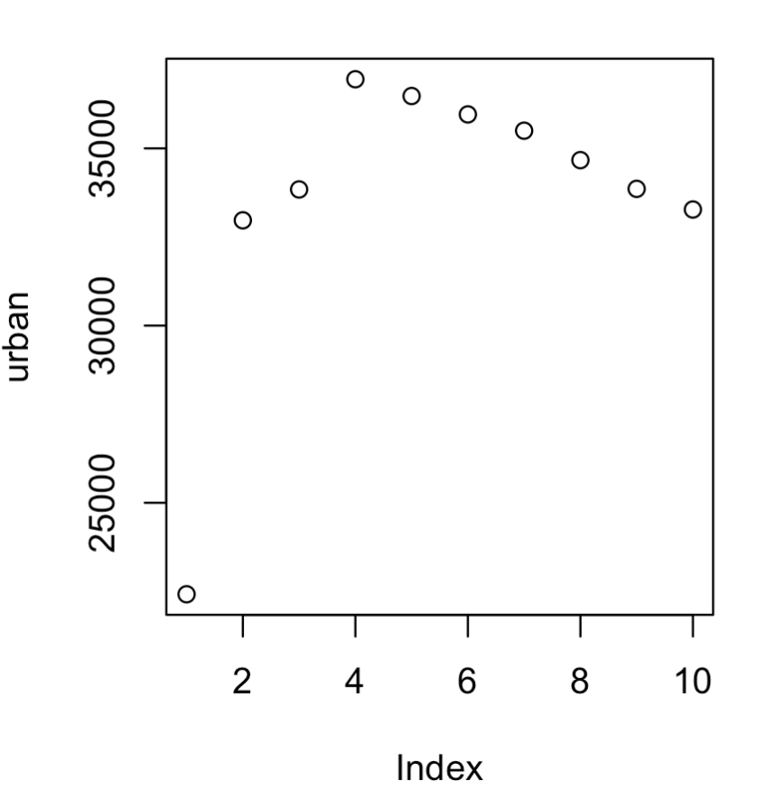

Average # of missing data in urban HHA/ Average # of missing data in rural HHA over years

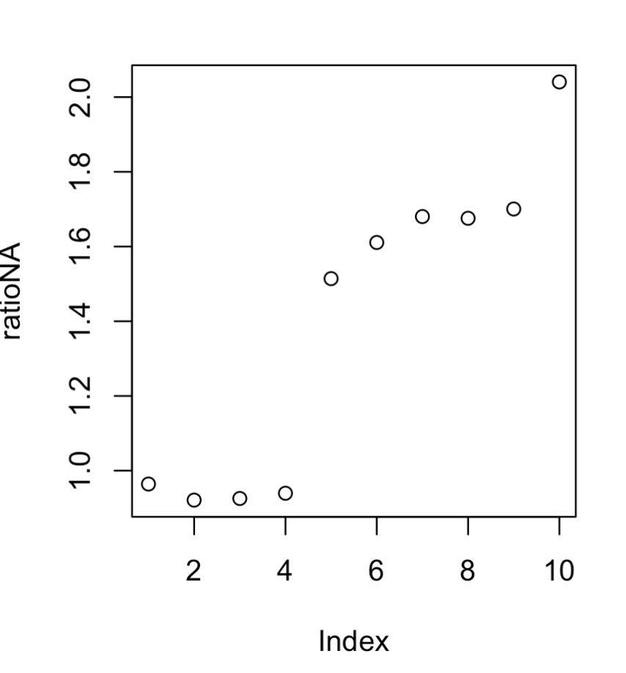

Average # of missing data in urban HHA - Average # of missing data in rural HHA over years

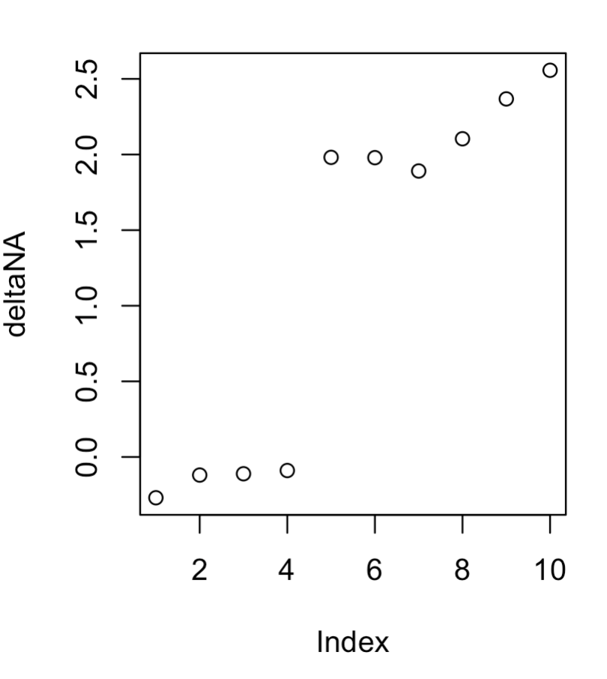

Average # of missing data in urban HHA

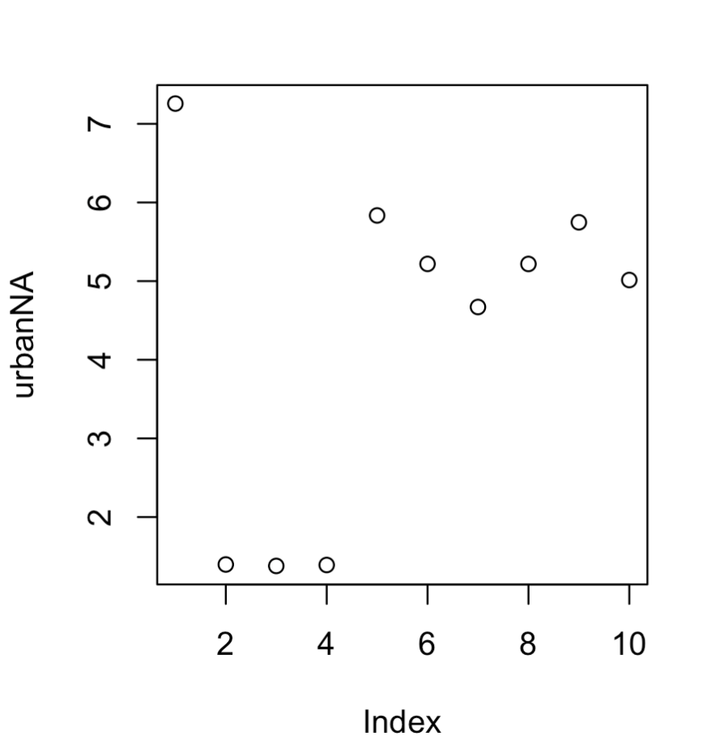

Average # of missing data in rural HHA

