Contents

Part I. Background 2

Part II Simulation Design 2

1. Defining CRP key parameters (CRP configuration) 2

2. Simulation Setup 3

2.1 Simulated market environments 3

2.2 Defining Evaluation Metrics 3

2.3 Reporting simulation results 4

Part III: CRP pool parameters recommendations 4

3.1 How ALEX compared with static collateral holding (similar to AVVE model) 4

3.2 What is the optimal combination of LTV and conversion threshold? 7

3.3 What is the optimal rebalance frequency? 7

Part IV: Simulated Stress Tests 9

4.1 Defining Market Risks 9

4.2 Under an extreme down-market 9

4.3 Under an extraordinary down-market tail event: 11

4.4 Under a up-market 11

Conclusions 13

Appendix 13

## Part I. Background

ALEX collateral rebalancing pool (CRP) integrates the concept of Portfolio management with collateral management by holding both risky asset and riskless asset. When a risky asset depreciates, the collateral pool has more riskless assets, reducing the risk of undercollatisation. On the contrary, higher weight is assigned to risky asset when its price surges, thus capturing most of the gain. This dynamic rebalancing, together with a careful choice of the key parameters allows ALEX to eliminate the liquidation needs. Any residual gap risk (which CRP cannot address entirely) is addressed through maintaining a strong reserve fund. The theoretical details of CRP are documented in ALEX’s whitepaper Collateral Rebalancing Pool [1].

In this report, we conducted performance assessment of the ALEX CRP via agent-based simulations under different market environments. Based on simulation results, we aim (1) to provide recommendations on the optimal key parameters and (2) to assess the market risk of the ALEX CRP protocol under extreme conditions. The simulation study has shown that ALEX CRP effectively reduces default risk while maintaining potential upside gain. It is robust to various market conditions and even tail event like March 2020. The contents of this report include Part II Simulation design, Part III CRP parameters recommendation, Part IV Simulated Stress Test and finally a conclusion session.

## Part II Simulation Design

### 1. Defining CRP key parameters (CRP configuration)

The key parameters consider in ALEX CRP including:

* **Loan-to-Value (LTV):** The ratio of the loan amount to the value of the collateralized asset. For example, if LTV is set to be 80%, a loan amount equivalent to 80 bitcoins requires 100 bitcoins as collateral. LTV depends on the quality of the collateralized asset and the market condition when the loan is taken out. Collaterisation Ratio (CR) is the inverse of LTV.
* **Implied Volatility:**In the Black-Scholes model, implied volatility is the upcoming actual volatility of the underlying security. A crude prediction of implied volatility is historical volatility. In practice, implied volatility is usually derived from the market observed option price.
* **Rebalancing Frequency:**Theoretically, continuous rebalancing is assumed for perfect replication of the option payoff. In practice, it is not feasible to do continuous rebalance due to transaction cost. Therefore ALEX rebalances the weights on a fixed frequency to avoid over-calibration.
* **Conversion Threshold:** The conversion threshold is the LTV level when the risky asset in the collateral pool is all converted to the riskless asset to prevent the loan from under-collateralization.

### 2. Simulation Setup

### 2.1 Simulated market environments

A CRP would serve as an agent (bot) response to the actual market environment by updating the pool weight based on current token price P, actual price volatility 𝞰, and estimated implied price volatility 𝞼. We simplify the market environment and let the percentage change of price follow a linear growth trend with variation, formally named the Geometric Brownian Motion[2]. (https://en.wikipedia.org/wiki/Geometric_Brownian_motion). By setting up different annualized return µ and volatility 𝞰, we can approximately mimic different market environments. We let µ = 0 in part III to represent a regular mean revert market and µ= -2 in Part IV to simulate an extreme downturn market.

The historical volatility 𝞰 is 80% based on the past 5 years' BTC daily price and will be used as estimated implied volatility throughout the report.

### 2.2 Defining Evaluation Metrics

We also define the following metrics that will help us quantify the simulation results.

* **Converting pool:** Any pool where the LTV hit the conversion threshold and convert all value to the riskless asset.
* **Final pool value percentage:** The net pool value at the end of a simulation run divided by the total collateral value of the pool at the beginning of the run.
* **Insolvent pool:** Any pool where the total loan value in USDC is larger than the total collateral value in USDC, i.e. borrower defaults.
* **Net insolvent value percentage:** The net insolvent value of the pool at the end of a simulation run divided by the total collateral value of the pool at the beginning of the run.
* **Cumulative impermanent loss due to weight rebalance percentage:** The cumulative net impermanent loss (IPL) due to weight rebalance, at the end of a simulation run or conversion (whichever occurs first) divided by the total collateral value of the pool at the beginning of the run.
* **Weight at conversion:** The weight of risky asset at conversion if occurred.

### 2.3 Reporting simulation results

For each study, we report the metrics based on 5000 runs, as a function of LTV and conversion threshold (Panels 1- 5). The scale bar on the right shows the actual value of each metric. Areas are gray out when metrics are not applicable, e.g. when conversion threshold is greater than an initial LTV.

## Part III: CRP pool parameters recommendations

### 3.1 How ALEX compared with static collateral holding (similar to AVVE model)

As an innovative design in the lending platform, we want to evaluate how ALEX CRP performs comparing to a static (single) collateral holding pool, a protocol design adopted in the most lending platforms such as AAVE. Panel 1 presents the simulation results of ALEX CRP under a mean revert market environment, while panel 2 presents the results of a static pool, assuming 5% liquidation penalty.

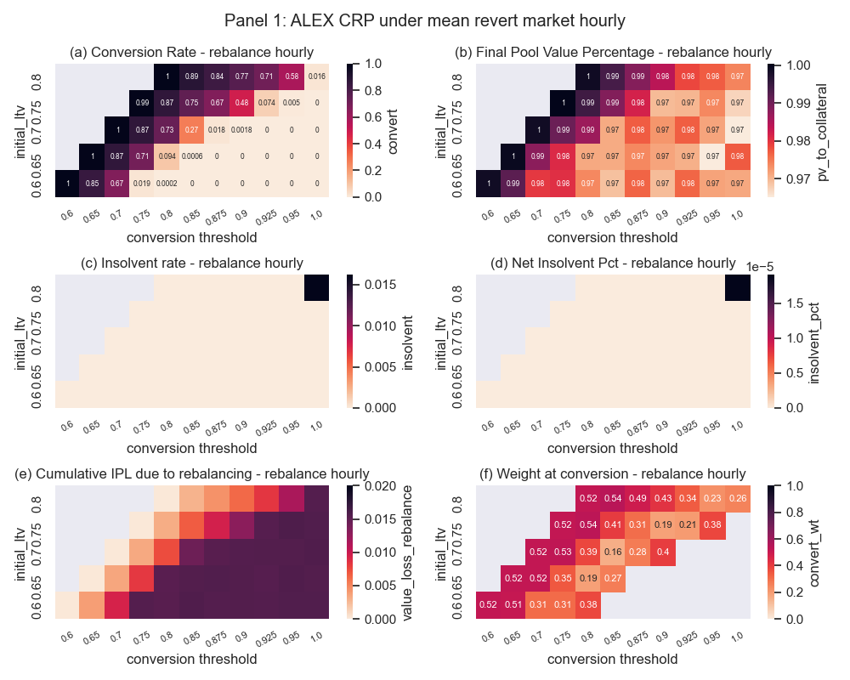

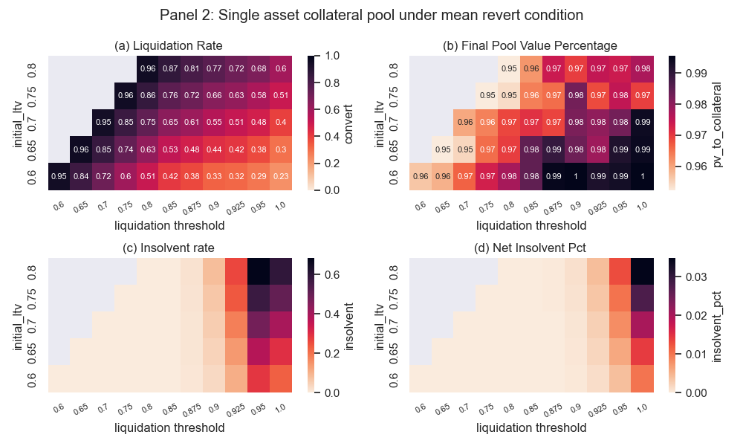

Base on the simulation, we confirmed that

1) ALEX CRP has consistent lower conversion rate comparing to the liquidation rate of statics single asset pool, benefiting from continuous rebalance according to the market movement.

2) The insolvent rate of ALEX CRP is almost 0, with the conversion threshold less than 95%.

3) The cumulative IPL due to weights rebalance is well controlled below 1.6% through the exponential moving average strategy.

### 3.2 What is the optimal combination of LTV and conversion threshold?

Panel 1-a clearly shows the trend that higher initial LTV and lower conversion threshold lead to higher conversion rate, as we expected. Under the mean revert market, with initial LTV equal 0.75 and conversion threshold 90%, the CRP has a converted rate around 48%. With this set of parameters, the CRP has the mean final value to collateral greater than 0.97. Given the stop-loss mechanism, the insolvent probability is close to 0 under this market condition, as shown in Panel 1-b and Panel 1-c. The average weight at conversion is 0.19, which means the CRP faces a lot less pressure should liquidity shrinks at conversion.

### 3.3 What is the optimal rebalance frequency?

We compare the simulation results of rebalance hourly (panel 1), 6-hourly (not shown for brevity), and daily (panel 3). We found that the results are comparable, given the recommended key parameters. But the hourly rebalance would response to price movement more promptly and lower the average weights at conversion. Therefore, we recommend setting the rebalance parameter to be hourly. 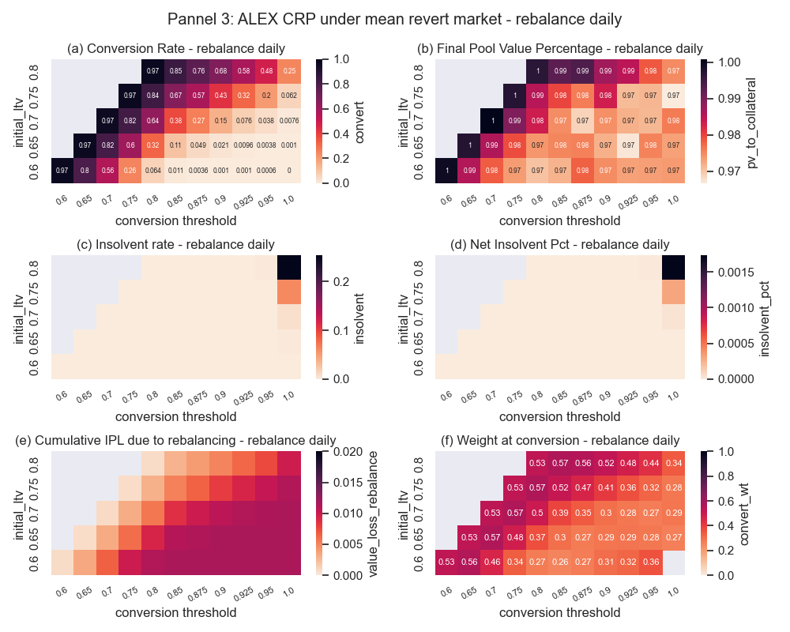

## Part IV: Simulated Stress Tests

### 4.1 Defining Market Risks

There are two primary sources of market risk within the protocol:

1. Extreme downward price movement: Shocks to market prices of collateral that cause the contract to become insolvent due to under-collateralization
2. Risky asset conversion: Price slippage and lack of liquidity in an external market place, leading delay and substantial price slippage in converting risky asset into riskless

In the following session, we test how CRP performed under extreme downward market conditions (section 4.2) and also compare with statics single asset pool in a tail event like March, 2020 (section 4.3).

### 4.2 Under an extreme down-market

The following panel shows simulation under an extreme down market. Panel 4-a shows the conversion rate would reach 80% under this extreme down market, and can maintain solvent almost all time. The average weight of risk asset is about 15% at the time of conversion. The pool would face less pressure at conversion.

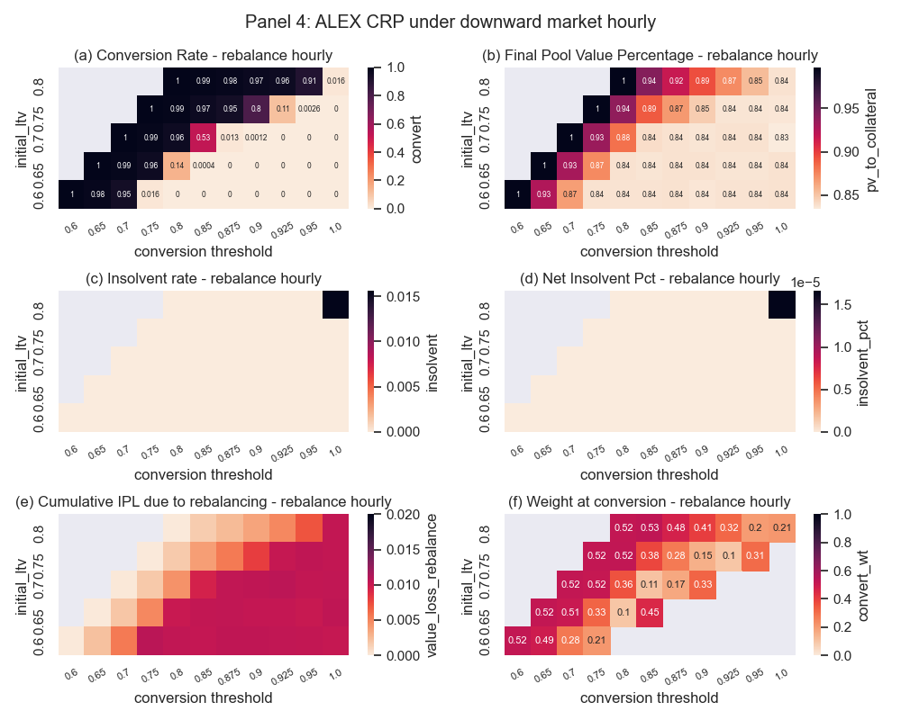

Not like other lending platforms, due to the stop-loss mechanism, ALEX doesn’t have the risk of liquidator inaction. However, in an extremely down market, we do expect substantial slippage in different volatilities and orders sizes. With the average of 15% risk asset, the CRP would face a lot less pressure of conversion comparing to the liquidation of a statics single asset pool.

### 4.3 Under an extraordinary down-market tail event:

The most extreme downward markets in BTC history happened on 2020/03 /12, with BTC price drop 49% within a day. We want to test how ALEX CRP would perform if the contract was implemented during that tail event.

We use a 3-month CRP contract as a stress testing case. Assume a contract starts on 2020/03/01, with 80% implied volatility, hourly rebalance frequency, 75% initial LTV0 and 90% conversion threshold, and the strike price is set at 7956 (BTC price on 2020/03/01).

Based on the simulation, the CRP pool value first hit the conversion threshold at 3/12/2020 12:00 PM. At that point, all BTC (44% of total pool value) is converted into USDC. The converted final pool value percentage equals to 83.16%. For static pool, 100% of BTC faces liquidation. The pool is insolvent with final pool value percent equals 70.5% (assuming 5% liquidation penalty), not even consider the risk of price slippage and liquidator inaction.

### 4.4 Under a up-market

For completeness, simulation results under a straight up trending market are presented. Panel 5-b confirms ALEX CRP is able to potential upside gain while minimize the risk of defaulting.

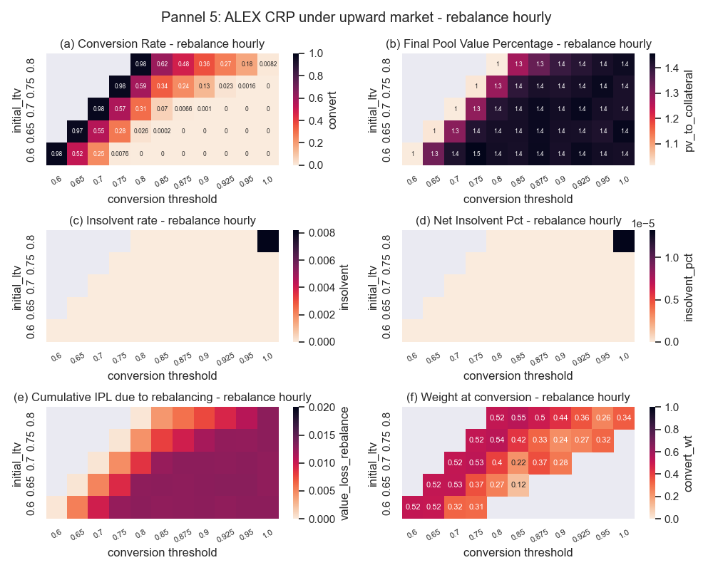

## Conclusions

This report conducted a performance assessment of the ALEX CRP via agent-based simulations under different market environments. We provide the recommendations of the key parameters for the ALEX CRP protocol based on the simulation results and stress-tested the insolvent rate and net value under extreme market conditions. We have shown that ALEX CRP is able to achieve: 1. Capture the potential upside gains while limit downside market; 2. Eliminate liquidation risk; 3. Maintain close to 0 insolvent rates under various market conditions; 4. Significantly reduce conversion pressure should liquidity shrink amid turmoil. As a result, ALEX's design provide a smoothing experience for both lending and borrowing, without the interruptions that plague many of existing alternatives.

## Appendix