Table A1. Critical stimuli and sentence-picture congruency ratings.
Item | Sentence | Congruent Picture | Sentence-Picture  Congruency Mean (SD) | Incongruent Picture | Sentence-Picture  Congruency Mean (SD) | Congruent − Incongruent | Holm p
苹果 (Apple) | 他看到树上有苹果。  (He saw the apple on the tree. ) | 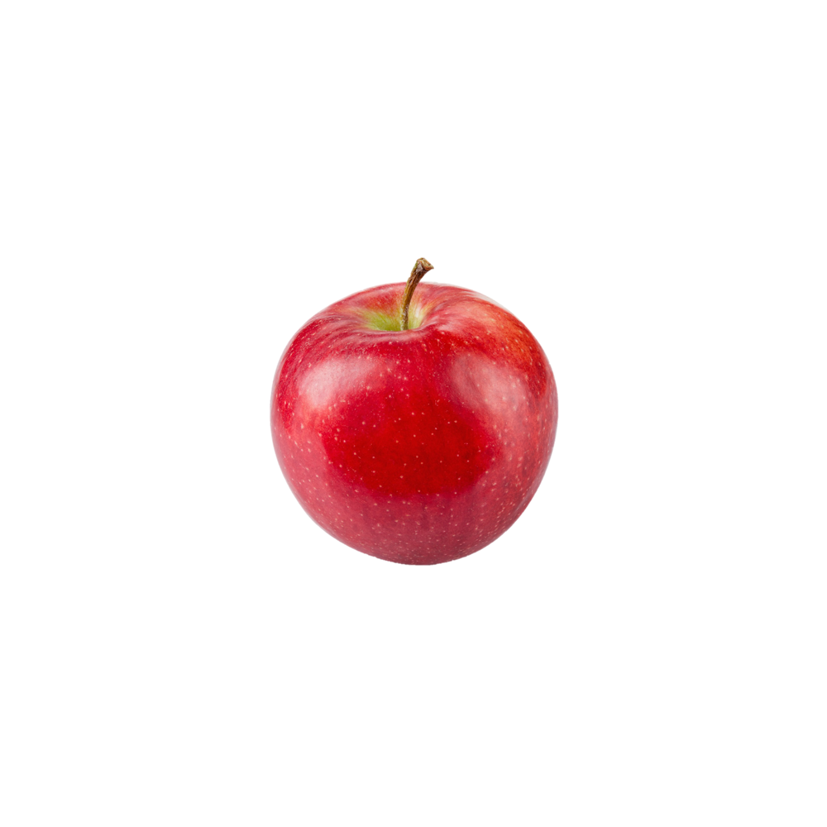 | 4.45 (1.10) | 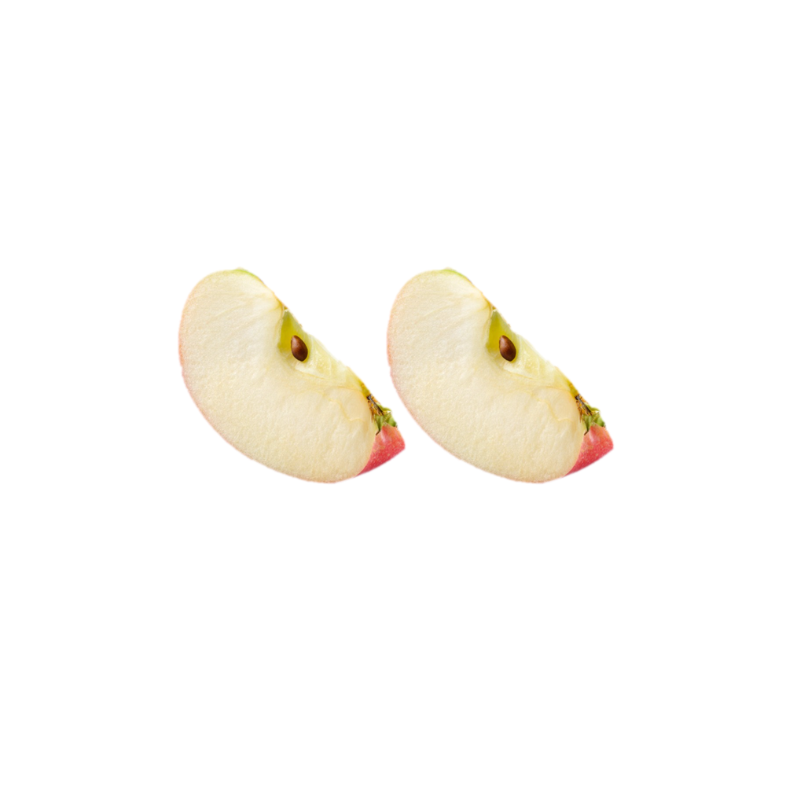 | 1.80 (1.20) | 2.65 | < .001
苹果 (Apple) | 他看到沙拉里有苹果。  (He saw the apple in the salad. ) |  | 2.95 (1.47) |  | 1.65 (1.23) | 1.30 | .005
柠檬 (Lemon) | 他看到树上有柠檬。  (He saw the lemon on the tree. ) | 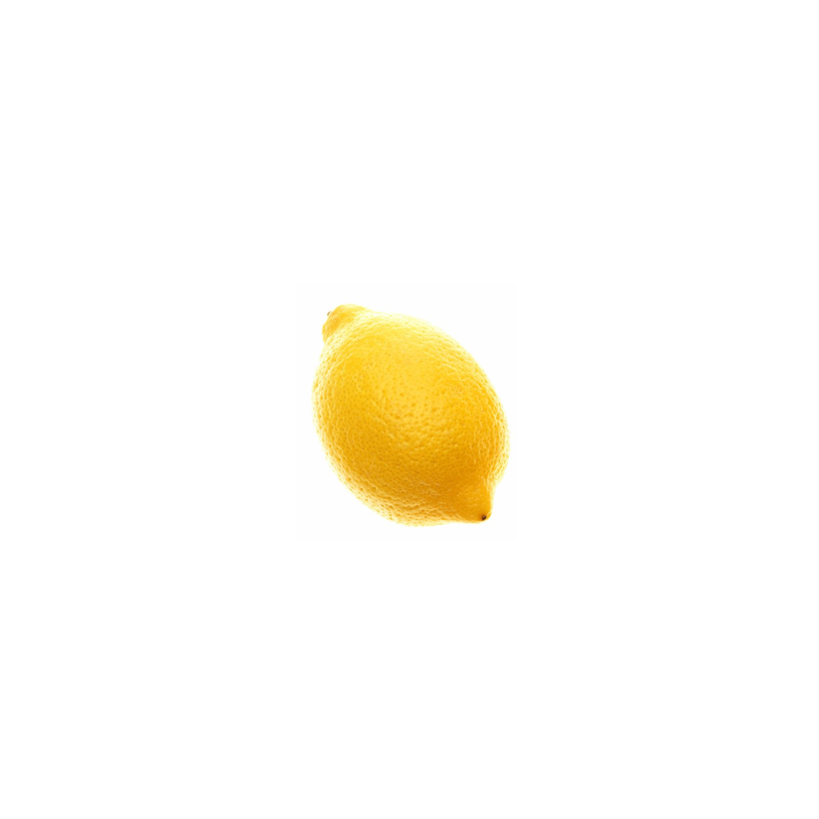 | 4.60 (0.94) | 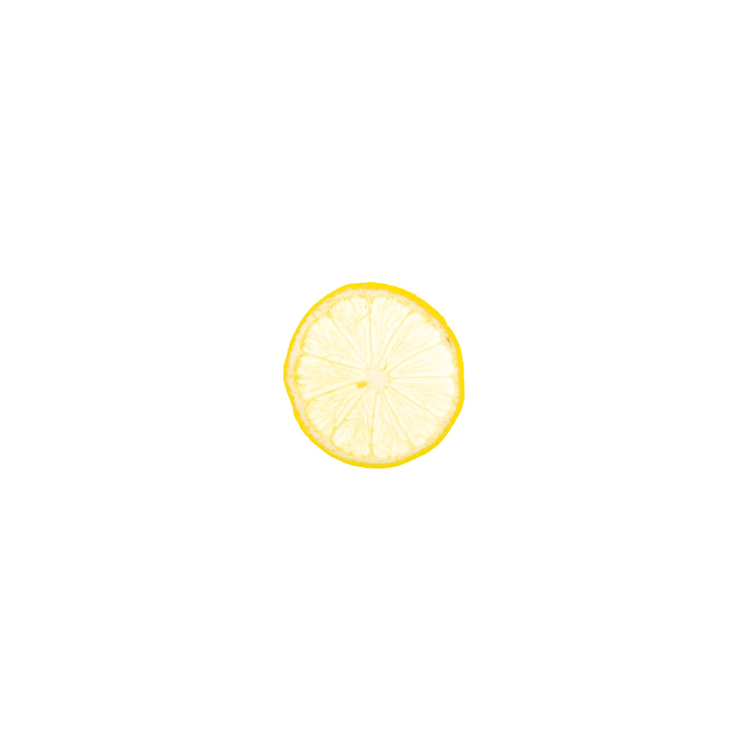 | 1.25 (0.72) | 3.35 | < .001
柠檬 (Lemon) | 他看到杯子里有柠檬。  (He saw the lemon in the cup. ) |  | 4.31 (1.16) |  | 2.23 (1.69) | 2.08 | < .001
桃子 (Peach) | 他看到树上有桃子。  (He saw the peach on the tree. ) | 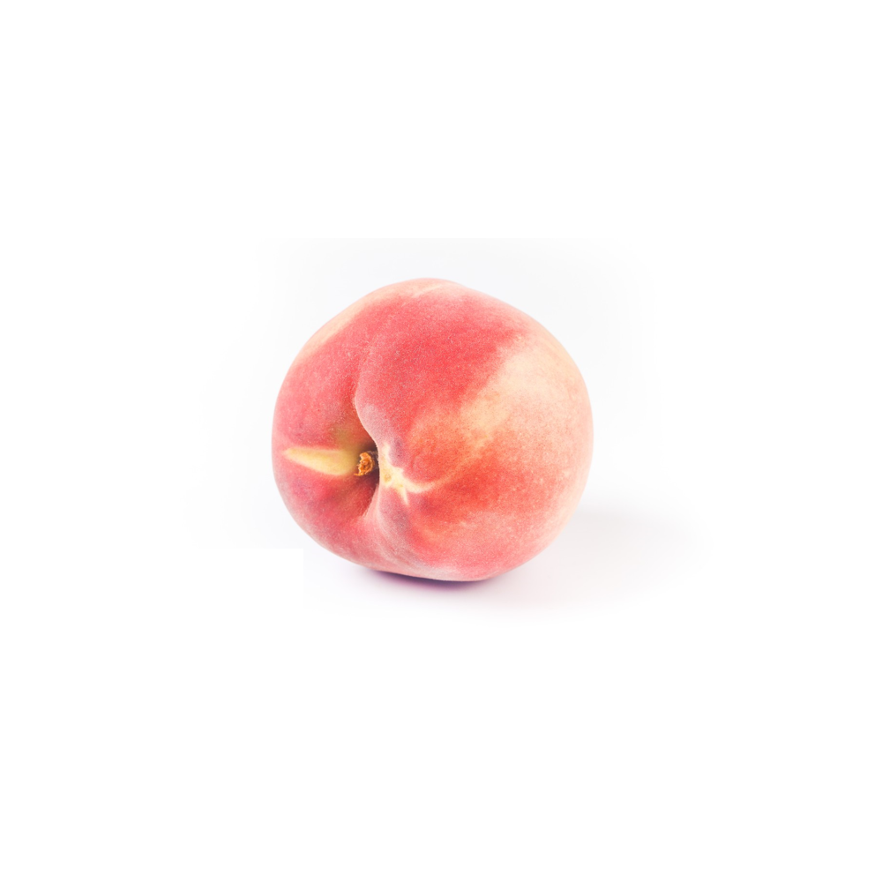 | 4.35 (0.94) | 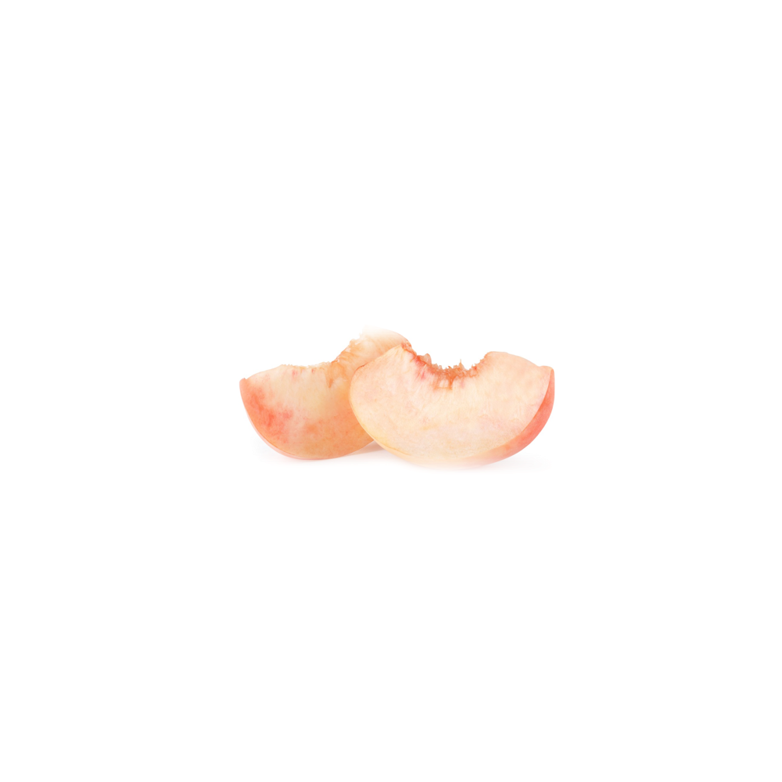 | 1.82 (1.30) | 2.53 | < .001
桃子 (Peach) | 他看到蛋糕上有桃子。  (He saw the peach on the cake. ) |  | 3.20 (1.28) |  | 1.70 (1.13) | 1.50 | .002
香蕉 (Banana) | 他看到商店里有香蕉。  (He saw the banana in the store. ) | 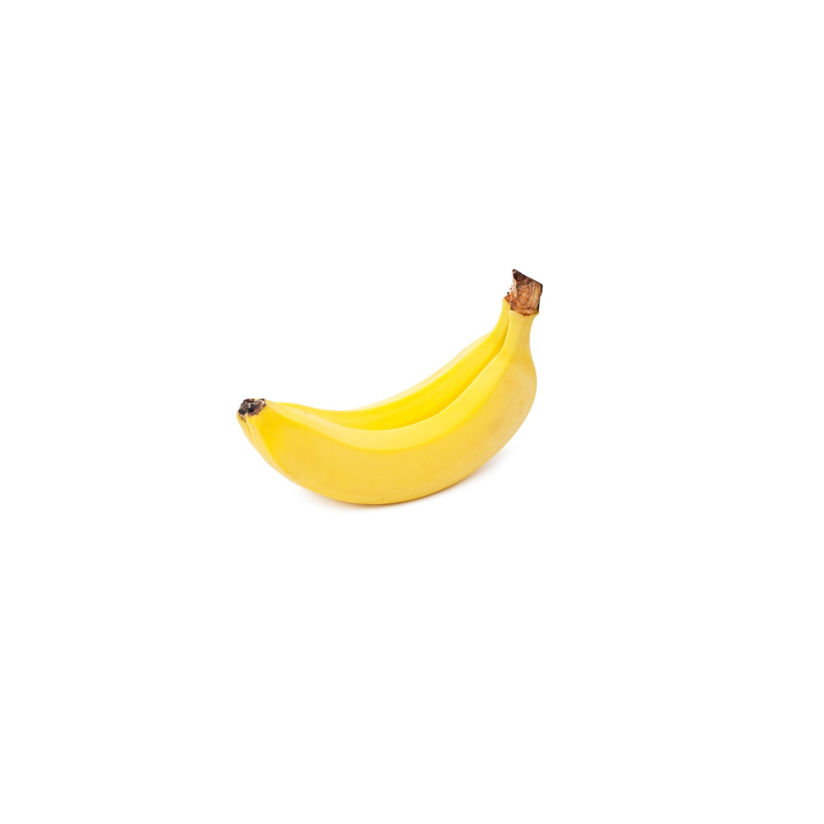 | 3.95 (1.13) | 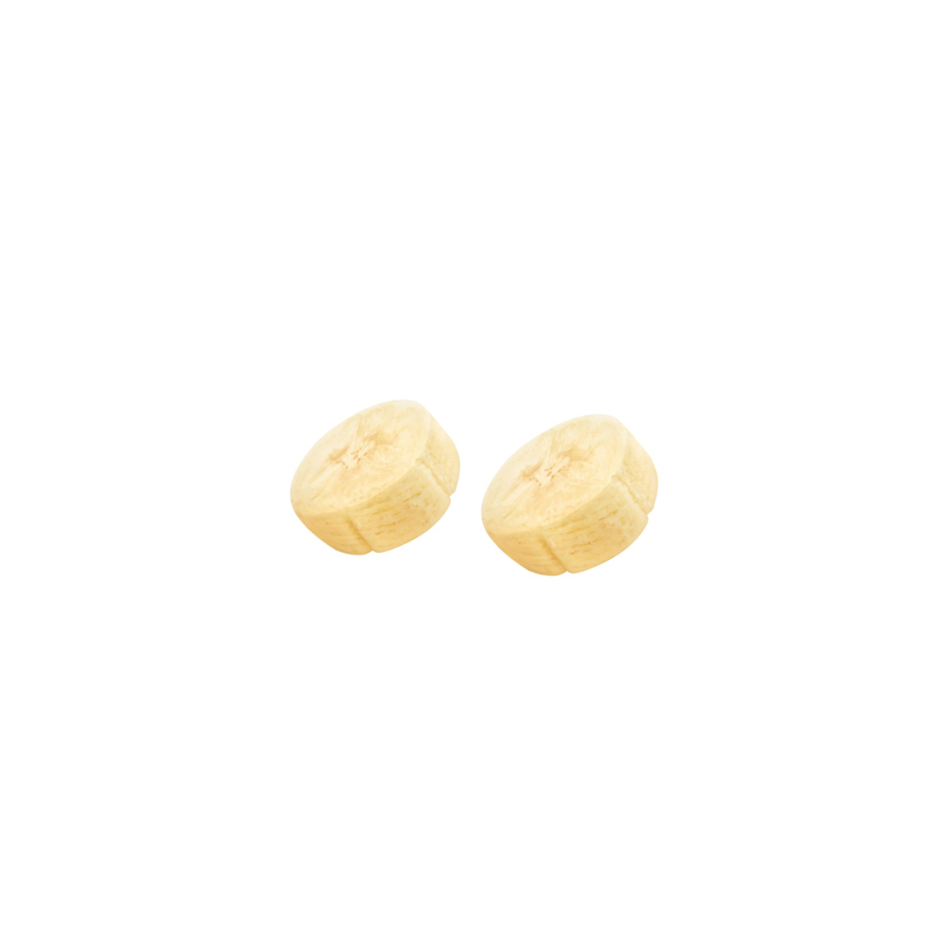 | 2.45 (1.05) | 1.50 | < .001
香蕉 (Banana) | 他看到比萨上有香蕉。  (He saw the banana on the pizza. ) |  | 4.10 (1.12) |  | 1.88 (1.45) | 2.22 | < .001
鸡蛋 (Egg) | 他看到超市里有鸡蛋。  (He saw the egg in the supermarket. ) | 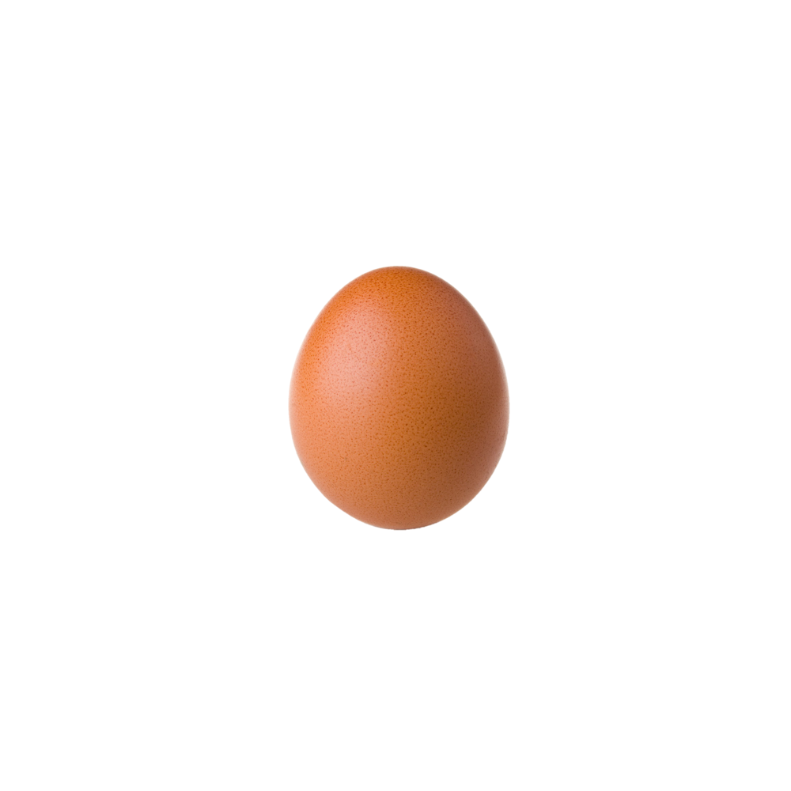 | 4.80 (0.52) | 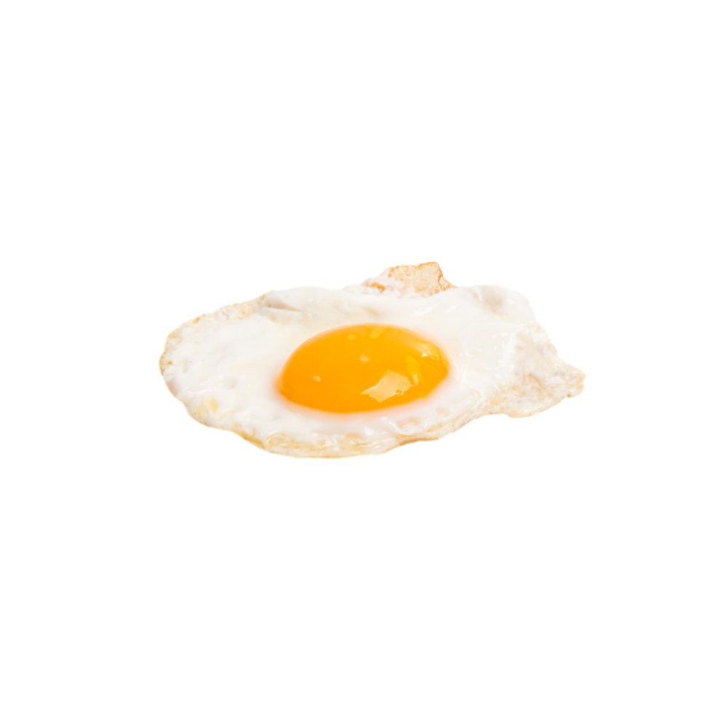 | 1.85 (0.93) | 2.95 | < .001
鸡蛋 (Egg) | 他看到煎锅里有鸡蛋。  (He saw the egg in the frying pan. ) |  | 4.46 (1.21) |  | 1.45 (0.86) | 3.01 | < .001
菠萝 (Pineapple) | 他看到箱子里有菠萝。  (He saw the pineapple in the box. ) | 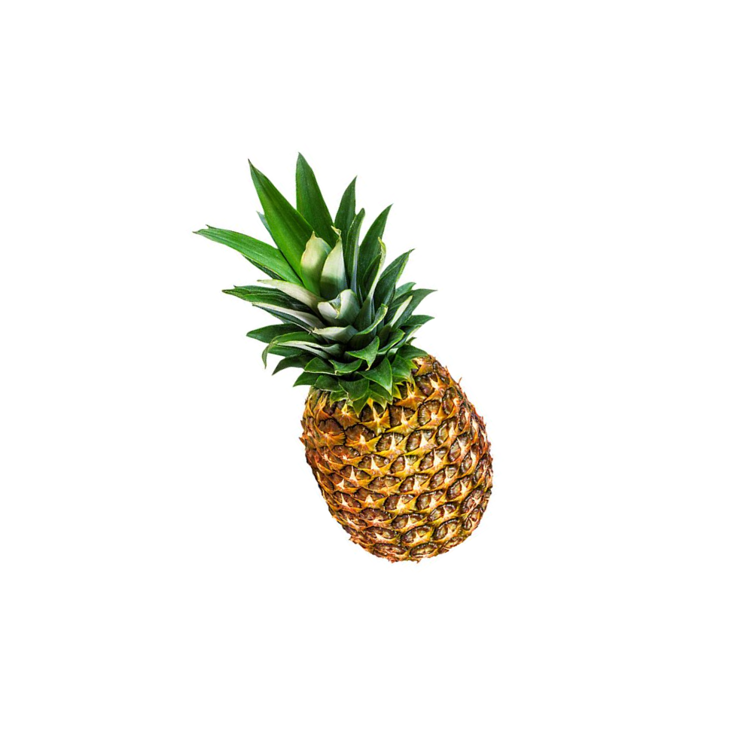 | 4.42 (0.90) | 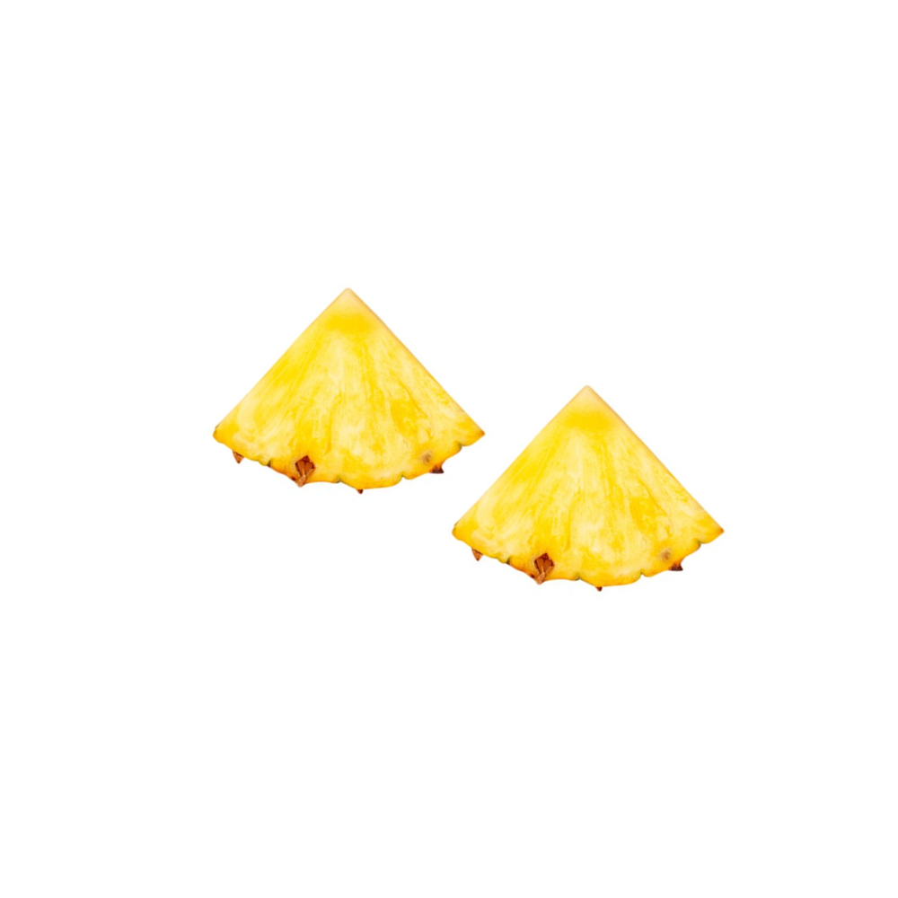 | 1.59 (1.01) | 2.83 | < .001
菠萝 (Pineapple) | 他看到蛋糕上有菠萝。  (He saw the pineapple on the cake. ) |  | 3.75 (0.97) |  | 1.25 (0.91) | 2.50 | < .001
草莓 (Strawberry) | 他看到菜园里有草莓。  (He saw the strawberry in the garden. ) | 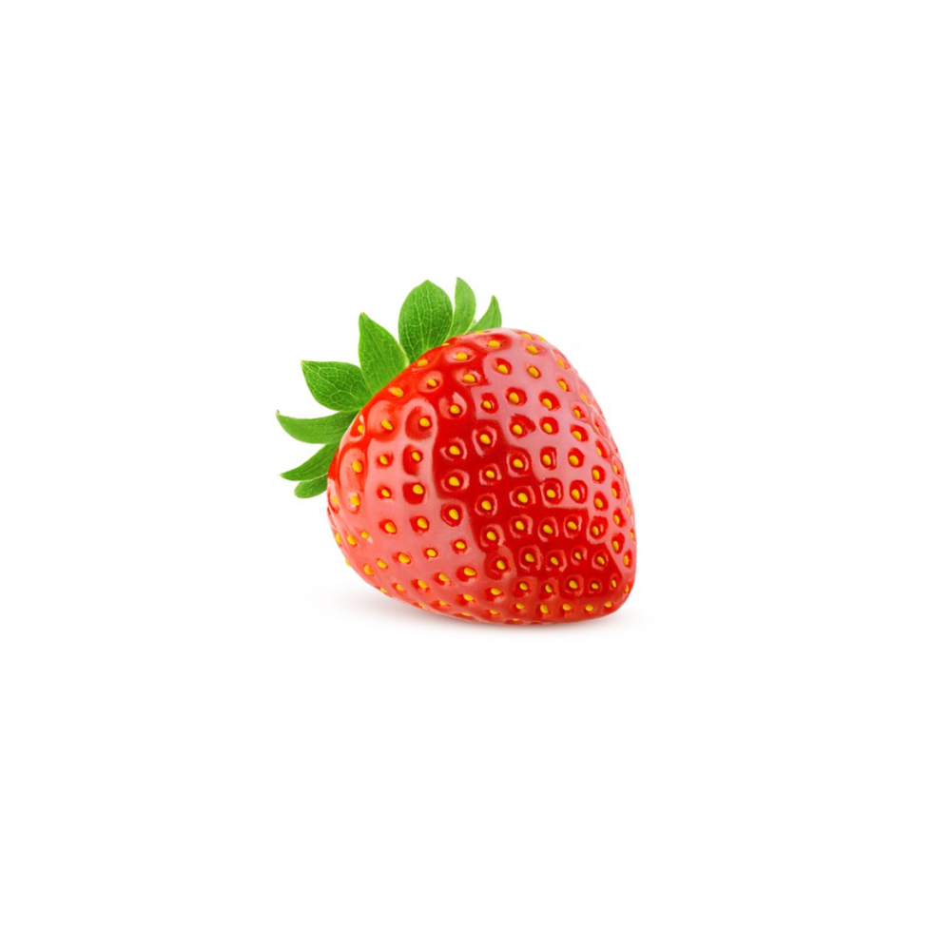 | 4.70 (0.47) | 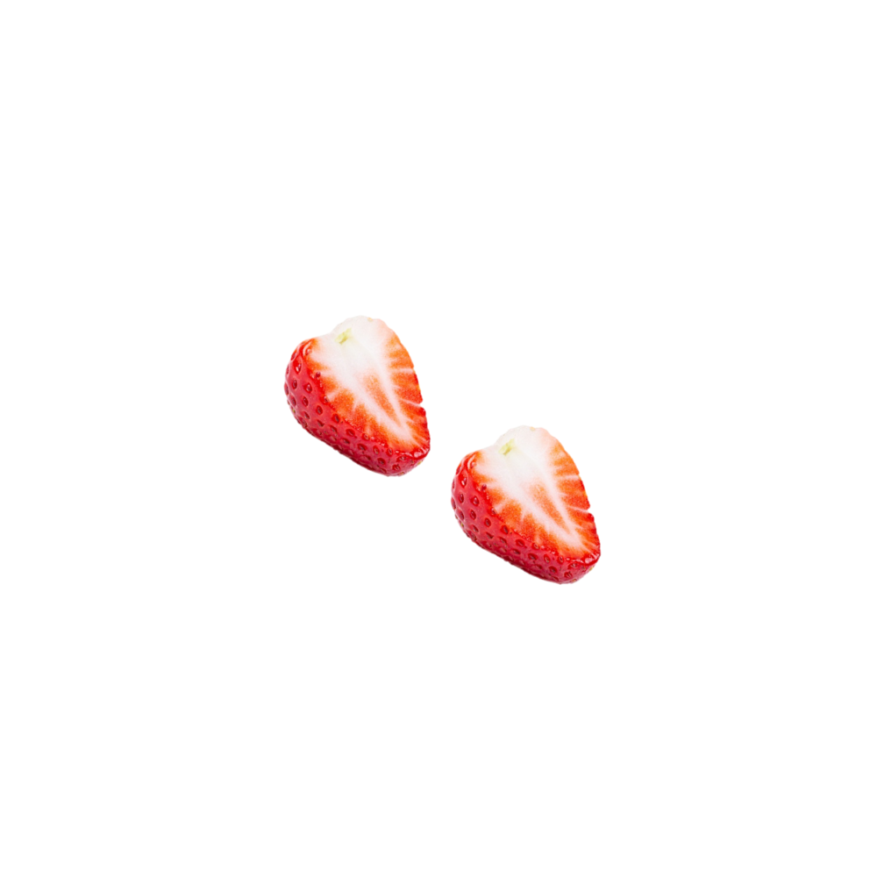 | 2.27 (1.25) | 2.43 | < .001
草莓 (Strawberry) | 他看到果冻里有草莓。  (He saw the strawberry in the jelly. ) |  | 2.86 (1.36) |  | 1.45 (0.60) | 1.41 | .001
西红柿 (Tomato) | 他看到袋子里有西红柿。  (He saw the tomato in the bag. ) | 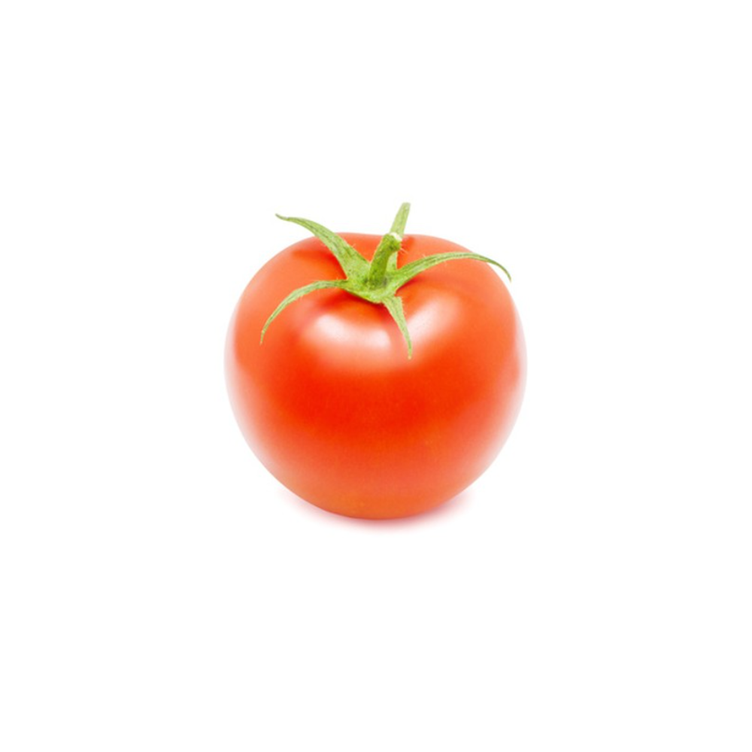 | 4.68 (0.95) | 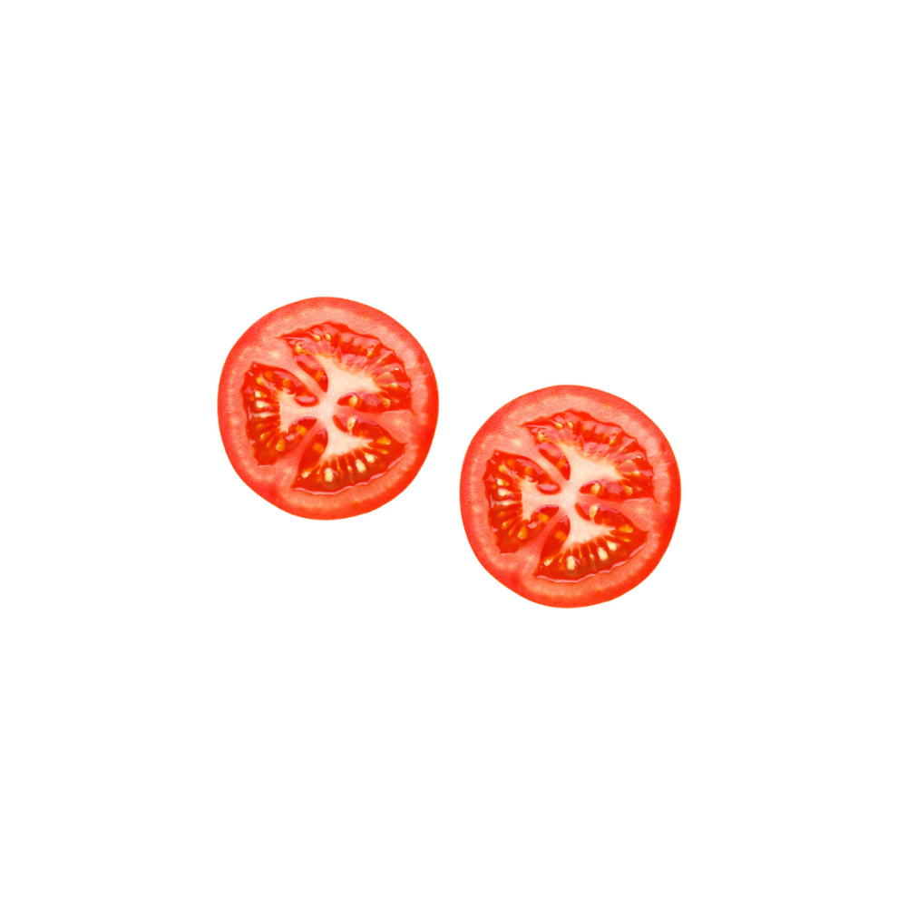 | 1.80 (0.89) | 2.88 | < .001
西红柿 (Tomato) | 他看到汉堡里有西红柿。  (He saw the tomato in the hamburger. ) |  | 4.85 (0.37) |  | 1.73 (1.28) | 3.12 | < .001
玉米 (Corn) | 他看到冰箱里有玉米。  (He saw the corn in the refrigerator. ) | 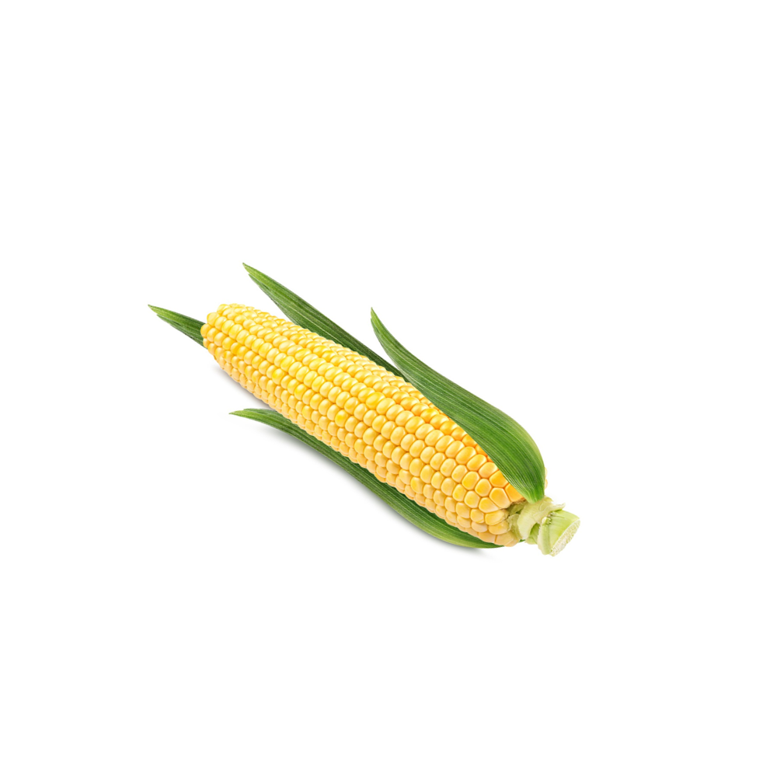 | 4.35 (0.75) | 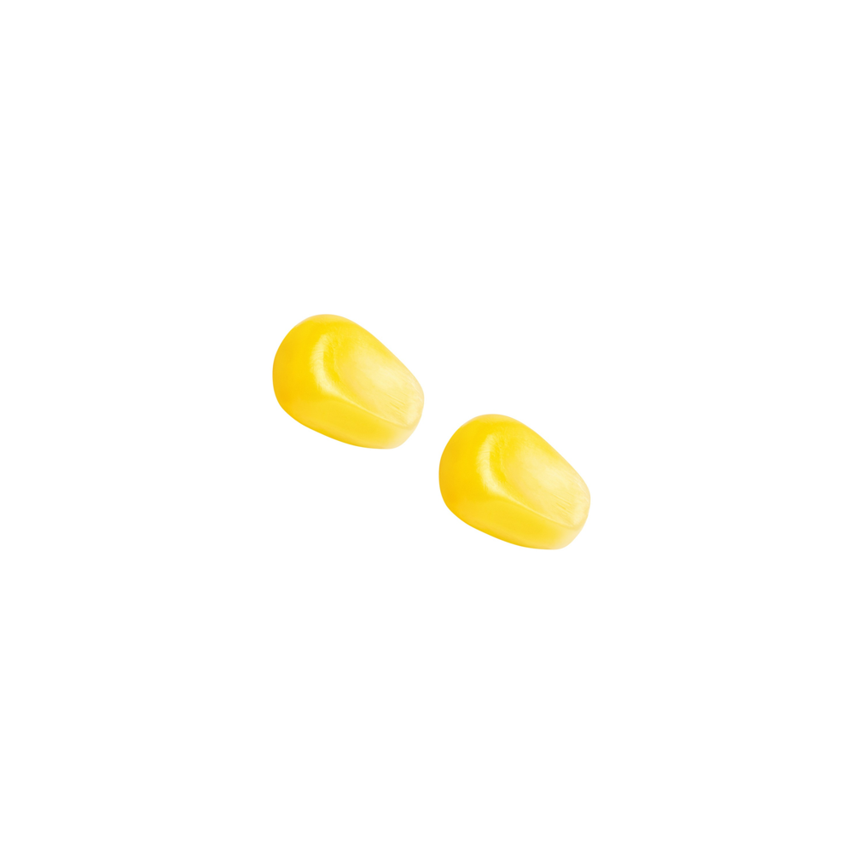 | 3.30 (1.08) | 1.05 | .005
玉米 (Corn) | 他看到汤里有玉米。  (He saw the corn in the soup. ) |  | 3.65 (1.35) |  | 1.59 (1.01) | 2.06 | < .001
黄瓜 (Cucumber) | 他看到架子上有黄瓜。  (He saw the cucumber on the shelf. ) | 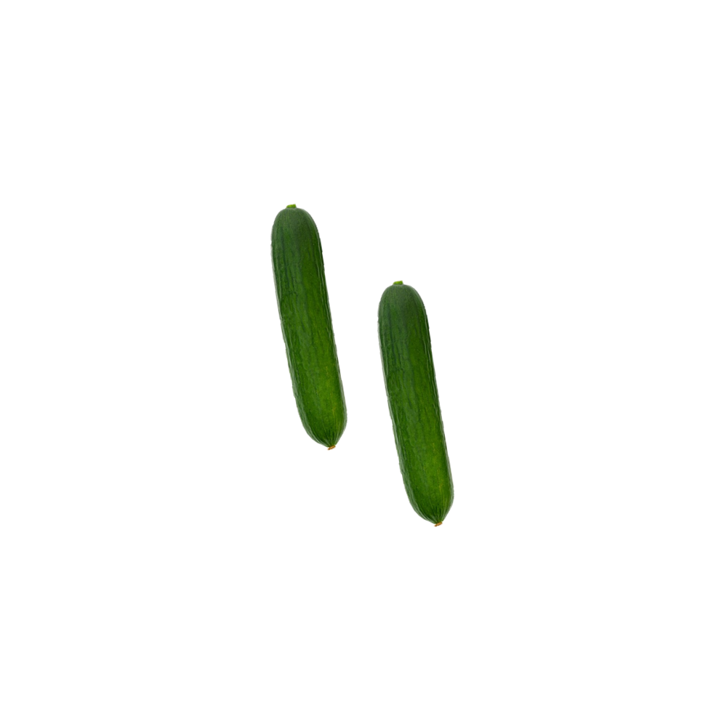 | 4.31 (1.16) | 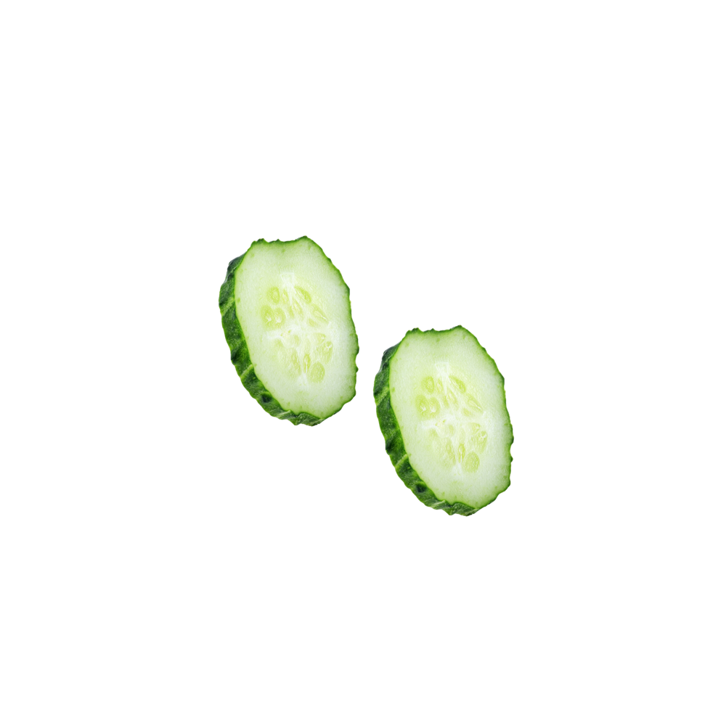 | 1.68 (1.25) | 2.63 | < .001
黄瓜 (Cucumber) | 他看到三明治里有黄瓜。  (He saw the cucumber in the sandwich. ) |  | 4.65 (0.75) |  | 1.25 (0.55) | 3.40 | < .001
土豆(Potato) | 他看到商店里有土豆。  (He saw the potato in the store. ) | 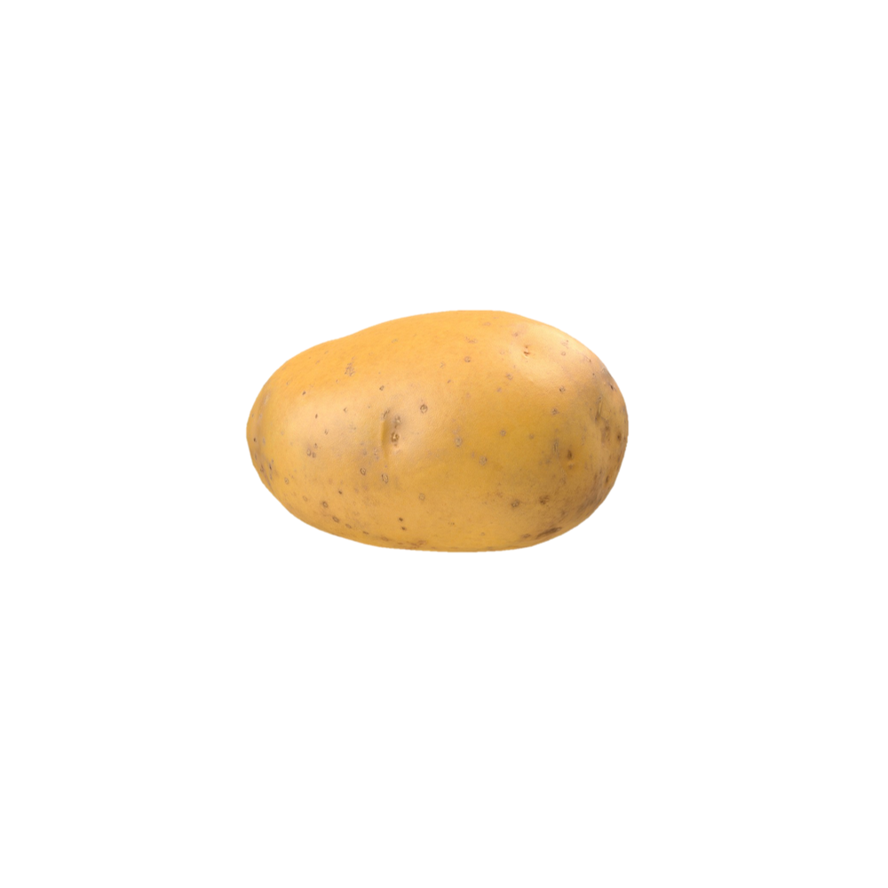 | 4.95 (0.22) | 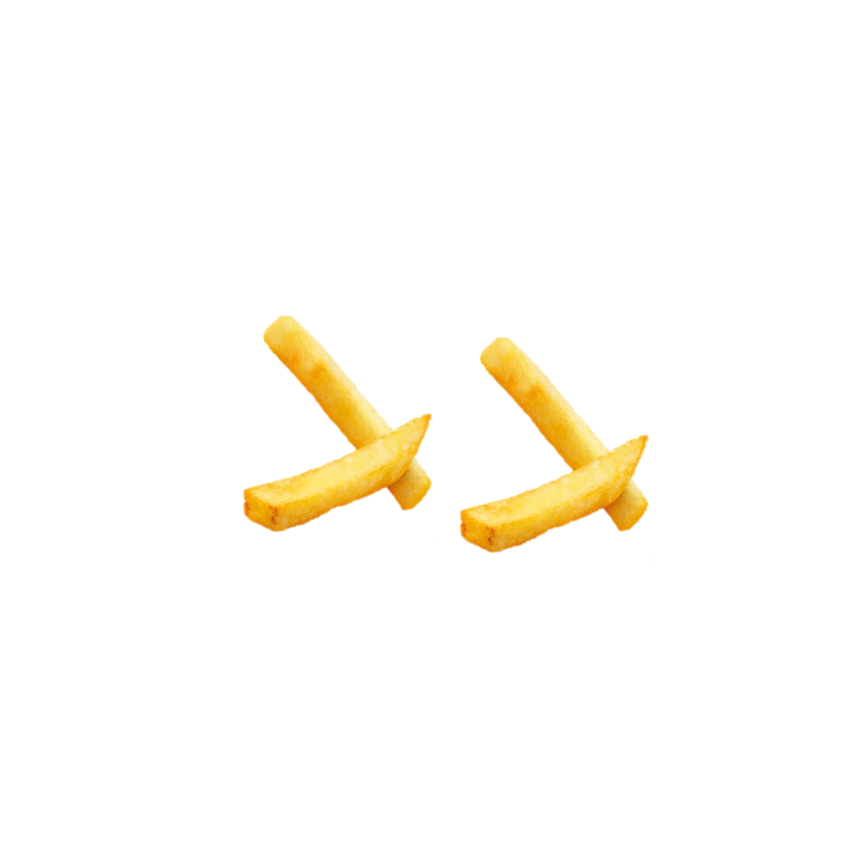 | 2.27 (1.12) | 2.68 | < .001
土豆(Potato) | 他看到煎锅里有土豆。  (He saw the potato in the frying pan. ) |  | 3.45 (1.37) |  | 1.25 (0.55) | 2.20 | < .001
莲藕 (Lotus root) | 他看到货架上有莲藕。  (He saw the lotus root on the shelf. ) | 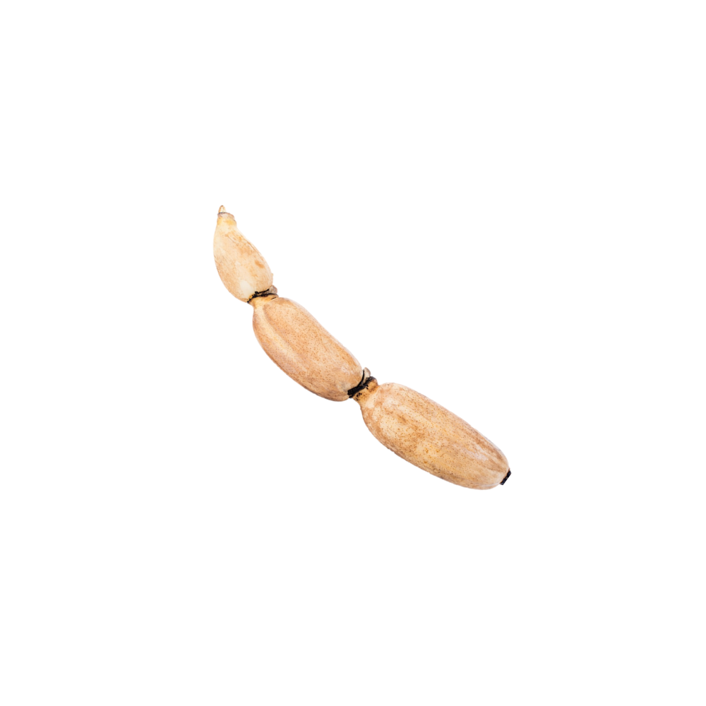 | 4.25 (1.02) | 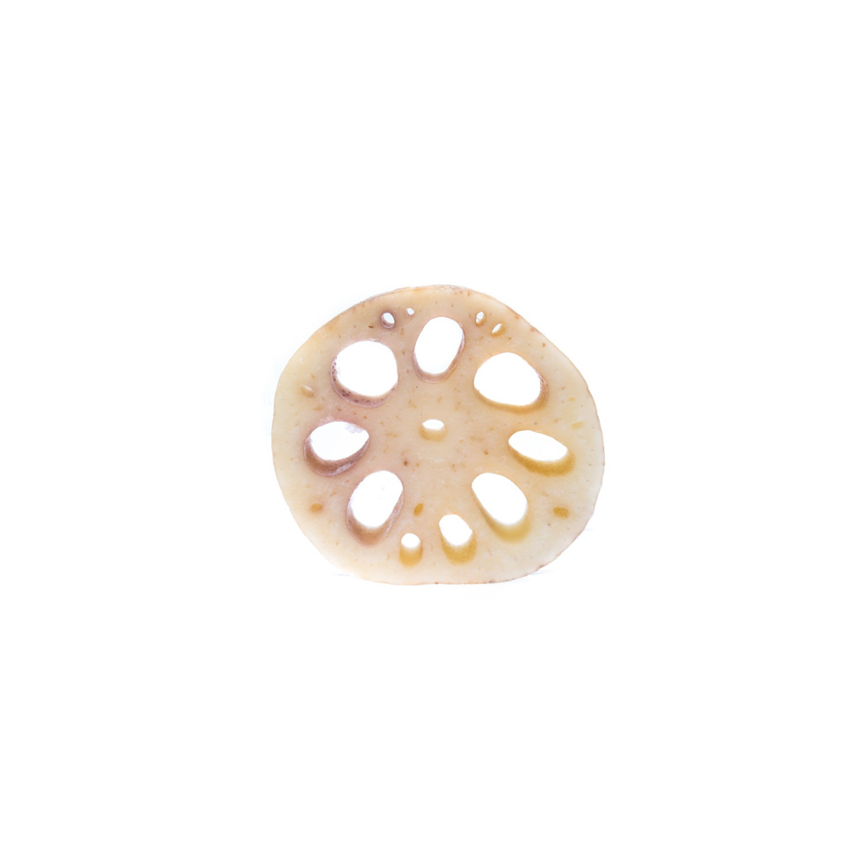 | 2.20 (1.01) | 3.05 | < .001
莲藕 (Lotus root) | 他看到菜里有莲藕。  (He saw the lotus root in the dish. ) |  | 4.42 (0.81) |  | 1.68 (1.04) | 2.74 | < .001
辣椒 (Chili pepper) | 他看到菜园里有辣椒。  (He saw the chili pepper in the vegetable garden. ) | 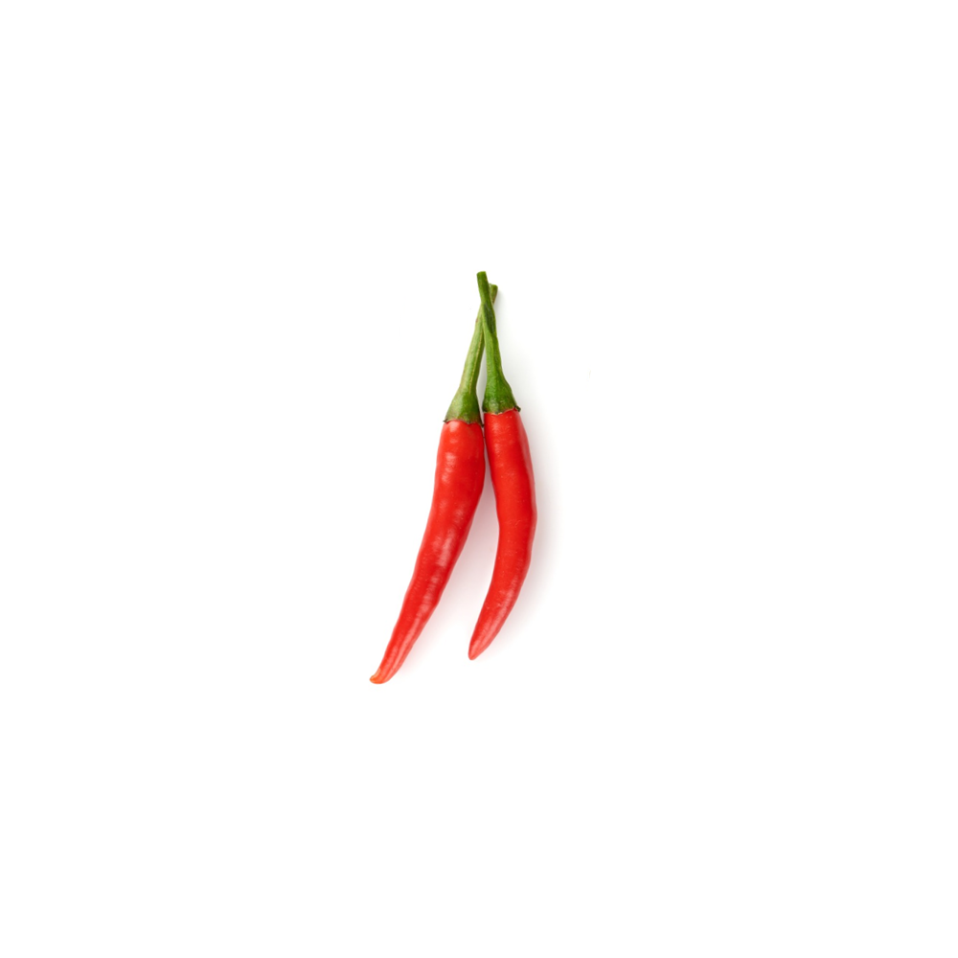 | 4.27 (1.04) | 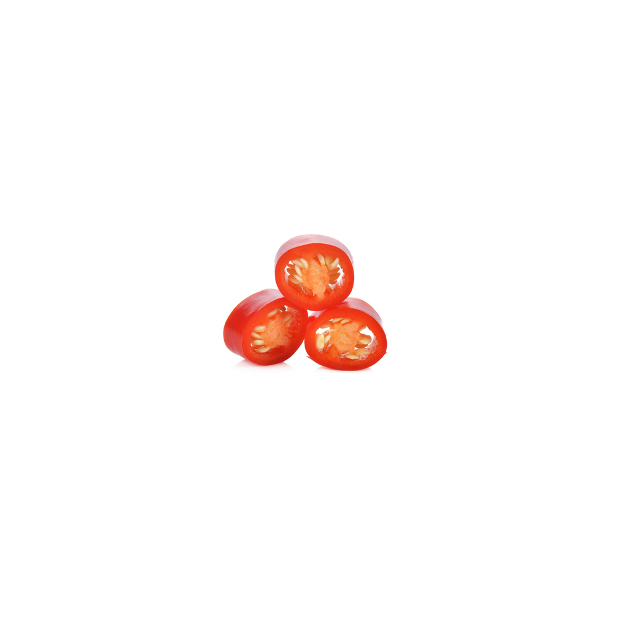 | 1.23 (0.53) | 3.04 | < .001
辣椒 (Chili pepper) | 他看到菜里有辣椒。  (He saw the chili pepper in the dish. ) |  | 4.05 (1.19) |  | 2.30 (1.03) | 1.75 | < .001
洋葱 (Onion) | 他看到篮子里有洋葱。  (He saw the onion in the basket. ) | 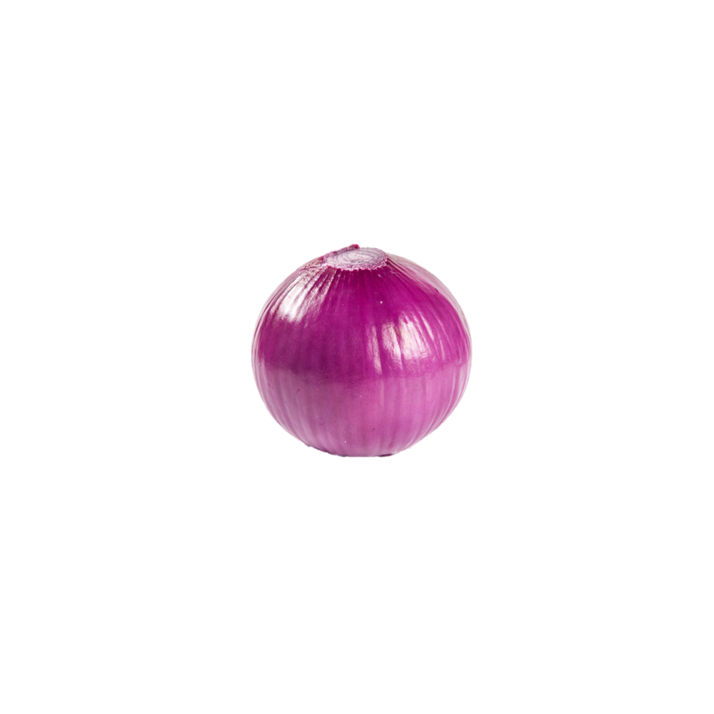 | 4.11 (1.28) | 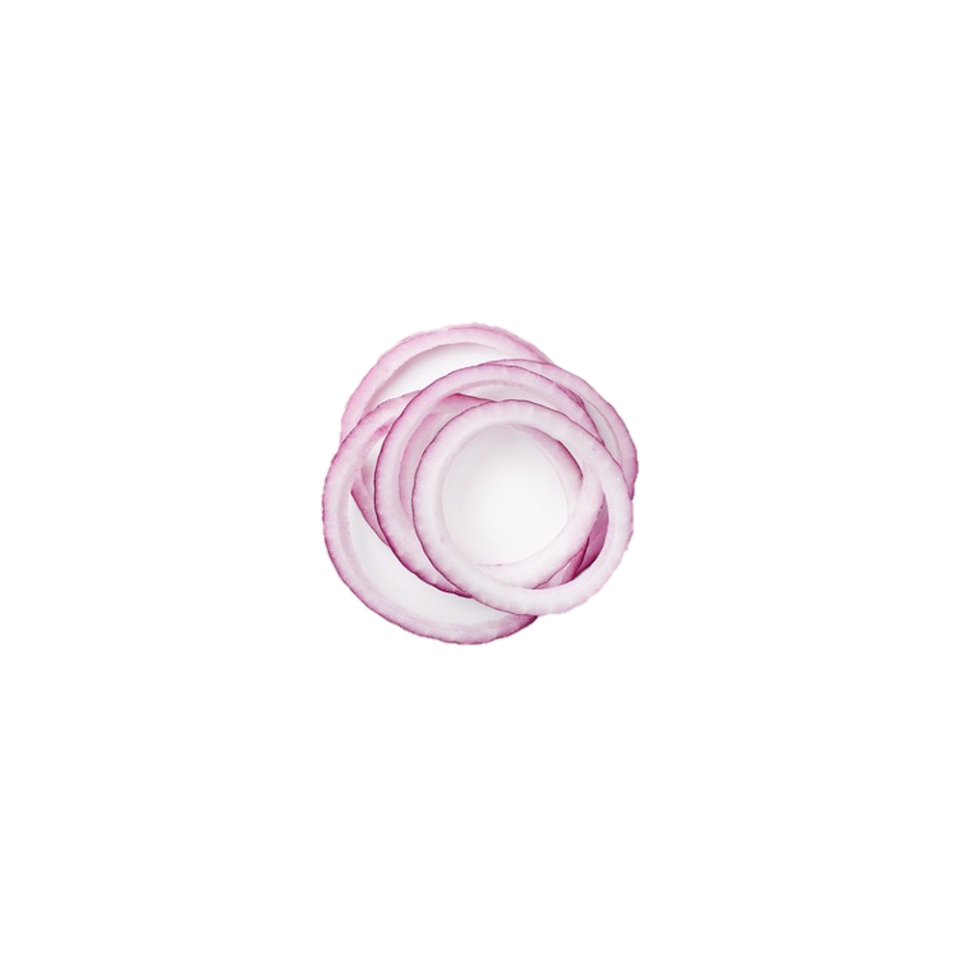 | 2.12 (1.28) | 2.00 | < .001
洋葱 (Onion) | 他看到沙拉里有洋葱。  (He saw the onion in the salad. ) |  | 4.10 (1.05) |  | 1.65 (1.09) | 2.45 | < .001
花生 (Peanut) | 他看到市场上有花生。  (He saw the peanut at the market. ) | 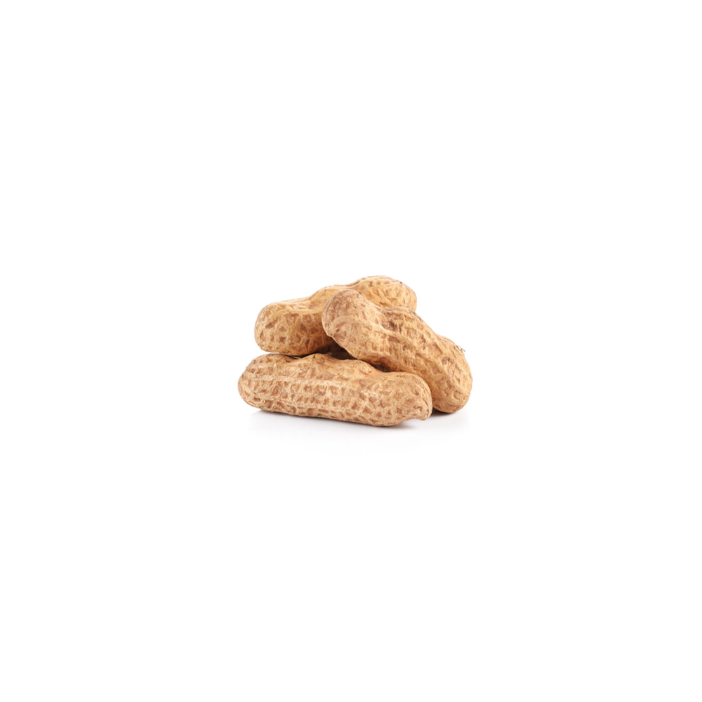 | 4.65 (0.49) | 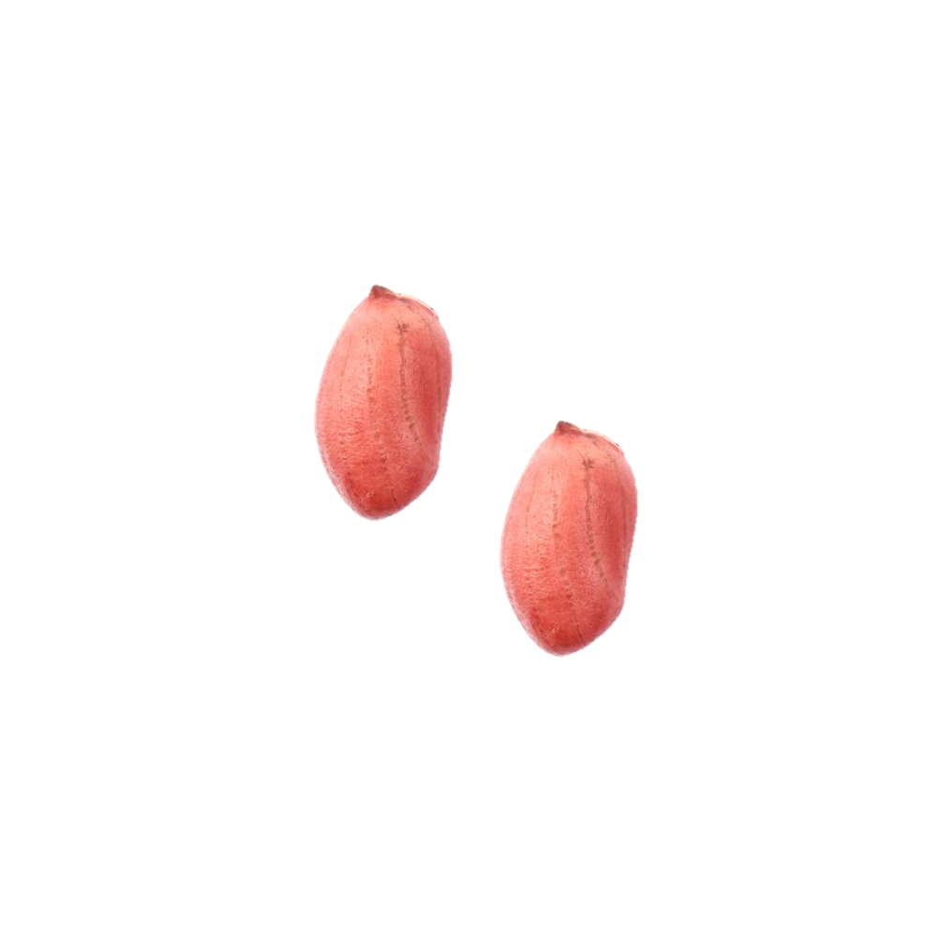 | 3.75 (1.02) | 0.90 | .005
花生 (Peanut) | 他看到菜里有花生。  (He saw the peanut in the dish. ) |  | 3.46 (1.33) |  | 1.59 (1.01) | 1.87 | < .001
蝙蝠 (Bat) | 他看到天上有蝙蝠。  (He saw the bat in the sky. ) | 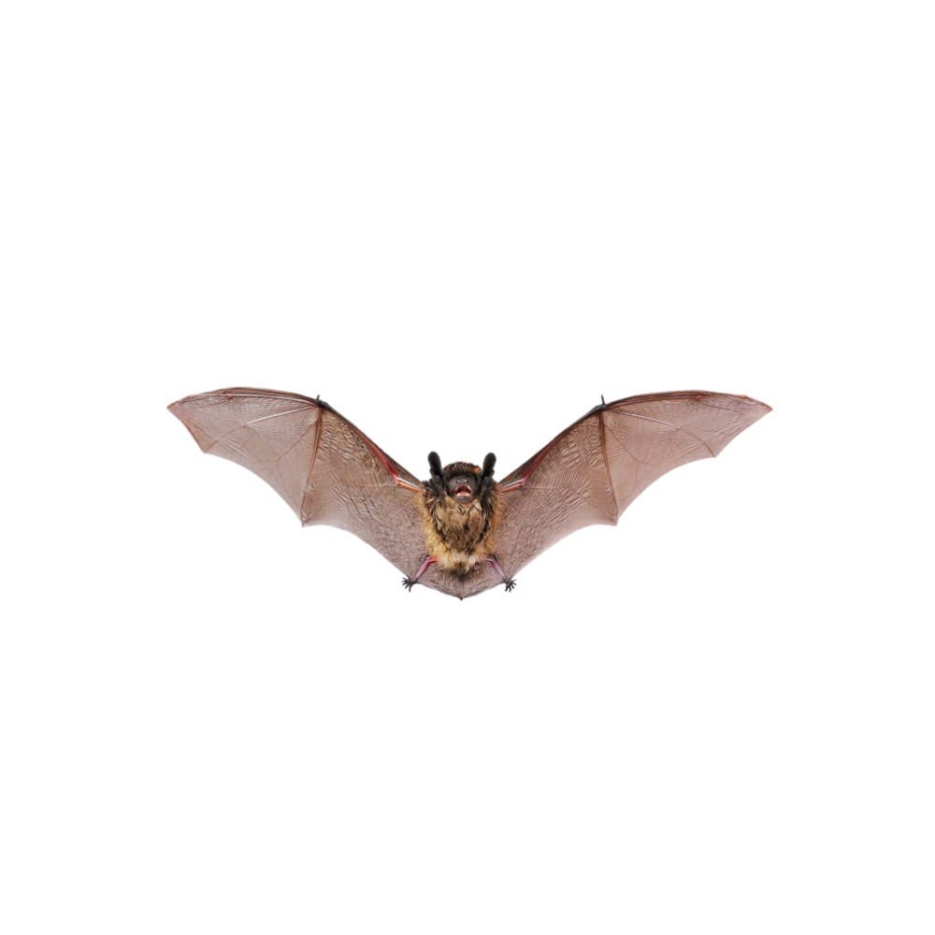 | 4.18 (1.01) | 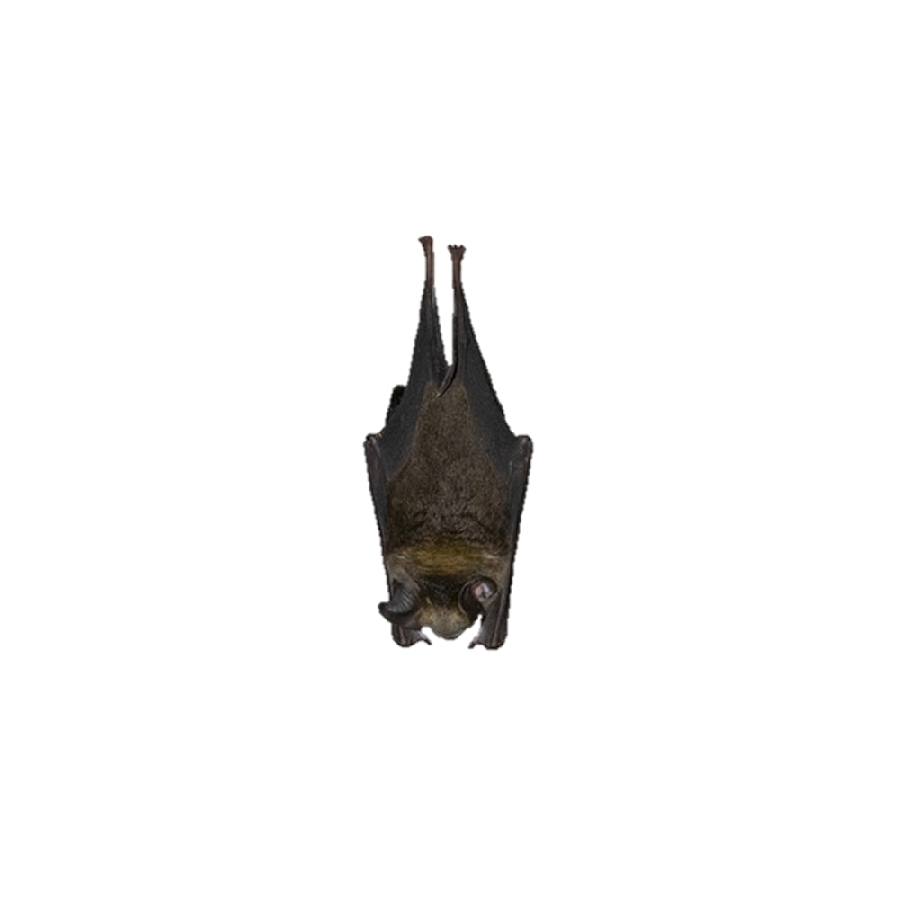 | 2.55 (1.54) | 1.63 | .002
蝙蝠 (Bat) | 他看到洞里有蝙蝠。  (He saw the bat in the cave. ) |  | 4.80 (0.41) |  | 3.62 (1.30) | 1.18 | .001
毛线 (Yarn) | 他看到篮子里有毛线。  (He saw the yarn in the basket. ) | 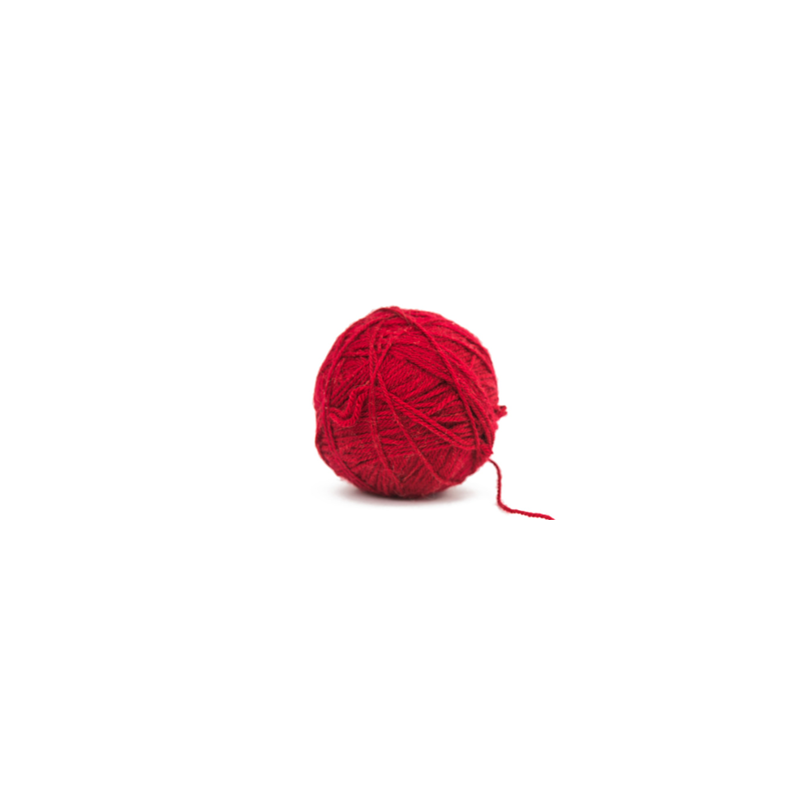 | 4.60 (0.50) | 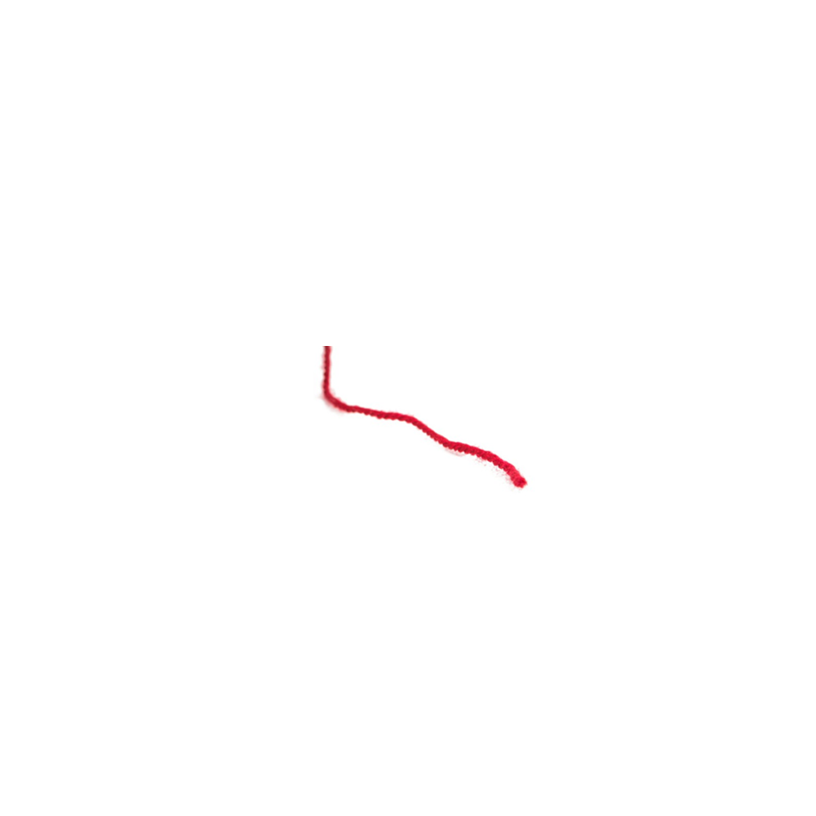 | 3.55 (1.23) | 1.05 | .005
毛线 (Yarn) | 他看到衣服上有毛线。  (He saw the yarn on the clothes. ) |  | 3.77 (1.14) |  | 1.55 (1.10) | 2.22 | < .001
气球 (Balloon) | 他看到口袋里有气球。  (He saw the balloon in the pocket. ) | 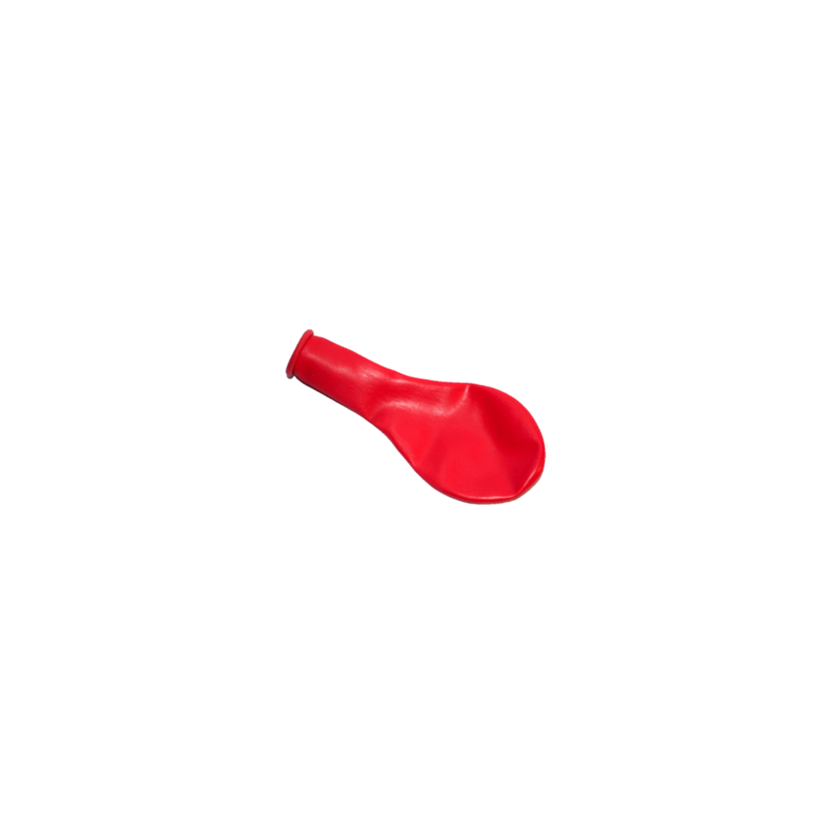 | 4.75 (0.44) | 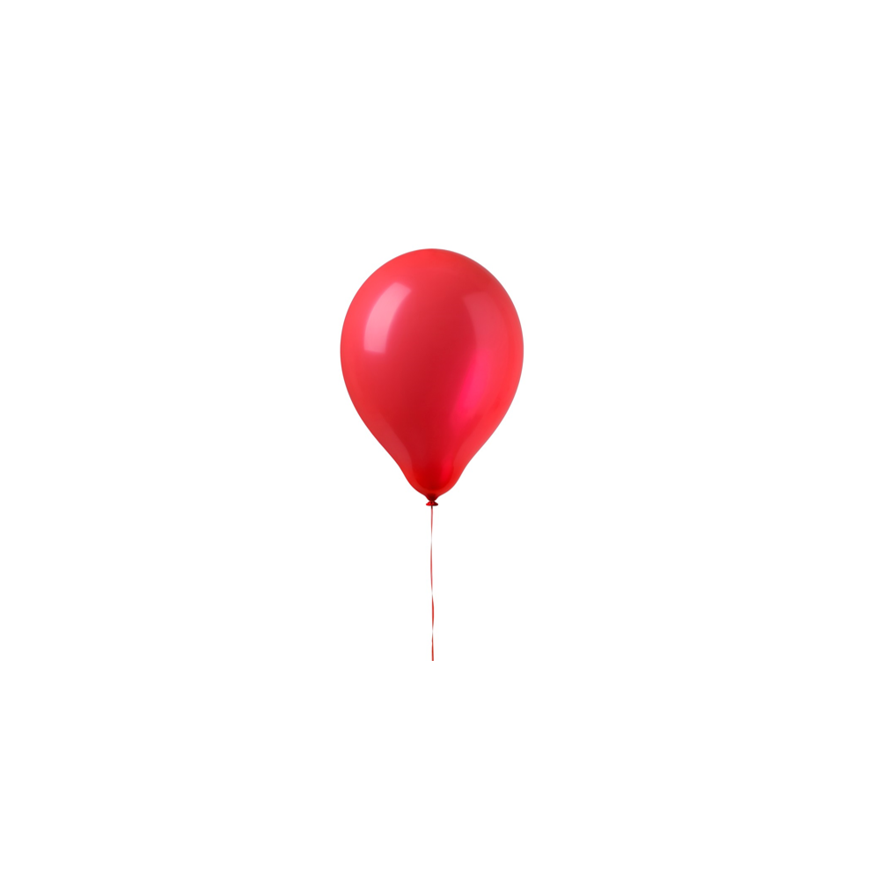 | 1.92 (1.29) | 2.83 | < .001
气球 (Balloon) | 他看到天空中有气球。  (He saw the balloon in the sky. ) |  | 4.45 (0.96) |  | 1.35 (0.75) | 3.10 | < .001
香烟 (Cigarette) | 他看到垃圾桶里有香烟。  (He saw the cigarette in the trash can. ) | 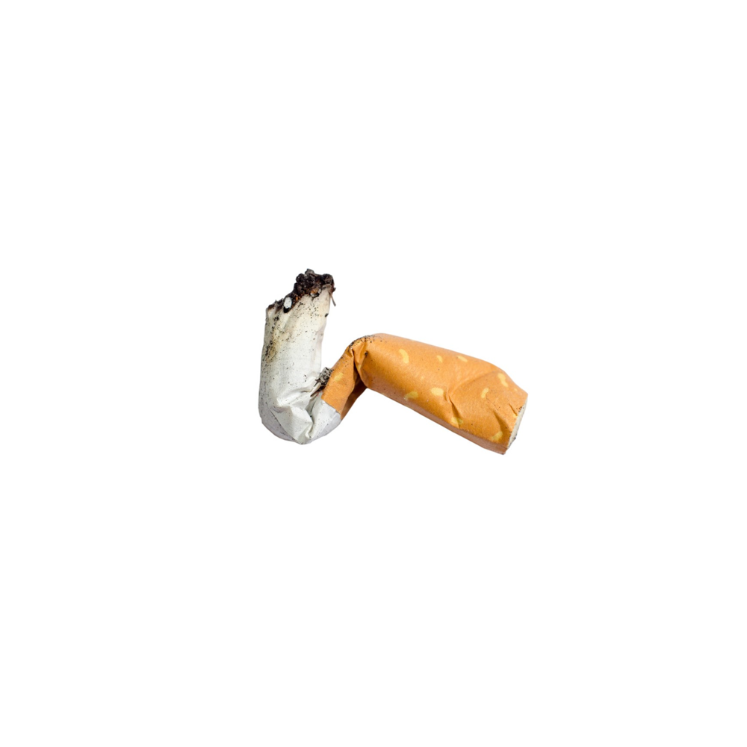 | 4.12 (1.11) | 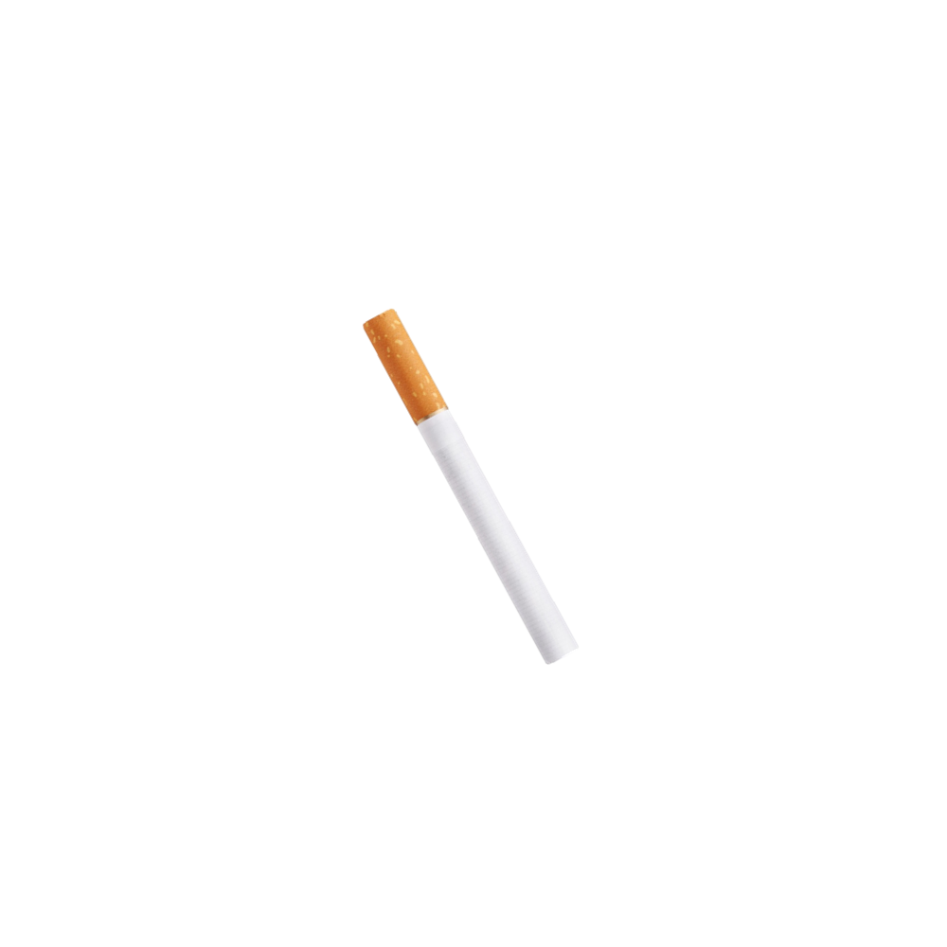 | 2.05 (1.25) | 2.07 | < .001
香烟 (Cigarette) | 他看到盒子里有香烟。  (He saw the cigarette in the box. ) |  | 4.80 (0.41) |  | 2.15 (1.09) | 2.65 | < .001
纸巾 (Tissue) | 他看到垃圾桶里有纸巾。  (He saw the tissue in the trash can. ) | 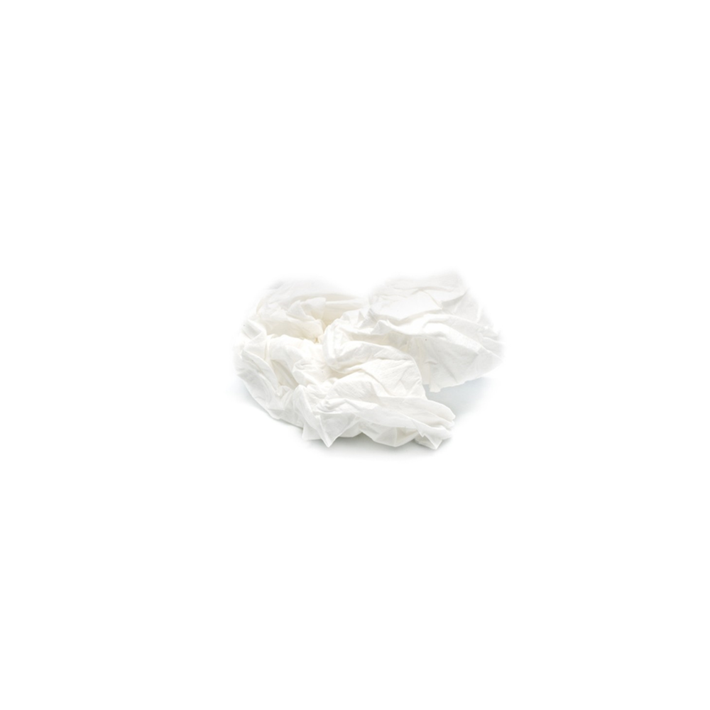 | 4.70 (0.47) | 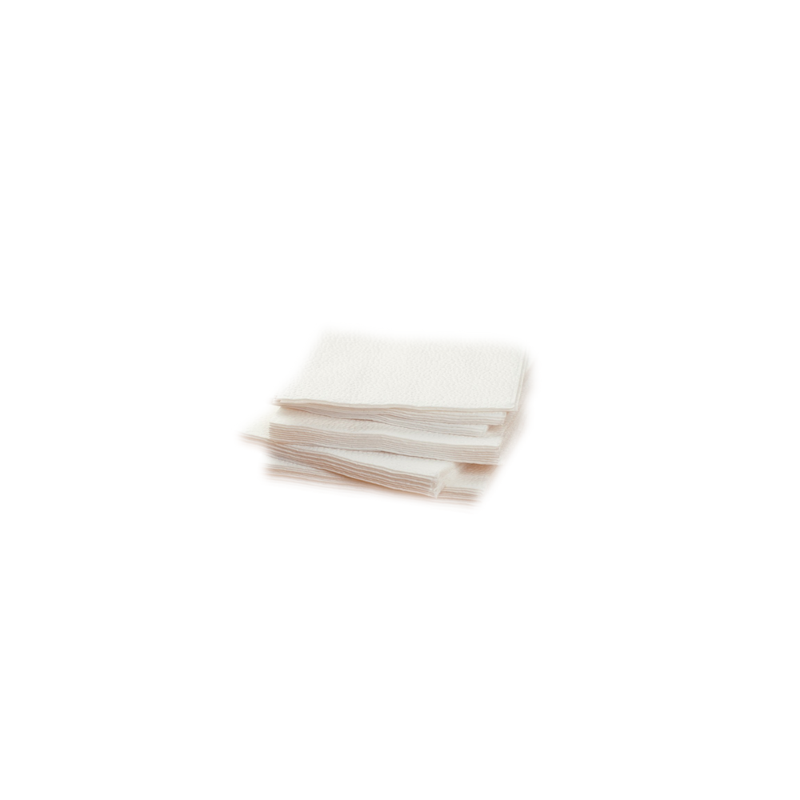 | 1.80 (0.62) | 2.90 | < .001
纸巾 (Tissue) | 他看到盒子里有纸巾。  (He saw the tissue in the box. ) |  | 4.19 (0.90) |  | 2.32 (1.43) | 1.87 | < .001
蘑菇 (Mushroom) | 他看到大树下有蘑菇。  (He saw the mushroom under the tree. ) | 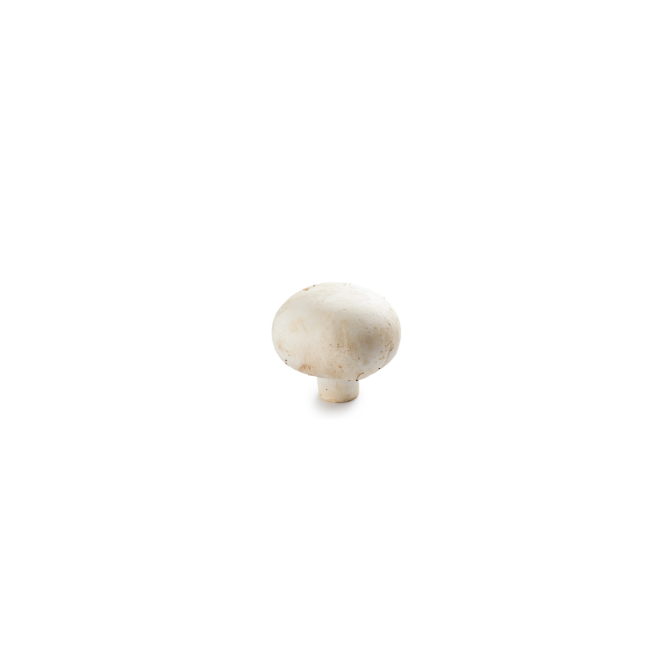 | 3.70 (0.92) | 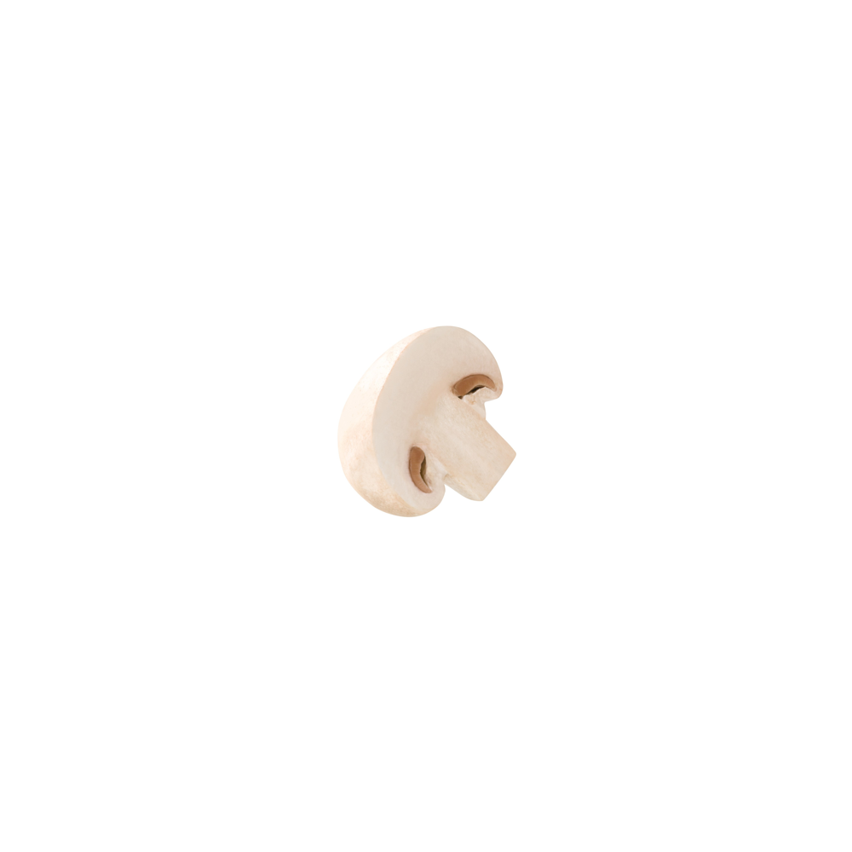 | 2.50 (1.39) | 1.20 | .005
蘑菇 (Mushroom) | 他看到沙拉里有蘑菇。  (He saw the mushroom in the salad. ) |  | 3.32 (1.17) |  | 1.85 (1.18) | 1.47 | .002
胡萝卜 (Carrot) | 他看到菜园里有胡萝卜。  (He saw the carrot in the vegetable garden. ) | 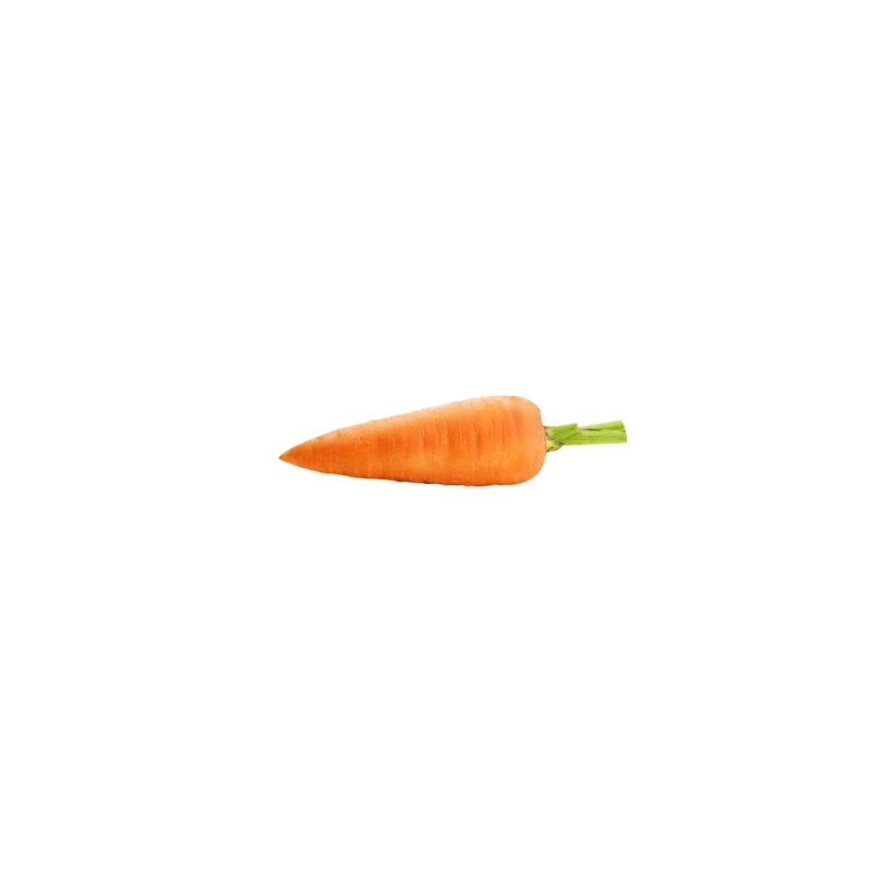 | 4.25 (1.16) | 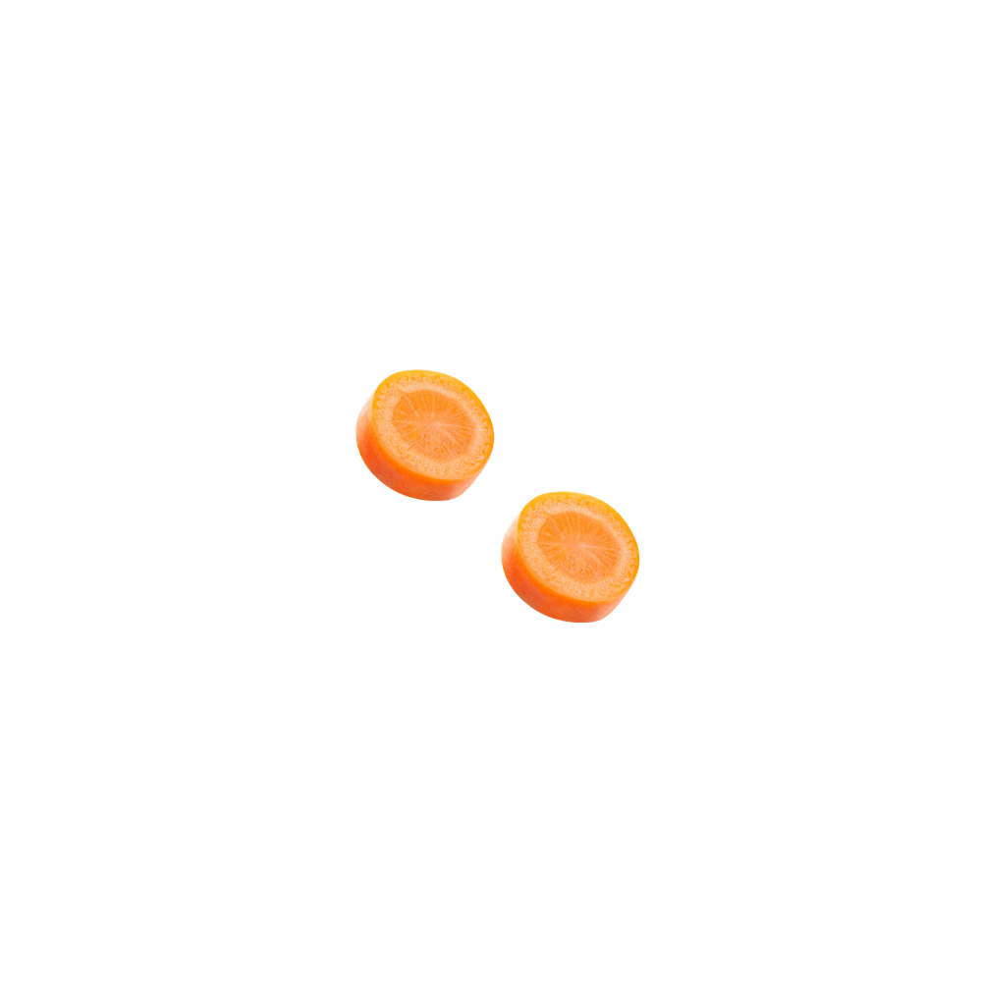 | 1.30 (0.47) | 2.95 | < .001
胡萝卜 (Carrot) | 他看到汤里有胡萝卜。  (He saw the carrot in the soup. ) |  | 3.81 (1.17) |  | 1.59 (0.80) | 2.22 | < .001
猕猴桃 (Kiwifruit) | 他看到袋子里有猕猴桃。  (He saw the kiwifruit in the bag. ) | 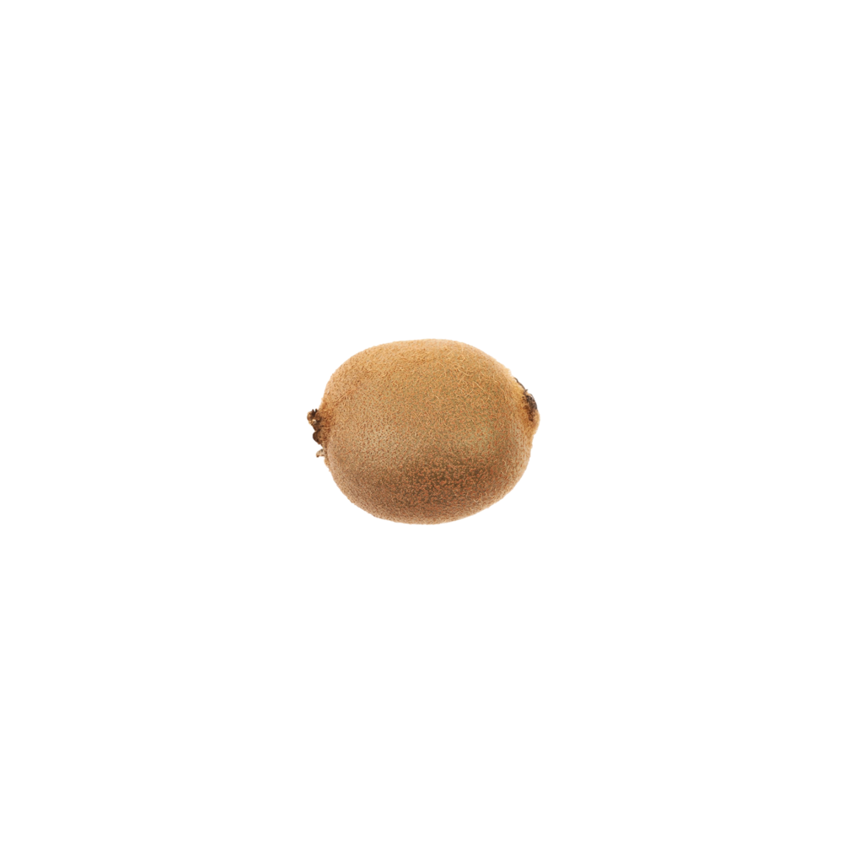 | 4.35 (1.06) | 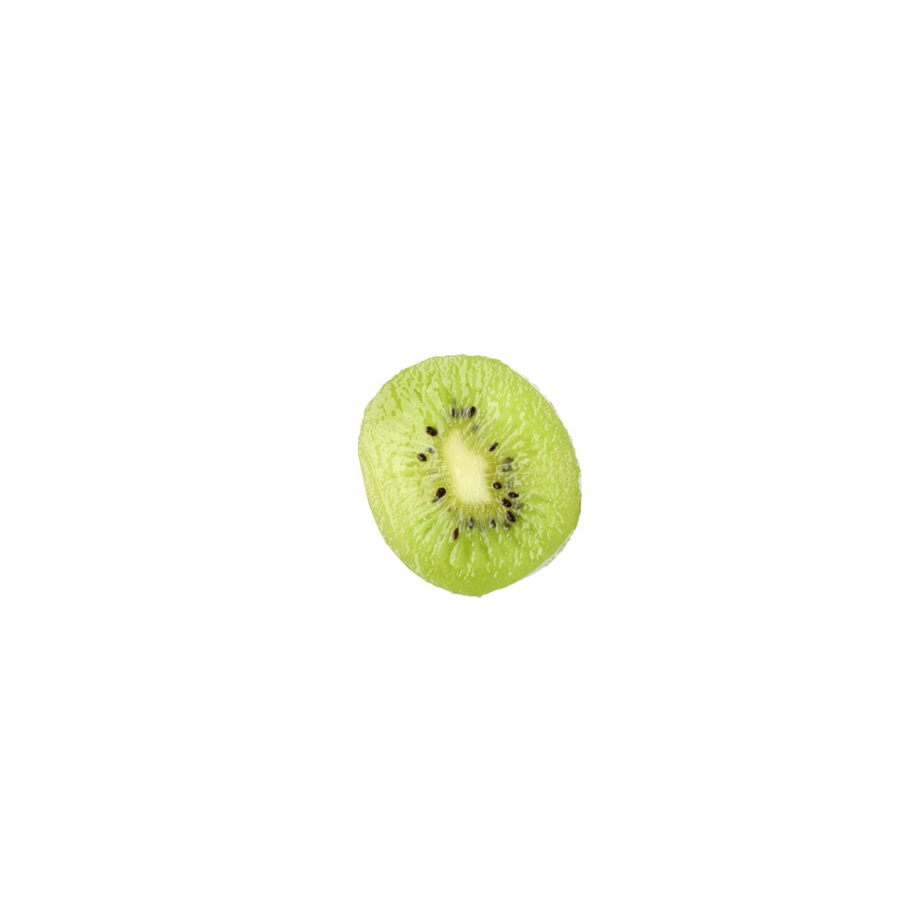 | 1.91 (0.97) | 2.44 | < .001
猕猴桃 (Kiwifruit) | 他看到沙拉里有猕猴桃。  (He saw the kiwifruit in the salad. ) |  | 3.90 (1.37) |  | 1.15 (0.37) | 2.75 | < .001
西兰花 (Broccoli) | 他看到袋子里有西兰花。  (He saw the broccoli in the bag. ) | 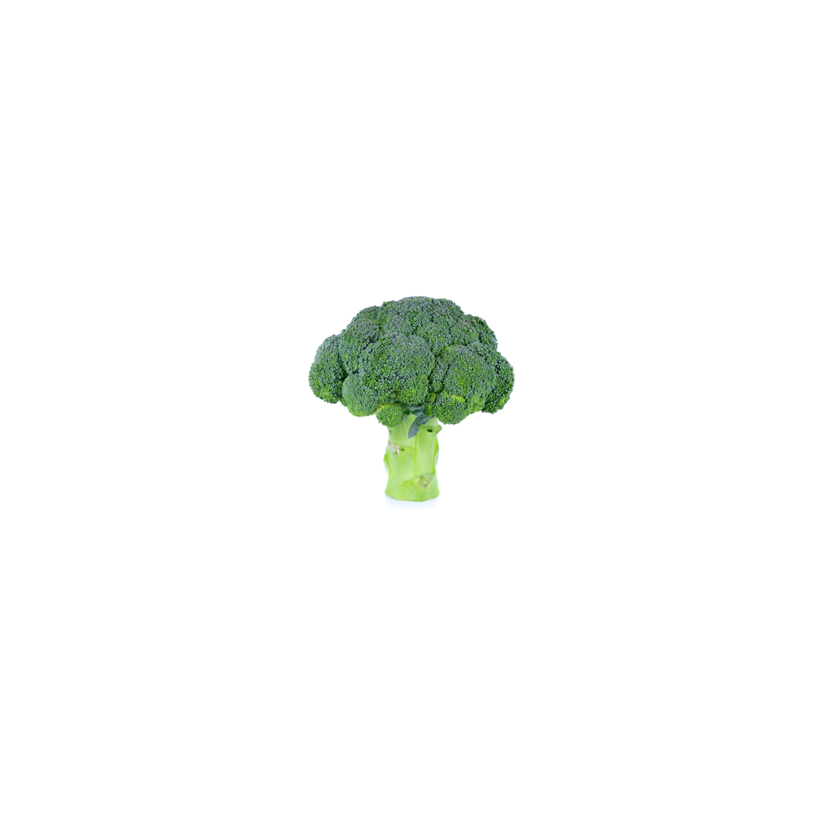 | 4.30 (0.80) | 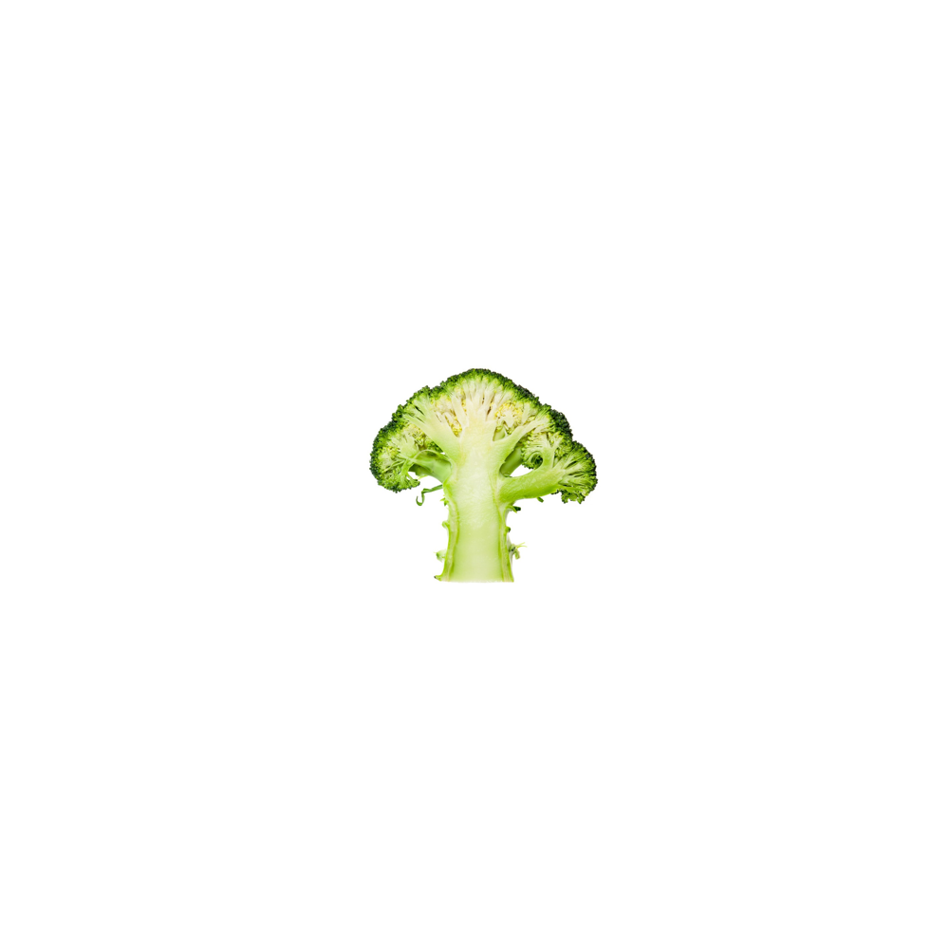 | 2.69 (1.41) | 1.61 | < .001
西兰花 (Broccoli) | 他看到沙拉里有西兰花。  (He saw the broccoli in the salad. ) |  | 4.05 (1.21) |  | 2.10 (1.37) | 1.95 | < .001
Note. Congruency ratings were made on a 1-5 scale. For broccoli 32a, the rating questionnaire used 篮子 (basket), whereas the final experiment used 袋子 (bag); the corresponding questionnaire rating is reported here.

