Table A2. Picture typicality ratings.
Item | Picture a | Mean (SD) | Picture b | Mean (SD) | Mean a – Mean b | Holm p
苹果 (Apple) | 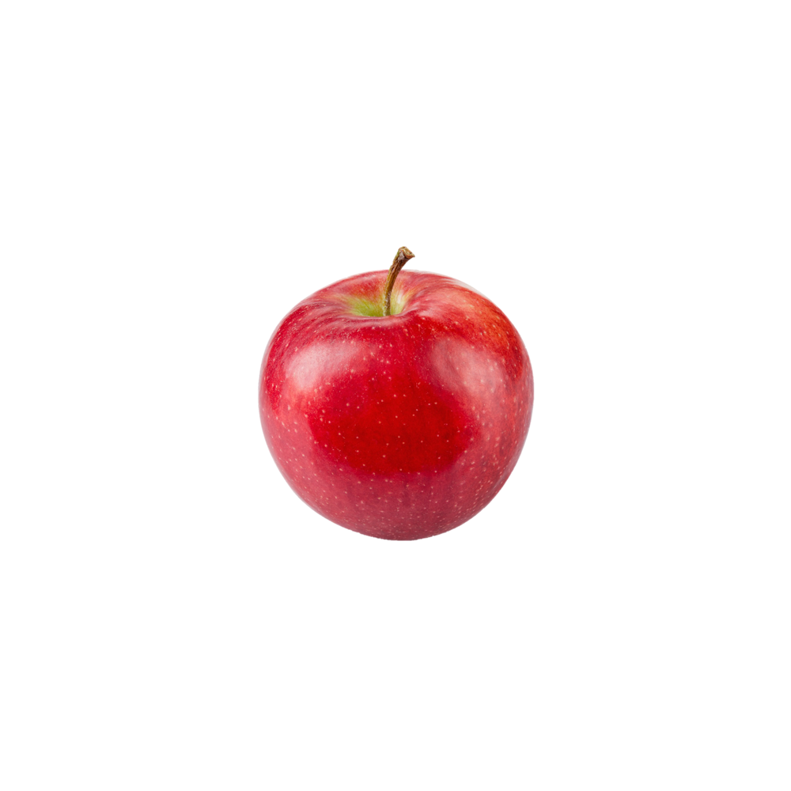 | 6.36 (1.29) | 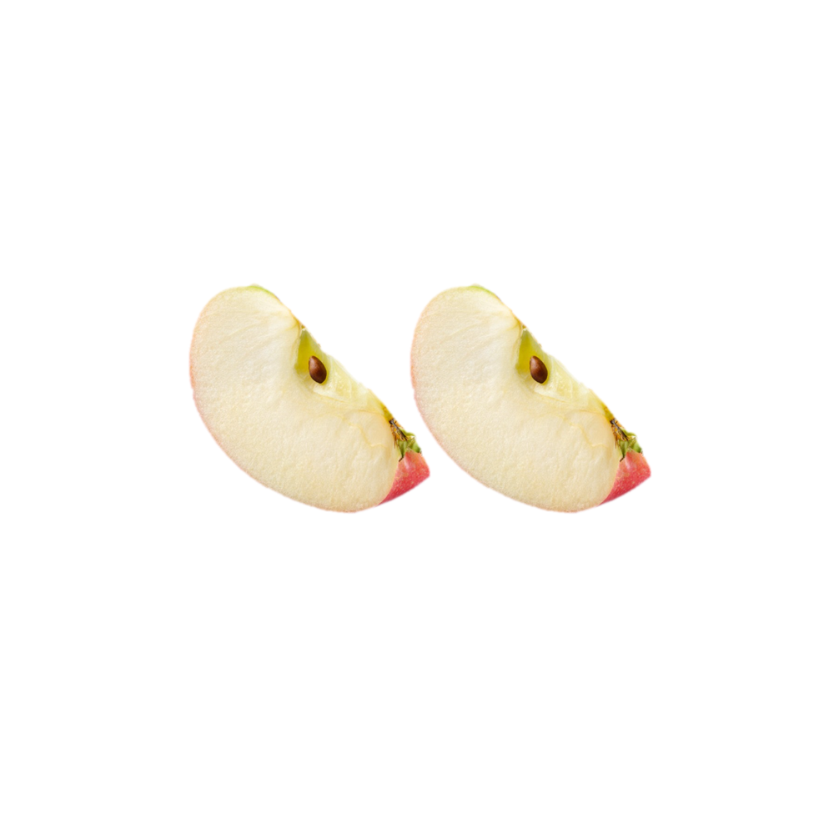 | 4.78 (1.92) | 1.59 | 0.747
柠檬 (Lemon) | 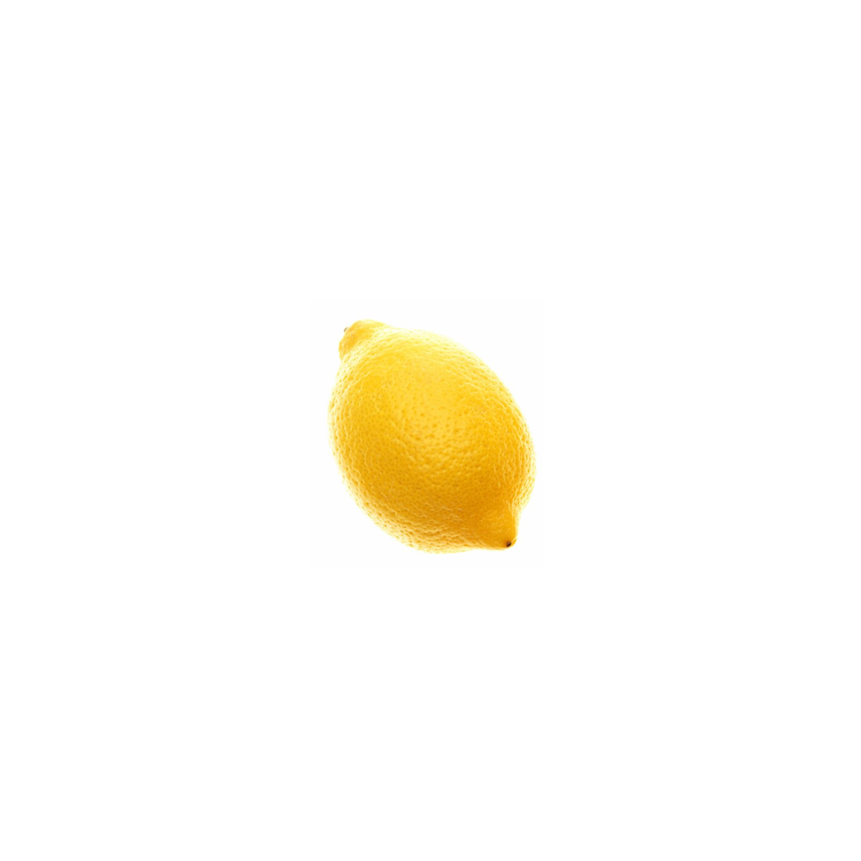 | 6.22 (1.72) | 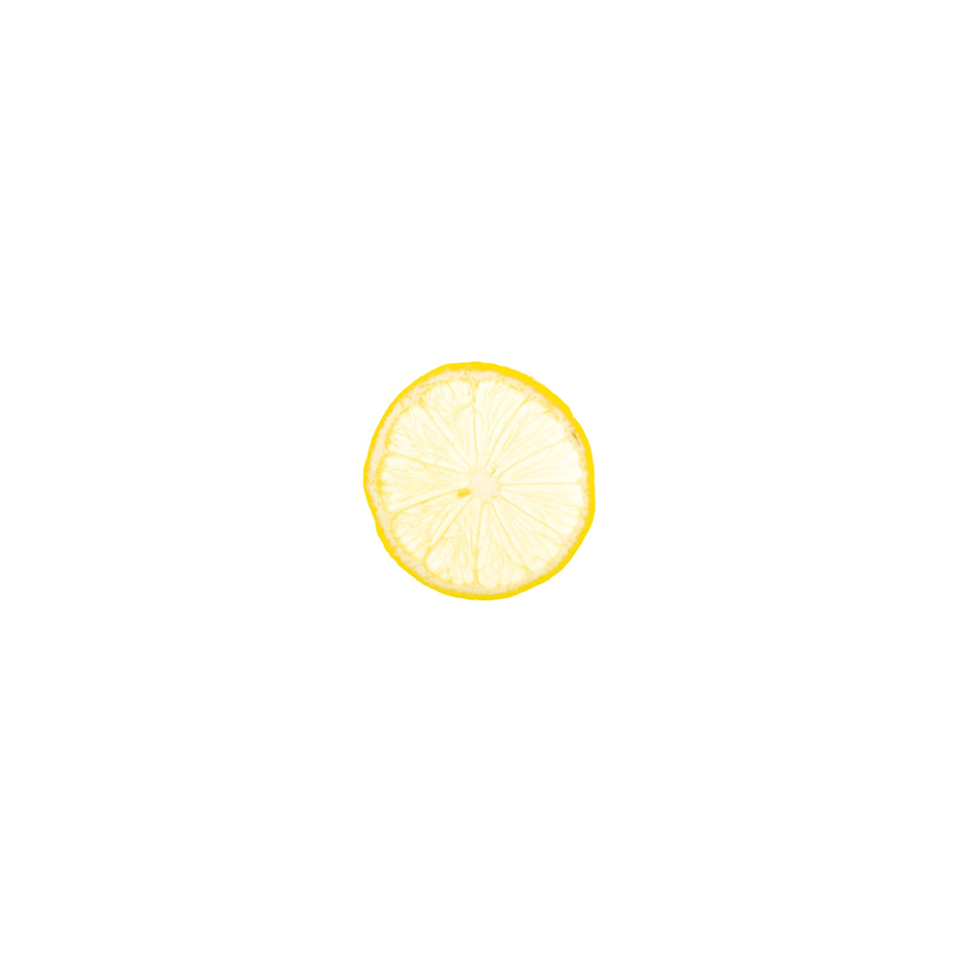 | 5.18 (1.54) | 1.04 | 1.000
桃子 (Peach) | 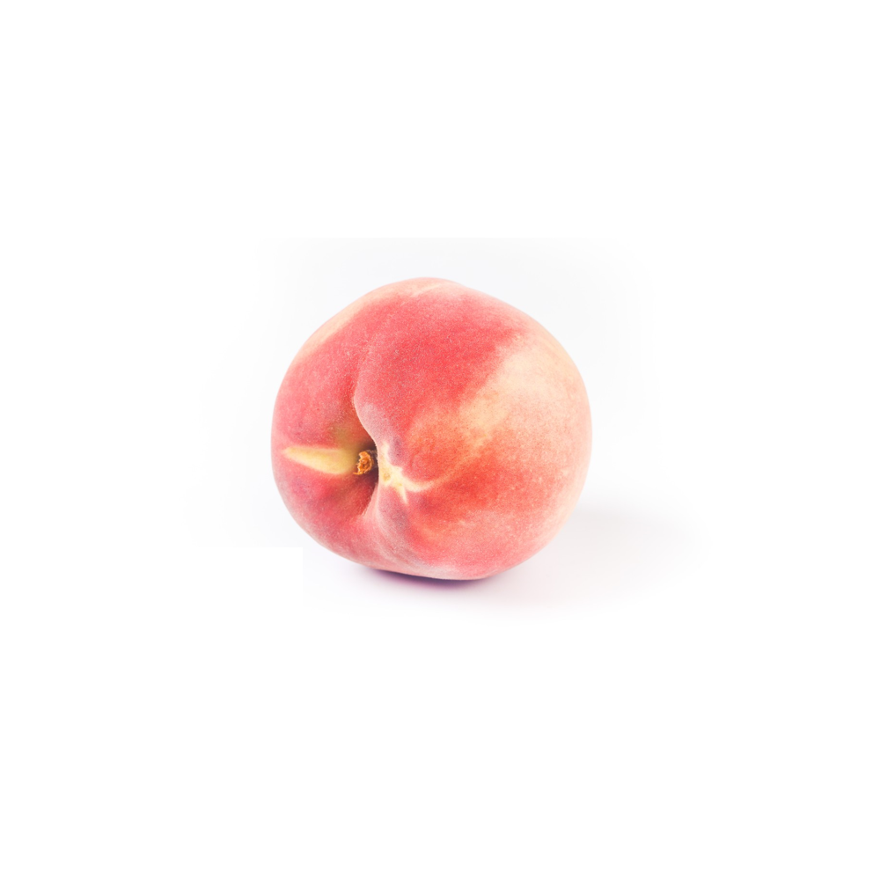 | 5.91 (1.45) | 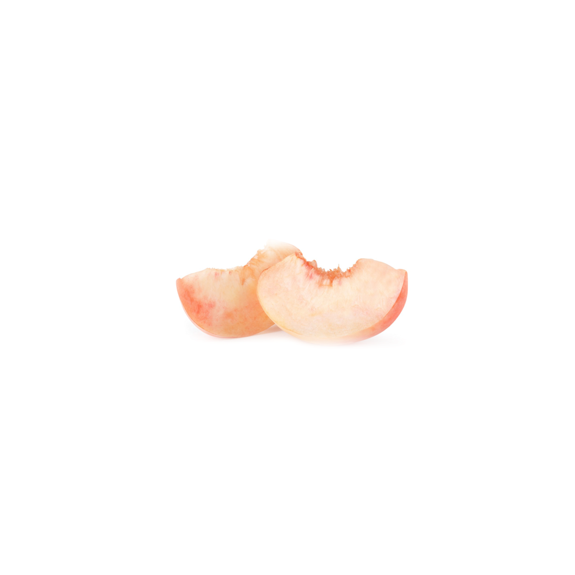 | 5.11 (1.69) | 0.80 | 1.000
香蕉 (Banana) | 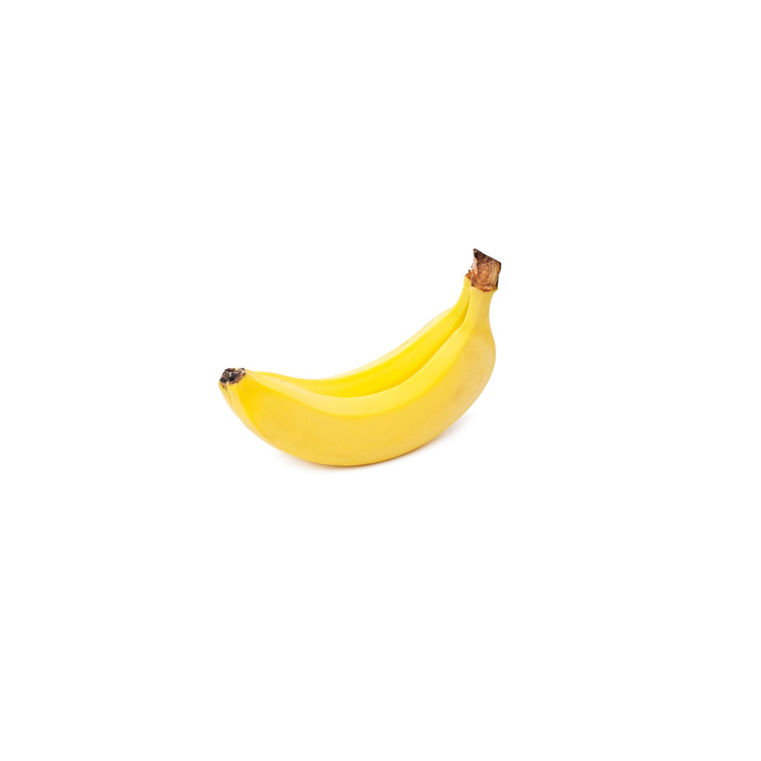 | 6.36 (1.50) | 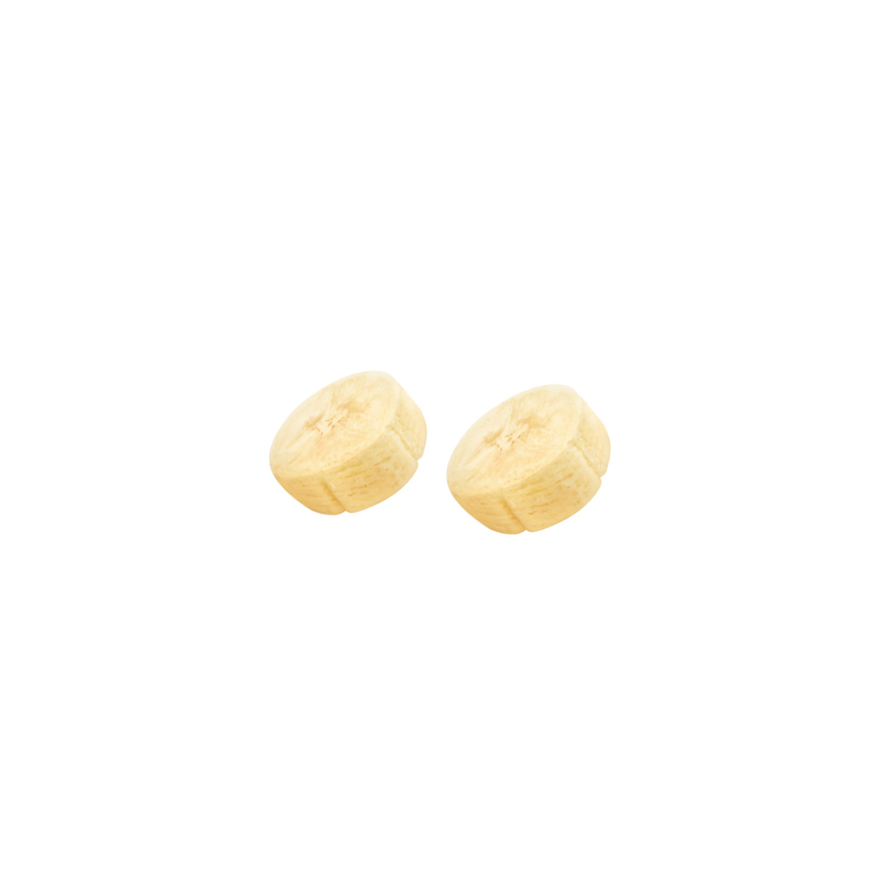 | 4.00 (1.58) | 2.36 | 0.063
鸡蛋 (Egg) | 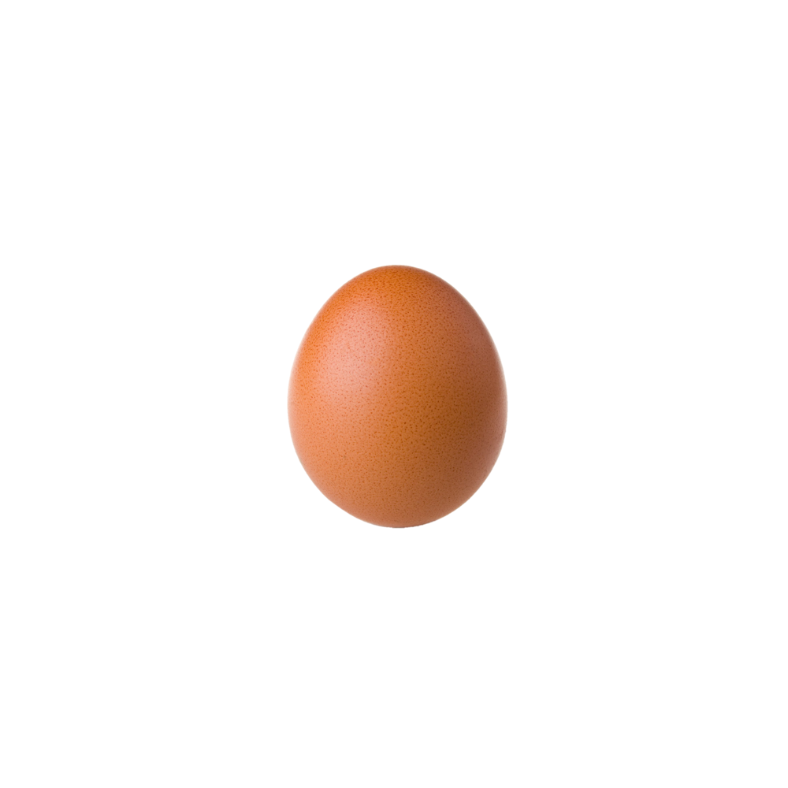 | 6.56 (1.01) | 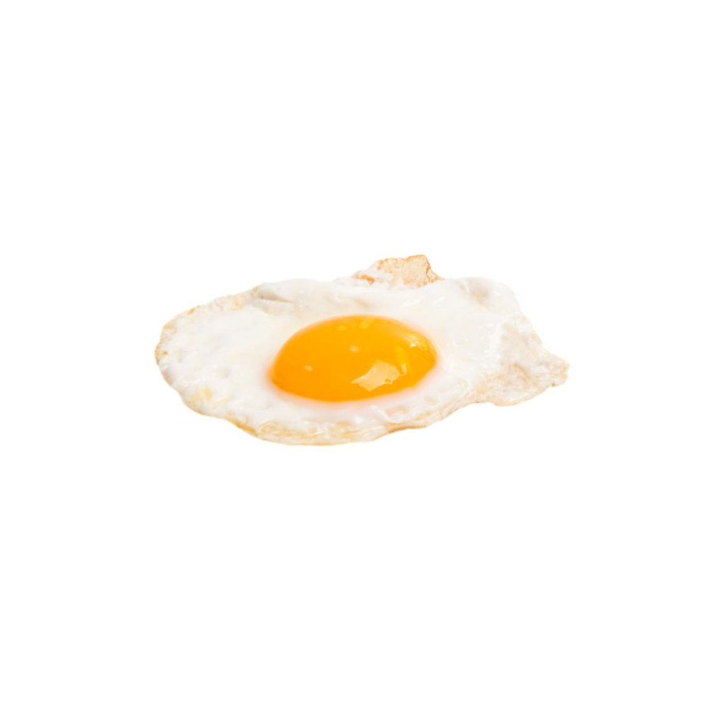 | 5.82 (1.08) | 0.74 | 1.000
菠萝 (Pineapple) | 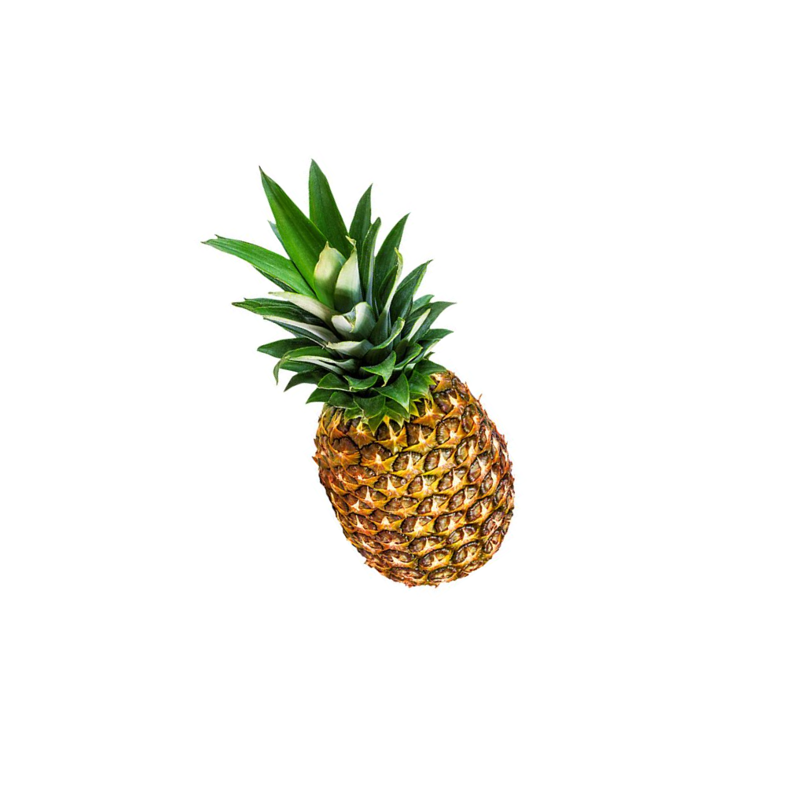 | 6.55 (1.21) | 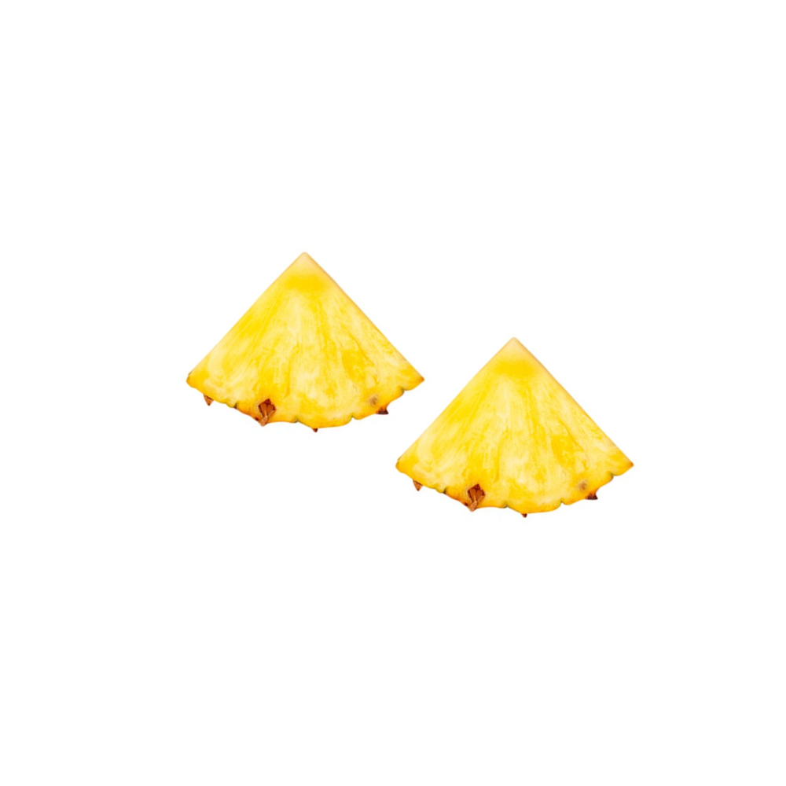 | 4.89 (1.45) | 1.66 | 0.226
草莓 (Strawberry) |  | 6.22 (1.39) | 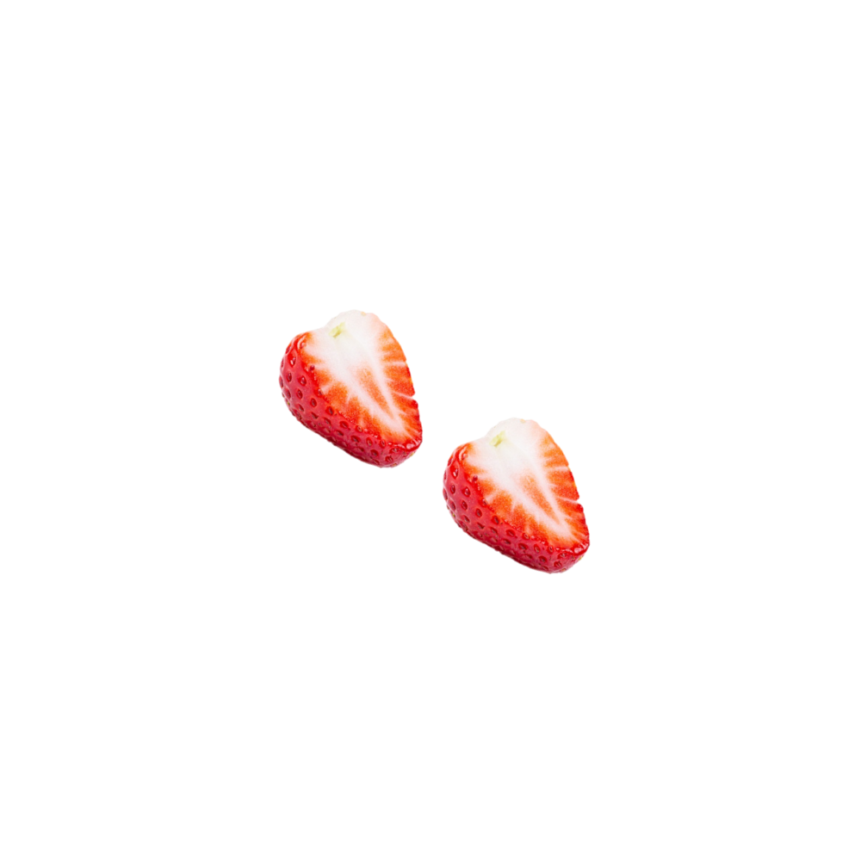 | 5.36 (1.29) | 0.86 | 1.000
西红柿 (Tomato) | 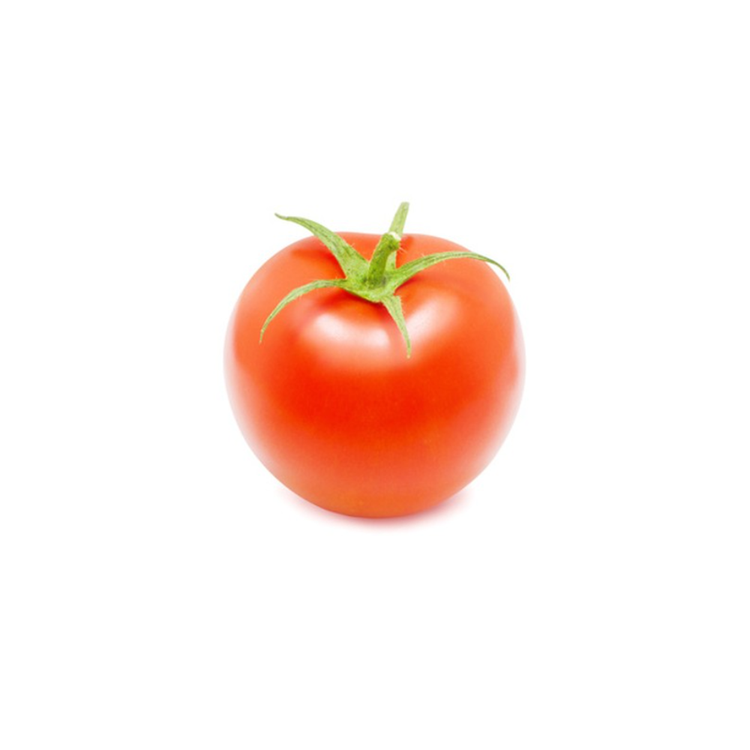 | 6.00 (1.67) | 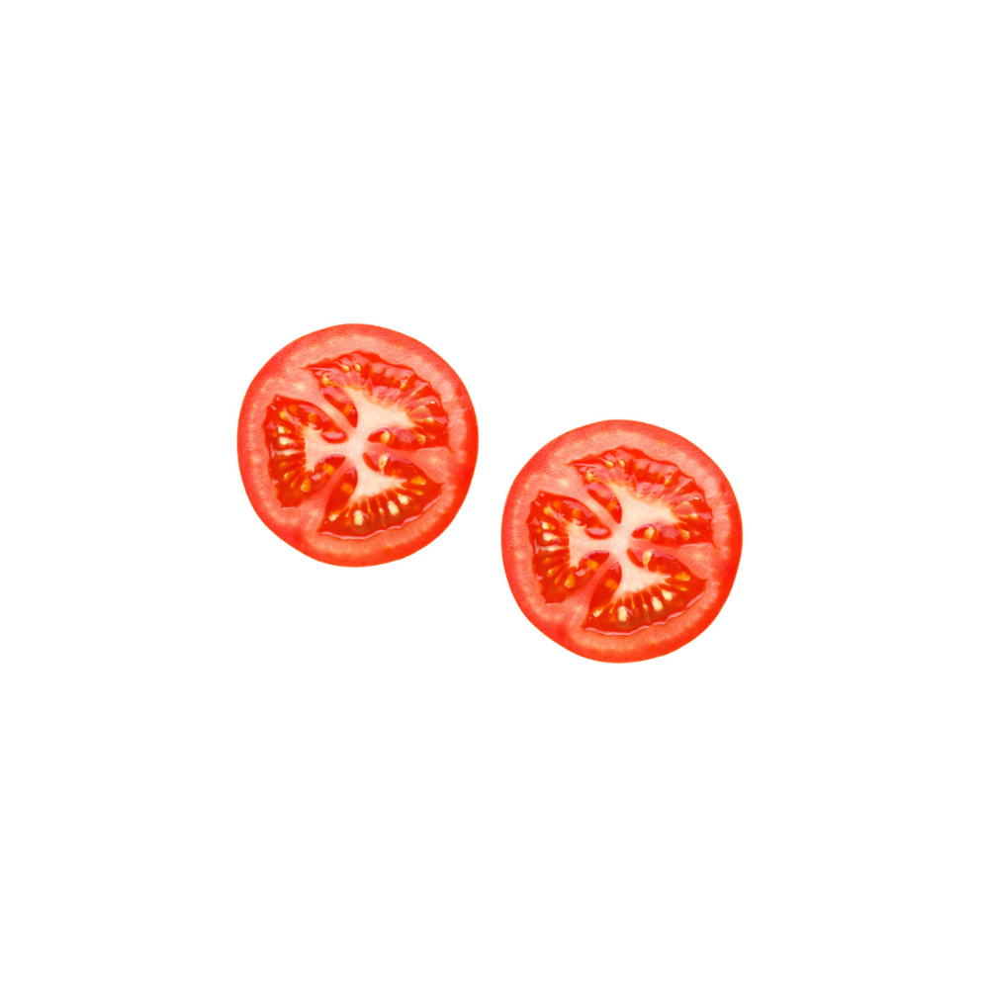 | 5.44 (1.81) | 0.56 | 1.000
玉米 (Corn) | 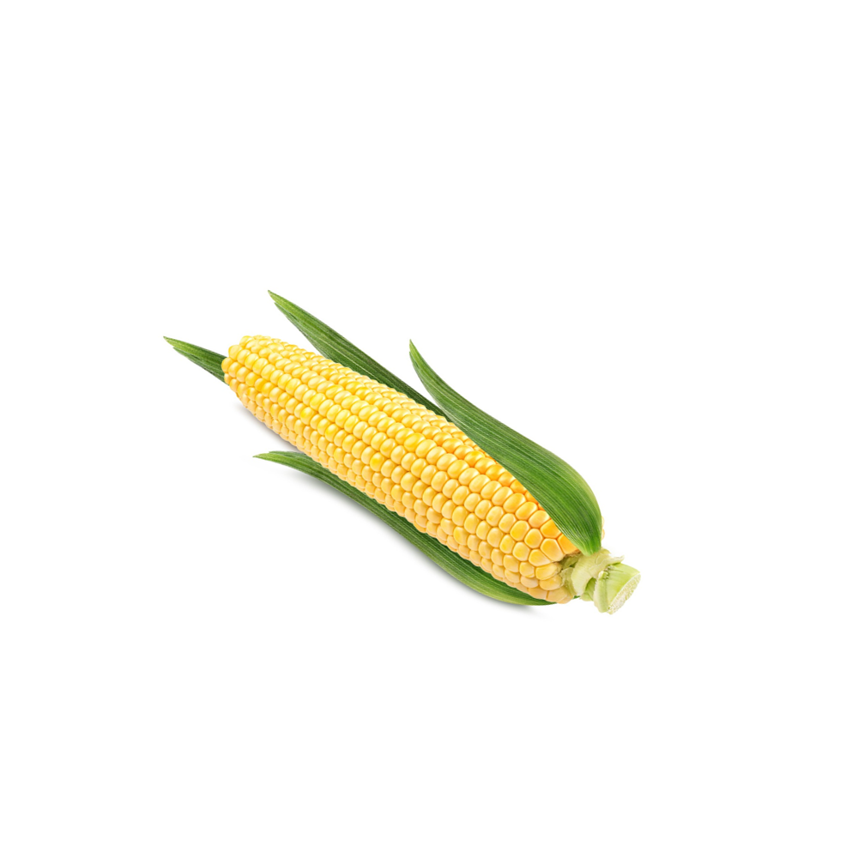 | 6.56 (1.01) | 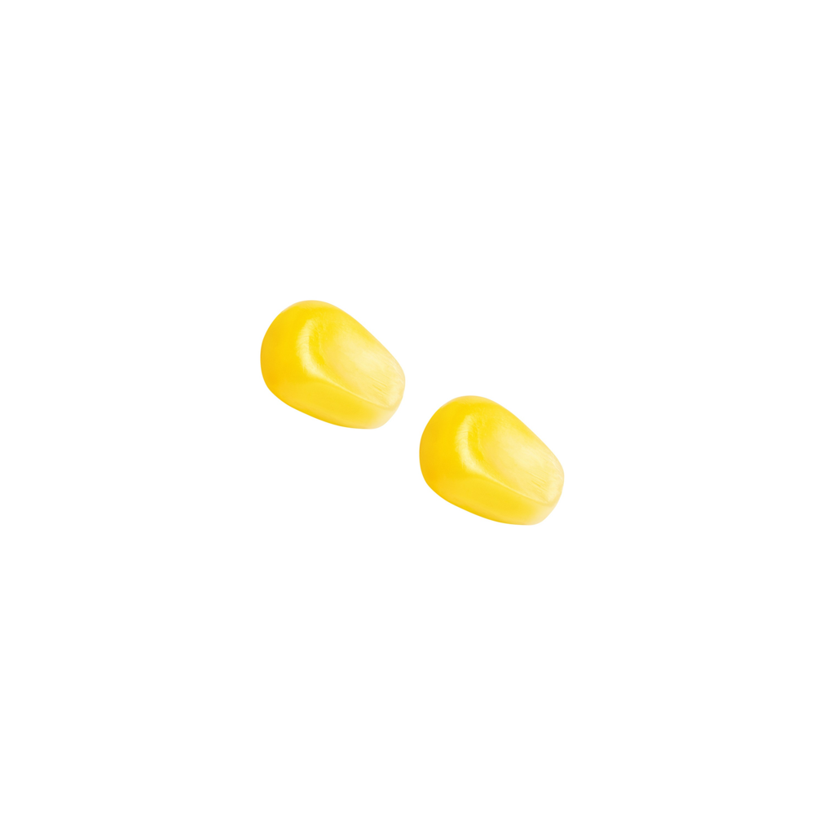 | 3.91 (1.45) | 2.65 | 0.003
黄瓜 (Cucumber) | 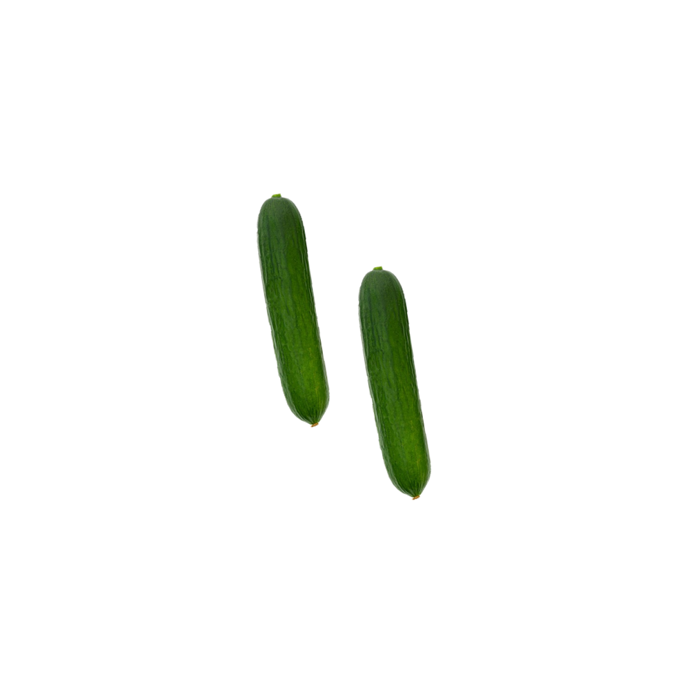 | 5.55 (1.57) | 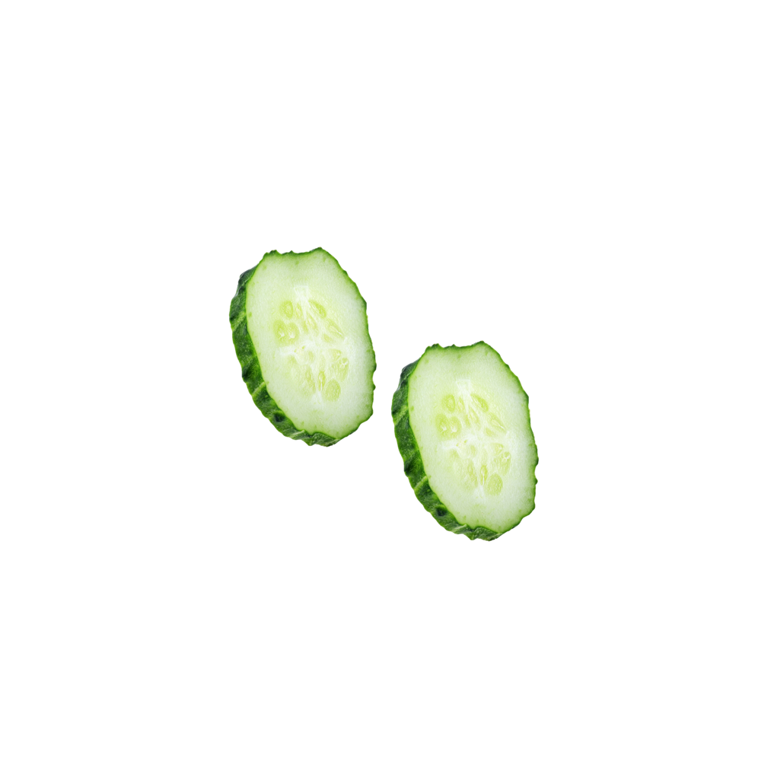 | 4.67 (1.94) | 0.88 | 1.000
土豆(Potato) | 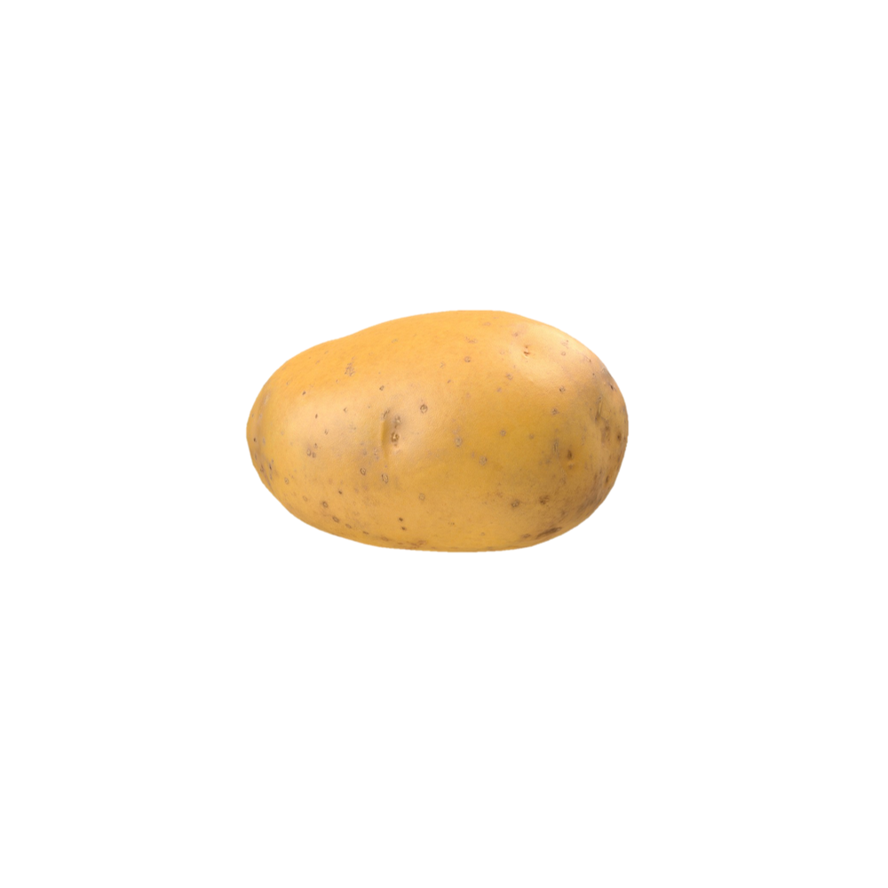 | 6.22 (1.09) |  | 3.09 (1.81) | 3.13 | 0.004
莲藕 (Lotus root) | 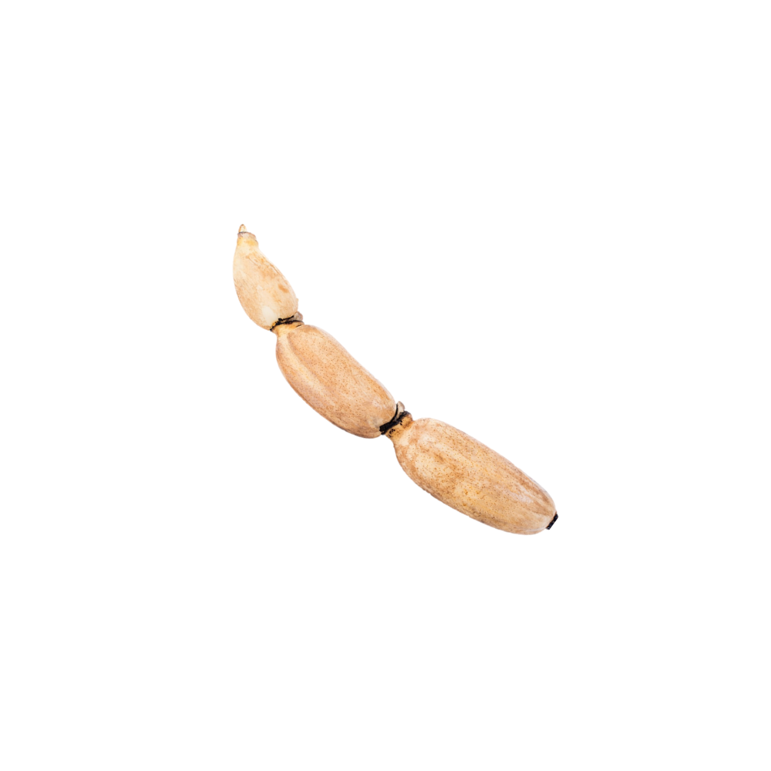 | 6.22 (1.30) | 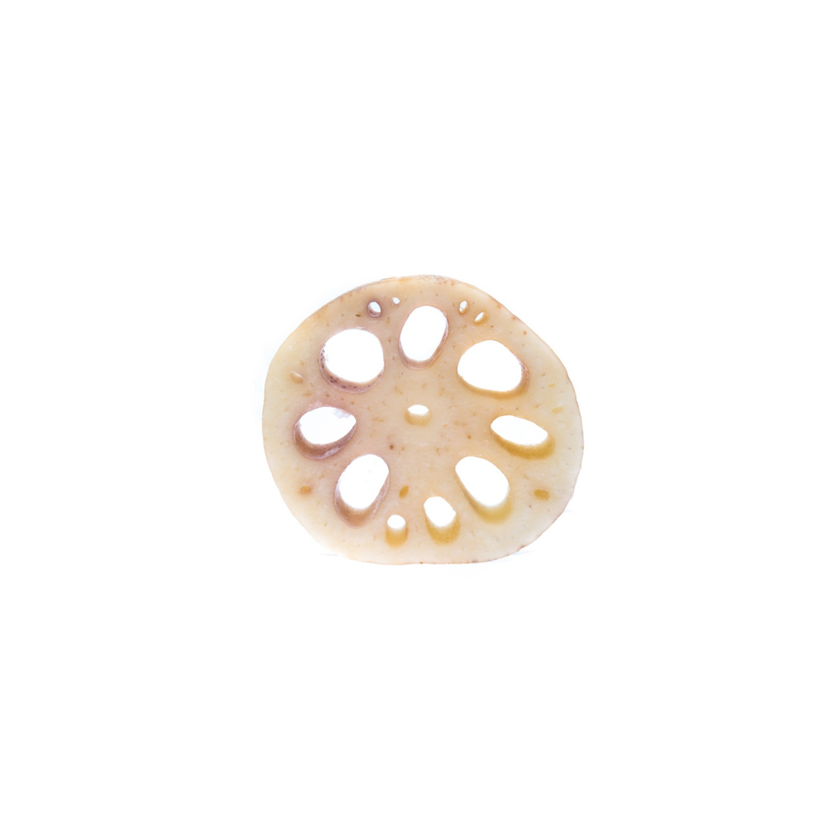 | 5.27 (2.10) | 0.95 | 1.000
辣椒 (Chili pepper) | 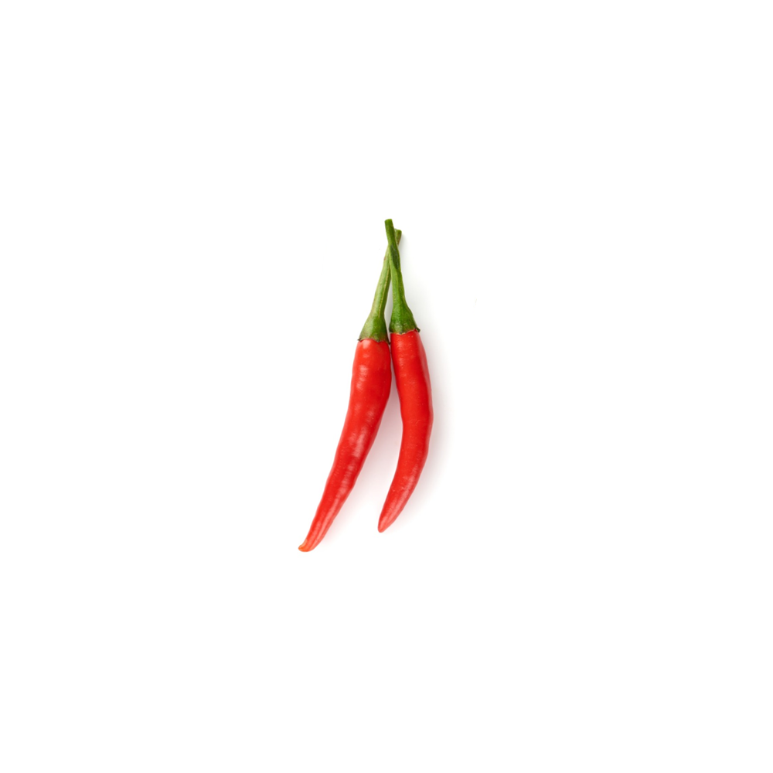 | 6.27 (1.49) | 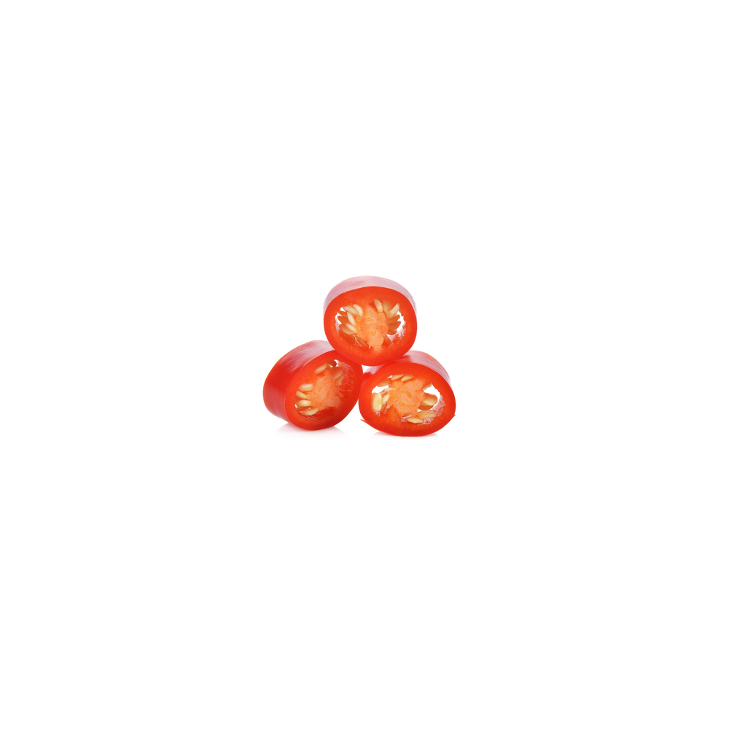 | 3.44 (2.01) | 2.83 | 0.063
洋葱 (Onion) | 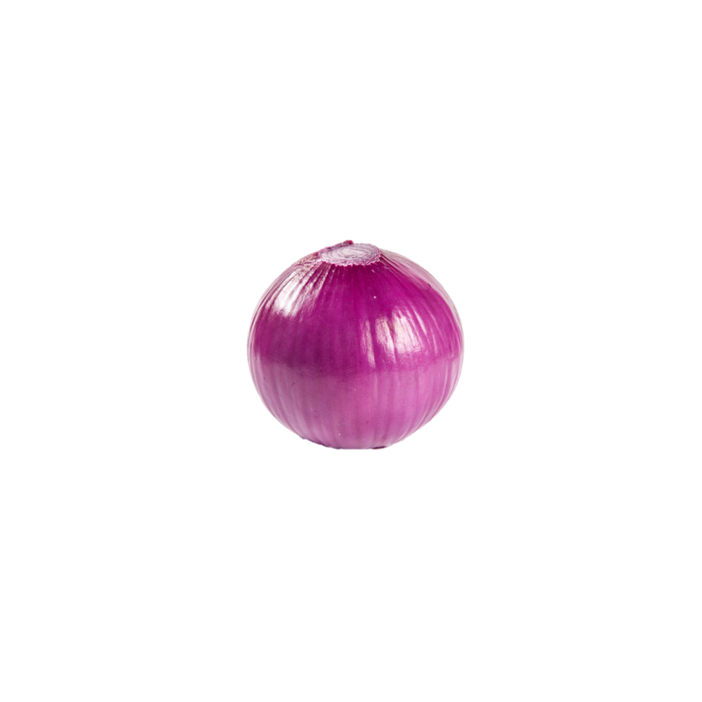 | 6.11 (1.36) | 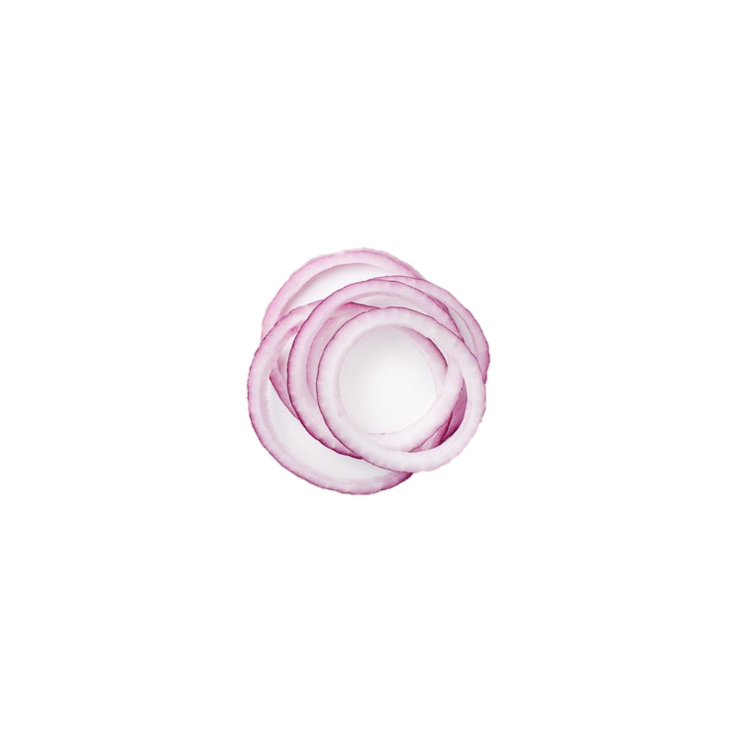 | 4.64 (2.01) | 1.47 | 0.818
花生 (Peanut) | 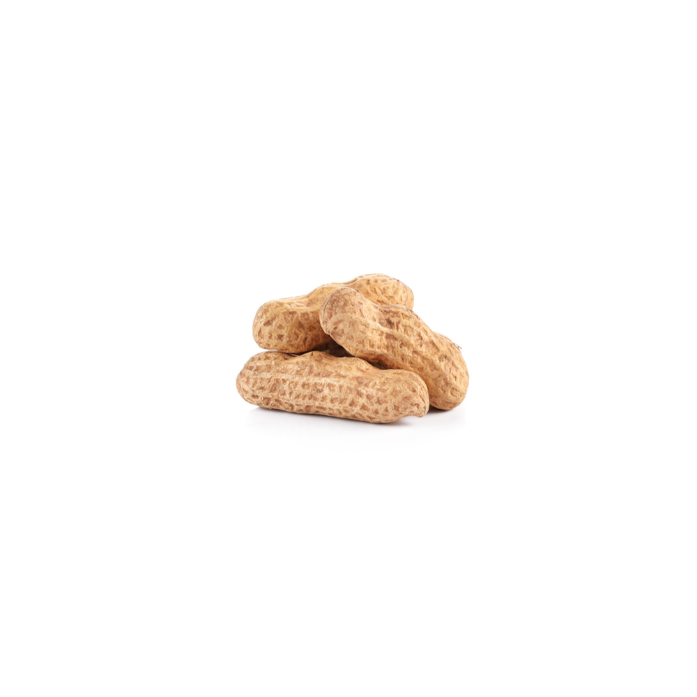 | 6.22 (1.09) | 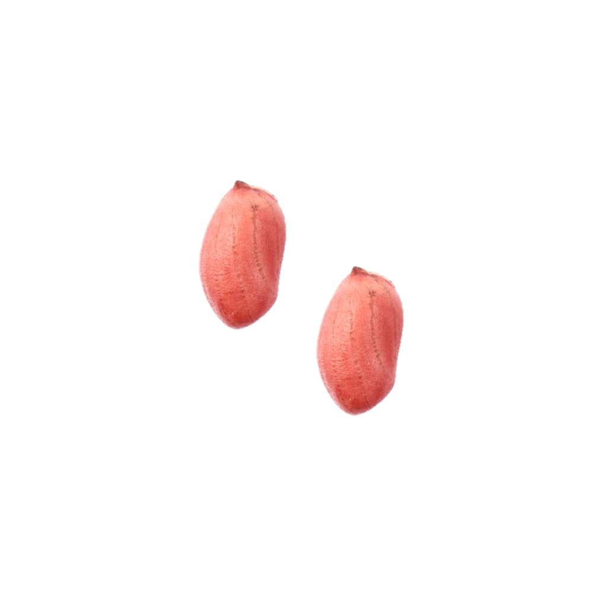 | 4.00 (2.19) | 2.22 | 0.158
蝙蝠 (Bat) | 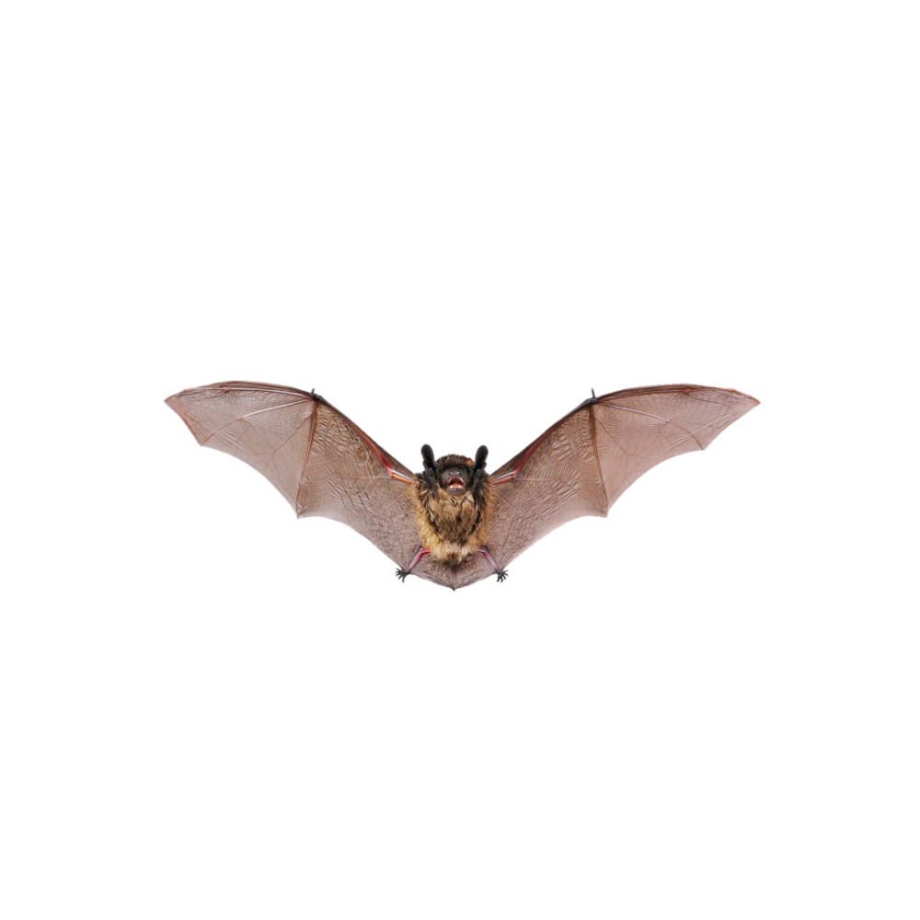 | 6.18 (1.54) | 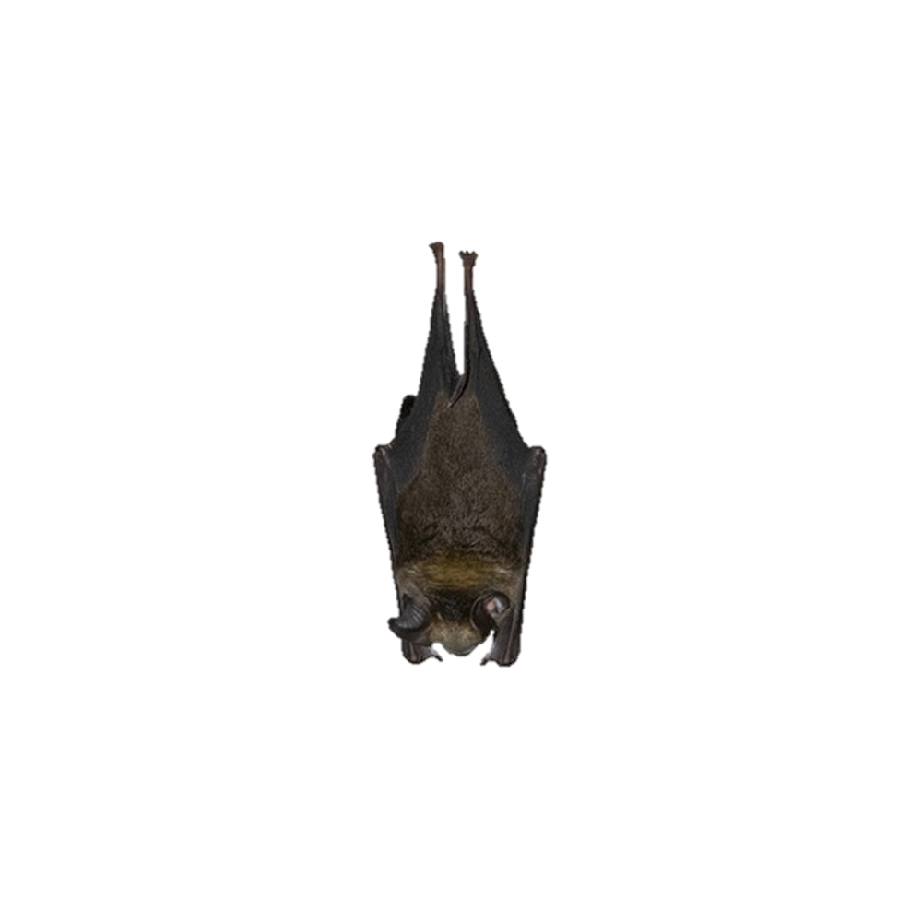 | 5.89 (1.36) | 0.29 | 1.000
毛线 (Yarn) | 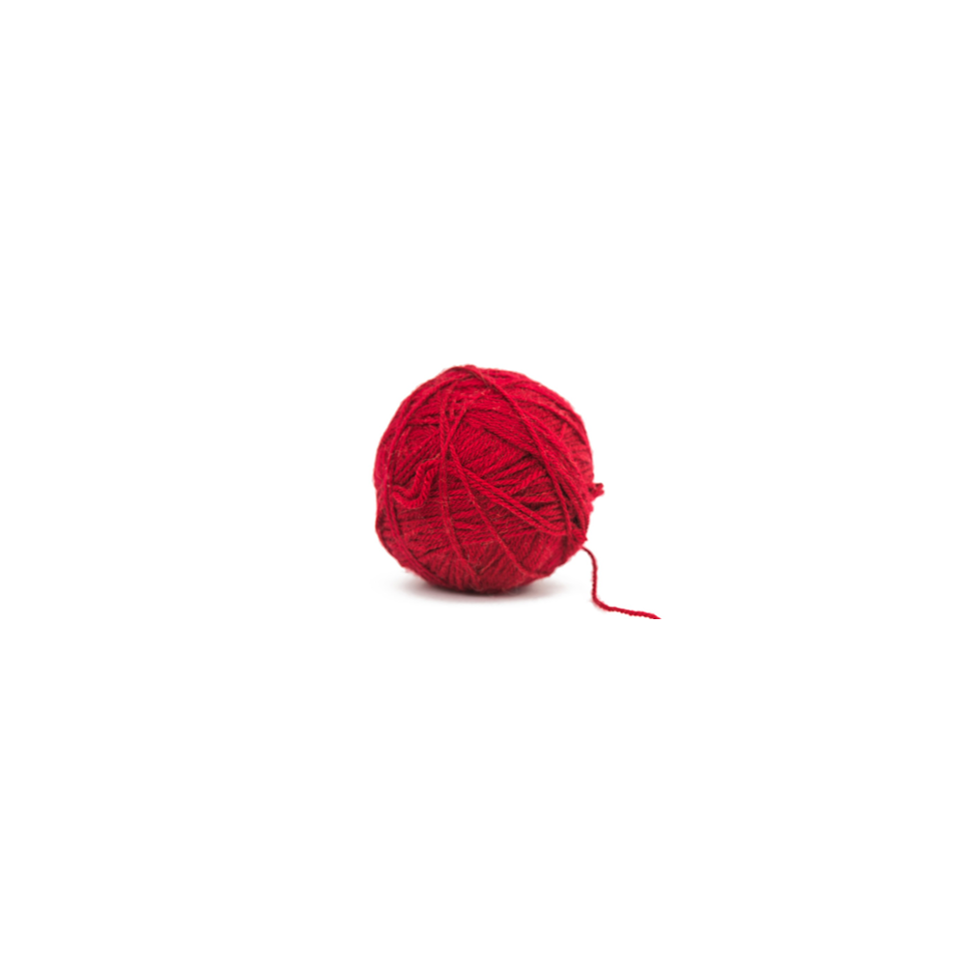 | 6.20 (1.21) |  | 3.27 (1.49) | 2.93 | 0.002
气球 (Balloon) |  | 6.09 (1.70) | 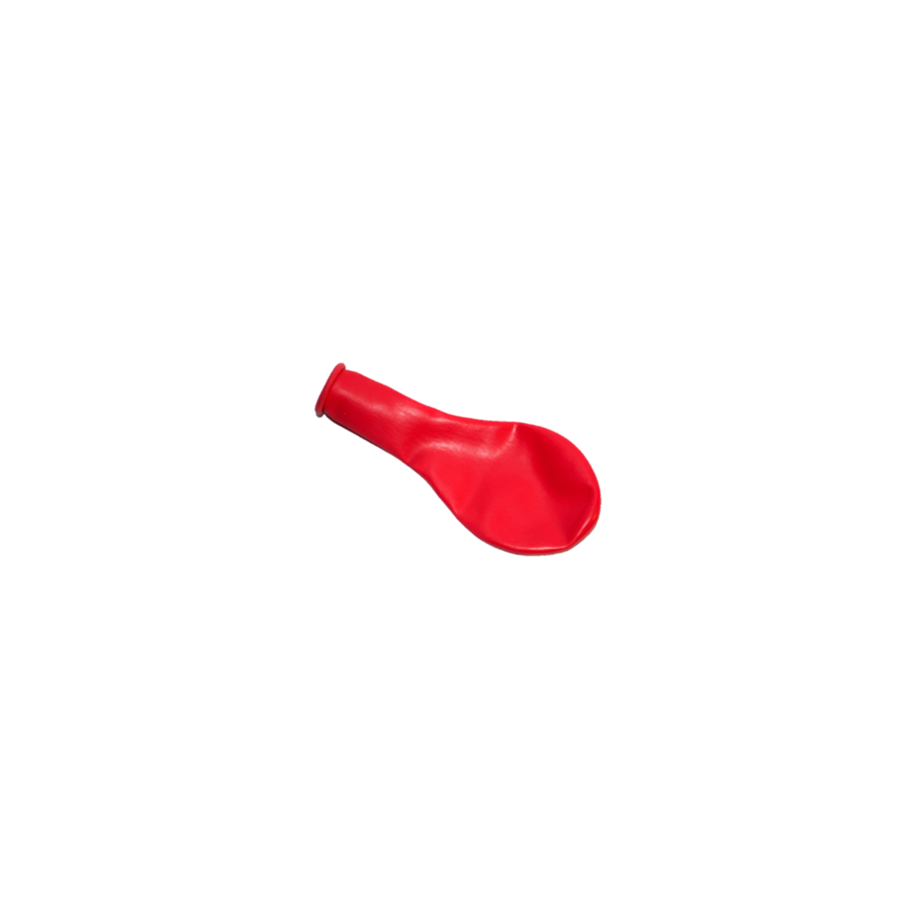 | 4.56 (1.67) | 1.54 | 0.752
香烟 (Cigarette) | 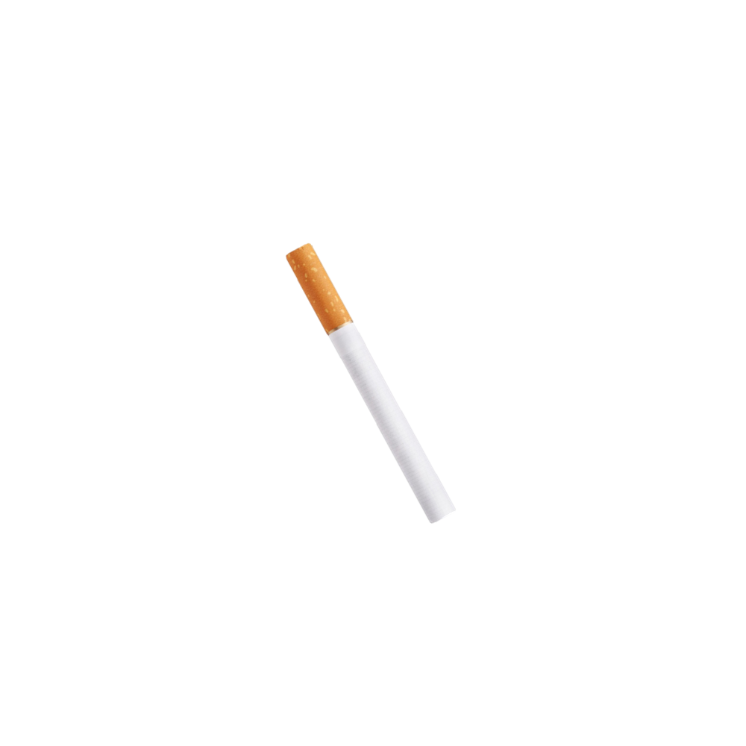 | 6.22 (0.83) | 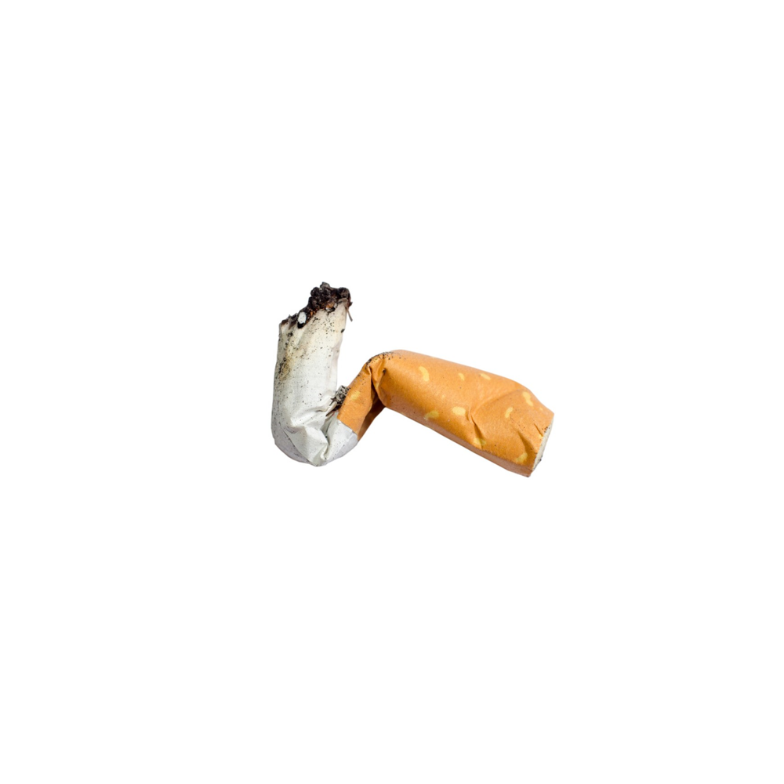 | 3.73 (2.15) | 2.49 | 0.063
纸巾 (Tissue) | 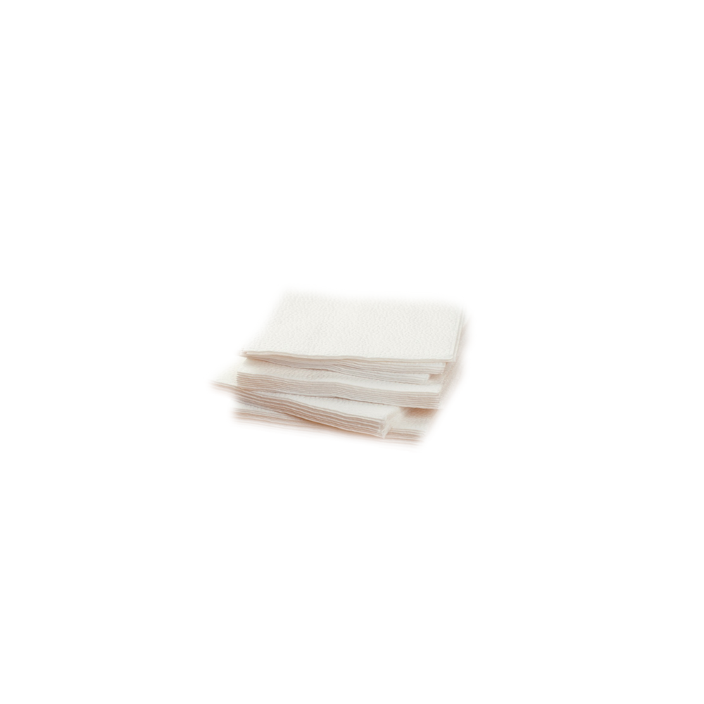 | 4.18 (2.36) | 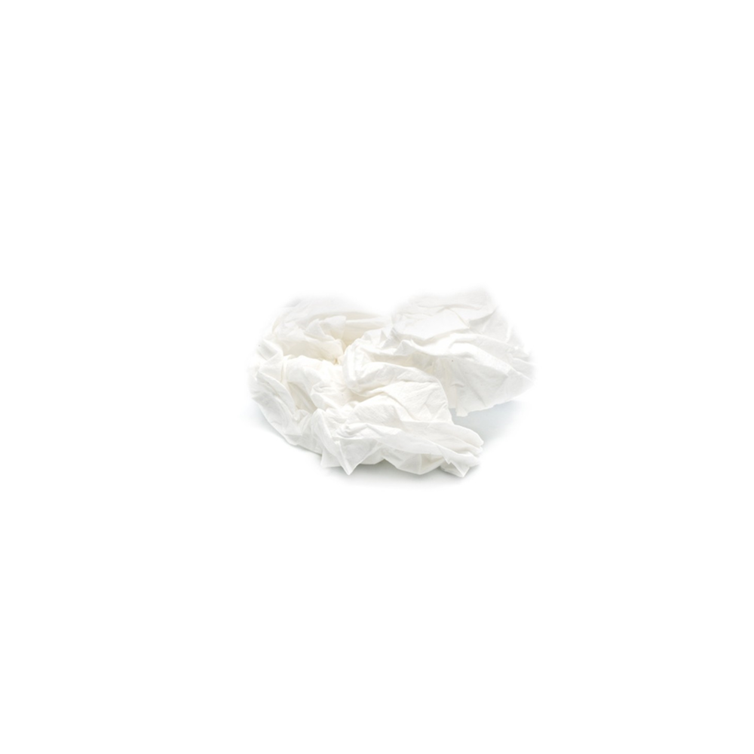 | 3.22 (1.72) | 0.96 | 1.000
蘑菇 (Mushroom) | 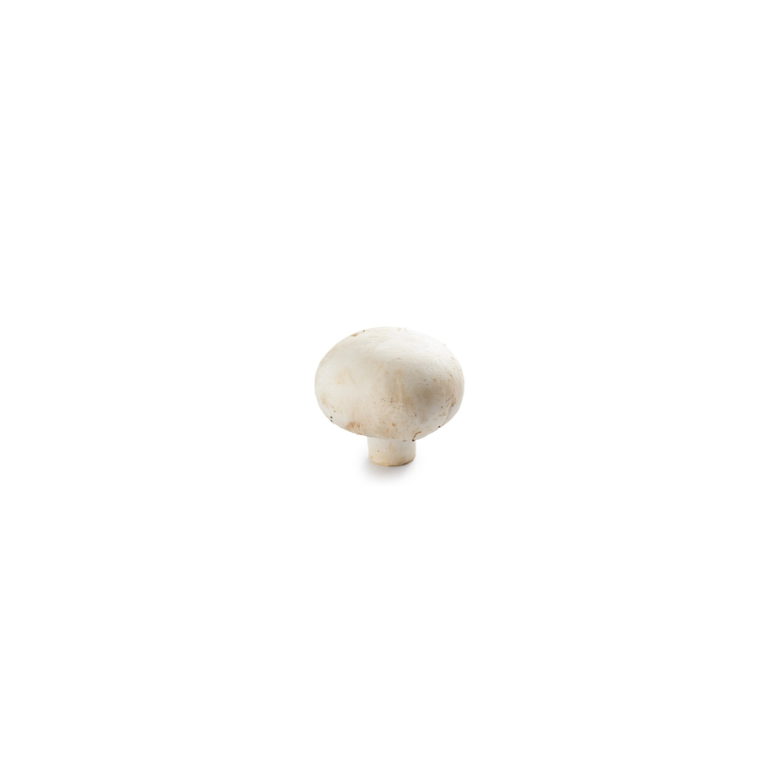 | 5.11 (1.76) | 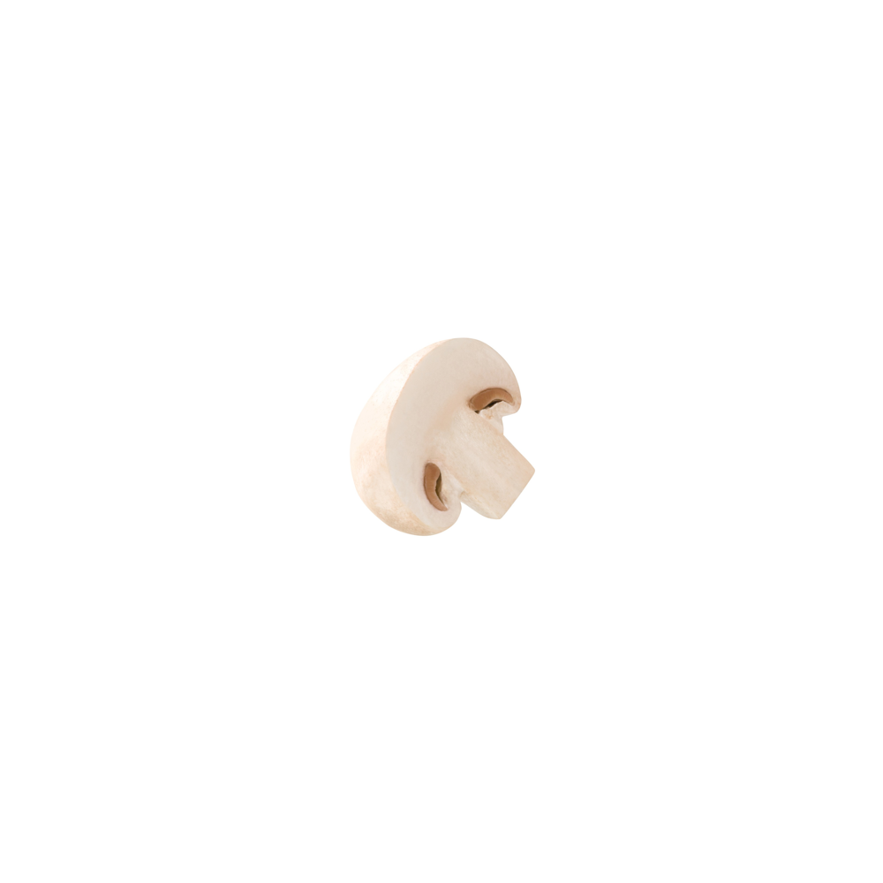 | 4.27 (2.10) | 0.84 | 1.000
胡萝卜 (Carrot) | 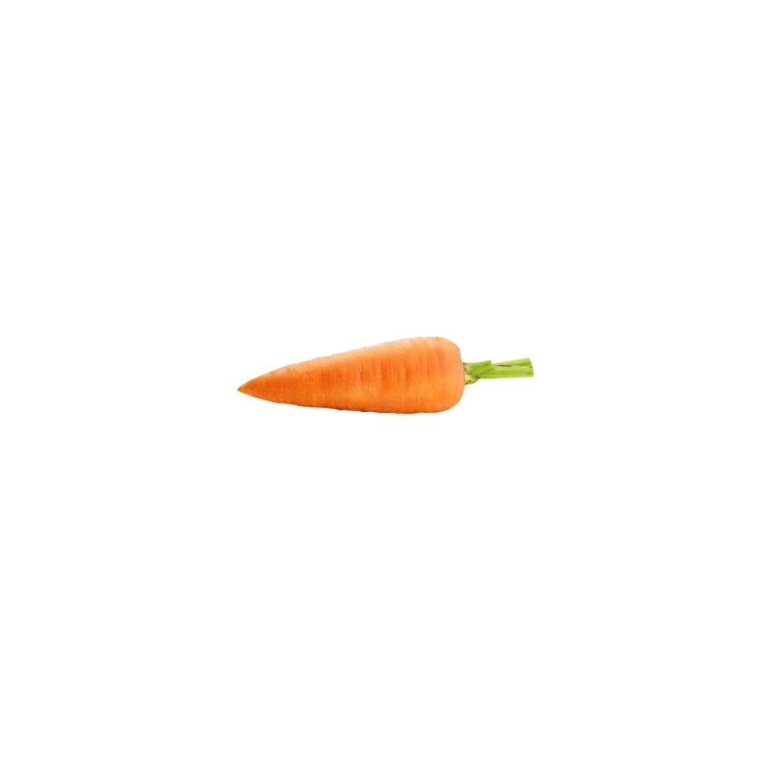 | 7.00 (0.00) | 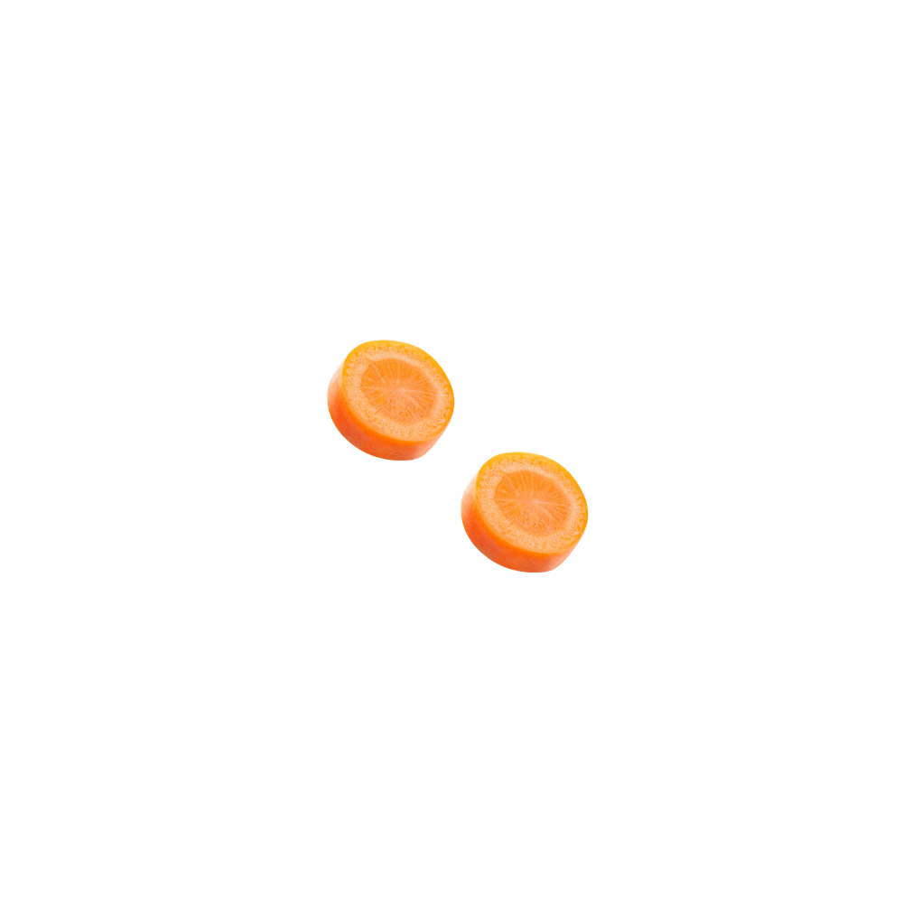 | 2.82 (1.78) | 4.18 | < .001
猕猴桃 (Kiwifruit) | 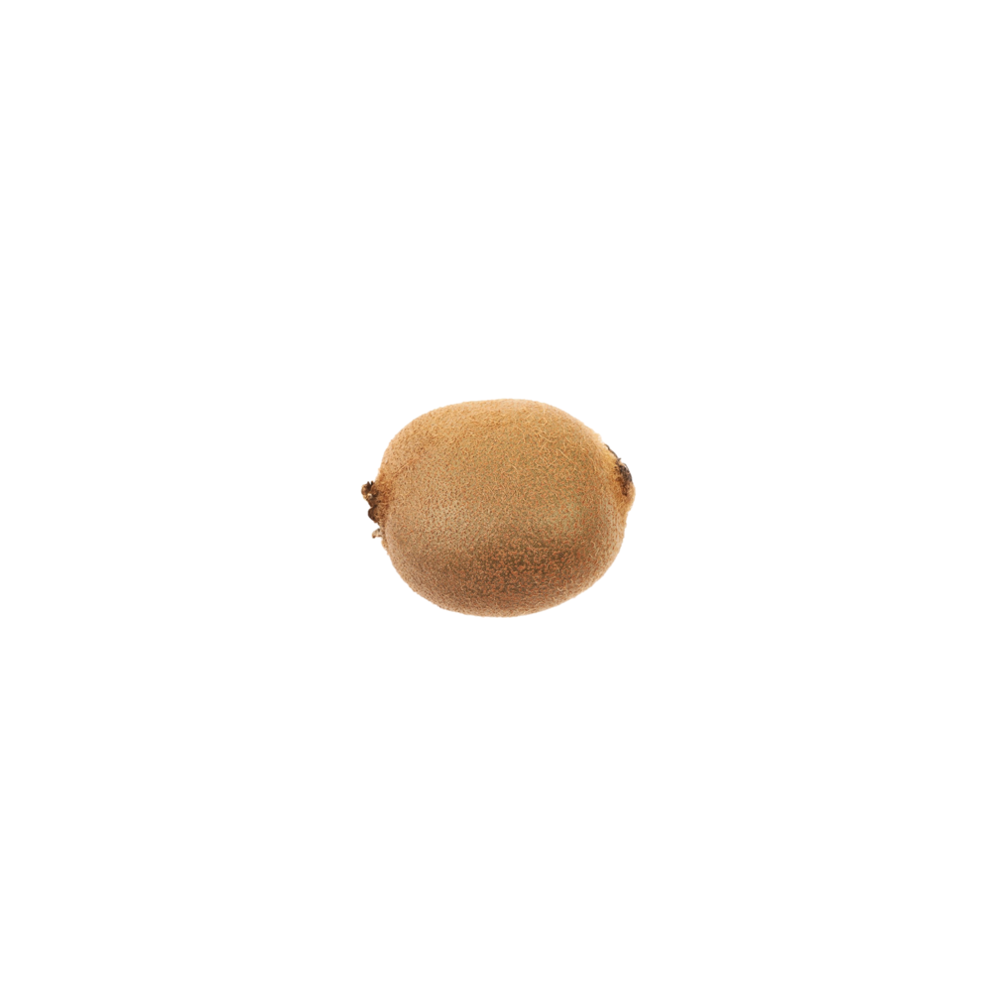 | 5.91 (1.38) | 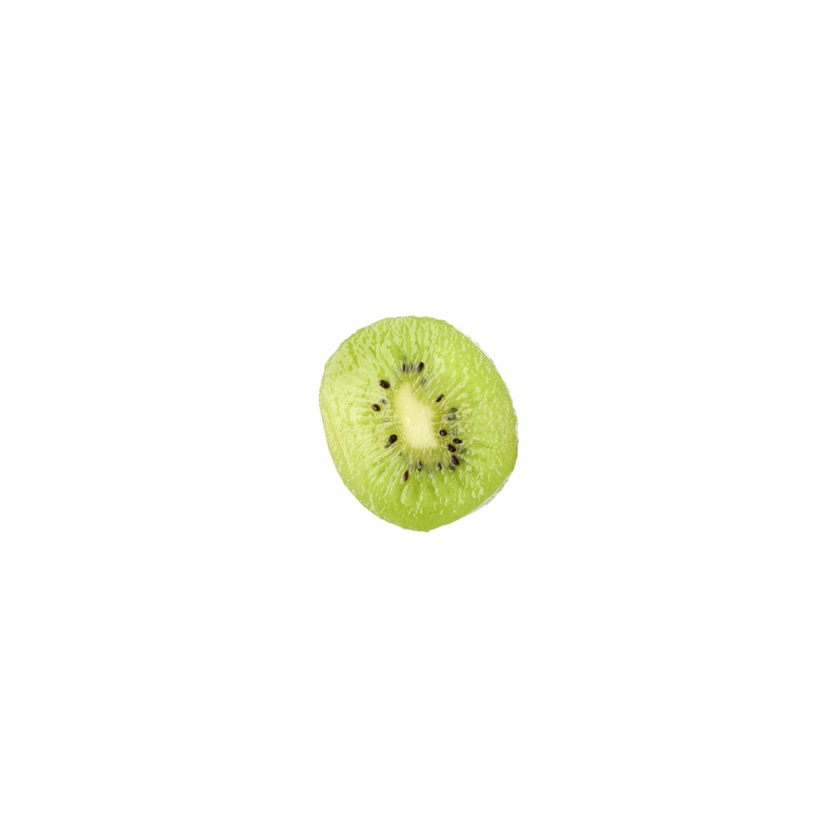 | 4.67 (1.73) | 1.24 | 1.000
西兰花 (Broccoli) | 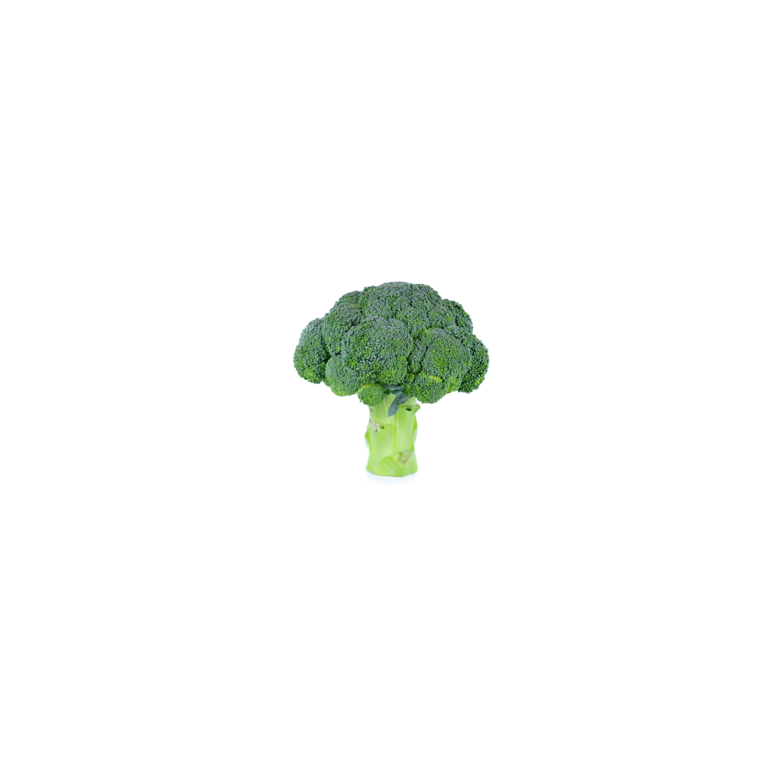 | 6.56 (0.73) | 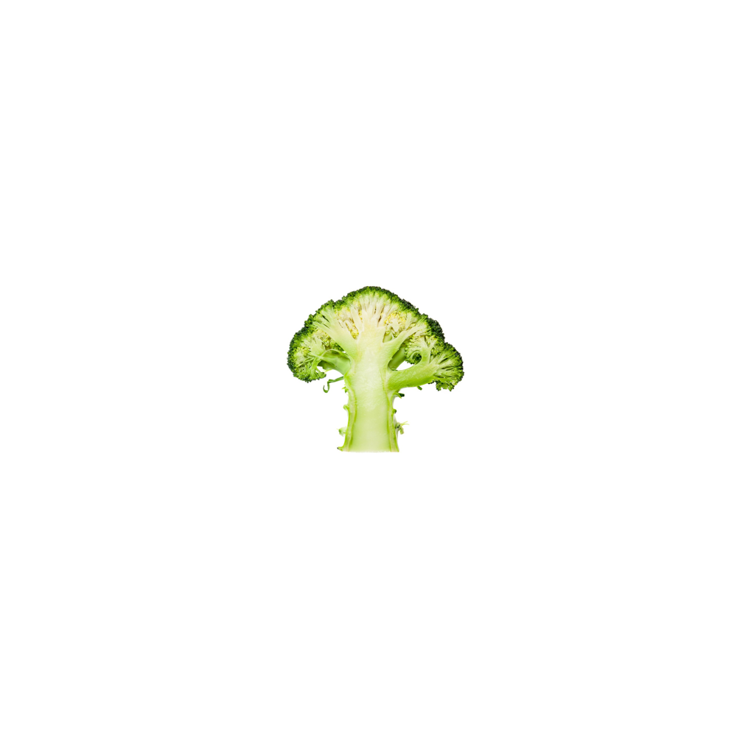 | 3.82 (2.14) | 2.74 | 0.033
Note. Ratings used a 1–7 scale. Holm p values adjust 24 item-wise Welch tests. At the item-mean level, picture a (M = 6.12, SD = 0.55) was rated as more typical than picture b (M = 4.41, SD = 0.88), t(23) = 8.30, p < .001, Cohen's dz = 1.69).

