Assignment 5: Data Visualization
Yimei Du
Fall 2025

OVERVIEW
This exercise accompanies the lessons in Environmental Data Analytics on Data Visualization

Directions
- Rename this file <FirstLast>_A05_DataVisualization.Rmd (replacing <FirstLast> with your first and last name).
- Change “Student Name” on line 3 (above) with your name.
- Work through the steps, creating code and output that fulfill each instruction.
- Be sure your code is tidy; use line breaks to ensure your code fits in the knitted output.
- Be sure to answer the questions in this assignment document.
- When you have completed the assignment, Knit the text and code into a single PDF file.

Set up your session
- Set up your session. Load the tidyverse, here & cowplot packages, and verify your home directory. Read in the NTL-LTER processed data files for nutrients and chemistry/physics for Peter and Paul Lakes (use the tidy NTL-LTER_Lake_Chemistry_Nutrients_PeterPaul_Processed.csv version in the Processed_KEY folder) and the processed data file for the Niwot Ridge litter dataset (use the NEON_NIWO_Litter_mass_trap_Processed.csv version, again from the Processed_KEY folder).
- Make sure R is reading dates as date format; if not change the format to date.
#1
library(tidyverse)
## ── Attaching core tidyverse packages ──────────────────────── tidyverse 2.0.0 ──
## ✔ dplyr 1.1.4 ✔ readr 2.1.5
## ✔ forcats 1.0.0 ✔ stringr 1.5.1
## ✔ ggplot2 4.0.0 ✔ tibble 3.2.1
## ✔ lubridate 1.9.3 ✔ tidyr 1.3.1
## ✔ purrr 1.0.2
## ── Conflicts ────────────────────────────────────────── tidyverse_conflicts() ──
## ✖ dplyr::filter() masks stats::filter()
## ✖ dplyr::lag() masks stats::lag()
## ℹ Use the conflicted package (<http://conflicted.r-lib.org/>) to force all conflicts to become errors
library(cowplot)
##
## Attaching package: 'cowplot'
##
## The following object is masked from 'package:lubridate':
##
## stamp
library(here)
## here() starts at /home/guest/EDE_Fall2025
library(ggplot2)
here()
## [1] "/home/guest/EDE_Fall2025"
nutrients <- read_csv(
file = here('Data', 'Processed_KEY','NTL-LTER_Lake_Chemistry_Nutrients_PeterPaul_Processed.csv')
)
## Rows: 23008 Columns: 15
## ── Column specification ────────────────────────────────────────────────────────
## Delimiter: ","
## chr (1): lakename
## dbl (13): year4, daynum, month, depth, temperature_C, dissolvedOxygen, irra...
## date (1): sampledate
##
## ℹ Use `spec()` to retrieve the full column specification for this data.
## ℹ Specify the column types or set `show_col_types = FALSE` to quiet this message.
litter <- read_csv(
file = here('Data', 'Processed_KEY', 'NEON_NIWO_Litter_mass_trap_Processed.csv')
)
## Rows: 1692 Columns: 13
## ── Column specification ────────────────────────────────────────────────────────
## Delimiter: ","
## chr (7): plotID, trapID, functionalGroup, qaDryMass, nlcdClass, plotType, g...
## dbl (5): dryMass, subplotID, decimalLatitude, decimalLongitude, elevation
## date (1): collectDate
##
## ℹ Use `spec()` to retrieve the full column specification for this data.
## ℹ Specify the column types or set `show_col_types = FALSE` to quiet this message.
#2
str(nutrients)
## spc_tbl_ [23,008 × 15] (S3: spec_tbl_df/tbl_df/tbl/data.frame)
## $ lakename : chr [1:23008] "Paul Lake" "Paul Lake" "Paul Lake" "Paul Lake" ...
## $ year4 : num [1:23008] 1984 1984 1984 1984 1984 ...
## $ daynum : num [1:23008] 148 148 148 148 148 148 148 148 148 148 ...
## $ month : num [1:23008] 5 5 5 5 5 5 5 5 5 5 ...
## $ sampledate : Date[1:23008], format: "1984-05-27" "1984-05-27" ...
## $ depth : num [1:23008] 0 0.25 0.5 0.75 1 1.5 2 3 4 5 ...
## $ temperature_C : num [1:23008] 14.5 NA NA NA 14.5 NA 14.2 11 7 6.1 ...
## $ dissolvedOxygen: num [1:23008] 9.5 NA NA NA 8.8 NA 8.6 11.5 11.9 2.5 ...
## $ irradianceWater: num [1:23008] 1750 1550 1150 975 870 610 420 220 100 34 ...
## $ irradianceDeck : num [1:23008] 1620 1620 1620 1620 1620 1620 1620 1620 1620 1620 ...
## $ tn_ug : num [1:23008] NA NA NA NA NA NA NA NA NA NA ...
## $ tp_ug : num [1:23008] NA NA NA NA NA NA NA NA NA NA ...
## $ nh34 : num [1:23008] NA NA NA NA NA NA NA NA NA NA ...
## $ no23 : num [1:23008] NA NA NA NA NA NA NA NA NA NA ...
## $ po4 : num [1:23008] NA NA NA NA NA NA NA NA NA NA ...
## - attr(*, "spec")=
## .. cols(
## .. lakename = col_character(),
## .. year4 = col_double(),
## .. daynum = col_double(),
## .. month = col_double(),
## .. sampledate = col_date(format = ""),
## .. depth = col_double(),
## .. temperature_C = col_double(),
## .. dissolvedOxygen = col_double(),
## .. irradianceWater = col_double(),
## .. irradianceDeck = col_double(),
## .. tn_ug = col_double(),
## .. tp_ug = col_double(),
## .. nh34 = col_double(),
## .. no23 = col_double(),
## .. po4 = col_double()
## .. )
## - attr(*, "problems")=<externalptr>
str(litter)
## spc_tbl_ [1,692 × 13] (S3: spec_tbl_df/tbl_df/tbl/data.frame)
## $ plotID : chr [1:1692] "NIWO_062" "NIWO_061" "NIWO_062" "NIWO_064" ...
## $ trapID : chr [1:1692] "NIWO_062_050" "NIWO_061_169" "NIWO_062_050" "NIWO_064_103" ...
## $ collectDate : Date[1:1692], format: "2016-06-16" "2016-06-16" ...
## $ functionalGroup : chr [1:1692] "Seeds" "Other" "Woody material" "Seeds" ...
## $ dryMass : num [1:1692] 0 0.27 0.12 0 1.11 0 0 0 0.07 0.02 ...
## $ qaDryMass : chr [1:1692] "N" "N" "N" "N" ...
## $ subplotID : num [1:1692] 31 41 31 32 32 32 40 40 40 40 ...
## $ decimalLatitude : num [1:1692] 40.1 40 40.1 40 40 ...
## $ decimalLongitude: num [1:1692] -106 -106 -106 -106 -106 ...
## $ elevation : num [1:1692] 3477 3413 3477 3373 3446 ...
## $ nlcdClass : chr [1:1692] "shrubScrub" "evergreenForest" "shrubScrub" "evergreenForest" ...
## $ plotType : chr [1:1692] "tower" "tower" "tower" "tower" ...
## $ geodeticDatum : chr [1:1692] "WGS84" "WGS84" "WGS84" "WGS84" ...
## - attr(*, "spec")=
## .. cols(
## .. plotID = col_character(),
## .. trapID = col_character(),
## .. collectDate = col_date(format = ""),
## .. functionalGroup = col_character(),
## .. dryMass = col_double(),
## .. qaDryMass = col_character(),
## .. subplotID = col_double(),
## .. decimalLatitude = col_double(),
## .. decimalLongitude = col_double(),
## .. elevation = col_double(),
## .. nlcdClass = col_character(),
## .. plotType = col_character(),
## .. geodeticDatum = col_character()
## .. )
## - attr(*, "problems")=<externalptr>

Define your theme
- Build a theme and set it as your default theme. Customize the look of at least two of the following:
- Plot background
- Plot title
- Axis labels
- Axis ticks/gridlines
- Legend
#3
mytheme <- theme_classic(base_size = 14) +
theme(axis.text = element_text(color = "black"),
legend.position = "top")

Create graphs
For numbers 4-7, create ggplot graphs and adjust aesthetics to follow best practices for data visualization. Ensure your theme, color palettes, axes, and additional aesthetics are edited accordingly.
- [NTL-LTER] Plot total phosphorus (tp_ug) by phosphate (po4), with separate aesthetics for Peter and Paul lakes. Add line(s) of best fit using the lm method. Adjust your axes to hide extreme values (hint: change the limits using xlim() and/or ylim()).
#4
nutrients %>%
filter(depth == 0) %>%
ggplot(aes(
x = po4,
y = tp_ug,
color = lakename)
) +
geom_point(alpha = 0.6, size = 2) +
geom_smooth(method = "lm", se = FALSE) +
facet_wrap(facets = vars(lakename), nrow = 2) +
labs(
title = "Total Phosphorus vs. Phosphate",
x = "Phosphate (PO₄, µg/L)",
y = "Total Phosphorus (TP, µg/L)",
color = "Lake"
) +
xlim(0, 50) +
ylim(0, 150) +
mytheme
## `geom_smooth()` using formula = 'y ~ x'
## Warning: Removed 902 rows containing non-finite outside the scale range
## (`stat_smooth()`).
## Warning: Removed 902 rows containing missing values or values outside the scale range
## (`geom_point()`).
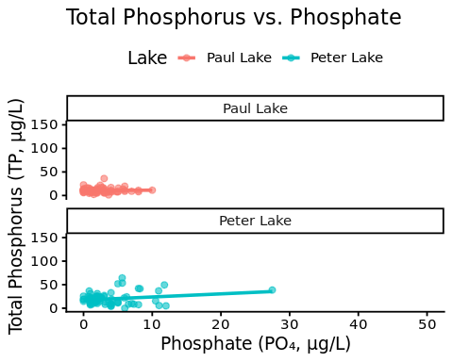
- [NTL-LTER] Make three separate boxplots of (a) temperature, (b) TP, and (c) TN, with month as the x axis and lake as a color aesthetic. Then, create a cowplot that combines the three graphs. Make sure that only one legend is present and that graph axes are aligned.
Tips: * Recall the discussion on factors in the lab section as it may be helpful here. * Setting an axis title in your theme to element_blank() removes the axis title (useful when multiple, aligned plots use the same axis values) * Setting a legend’s position to “none” will remove the legend from a plot. * Individual plots can have different sizes when combined using cowplot.
#5
nutrients <- nutrients %>%
mutate(month = factor(month, levels = 1:12))
# Temperature plot
temp <- nutrients %>%
filter(depth == 0) %>%
ggplot(aes(x = month, y = temperature_C, color = lakename)) +
geom_boxplot() +
scale_x_discrete(drop = FALSE) +
labs(y = "Temperature (°C)", x = "Month", color = "Lake") +
mytheme +
theme(axis.title.x = element_blank(),
legend.position = "none")
# Total Phosphorus (TP)
total_phosphorus <- nutrients %>%
filter(depth == 0) %>%
ggplot(aes(x = month, y = tp_ug, color = lakename)) +
geom_boxplot() +
scale_x_discrete(drop = FALSE) +
labs(y = "Total P (µg/L)", x = "Month", color = "Lake") +
mytheme +
theme(axis.title.x = element_blank(),
legend.position = "none")
# Total Nitrogen (TN)
total_nitrogen <- nutrients %>%
filter(depth == 0) %>%
ggplot(aes(x = month, y = tn_ug, color = lakename)) +
geom_boxplot() +
scale_x_discrete(drop = FALSE) +
labs(y = "Total N (µg/L)", x = "Month", color = "Lake") +
mytheme +
theme(legend.position = "bottom")
library(cowplot)
shared_legend <- get_legend(total_nitrogen)
## Warning: Removed 872 rows containing non-finite outside the scale range
## (`stat_boxplot()`).
## Warning in get_plot_component(plot, "guide-box"): Multiple components found;
## returning the first one. To return all, use `return_all = TRUE`.
temp_noleg <- temp + theme(legend.position = "none")
combined_plots <- plot_grid(
temp_noleg,
total_phosphorus,
total_nitrogen,
ncol = 1,
align = "v", # vertical alignment
axis = "lr" # align left/right axes
)
## Warning: Removed 17 rows containing non-finite outside the scale range
## (`stat_boxplot()`).
## Warning: Removed 806 rows containing non-finite outside the scale range
## (`stat_boxplot()`).
## Warning: Removed 872 rows containing non-finite outside the scale range
## (`stat_boxplot()`).
# Add the shared legend at the bottom
final_plot <- plot_grid(
combined_plots,
shared_legend,
ncol = 1,
rel_heights = c(1, 0.1) # make legend smaller
)
# Display final combined figure
final_plot
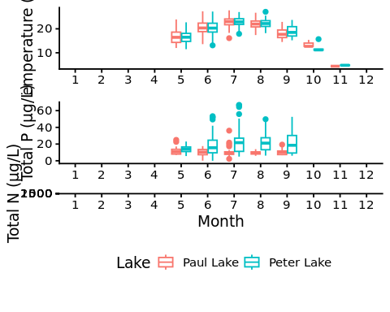
Question: What do you observe about the variables of interest over seasons and between lakes?
Answer: According to the plot, there is a clear pattern showing the temperature is higher in June, July, August and September. Temperature is about the same for both lakes since they are so close to each other. Peter lake has a noticable higher phosphorus and nitrogen level compare to Paul Lake. But both phosphorus and nitrogen level stays about the same through out the year with slightly higher concentration in the summer. There is no data for January till April, October till December.
- [Niwot Ridge] Plot a subset of the litter dataset by displaying only the “Needles” functional group. Plot the dry mass of needle litter by date and separate by NLCD class with a color aesthetic. (no need to adjust the name of each land use)
- [Niwot Ridge] Now, plot the same plot but with NLCD classes separated into three facets rather than separated by color.
#6
library(dplyr)
needles <- litter %>%
filter(functionalGroup == "Needles")
ggplot(needles, aes(x = collectDate, y = dryMass, color = nlcdClass)) +
geom_point(size = 2, alpha = 0.7) +
geom_line(aes(group = nlcdClass), alpha = 0.5) +
labs(
title = "Dry Mass of Needle Litter over Time",
x = "Collection Date",
y = "Dry Mass (g)",
color = "NLCD Class"
) +
mytheme
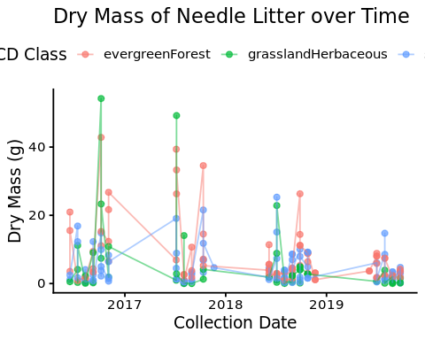
#7
needles <- litter %>%
filter(functionalGroup == "Needles")
ggplot(needles, aes(x = collectDate, y = dryMass)) +
geom_point(color = "orange", size = 2, alpha = 0.7) +
geom_line(aes(group = 1), color = "orange", alpha = 0.5) +
facet_wrap(vars(nlcdClass), ncol = 3) +
labs(
title = "Dry Mass of Needle Litter over Time",
x = "Collection Date",
y = "Dry Mass (g)"
) +
mytheme
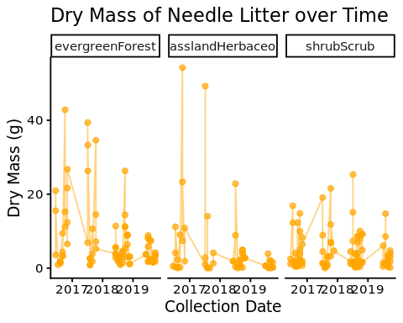 Question: Which of these plots (6 vs. 7) do you think is more effective, and why?
Answer:I think plot 7 is more effective because it is easier to read. You can easily see the trend of each nlcd class while comparing them to each other.

