Modeling MEPERS: Preliminary results for discussion

Table of Contents

# **Overview of key risk-sharing features**

Key policy features:

1. **ADC shared between employer and employees**. Normal costs and amortization costs for UAAL created after 7/1/2018 shall be paid through employer and employee contributions allocated **58% to the employer and 42% to the employee**.
2. **Contribution caps**. The employer and employee contribution rates are capped at 12.5% and 9%, respectively.
3. **Variable COLA**. If the ADC rates exceeds the caps (ADC rate >= 21.5%), COLA will be reduced to maintain “cost-neutrality”, but not below zero. If the reduction otherwise would have been below zero, then zero COLA will be applied and capped contributions will be paid in following years until “cost neutrality” is achieved.

**Note**: “Cost neutrality” is the concept used in the official plan rules. For modeling purposes, our undertading is that cost neutrality is achieved when the ADC rate is equal to the actual total contribution rate. (caps not binding.)

# **Summary of modeling approach**

## Policy scenarios

To examine the impact of the MEPERS risk-sharing features on plan costs, funded status, and member benefit, we run the simulation under the following three policy scenarios.

1. **Shared-ADC and variable COLA** (MEPERS policy)
   * EEC = 48% * ADC, capped at 9% of payroll
   * ERC = 52% * ADC, capped at 12.5% of payroll
   * COLA: 0~2.5% (cola assumption valuation: 1.91%)
2. **Shared ADC and fixed COLA**
   * The shared-ADC policy is the same as 1.
   * COLA rate is fiexed at 1.91%.
3. **EEC as a fixed percentage of normal cost**
   * Only normal cost is shared. EEC = 48% of normal cost (about 6~7% of payroll). Amortization costs are not shared with employees.
   * COLA rate is fiexed at 1.91%.

**Note**: In 1 and 2, EEC rate can fall to as low as 0%. To make 3 comparable to 1 and 2, EEC are allowed to fall below 48% of NC if the total ADC rate is lower than 48% of NC due to negative amortization cost; EEC rate is still floored at 0%.

Additional variants will be examined in future analysis.

## Investment return scenarios

1. Stochastic: 7% expected mean return, 12% standard deviation. (to be replaced by scearnios and capital market assumptions provided by Pew)

## Model assumptions and Simplifications

* Benefit rules for Tier 1 Regular members are applied to all members. We will model three tiers in later versions: Tier 1 Regular (pre-2014 members), Tier 2 Regular (post-2014 members), and Speical. For
* Benefit rules for Tier 1 Regular members:
  + Normal retirement age: 60
  + benefit factor: 2% per year of service
* Key valuation methods and assumptions:
  + Discount rate: 6.75%
  + Cost method: EAN
  + Asset smoothing: 3 years
  + Amortization of UAAL: 20-year level-percent closed amortization

## Questions about valuation with variable COLA

We need to better understand how the adjustable COLA is reflected in actuarial valuation calculations of liability in MEPERS. We are not sure what assumption they use about future COLAs when calculating the COLA reduction needed to bring the contribution rates under the caps. There are at least two possibilities:

* Assume that the reduced COLA will be applied only in the next year, and then use the regular COLA assumptions (1.91%) for following years.
* Assume that the reduced COLA will be applied for all following years (this is like what SDRS does).

Also, we assume that the COLA reduction and suspension are only applied in the valuation of retiree liabilities, but not the active member liabilities.

# **Simulation results**

## Analysis of contributions

### Distribution of long-term costs

(Click tabs below to show tables)

#### PV of total contribution with terminal UAAL

Distribution of 30-year present value of total contribution plus terminal UAAL

Policy

90th

75th

50th

25th

10th

Shared ADC; caps; Variable COLA (MEPERS)

139.4

126.0

100.0

68.8

45.6

Shared ADC; caps; Fixed COLA

141.3

129.4

97.5

63.7

43.0

Shared NC; no caps; Fixed COLA

172.6

139.6

99.9

65.6

44.0

#### PV of employer contribution

Distribution of 30-year present value of ERC

Policy

90th

75th

50th

25th

10th

Shared ADC; caps; Variable COLA (MEPERS)

139.4

126.0

100.0

68.8

45.6

Shared ADC; caps; Fixed COLA

141.3

129.4

97.5

63.7

43.0

Shared NC; no caps; Fixed COLA

242.4

187.4

124.2

75.8

47.1

#### PV of employee contribution

Distribution of 30-year present value of EEC

Policy

90th

75th

50th

25th

10th

Shared ADC; caps; Variable COLA (MEPERS)

139.4

126.0

100.0

68.8

45.6

Shared ADC; caps; Fixed COLA

141.3

129.4

97.5

63.7

43.0

Shared NC; no caps; Fixed COLA

75.8

75.3

66.5

51.7

37.7

#### PV of terminal UAAL

Distribution of present value of terminal UAAL (year 30)

$million

Policy

90th

75th

50th

25th

10th

Shared ADC; caps; Variable COLA (MEPERS)

402

223

−16

−394

−1,039

Shared ADC; caps; Fixed COLA

556

339

−1

−428

−1,142

Shared NC; no caps; Fixed COLA

265

119

−101

−510

−1,196

Note: negative values are surplus

### Short-term volatility of costs

#### Risk of sharp ERC increase

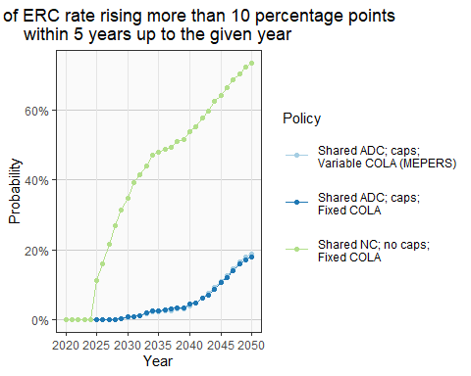

#### Risk of sharp EEC increase

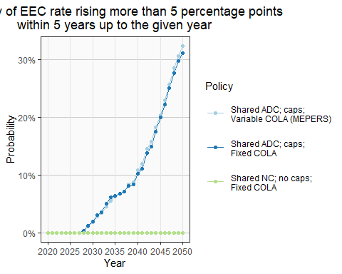

## **Analysis of funded status**

* Chance that funded ratio fall below 90%
* Chance that funded ratio fall below 60%
* Chance of the plan at least 100% funded in the given year
* Chance that the cash flow net of investment income being less than -5%

### Risk of low funded ratio (cumulative)

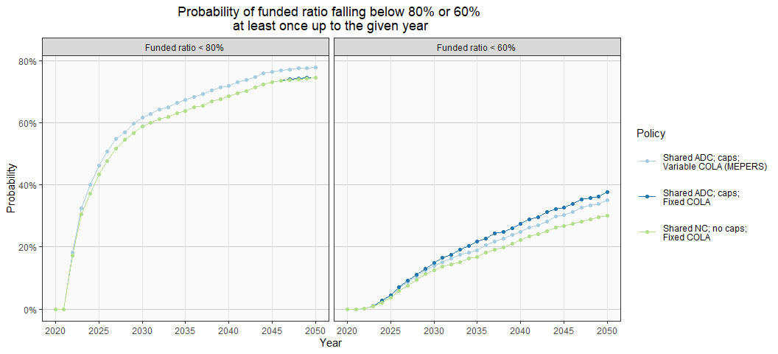

### Risk of low funded ratio (non-cumulative)

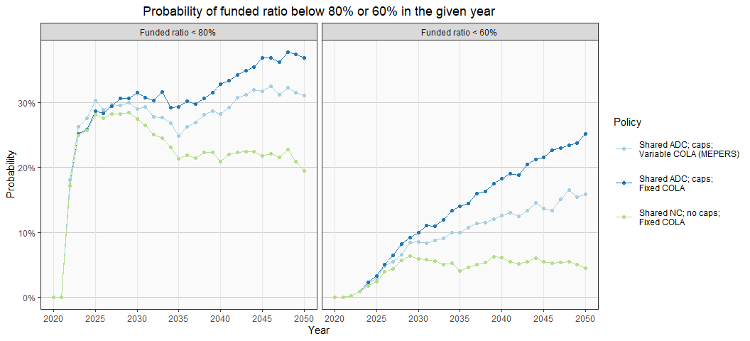

### Probability of full funding

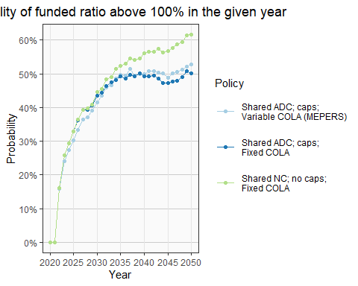

## **Analysis of member benefit**

Cohort examined:

* Joined the plan at age 25 in 1986
* Start receiving benefit at age 60 in 2021
* live to age 90 (30 years in retirement)

### distribution of present value of benefit

Distribution of 30-year present value of benefit

For members who retire at age 60 with 35 years of service in 2021

Policy

90th

75th

50th

25th

10th

Shared ADC; caps; Variable COLA (MEPERS)

1,769

1,763

1,681

1,558

1,466

Shared ADC; caps; Fixed COLA

1,657

1,657

1,657

1,657

1,657

Note: starting benefit is normalized to $100

### distribution of replacement rate at age 75

Distribution of replacement rate at age 75

For members who retire at age 60 with 35 years of service in 2021

Policy

90th

75th

50th

25th

10th

Shared ADC; caps; Variable COLA (MEPERS)

0.67

0.67

0.63

0.55

0.50

Shared ADC; caps; Fixed COLA

0.62

0.62

0.62

0.62

0.62

Note: benefits at age 75 are adjusted for inflation; assumed inflation = 2.75% (MEPERS assumption)