**TeAM**

Digitally signed by TeAM YYePG DN:cn=TeAM YYePG,c=US,

o=TeAM YYePG,ou=TeAM

YYePG,email=yyepg@msn.com

Reason: I attest to the accuracy and integrity of this document

Date:2005.01.2316:28:19+0800'

V.B.AlekseevYYePG

**Abel's Theorem**

**in Problems and Solutions Based on the lectures of Professor V.I.Armold**

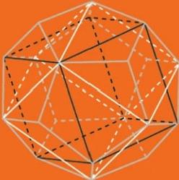

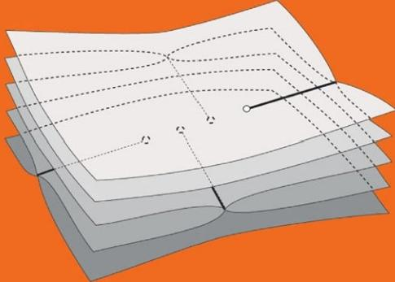

**Kluwer Academic Publishers**

ABEL’S THEOREM IN PROBLEMS AND SOLUTIONS

Abel’s Theorem

in Problems and Solutions Based on the lectures of Professor V.I. Arnold

*by*

V.B. Alekseev

*Moscow State University, Moscow, Russia*

**KLUWER ACADEMIC PUBLISHERS**

NEW YORK, BOSTON, DORDRECHT, LONDON, MOSCOW