**Swift**

**Notes for Professionals**

**Chapter 4:Strings and Characters**

**Section 4.1:String &Choracter Literals**

ng lieasins%itae defniedm duie quotes]

let grsting·"ellni Jt gretig's typi string

Crsto canbe ncalice frem swreg loraks a lergsthe liea contains ony ne gnphene dus ***oapter*** ***24:Reading*** ***&Writina*** ***I*** ***C*** ***o***

1t r2:aracter · tu

Chapter 3:Numbers

Section 3.1:Number types and literols

**BpiePo31dSonsriong 5ng nd Docod**ing with

*h* *eS5* *azndaisbtrm* u

yp*T*regHc he *wejuct* *tienta* *funstionade* *maedmomsauu*

10t mr:(darncter ·e"/ina1emristu grapes (uar

**string intarpelatien**

Scring interpechation alows hietirg anexpresiendiresy ime astrg tera.Tisante fore weallopesf ue%,indukng stns.intiegrs noatgpont mumbers ind moxre.

and u e ,ns and useed ey

*ini's*es*t*in *n n**n*et*y*pe*eat*

·woee(aeredpener

The ya sabecksanh fnlowed byperentheseswrappingtewaue v(hue).Peyyske erestonmy apcear in the srentreses insudrg furctiencs.

a

lat fortyT0·"M[6+7P 喜

p

L

*nomeneitera ypeis irferen frem coreat*

0

rJw fr50eta et Jenyjet -ty

(/F yeeding) i(

tng

br oucto

lt nule= Ts post fa e1wiew(ttnuabe 11 8"

oet

t il oupet Thts post h8s EV1ess tor the o5ove Bsomple.

w.5Debm

rhate

iY te ariatu nurbar heu the wue 1, 共 oula autpu The gbst ha 1 va nstead.

, ,

*aita.btion*ID)*

forcostm tpe thes heberofstginteredsntons obji sewsletokrtre(eyscbj)

the sare mpenenttionsed byrtlny⁰1),Wucn ostomiethe boewe byimelemeung the ntatudnarbe foryur type

_

1eate

ro aresLmaybewedto sepr cgs inrumere iheatteadngres

*baing* *psalsmybezereduoguratang* *adeoru* *pang* *地*

*tbsigyfodpnpowwfheao*

:ieren

t 4"*r

ennayrdcr

ralms3

For Sift inacnrdoxt w 1 string,ntefe]hes terenawredtostring tmtfT+(deoriag The siegrtepotin ysyr #lprele the nwr,mtcT:Lansleustrin:nvwrthle(-1)

*1it* *redngOM* *sheo*

…

**integer eral syntax**

inchlbDu,uwi fal a to in1(rthng)rhu valeais no aieustrtmgcmvurtsl

**tejSON**

G oroconbechyuer

*robs*

**Spadatcharacters**

Certancwstersnegreaspeclsl escape sequence to ise themsthg Eerak

**Meanirg**

lee

the nullcster apiain bachslash, atbcharacter

t Jonat by erL

orir JSs ata:Mjsorzmta

cansensta eng

Charactar

ejanrabj

caf1

jon,ytlomu(n

avertieal tab

WW

W

10

ach cr:Viminatrng surretrtgfncndingy)

Garge renm

aire fedrnentine"l a doublequone,

ra( ror ig erer)

W

asde quote,

W

**He**三**aingpint irralsytax**

。

Youcanpaspti retty irsudelaptis:ll6pcyphang

*iainsfo*

*inebhorin sut9but wimaofarentsyita*

rura ut j ·the 1 mm

t eaeil

et hesisal 2 *Pfes*

**200+pages**

of professional hints and tricks



This is an unofficial free book created for educational purp**ile**i

the property of their respective owners

not affiliatedkl iTrggi(dS.

**GoalKicker.com Free Programming Book**s

**Contents**

**About** 1



Section 1.3:Your first program in Swift Playgrounds app on iPad 7

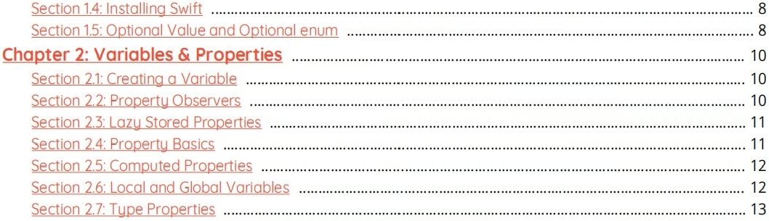

**Chapter 3:Numbers** 14



Section 3.3:Rounding 15

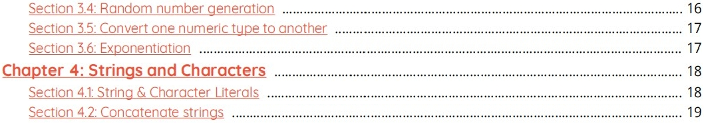

Section 4.3:String Encoding and Decomposition 20



Section 4.7:String Iteration 2

Section 4.8:Splittinga Stringinto an Array 24

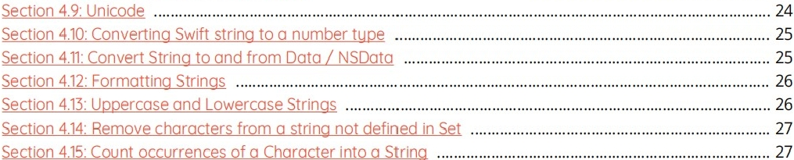

Section 4.16:Remove leading andtrailing WhiteSpace andNewLine 27

**Chapter 5:Booleans** 29



Section 5.4:Negate aBool with the prefix! operator 30



Section 6.2: Extracting values of a given type froman Array with flatMap(:) 32

Section 6.3:Combining an Array's elements withreduce(_:combine:) 32

Section 6.4: Flattening the result of an Array transformation with flatMap(三) 33

Section 6.5: Lazily flattening a multidimensional Array with flattenQ 33

Section 6.6: Filteringout nil from an Array transformation with flatMap(:) 34

Section 6.7:Subscriptingan Array with a Range 34

Section 6.8:Removing element froman array without knowingit's index 35

Section 6.9: Sorting an Array of Strings 35

Section 6.10:Accessing indices safely 36

Section 6.11: Filtering an Array 37

Section 6.12:Transforming the elements of an Array withmap(:) 37

Section 6.13: UsefulMethods 38

Section 6.14:Sorting anArray 38

Section 6.15: Finding the minimum or maximum element of an Array 39

Section 6.16:Modifyingvalues inan array 40

Section 6.17:Comparing 2 Arrays with zip 40

Section 6.18:Grouping Array values 41

Section 6.19:Value Semantics 42

Section 6.20: Accessing Array Values 42

**Chapter 7: Tuples** 4

Section 7.1: What are Tuples? 4

Section 7.2:Decomposinginto individualvariables 44

Section 7.3: Tuples asthe Return Value of Functions 45

Section 7.4:Using a typealias to name your tuple tupe 45

Section 7.5: Swappingvalues 46

Section 7.6:Tuples as CaseinSwitch 46

**Chapter 8: Enums** 48

Section 8.1: Basic enumerations 48

Section 8.2: Enums with associated values 48

Section 8.3: Indirect payloads 49

Section 8.4:Rawand Hash values 50

Section 8.5: Initializers 51

Section 8.6: Enumerations share many features with classes and structures 52

Section 8.7:Nested Enumerations 53

**Chapter 9: Structs** 54

Section 9.1: Structsarevalue tupes 54

Section 9.2:Accessing members ofstruct 54

Section 9.3: Basics of Structs 54

Section 9.4:Mutating a Struct 5

Section 9.5: Structs cannot inherit 5

**Chapter 10:Sets** 57

Section 10.1: Declaring Sets 57

Section 10.2: Performing operations on sets 57

Section 10.3: CountedSet 58

Section 10.4:Modifying values ina set 58

Section 10.5: Checking whether asetcontains a value 58

Section 10.6: Adding values of my own type toa Set 58

**Chapter 11: Dictionaries** 60

Section 11.1: DeclaringDictionaries 60

Section 11.2:Accessing Values 60

Section 11.3: Change Valueof Dictionary using Key 61