

**Assignment 2: Decision Tree**

Group 3 Members:

Zisi Ye

Yiming Zhang

Zhihan Zhang Afraz Hussain Zher Shin Tan

**Introduction**

The second assignment asks the group to create and train six binary classification trees by using provided facial point data. The group named six trees: Tree 1, Tree 2, Tree 3, Tree 4, Tree 5, and Tree 6. In addition, each tree corresponds to one emotion. For example, if the group tests one set of facial point data in the Tree 6, and the outcome is 1, then this means this set of facial point data is the emotion ‘surprise’.

Following is a brief overview of how the team achieved this task:

Firstly, the group processed the input data. In the file ‘label2bin.m’, it transferred one set of data y to six sets of same size data, however the new data only contains 0 and 1.

Next, the group followed id3 algorithm pseudo code below to build the decision tree.

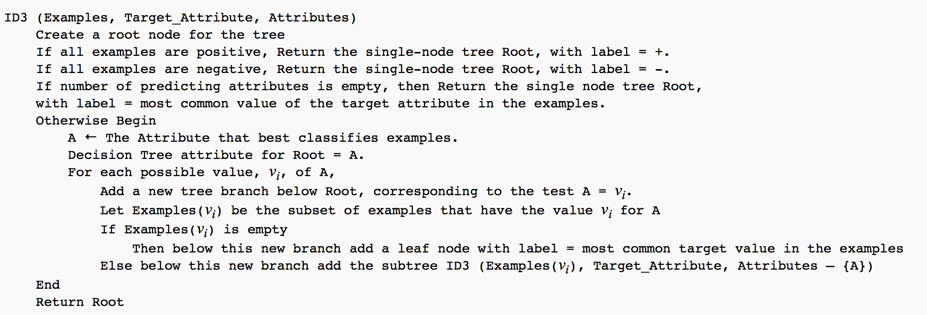

‘CreateDecisionTree.m’ , ‘bestFeature.m’, ‘entropy.m’, ‘gain.m’ implemented the id3 algorithm.

Finally, the group used 10 fold cross validation to train and test the decision tree. Also, the confusion matrix has been plotted and hence calculated the recall, precision, F1 measure. ‘cw2.m’, ‘crossvalidation.m’, ‘DrawConfusionMatrix.m’, ‘dtclassify.m’, ‘Fmeausre.m’ are used in the evaluation part.

**Run the code**

It may need to clear workspace first.

‘cw2_1.m’ : plots 6 trees.

‘cw2.m’: results are 10 matrices(cross validation) and a result matrix named ‘result’, also can plot 60 trees.

‘evaluation.m’: after run this file, created recall, precision and F1 measure for the ‘result’ matrix.

The rest files are all functions that are needed in these three files.

**Results**

**1.1 Decision Trees graphs**

These 6 trees below are trained and plotted by using 612 sets of facial data(x). The group wrote the script ‘cw2_1.m’ to implement this. Each node has two values , the first value represents the best attribute, and the second value is the best threshold. Attributes are basically named from 1 to 132 just as what it is given in the data x.

Tree 1(target label is 1)

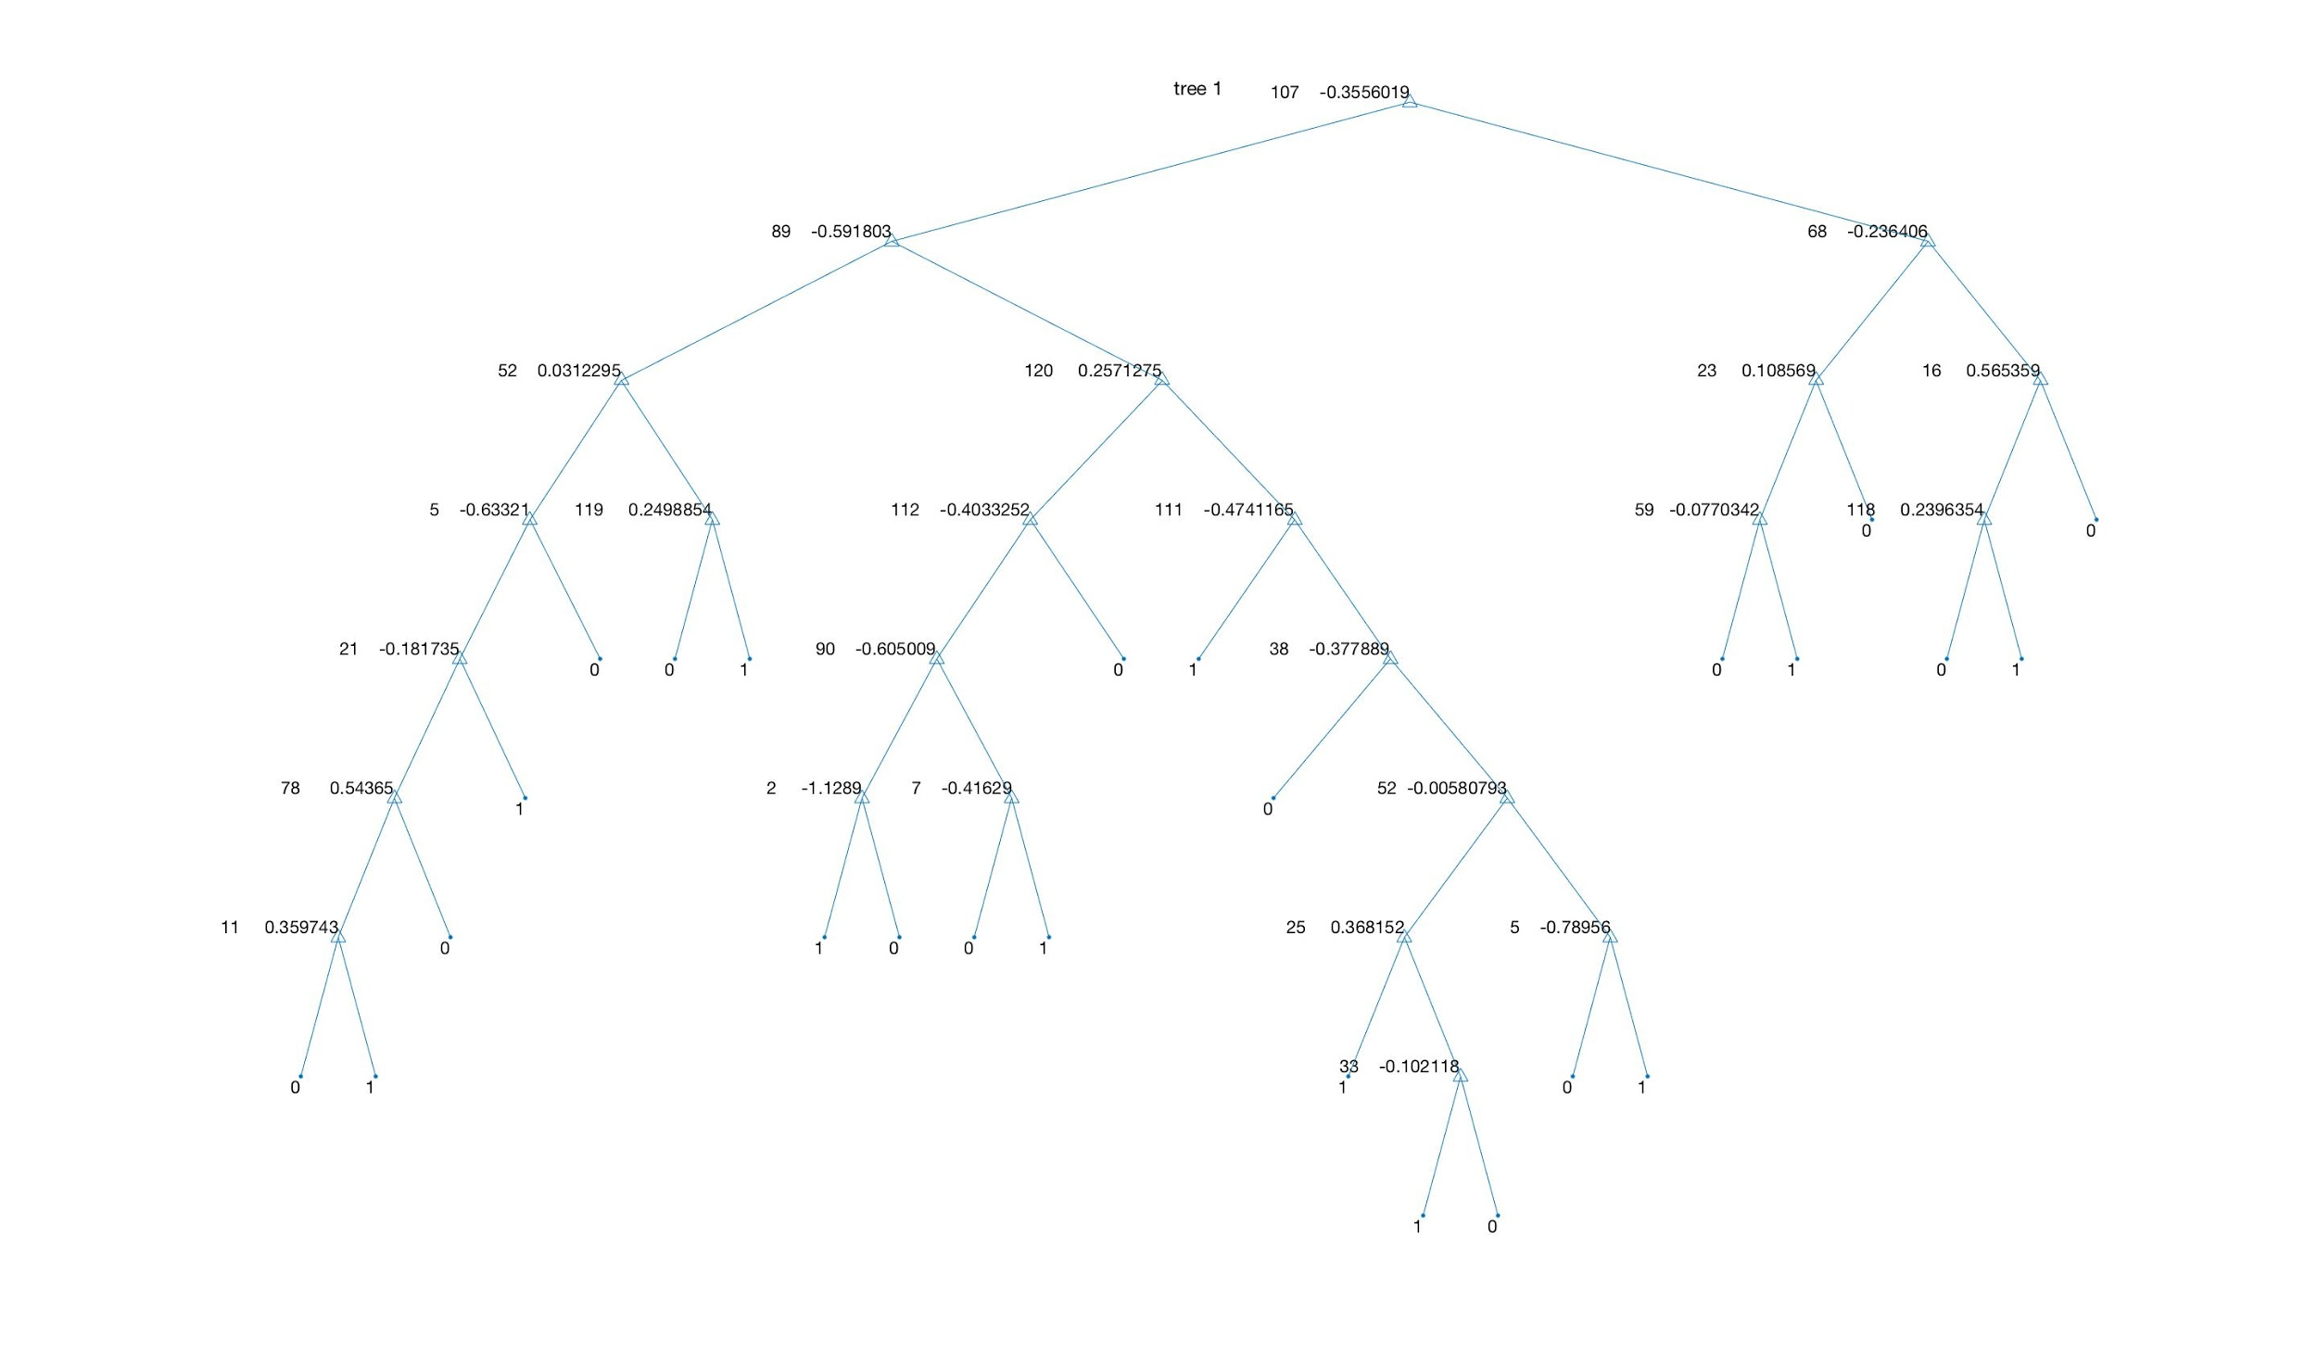

Tree 2(target label is 2)

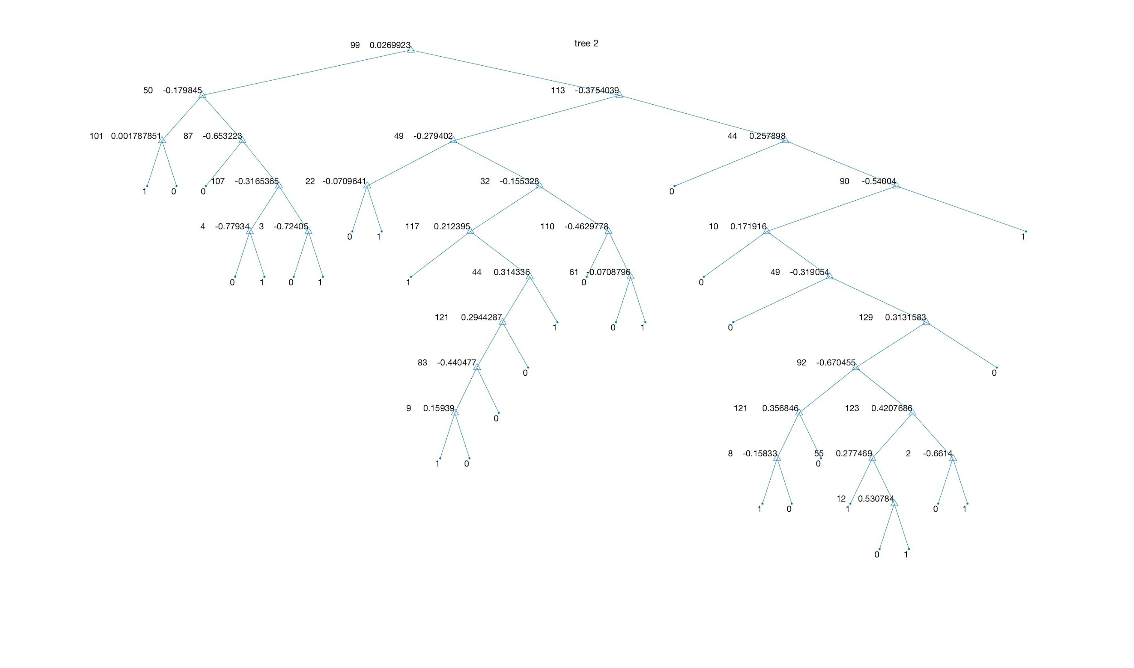Tree 3(target label is 3)

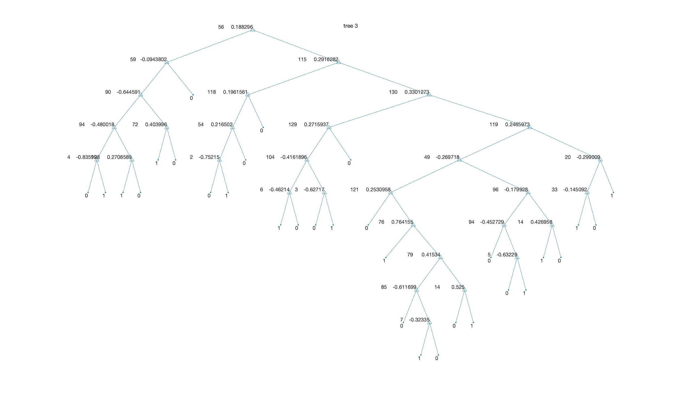

Tree 4(target label is 4)

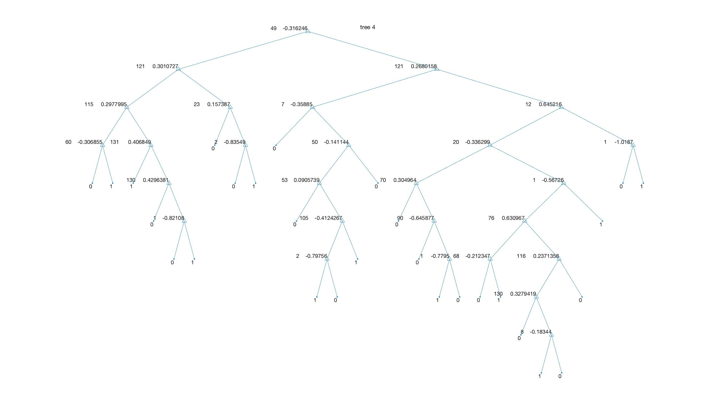

Tree 5(target label is 5)

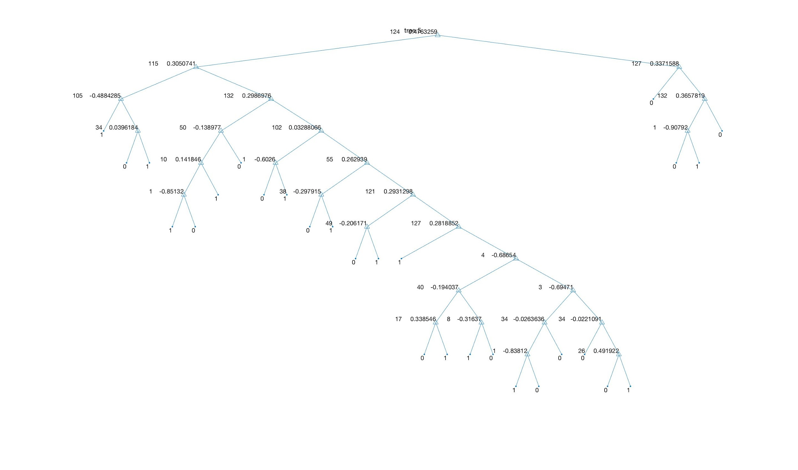

Tree 6 (target label is 6)

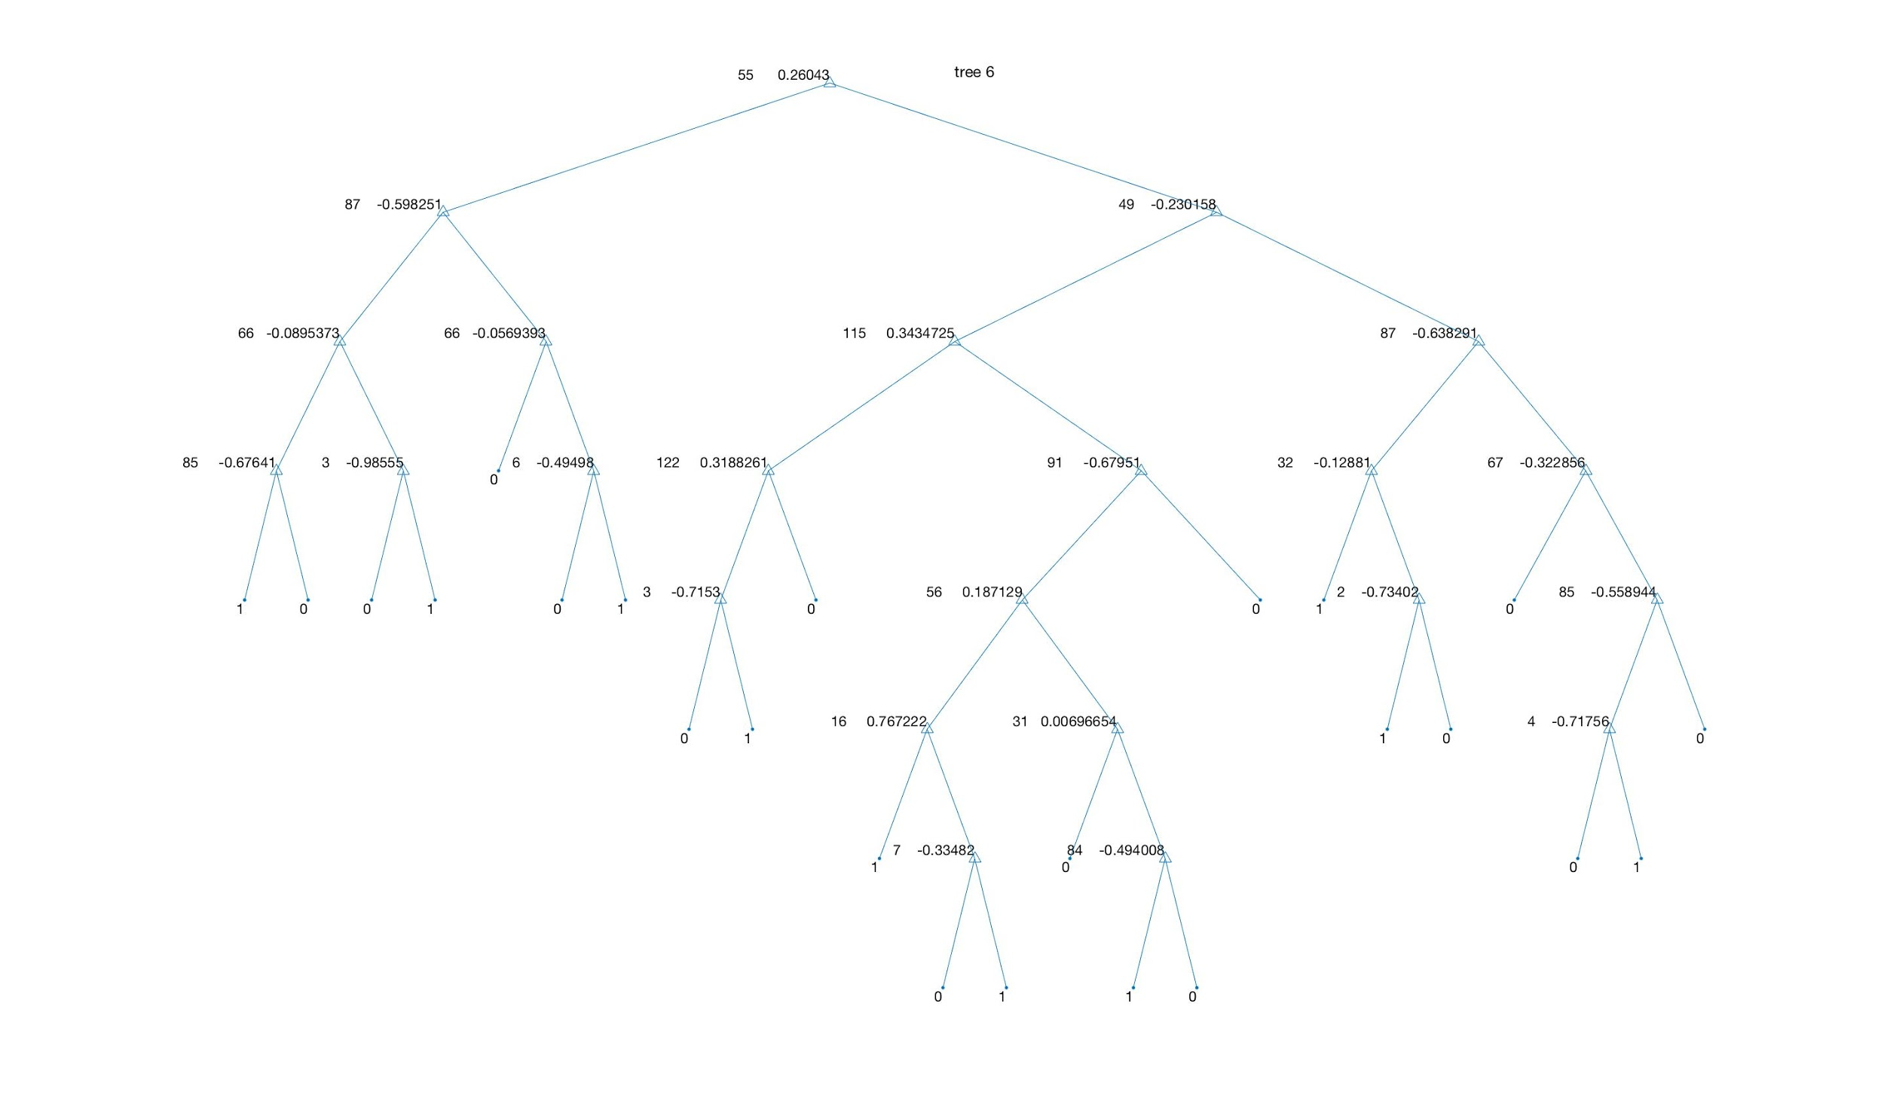

**1.2 Confusion matrix**

This part result was run by ‘cw2.m’. The group used 10 fold cross validation, this means the group split original 612 sets of data into 10 folds. Then 1 fold was used to test and rest 9 folds were used to train the decision tree. After each fold has already been used to test, the group got 10 confusion matrix. Noticed, the group deleted the input data when they are failed to classify into any of the emotion. Then, the group sumed 10 confusion matrices to get the result average confusion matrix. False negatives are cases predicated negative which are actual positive. So in this question, what the group deleted can be seen as false negatives. In the below confusion matrix, the sum of all elements is 537, namely, 75 sets of input data are false negatives.

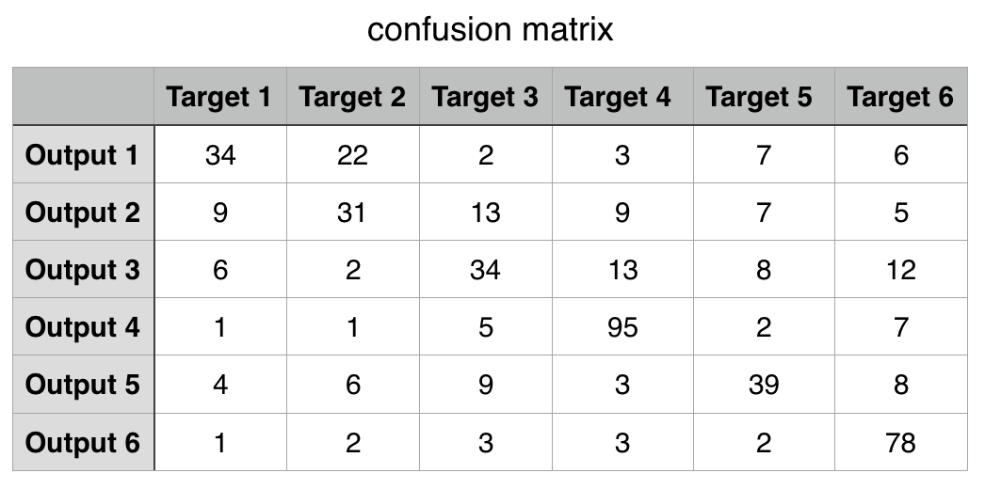

**1.3 Average precision, recall rates and F1-measure**

The group wrote the file ‘evaluation.m’ to calculate the recall, precision and F1 measure. The calculation of them are based on the function:

Recall = TP/TP + FN

Precision = TP/ TP + FP

F1 measure = 2*(Precision*Recall)/(Precision + Recall)

By evaluating them, the group can find out the decision trees’ behaviour. From the chart, Tree 2 was trained poorest and Tree 4 was the best training tree.

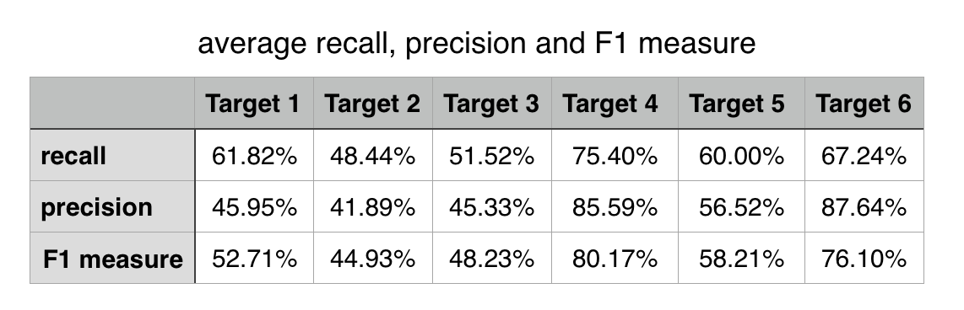

**1.4 Difference between the original tree and pruned tree**

Pruning is a frequently used technique which helps to reduce error, cost complexity and also prevent overfitting of a decision tree. However, choosing the right node to prune is a hard decision as the selected node might not reduce the error. The idea of applying pruning on a decision tree is to start pruning from leaf nodes to the root nodes. Image 1 shows the tree without pruning, and image 2 shows the tree after pruning. (This tree was actually Tree 1 in the part 1.1.)

Firstly, the group found out there are 7 pairs of leaf nodes that can be pruned in the tree, as it showed in the Image 1. The group should eliminate the pairs of leaf nodes with the smallest impurity penalty. After calculation, the group found one pair of leaf nodes which has red circle in the Image 1, and it should be pruned. The Image 2 is the result of pruned tree. Compared these two trees, the pruned one has a better performance, because what the group prune is one pair of leafs whose one leaf node is 1 set with label 0 but another node has 22 sets with label 1.



Image 1: Tree before pruning.



Image 2: Tree after pruning.

**1.5 Explanation on final decision on what emotion is present**

Given the condition that the team had six trained trees for the six different emotions. Then a test set which consists of 6 different emotions is tested on each tree. Each data of the test set has 132 attributes to represents an emotion, and those attributes are used to compare with the trained tree value. For instance, the root node of the tree1 which represents emotion 1 has a threshold of -0.3556 at attributes 107, so the data will be categorised based the value in attribute 107 whether it has smaller or larger number than the calculated information gain. This process is repeated until the data has reached the leaf node which has only either 1 or 0. If the tree returns 1 to the data, that means the data is categorised as emotion 1. For the data which categorised as 0 will further proceed to tree2, tree3 and so on until the data is classified.

However, when the group tested the tree using 10 fold cross validation, the outcome showed that most sets of test data will result into only one emotion, but some sets of test data will not match any emotion, or some will match more than one emotion. To solve this problem, for the multiple result case, the group determined to use the first emotion as it found when processed from Tree 1 to Tree 6. Also, the group deleted the related results when no emotion can be found. Because if the output is all 0, then it does not exist true positives and false positives. The sum of the elements of the final confusion matrix will smaller than 612.

**1.6 Ways to have a single tree that could perform classification directly**

If the group would like to change the code in order that a single tree can classify 6 emotions, then firstly, the group doesn’t need to process the input data y, it can just be numbers from 1 to 6 where each number corresponds to one emotion. Next, the tree is no longer a binary classification tree, because if the group build the decision tree, the leaf nodes should be ranged from 1 to 6 instead of only 1 and 0. This change can be done in the file ‘ CreateDecisionTree’ by implementing new base cases for 1, 2, 3, 4, 5, 6 to decide how to reach a leaf node in this case. For example , the pseudocode to implement leaf node of value 6 can be like: ‘ If all examples are 6 then return the single-node tree root with label = 6.’ However, the difficulty of this problem is to determine when does all the nodes are 6. This should be carefully considered and maybe write other functions to help achieve that.