dd2432, lab 3, report

self-organizing maps (som)

part 3, animals

set #epochs = 100, neighbor size = 25, which decreases with exponential rate tau = 1000

the result is shown below.

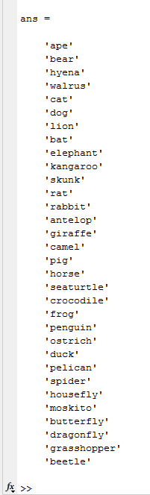

basically the insects have relatively high points and are clustered together, meaning that those species are similar in various characteristics. cat and dog are clustered together, proving their affinity. on the other hand, big animals have relatively low points.

part 4, cyclic tour

set #epochs = 100, neighbor size = 2. after half of the epochs (50 for now), the neighbor size is set to be 1.

the result is shown below.

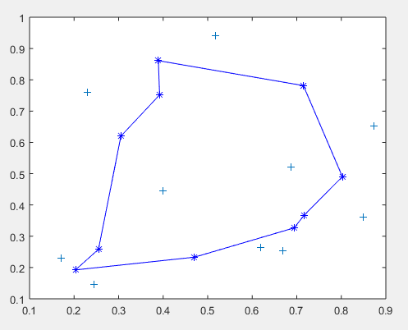

set #epochs = 1000, and below is the result.

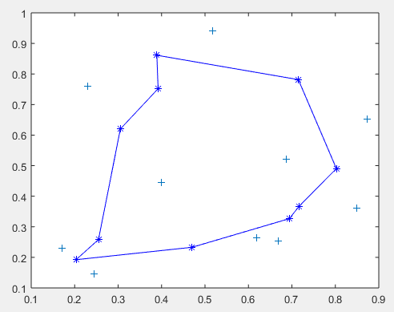

those two figures are basically identical. thus it is fine to state the correctness.

part 5, votes of MPs

set #epochs = 100 (actually when #epochs = 1000 the result are basically identical we could say that 100 epochs is enough to derive a good result)

set neighbor size = 5, every 20 epochs decreases by 1.

the clustering of parties is shown below.

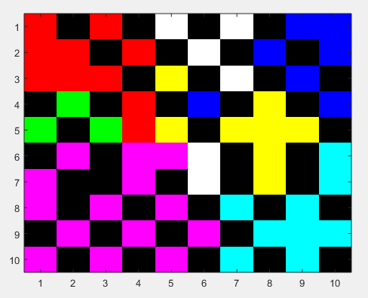

different parties (which hold different political views, thus different kinds of votes) are clustered significantly.

the clustering of sex are shown below.

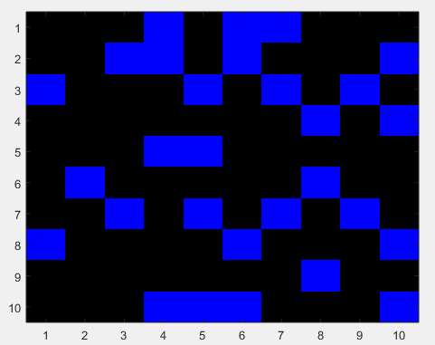

black: male, blue: female. male MPs are more than female MPs but their political view are not significantly based their sex.

the clustering of district (numerical display of indices and the figure) are shown below.

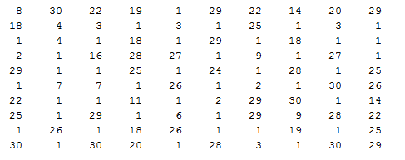

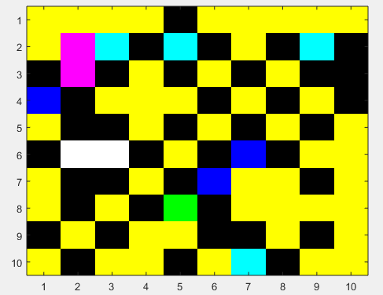

there are now significant distinction between political views and MPs’ districts.