**dd2432, lab 3, report**

Self-organizing maps (som)

**Part 3, animals**

input: 32 animals, 84 attributes

output: 100 nodes

Set #epochs = 100, learning rate eta = 0.2, initial neighbor size = 25(*2), which decreases with exponential rate tau = 1000

The result is shown below.

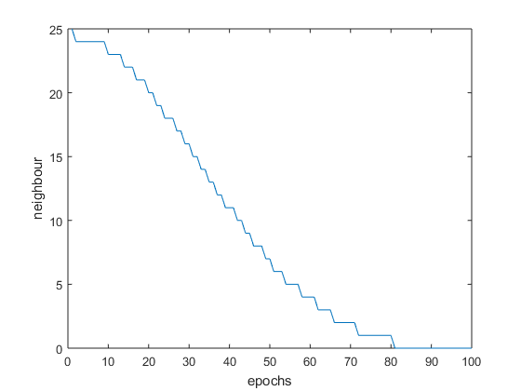

'beetle'

'butterfly'

'dragonfly'

'grasshopper'

'housefly'

'moskito'

'spider'

'ostrich'

'penguin'

'duck'

'pelican'

'frog'

'crocodile'

'seaturtle'

'horse'

'pig'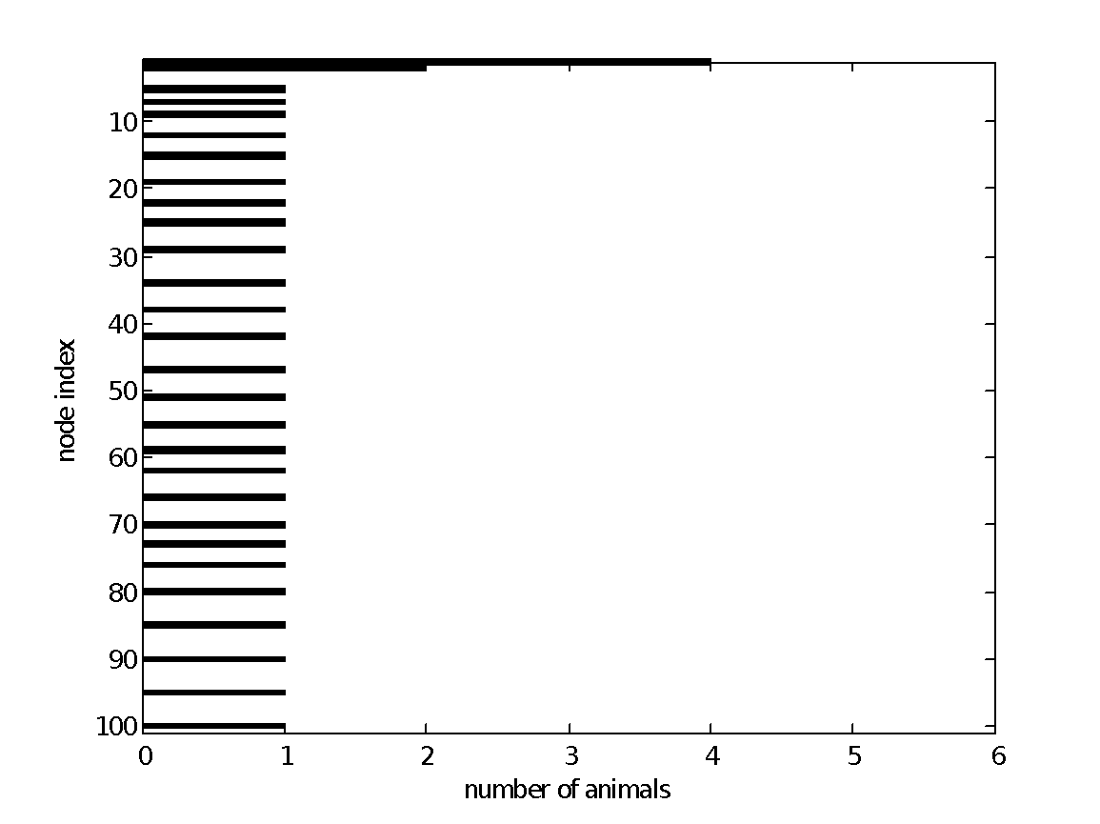

'camel'

'giraffe'

'antelop'

'kangaroo'

'rabbit'

'rat'

'bat'

'elephant'

'skunk'

'hyena'

'bear'

'dog'

'walrus'

'lion'

'cat'

'ape'

Basically the insects have relatively high points and are clustered together, meaning that those species are similar in various characteristics. Cat and dog are clustered together, proving their affinity. on the other hand, big animals have relatively low points. [Since it is a topology preservation algorithm, the order can be inversed]

**Part 4, cyclic tour**

Set #epochs = 100, neighbor size = 2(*2). After 20 epochs the neighbor size is set to be 1.

The result is shown below.

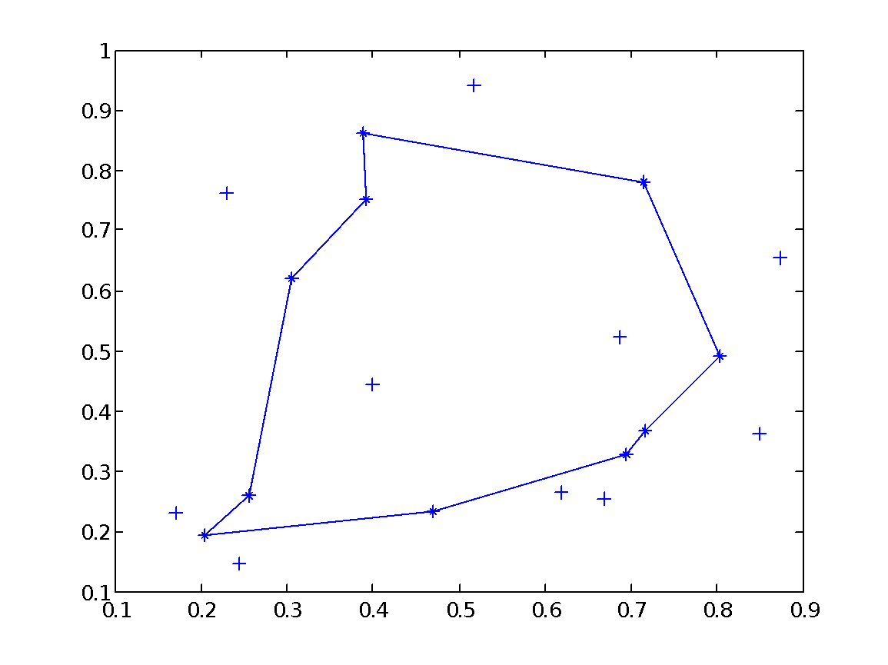

. After 20 epochs the neighbor size is set to be 1. Then set to 0. (after epochs= 40)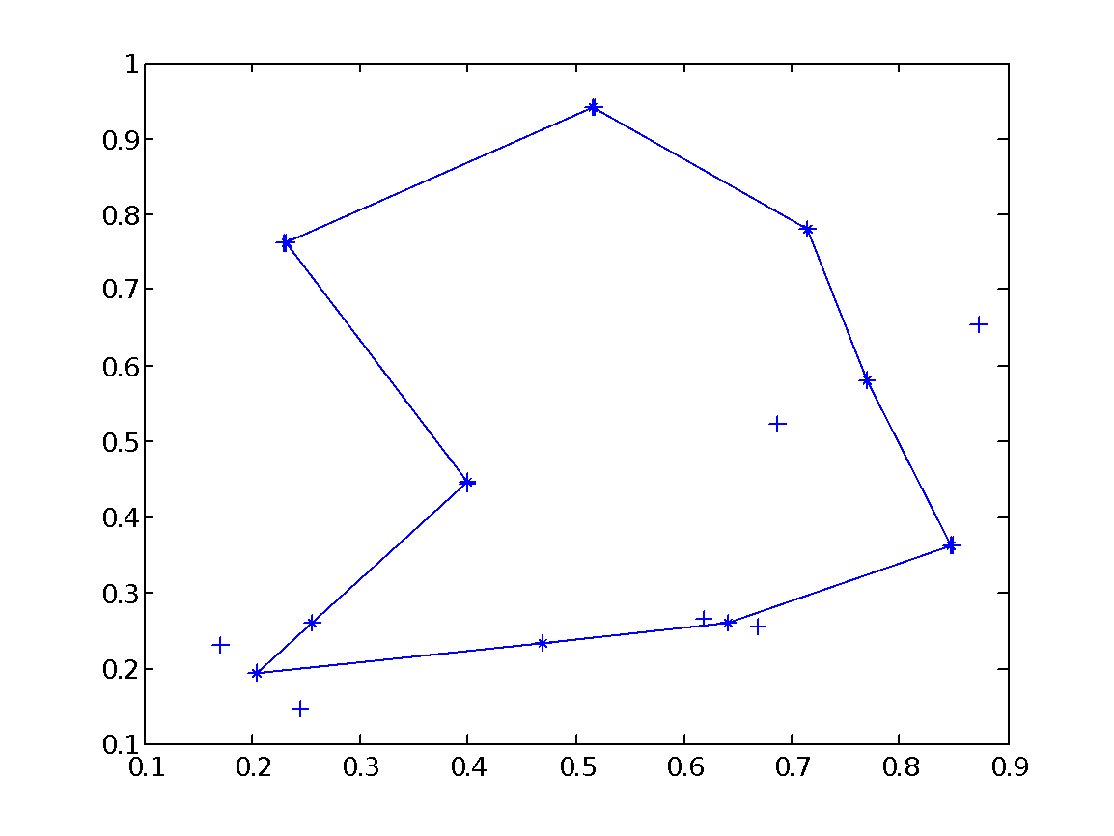

* Set #epochs = 100, neighbor size = 0:

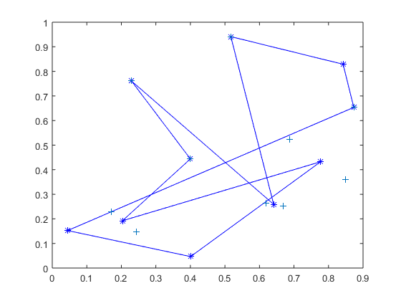

The overall structure is not organized when we doesn’t update the neighbours.

* Set #epochs = 100, neighbor size = 4(*2), which decreases with exponential rate tau = 1000:

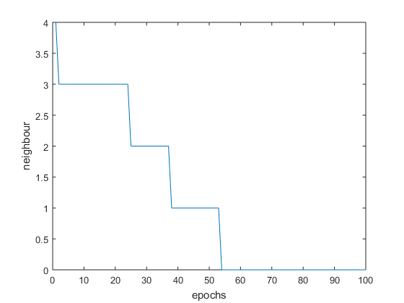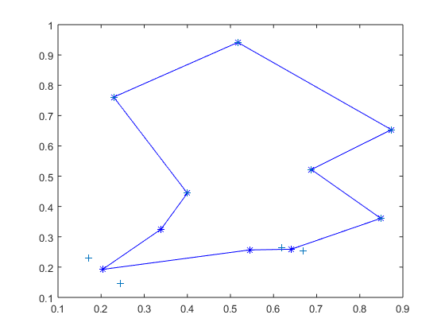

**Part 5, votes of MPs**

Set #epochs = 100 (actually when #epochs = 1000 the result are basically identical we could say that 100 epochs is enough to derive a good result)

Set neighbor size = 5, every 20 epochs decreases by 1.

The clustering of parties is shown below.

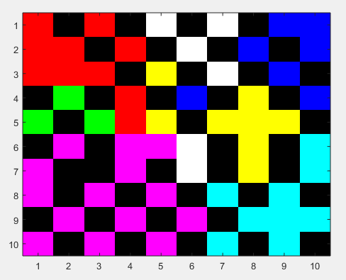

* Different parties (which hold different political views, thus different kinds of votes) are clustered significantly. Parties with similar voting close to each other

The clustering of sex is shown below.

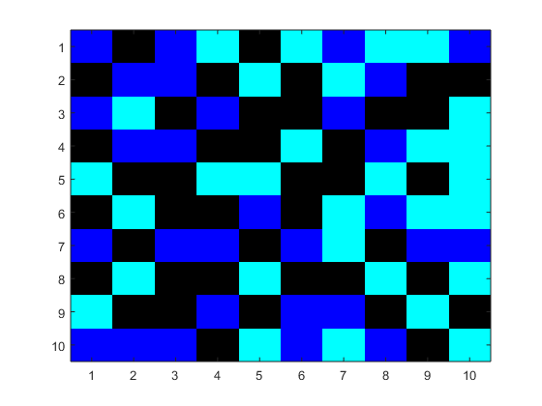

Black: dummy

Conclusion: no significant pattern according to sex

The clustering of district (numerical display of indices and the figure) are shown below.

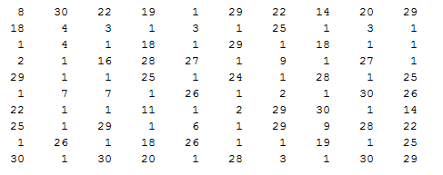

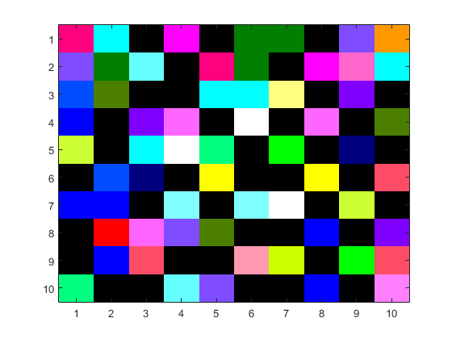

There are now significant distinction between political views and MPs’ districts.

