DD2423 project proposal (projektförslag)

Yiming Fan ([yimingf@kth.se](mailto:yimingf@kth.se))

**Project Description: Pokémon Handbook**

Pokémon (ポケモン aka pocket monsters) is a media franchise started by the Pokémon Company in Japan in 1995. The world is centered with fictional creatures called “Pokémon”. In this world, people could encounter, capture and collect various kinds of Pokémons. Moreover, Pokémons could fight each other for their masters. Started in 1990s, the Pokémon quickly became a hit throughout Japan and the rest of the world. The animations, comic and games of Pokémon were successfully sold in the pasting 20 years. By now, there are 26 generations of Pokémon video games with totally 720 different Pokémons released.

Collecting Pokémons is an interesting but tedious job. Some Pokémons have extremely critical requirement to be captured, which increases the difficulty of obtaining a whole collection of Pokémons. Therefore, to create an online “capturing handbook” for those Pokémon-holics becomes important. This project is aimed at visualizing a database for all those Pokémons with adequate informations, both for fans and free-lookers.

Interface Description

In this part I will provide a rough description of the interface based on the Japanese Wikipedia of Pokémons, which is shown below. My project will have more integrated visualization of interface than presented in the Wikipedia.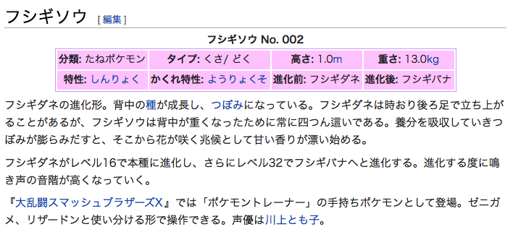

(IVYSAUR No. 002, class: seed, type: grass / poison, height: 1.0m, weight: 13.0kg, speciality: mind power, hidden speciality: chlorophyll, before evolving: BULBASAUR, after evolving: VENUSAUR. Below are the description, translation omitted. source: <https://ja.wikipedia.org/wiki/ポケモンの一覧>)

As shown above, for complete description, some important features of this Pokémon, including the methods of capturing, average sex ratio, important skills and the suitability of fighting, are missing. Those missing features will be added into my project database. Between the name of the Pokémon and the characteristics, a certain portrait of the Pokémon is also needed. Moreover, I would provide multi-language versions (mainly Japanese and English, may add Swedish description if possible) for wikipedia characteristics.

Basic technologies including DTD, MySQL, XSLT, RSS is out of question to be applied. Below I would like to talk about some extensions.

Possible extensions

* **Multi language support**, as I mentioned above. Actually I would like to implement the structure firstly in English. After multi-language function is implemented, most contents could be quickly transplanted to Japanese.
* **Access control**. This could be done by setting user “priorities”, in which only “super-user” are granted to modify the database.
* **Sort and search**. This could be done by adding an interface to the database on the pages. The database may return the result to the browser.
* **Dynamic resizing images**. This could be possibly done by gd library of php. I haven’t used that library before, so it’s a good chance to try.
* **Use SNS APIs (e.g. Twitter, Facebook) for sharing**. People all love to share nowadays. I may create a “share in Twitter / Facebook timeline” button for those users who think some Pokémons are cool and want other people to know it.
* **Write the report in DocBook format**. This could be done by OpenOffice or Jaxe. I haven’t tried those PDF generators, so this may be a good chance.