Problem 6

1. The code is shown below.

/* sample hello world program *

* C Michael Hanke 2006-10-19 */

#include <stdio.h>

#include <string.h>

#include <assert.h>

#include <mpi.h>

#define M 2048

#define N 2048

typedef struct complex {

double real;

double imag;

} Complex;

int mb(Complex c) {

int count, num_iter;

Complex z;

double foo;

count = 0;

num_iter = 256;

z.real = 0;

z.imag = 0;

while ((z.real*z.real+z.imag*z.imag<4.0) && (count<num_iter)) { // we know if |z|<2 then z is considered converge

foo = z.real*z.real-z.imag*z.imag+c.real;

z.imag = 2*z.real*z.imag+c.imag;

z.real = foo;

count++;

}

return count;

}

main(int argc, char **argv) {

int rank, size, tag, rc, i, j, k, num_rows, start, end;

double r, rx, ry, foo;

int *data, *data_foo;

Complex c;

MPI_Status status;

FILE *fp;

rc = MPI_Init(&argc, &argv);

rc = MPI_Comm_size(MPI_COMM_WORLD, &size);

rc = MPI_Comm_rank(MPI_COMM_WORLD, &rank);

// test if divided

assert(N%size == 0);

num_rows = N/size;

// allocate memories for each calculations

data = (int*)malloc(num_rows*M*sizeof(int));

data_foo = data; // a pointer for further use.

start = rank*num_rows;

end = start+num_rows-1;

r = 0.05; // display range and radius.

rx = 0.25;

ry = -0.025;

for (i = start; i < end; i++) {

c.imag = i/((double)M)*(2*r)+ry; // map array position to 2d-position

for (j = 0; j < M; j++) {

c.real = j/((double)N)*(2*r)+rx;

foo = mb(c);

*data++ = foo;

}

}

data = data_foo;

tag = 100;

if (rank == 0) {

// write to file.

fp = fopen("color.txt", "w");

printf("num_rows %d\n", num_rows);

for (i = 0; i < num_rows; i++) {

for (j = 0; j < M; j++) {

fprintf(fp, "%hhu ", (unsigned char)data[j+i*M]);

}

fprintf(fp, "\n");

}

fclose(fp);

// then others' results.

for (k = 1; k < size; k++) {

MPI_Recv(data, num_rows*N, MPI_INTEGER, k, tag, MPI_COMM_WORLD, &status);

printf("received message from process %d\n", k);

fp = fopen("color.txt", "a");

for (i = 0; i < num_rows; i++) {

for (j = 0; j < M; j++) {

fprintf(fp, "%hhu ", (unsigned char)data[j+i*M]);

}

fprintf(fp, "\n");

}

fclose(fp);

}

} else {

rc = MPI_Send(data, num_rows*N, MPI_INTEGER, 0, tag, MPI_COMM_WORLD);

}

rc = MPI_Finalize();

}

b) The figure from the lecture note is shown below.



c) We tested figures surrounding point (0.25,0) since we know f will reach a boundary between convergence and divergence at z=0.25+0i. Below are figures when the radius converge from 0.25 to 0.125, 0.05, 0.01 respectively.



r=0.25

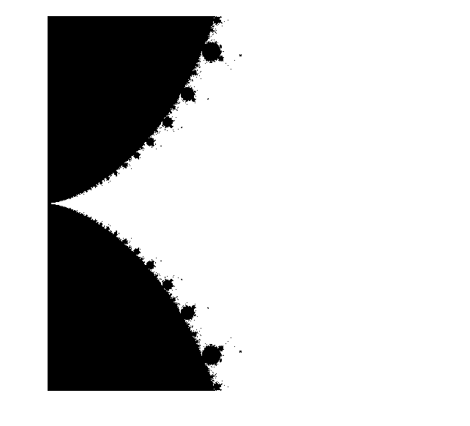

r=0.125

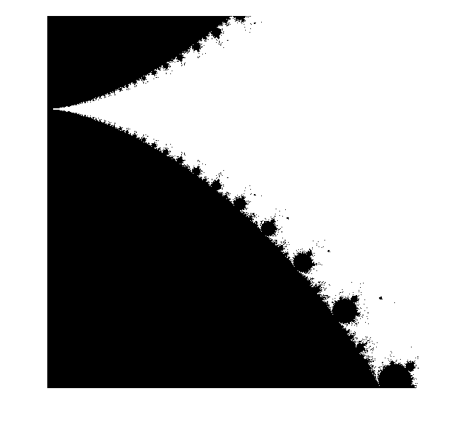

r=0.05

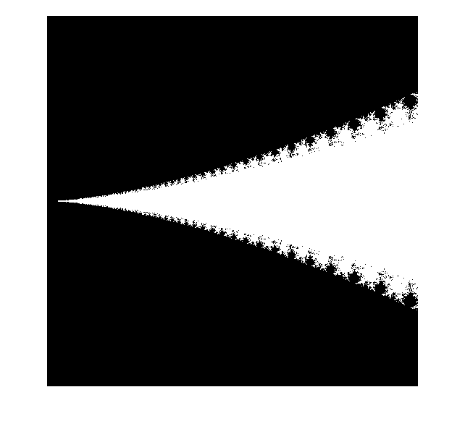

r=0.01. We can clearly see the fractal copies at every scale.