Problem 3

1. The program was implemented correctly. We tried N=16 and P=8 and below is the running result in terminal:



1. We tried generating random numbers with range [1~10000000]. The program was executed with P=1,2,3,4,8 processors. Every test was done 8 times and we averaged the result.

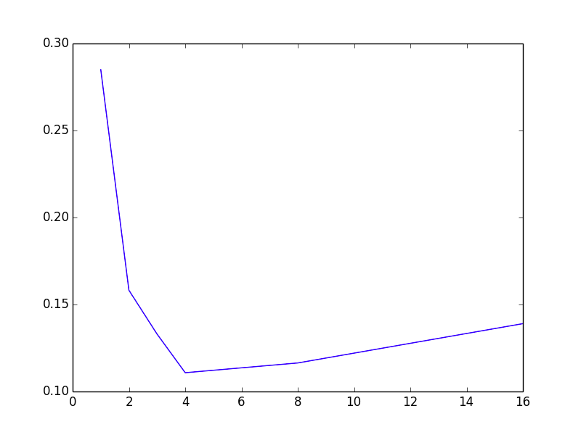

The speedup is optimal when P=4 but the efficiency decreases when P=8. Furthermore we tried P=16 and noticed the clear decrease in speedup.

**Conclusion**: There is a certain ‘optimal’ number of processors for some amount of data. The reason why speedup start to decrease as P grows after the ‘optimal’ number may be due to the increase of number of chunks, which will increase the number of computation steps.

