ITEC 620 - Assignment 2

Johnson ODEJIDE

2022-11-06

## Load required libraries

library(tidyverse) # Required for forecasting - HoltsWinter

## -- Attaching packages --------------------------------------- tidyverse 1.3.2 --  
## v ggplot2 3.3.6 v purrr 0.3.5   
## v tibble 3.1.8 v dplyr 1.0.10  
## v tidyr 1.2.1 v stringr 1.4.0   
## v readr 2.1.3 v forcats 0.5.2   
## -- Conflicts ------------------------------------------ tidyverse_conflicts() --  
## x dplyr::filter() masks stats::filter()  
## x dplyr::lag() masks stats::lag()

library(arules) # Required for association rules - apriori

## Loading required package: Matrix  
##   
## Attaching package: 'Matrix'  
##   
## The following objects are masked from 'package:tidyr':  
##   
## expand, pack, unpack  
##   
##   
## Attaching package: 'arules'  
##   
## The following object is masked from 'package:dplyr':  
##   
## recode  
##   
## The following objects are masked from 'package:base':  
##   
## abbreviate, write

# *Section 1 - Association Rules*

## Read data from csv file

principal <- read_csv("../../assignments/02/Dataset/Principal.csv", show_col_types = FALSE)

## Transform data to binary from numbers

principal.binary <- principal >= 0.1

# (A)

rules <- apriori(principal.binary, parameter = list(supp = 0.03, conf = 0.08))

## Apriori  
##   
## Parameter specification:  
## confidence minval smax arem aval originalSupport maxtime support minlen  
## 0.08 0.1 1 none FALSE TRUE 5 0.03 1  
## maxlen target ext  
## 10 rules TRUE  
##   
## Algorithmic control:  
## filter tree heap memopt load sort verbose  
## 0.1 TRUE TRUE FALSE TRUE 2 TRUE  
##   
## Absolute minimum support count: 23   
##   
## set item appearances ...[0 item(s)] done [0.00s].  
## set transactions ...[9 item(s), 784 transaction(s)] done [0.00s].  
## sorting and recoding items ... [9 item(s)] done [0.00s].  
## creating transaction tree ... done [0.00s].  
## checking subsets of size 1 2 done [0.00s].  
## writing ... [14 rule(s)] done [0.00s].  
## creating S4 object ... done [0.00s].

princip.rules <- sort(rules, by = "confidence")  
inspect(princip.rules)

## lhs rhs support confidence coverage lift   
## [1] {} => {StockIndex} 0.29336735 0.29336735 1.0000000 1.0000000  
## [2] {} => {BondIndex} 0.25765306 0.25765306 1.0000000 1.0000000  
## [3] {LargeCap} => {StockIndex} 0.03061224 0.23529412 0.1301020 0.8020460  
## [4] {} => {AggroCap} 0.20918367 0.20918367 1.0000000 1.0000000  
## [5] {BondIndex} => {StockIndex} 0.04591837 0.17821782 0.2576531 0.6074903  
## [6] {StockIndex} => {BondIndex} 0.04591837 0.15652174 0.2933673 0.6074903  
## [7] {} => {MidCap} 0.15178571 0.15178571 1.0000000 1.0000000  
## [8] {AggroCap} => {StockIndex} 0.03061224 0.14634146 0.2091837 0.4988335  
## [9] {} => {SmallCap} 0.13647959 0.13647959 1.0000000 1.0000000  
## [10] {} => {LargeCap} 0.13010204 0.13010204 1.0000000 1.0000000  
## [11] {} => {DiamondBond} 0.11862245 0.11862245 1.0000000 1.0000000  
## [12] {StockIndex} => {LargeCap} 0.03061224 0.10434783 0.2933673 0.8020460  
## [13] {StockIndex} => {AggroCap} 0.03061224 0.10434783 0.2933673 0.4988335  
## [14] {} => {PlatinumBond} 0.09183673 0.09183673 1.0000000 1.0000000  
## count  
## [1] 230   
## [2] 202   
## [3] 24   
## [4] 164   
## [5] 36   
## [6] 36   
## [7] 119   
## [8] 24   
## [9] 107   
## [10] 102   
## [11] 93   
## [12] 24   
## [13] 24   
## [14] 72

# (B)

With a lift ratio of 0.61, it simply means that it is 61% less likely that those with Bond Index also have a stock index. We could say that the relationship is negligible.

# *Section 2 - Forecasting*

## Read csv from file

phoneplans <- read_csv("../../assignments/02/Dataset/PhonePlans.csv", show_col_types = FALSE)

# (A)

## Plot of the time series for Land lines in Developing Countries

landlinedeving.ts <- ts(phoneplans$LandLinesDeveloping, start = 2005, frequency = 1)  
plot(landlinedeving.ts)

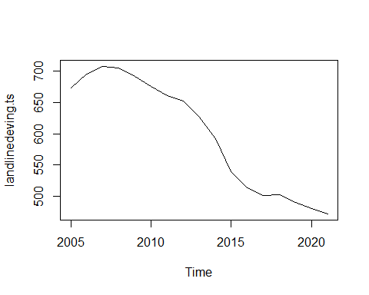

# (B)

## Single Exponential Model for Land lines for Developing Countries

model_landdeving.SESmodel <- HoltWinters(landlinedeving.ts, beta = FALSE, gamma = FALSE)  
plot(model_landdeving.SESmodel, main = "Land lines for developing countries")

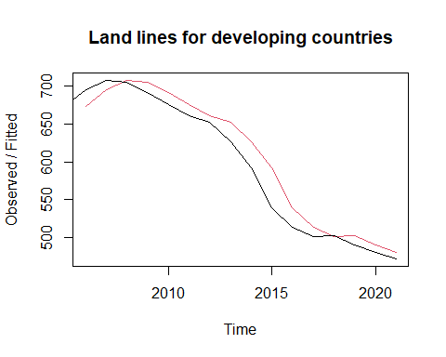

## Single Exponential model for Mobile plans for developing countries

mobplandeving.ts <- ts(phoneplans$MobilePlansDeveloping, start = 2005, frequency = 1)  
model_mobplandeving.SESmodel <- HoltWinters(mobplandeving.ts, beta = FALSE, gamma = FALSE)  
plot(model_mobplandeving.SESmodel, main = "Mobile plans for developing countries")

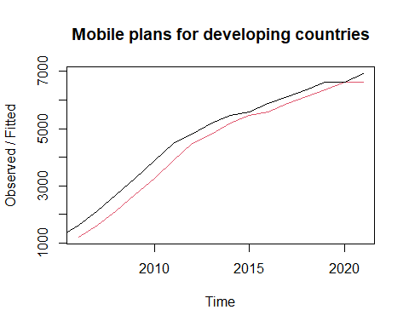

# (C)

## Predict number of land lines for developing countries in 2022

The number of land lines for developing countries in 2022 is predicted to be ***471***

predict(model_landdeving.SESmodel, 1)

## Time Series:  
## Start = 2022   
## End = 2022   
## Frequency = 1   
## fit  
## [1,] 471.4006

## Predict the number of mobile plans for developing countries in 2022

The number of mobile plans for developing countries in 2022 is predicted to be ***6921***

predict(model_mobplandeving.SESmodel, 1)

## Time Series:  
## Start = 2022   
## End = 2022   
## Frequency = 1   
## fit  
## [1,] 6921.087

# (D)

Yes, by tweaking the alpha to a value that yields the best result. Other than that, we may have to use the double exponential smoothing model since there’s a ***trend*** in the patterns of the forecast.