The Minnesota Department of Transportation contacted me about building a dashboard to help their team monitor traffic patterns. Their goal was to learn more about:

* Traffic volume throughout the year; ideally organized by year, month, week, day, and hour
* Traffic volume in various weather conditions
* Traffic volume on different holidays

Knowing traffic patterns under these conditions will help the team make important infrastructure decisions.

They provide the Metro Interstate Traffic Volume data in csv format. To download the data, click here

To answer their questions, I provided this dashboard

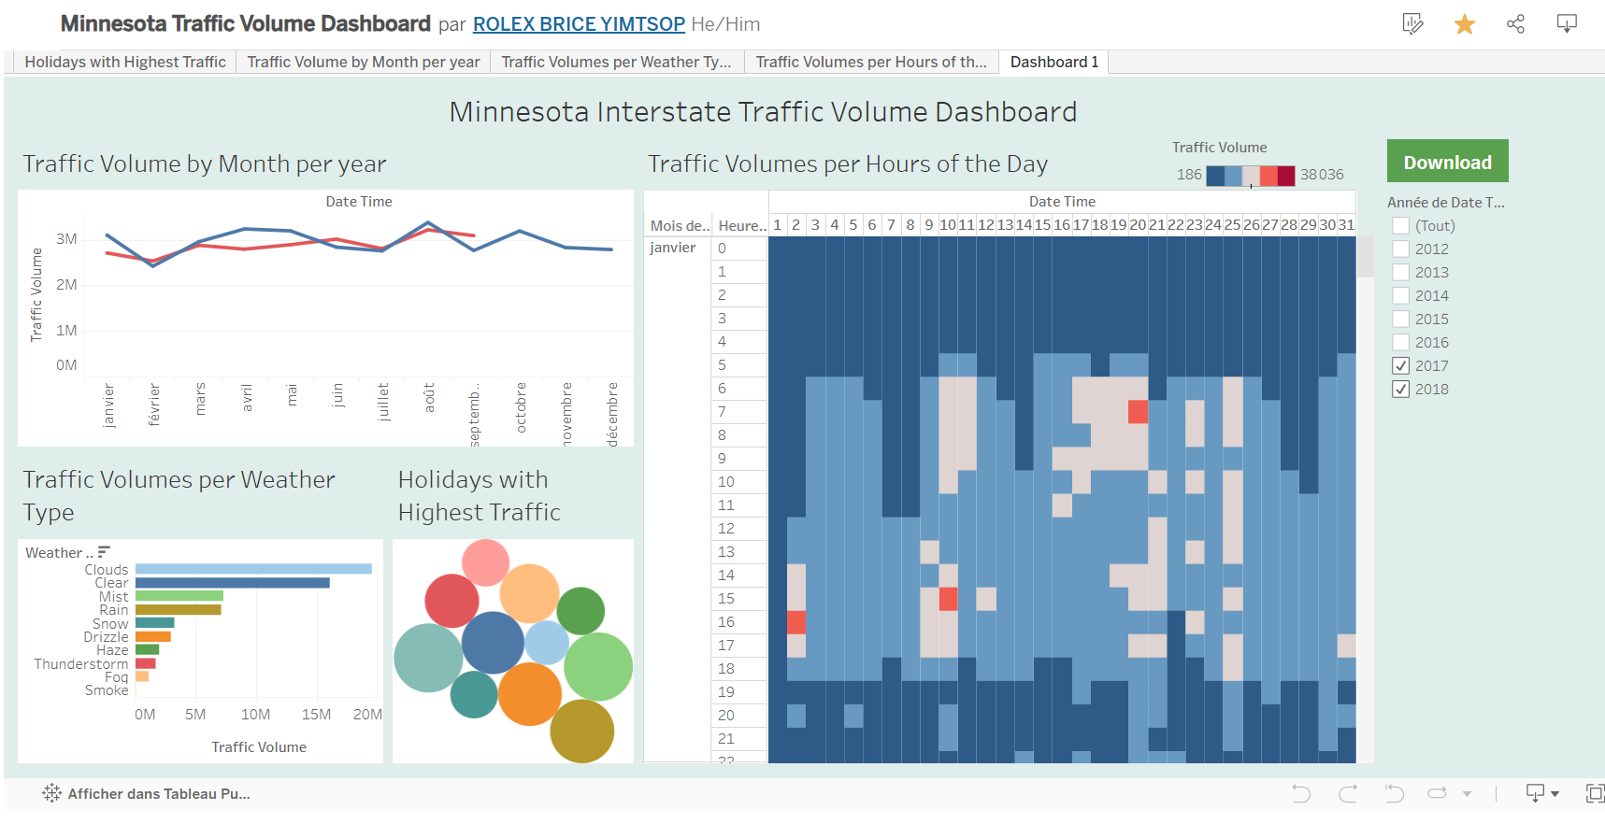

To view the entire dashboard on my Tableau account, [click here](https://public.tableau.com/views/MinnesotaTrafficVolume_17401590182630/Dashboard1?:language=fr-FR&:sid=&:redirect=auth&:display_count=n&:origin=viz_share_link)

Note: to answer the question about holiday with highest traffic volume, I did a calculation on Tableau in the data column “traffic volume’’ with the code **IF[Holiday] = “null” THEN null ELSE “X” END** to create a new column called “IS_HOLIDAY”. From there I was able to filter the data with the metric “IS_HOLIDAY”.

After the dashboard, a presentation was done on PowerPoint to present the key insight to the stakeholder.

To view the presentation, [click here](My_Minnesota_Interstate_Traffic_Volume.pptx)