毕业设计(英文翻译)

题 目 基于Springboot+ElasticSearch的 vlog共享平台的设计与实现
学院名称 船山学院
指导教师 蒋良卫
职 称 讲师
班 级 船本20软件04班
学 号 20209350401
学生姓名 尹建栋

2023年12月24日

Advances in Computer, Signals and Systems (2022) Clausius Scientific Press, Canada
DOI: 10.23977/acss.2022.060604 ISSN 2371-8838 Vol. 6 Num. 6

Design and Implementation of Student Information Management System Based on Springboot
Yu Yang
College of Information Engineering, Guangzhou Vocational and Technical University of Science and Technology, Guangzhou, 510555, China

Keywords: Springboot, Student information management, Graduation thesis, Vue. js, Permission

Abstract: In order to facilitate the teachers in the university during the students' course selection, grades, graduation thesis, employment and other information fine management. The system uses the Springboot framework at the back end, the Vue js framework at the front end, and the mysql database to develop the student information management system. The main functions include: teacher information management, student information management, permission setting management, graduation project management, employment information management, achievement information management and so on.The information management of college students' documents enables teachers to master students' achievements, graduation design and employment information more effectively, and also enables students to understand their own information more quickly and improve work efficiency.

Background

With the emergence of new information technology, people's life style is also changing. At present, the management of student information in colleges and universities is imminent, and some studies have been put forward. The technology is mainly based on B/S architecture ^{[1-5]}, On this basis, MVC three-tier architecture technology is added^{[6-10]}, Some problems were solved. Due to the addition of new business of graduation thesis and employment information in college students, relying only on manual operation is very affect the work efficiency, therefore, this paper designs and implements a set of student information management system based on springboot.

Web Front-End Technology Comparison

The student information management system designed in this paper is developed by the technology of separation of front and back ends. The correct choice of front frame is important to the development schedule. Through the comparison of the current more popular Jquery, Vue. js, Angular. js, Recat.js front-end framework,Vue.js framework has the advantages of small size, convenient modification, fast speed and so on, so the final choice of Vue. js framework as the front-end technology of the design system in this paper.

Back-End Technology Comparison

The choice of back-end development technology will determine the speed of system development, but also determine the scalability of the system. Through the current popular web back-end development framework: springboot, Jersey, Play, Diango, Go, node.js, the springboot framework is the best choice for this system.

Demand Analysis of Student Information Management System Based on Springboot

College student information management system sets up two kinds of user identity: administrator identity and student identity. Each identity can only access content that meets its permissions. The administrator is mainly responsible for the management of students' basic information, including the addition, deletion, change and check of students' information.
Students can only query information relevant to themselves.

Overall System Design

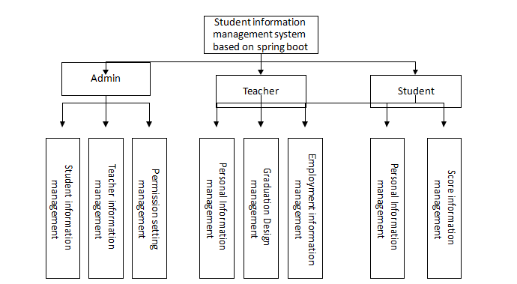

Figure 1: Overall system design

As figure 1，the overall design of the system, including the administrator, teacher and students three modules, in the administrator module has student information management, teacher information management and permission setting management module. Under the teacher module, there are personal information management, graduation design management and employment information management modules. Under the student module, there are personal information management and score information department management module. Among them, teachers can manage students' graduation project, employment information and achievement information.
The main function modules:
    - Student Information module: After successful login, the administrator enters the operation interface, which is mainly responsible for adding, deleting, modifying, and checking the basic information of students.
    - Teacher information module: After the administrator successfully logs in, the operation page is displayed. The administrator is mainly responsible for adding, deleting, modifying, and checking the basic information of the teacher.
    - Permission setting management module: Administrators according to the identity of teachers and students, set the graduation project management, employment information management,

performance information management of the relevant authority functions.
    - Teacher personal information management module: Add, delete, and check the basic information of teachers, professional titles, academic achievements and other information.
    - Student personal information management module: Add, delete, change, check and other operations of students' basic information, grade, grades, graduation project and employment information.。
    - Graduation design management module: Mainly responsible for uploading the proposal report, assignment book, first draft of the paper, second draft of the paper, final draft of the paper, adding, deleting, modifying and checking the defense information and other operations。
    - Employment information management module: Employment unit, start and end time, work content, reward and punishment information and other contents of the addition, deletion, change, check and other operations.

Detailed System Design

2.2.1. Database Design

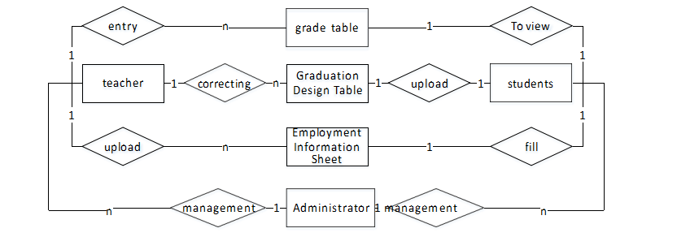
Figure 2: Entity Relationship Diagram

Through the analysis, the main users in the system are: administrators, teachers, students. Administrator: mainly manage the information of teachers and students, set the permission of teachers and students in the graduation design, employment information, achievement information module. Teacher: Mainly manage their own basic information, participate in the management of students' grades, graduation thesis and employment information. Students: Mainly responsible for personal basic information, query results, upload graduation thesis and fill in employment information. The connections between various entities include: a manager can manage multiple teachers and students, belonging to a one-to-many relationship. Each student can only and a score sheet, a graduation design table, employment, belong to the relationship of 1 to 1. Teachers can manage multiple score sheets, graduation design sheets, employment information sheets, which belong to a large relationship, as shown in Figure 2.

System Test and Implementation

Login Module Test

The administrator needs to log in first, and then can manage related information. Determine the login user's identity based on the login account. If the login fails, an error message will be given, as shown in Figure 3.

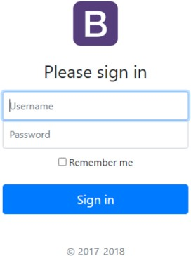

Figure 3: System login

In Figure 3, Chinese and English conversion is set in the login interface. The basic information of the user is obtained through the login form, and whether the user has logged in is judged by querying the database. If the user has logged in, the user is released. If you are not logged in, the system displays "No permission, please log in first" and returns to the login page.

3.2 Teacher Information Management Module Test

After the administrator login successfully, you can manage the basic information of the students and teachers, the grades management, graduation thesis management, employment information management and other modules for authority management, to the teacher information management module, you can add, delete, change, check and other operations of the teacher's information.
As Figure 4, the teacher management module is used for demonstration. Other functional modules are similar to the teacher management module, which can add, delete, change and check the table.

Conclusion

This system combined with the actual needs, analyzes the problem of information asymmetry between administrators, teachers and students in college. The back end uses springboot framework, the front end uses vue.js framework, the database uses mysql, the development of college student information management system. It effectively solves the information exchange between teachers and students, and also reduces the redundancy of data.

Reference

- Liu Z, Wang H, Zan H. Design and implementation of student information management system//2010 International symposium on intelligence information processing and trusted computing. IEEE, 2010: 607-610.
- Yue Z, Jin Y. The development and design of the student management system based on the network environment// 2010 International conference on multimedia communications. IEEE, 2010: 5-8.
- Zhang Y, Li Z, Wen Y, et al. Design and implement of international students’ management and security warning system based on B/S architecture//International Conference of Pioneering Computer Scientists, Engineers and Educators. Springer, Singapore, 2018: 623-631.
- Xianli L, Ping W, Guosong L, et al. Research On Student Comprehensive Quality Management Information System Based On B/S Architecture//2021 18th International Computer Conference on Wavelet Active Media Technology and Information Processing (ICCWAMTIP). IEEE, 2021: 471-473.
- Zhu Z M, Xu F Q, Gao X. Research on school intelligent classroom management system based on Internet of Things. Procedia Computer Science, 2020, 166: 144-149.
- Subari A. Development of Information System Based on Web Application for Measuring Educational Performance Indicator Using Codeigniter Framework. Advanced Science Letters, 2018, 24(12): 9520-9522.
- Xiaokun Y. Design and implementation of student status management system based on SSH2 framework technology//2016 International Conference on Smart City and Systems Engineering (ICSCSE). IEEE, 2016: 222-225.
- Lv Z, Zhou C, Zhou C. Design and implementation of ideological and political education evaluation system//Journal of Physics: Conference Series. IOP Publishing, 2019, 1176(4): 042067.
- Xue L. Design and implementation of university students internship employment tracking system based on MVC Framework. Journal of Applied Science and Engineering Innovation, 2015, 2(3): 93-95.
- Li Y, Jing W. Research on Integrated Management System of Physical Education Course Information based on Spring MVC Framework//2022 International Conference on Information System, Computing and Educational Technology (ICISCET). IEEE, 2022: 121-124.

基于Springboot的学生信息管理系统设计与实现
于洋
广州科技大学信息工程学院,广州,510555

摘 要：为方便本校教师对学生选课、成绩、毕业论文、就业等信息进行精细化管理。 系统在后端使用Springboot框架，前端使用Vue js框架，mysql数据库开发学生信息管理系统。 主要功能包括：教师信息管理、学生信息管理、权限设置管理、毕业项目管理、就业信息管理、成绩信息管理等。大学生文书的信息管理，使教师能够更有效地掌握学生的成绩、毕业设计和就业信息，也使学生能够更快速地了解自己的信息，提高工作效率。

关键词：Springboot,学生信息管理,Vue. js，权限

背景资料

随着新信息技术的出现，人们的生活方式也在发生变化。 目前高校学生信息的管理迫在眉睫，已经提出了一些研究。 该技术主要基于B S架构[1]，在此基础上增加了MVC三层架构技术[6-10]，解决了一些问题。 由于大学生毕业论文和就业信息新业务的增加，仅仅依靠人工操作非常影响工作效率，因此，本文设计并实现了一套基于springboot的学生信息管理系统。

Web前端技术对比

本文设计的学生信息管理系统是利用前后端分离技术开发的。 前框的正确选择对开发进度很重要。 通过对比目前比较流行的Jquery，Vue。 js，Angular。 js，重述。js前端框架，Vue。js框架具有体积小、修改方便、速度快等优点，所以最终选择Vue。 js框架作为本文设计系统的前端技术。

后端技术比较
后端开发技术的选择将决定系统开发的速度，同时也决定了系统的可扩展性。 通过目前流行的web后端开发框架：springboot，Jersey，Play，Diango，Go，node。js，springboot框架是这个系统的最佳选择。

基于Springboot的学生信息管理系统需求分析
大学生信息管理系统设置了管理员身份和学生身份两种用户身份。 每个身份只能访问符合其权限的内容。 管理员主要负责学生基本信息的管理，包括学生信息的增删改查。学生只能查询与自己相关的信息。

整体系统设计

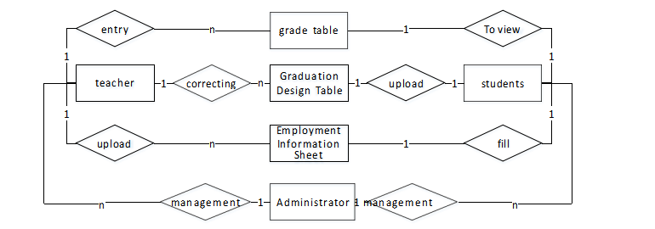

图1：整体系统设计
如图1，系统整体设计，包括管理员、教师和学生三个模块，在管理员模块中有学生信息管理、教师信息管理和权限设置管理模块。 教师模块下设有个人信息管理、毕业设计管理和就业信息管理模块。 在学生模块下，有个人信息管理和分数信息部门管理模块。 其中，教师可以管理学生的毕业项目、就业信息和成绩信息。
主要功能模块:
    - 学生信息模块：登录成功后，管理员进入操作界面，主要负责增加、删除、修改、查看学生基本信息。
    - 教师信息模块：管理员登录成功后，显示操作页面。 管理员主要负责增加、删除、修改和检查教师的基本信息。
    - 权限设置管理模块：管理员根据师生身份，设置毕业项目管理、就业信息管理,

相关权限职能的绩效信息管理。
    - 教师个人信息管理模块：对教师基本信息、职称、学术成果等信息进行添加、删除、核对。
    - 学生个人信息管理模块：对学生的基本信息、年级、成绩、毕业项目和就业信息进行增删改查等操作。。
    - 毕业设计管理模块：主要负责上传提案报告、作业本、论文初稿、论文二稿、论文定稿、答辩信息的增删改查等操作。
    - 用工信息管理模块：用工单位、起止时间、工作内容、奖惩信息等内容的增删改查等操作。

详细的系统设计

数据库设计

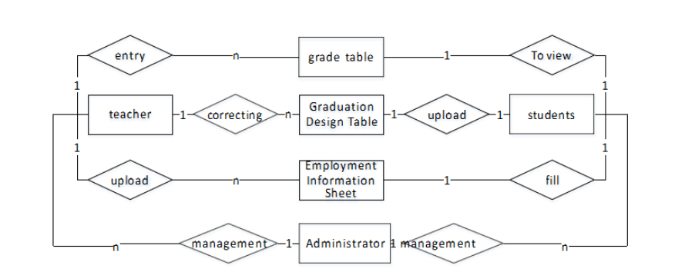

图2：实体关系图
通过分析，系统中的主要用户有：管理员、教师、学生。 管理员：主要管理师生的信息，在毕业设计、就业信息、成绩信息模块中设置师生的权限。 师：主要管理自己的基本信息，参与管理学生的成绩、毕业论文和就业信息。 生：主要负责个人基本信息、查询成绩、上传毕业论文和填写就业信息。 各个实体之间的联系包括：一个管理者可以管理多个教师和学生，属于一对多的关系。 每个学生只能和一张成绩表，一张毕业设计表，就业，属于1比1的关系。 教师可以管理多张成绩表、毕业设计表、就业信息表，属于一个很大的关系，如图2所示。

系统测试与实现
登录模块测试
管理员需要先登录，然后才能管理相关信息。 根据登录账号确定登录用户的身份。 如果登录失败，将给出错误消息，如图3所示。

图3 系统登录
在图3中，在登录界面中设置了中英文转换。 通过登录表单获取用户的基本信息，通过查询数据库判断用户是否已登录。 如果用户已登录，则释放该用户。 如果您没有登录，系统显示"没有权限，请先登录"并返回登录页面。

教师信息管理模块测试
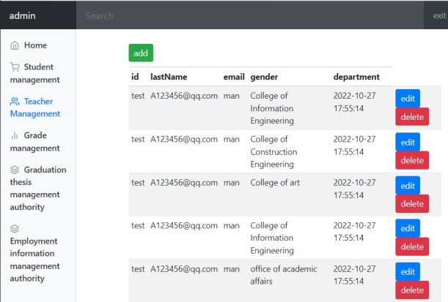
管理员登录成功后，可以对师生基本信息进行管理，对成绩管理、毕业论文管理、就业信息管理等模块进行权限管理，到教师信息管理模块，可以对教师信息
图4：学生信息查询结果

如图4所示，教师管理模块用于演示。 其他功能模块与教师管理模块类似，可以对表进行增删改查。

结论
本系统结合实际需求，分析了高校行政人员、教师和学生之间的信息不对称问题。 后端使用springboot框架，前端使用vue。js框架，数据库采用mysql，开发大学生信息管理系统。 它有效地解决了师生之间的信息交换，也减少了数据的冗余。

