PACKING LIST
SICHUAN BO NI SENG TECHNOLOGY Co. LTD
2601 WESTGATE DR STE 12
pearland, TX 77581-7417
US
+1-409-370-3285

Ship From
IUSJ
36900 West 4th Street BEAUMONT, CA 92223 US
Amazon ID: APDAT9C0AQQ9

Packing List Date: Shipment ID:  Shipment Name: SKU Total:  Unit Total: | 12/12/2025  FBA1961YHSPH  FBA ASDN (01/12/2026 01:27)-SBD1  1  132

Ship To:
Amazon Fullfilment Center (SBD1)



Shipment Items

Signature:
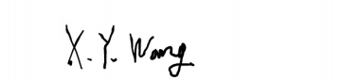

FNSKU | Seller SKU | Product Name | Shipped Quantity
X004S72631 | New-2pc pet can cover-BO | Lydia's Deal 2 Pack Pet Food Can Covers, Universal Silicone Can Lids for Dog & Cat Food, Fits Most Standard Size Food Cans, BPA Free & Dishwasher Safe (Blue + Orange) | 132

Name of Authorized Signatory:
Xiaoyu Wang

