PACKING LIST
SICHUAN BO NI SENG TECHNOLOGY Co. LTD
2601 WESTGATE DR STE 12
pearland, TX 77581-7417
US
+1-409-370-3285

Ship From
IUSJ
36900 West 4th Street BEAUMONT, CA 92223 US
Amazon ID: APDAT9C0AQQ9

Packing List Date: Shipment ID:  Shipment Name: SKU Total:  Unit Total: | 12/12/2025  FBA1961YHSPH  FBA ASDN (01/12/2026 01:27)-SBD1  1  132

Ship To:
Amazon Fulfillment Center (SBD1)

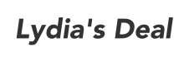

Shipment Items

FNSKU | Seller SKU | Shipped Quantity
X004S72631 | New-2pc pet can cover-BO | 132
Signature:
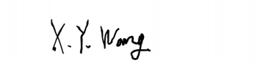

Name of Authorized Signatory:
Xiaoyu Wang

