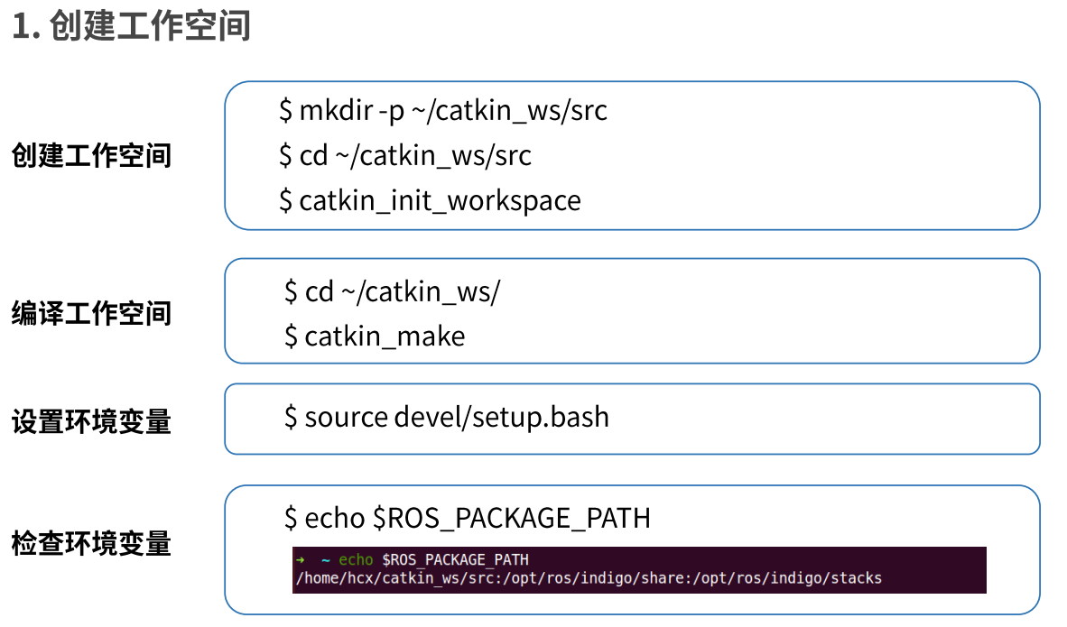

创建工作空间：

1.在主目录下，新建一个文件夹，并命名为catkin_ws

2.在catkin_ws目录下新建一个src文件夹

3.在src区域内，右击，选择在终端中打开

4.进入如图所示界面：

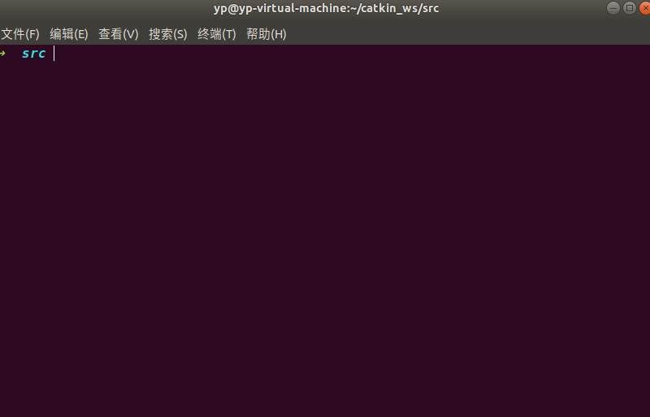

5.在终端中输入

catkin_init_workspace

得到下图所示：



即在src目录下创建了一个CMake文件

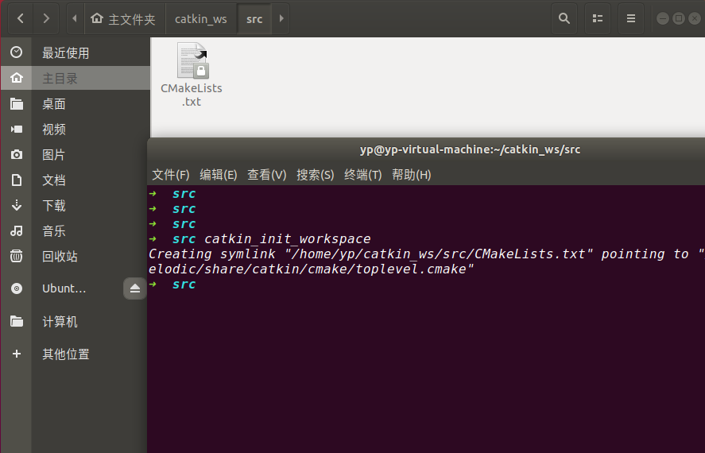

编译工作空间：

1.进入到catkin_ws目录下;

2.使用catkin_make进行编译

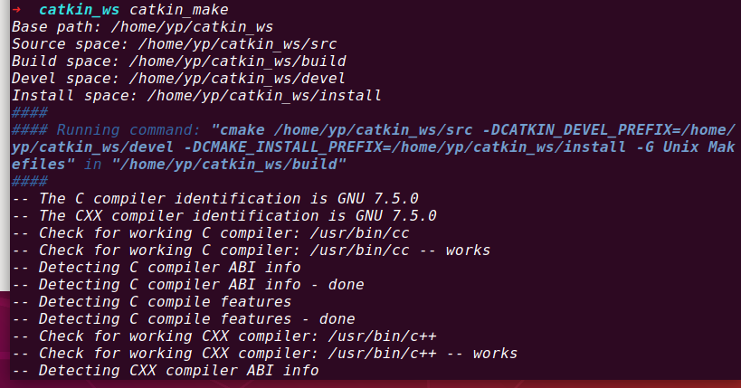

显示如下界面，表示编译成成功

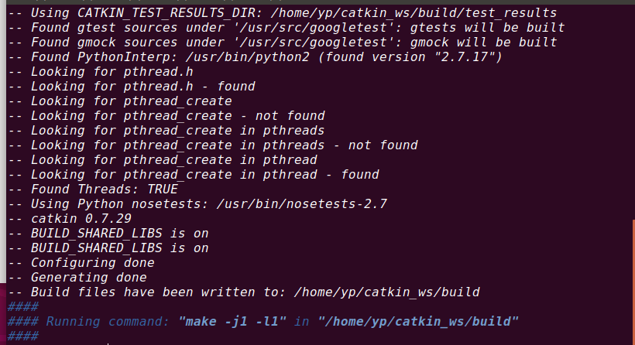

并且在src根目录下新出现了两个文件夹：

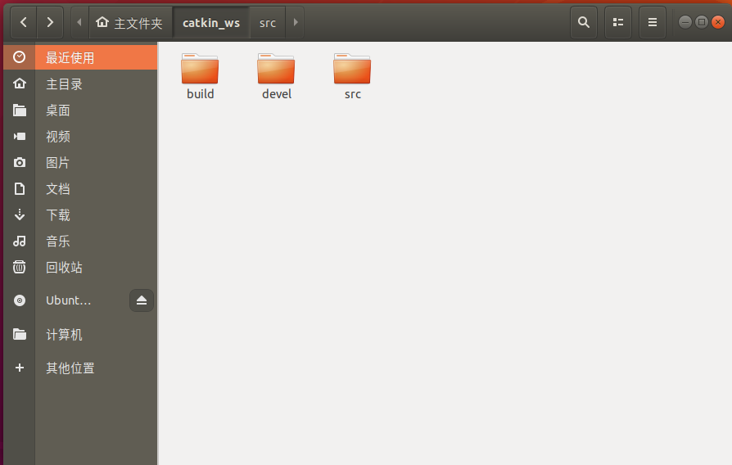

设置环境变量：作用是：让系统知道环境变量放在devel目录下

source devel/setup.zsh

//如果终端是zsh的话，后跟setup.zsh

//如果终端是bash的话，后跟setup.bash

//缺点就是这个环境变量的设置，只能在当前终端下生效，新开一个终端无效

通过如下设置：可以让新打开的环境变量也能实现相同的功能

vi ~/.zshrc

//翻到最后一行，在之前修改了终端bash为zsh后

//添加环境变量如下

source ~/catkin_ws/devel/setup.zsh

//:wq保存退出

打印当前环境变量：

echo $ROS_PACKAGE_PATH

得出下图所示：

clipboard.png

冒号前的是刚才设置的环境变量，冒号后的是ROS安装时系统默认的环境变量地址

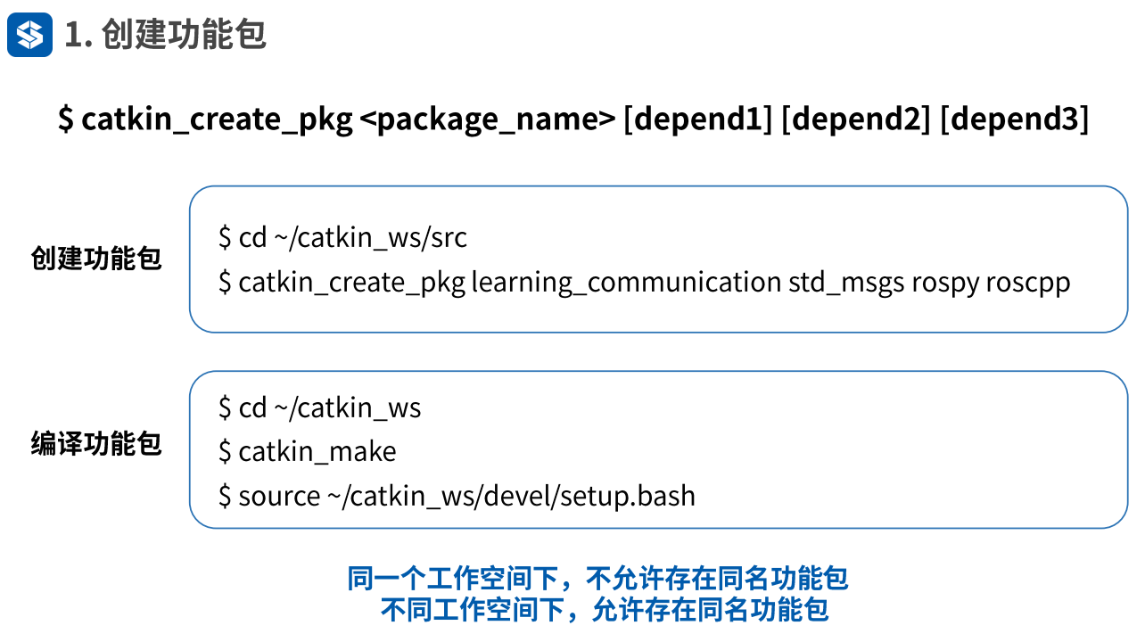

功能包是实现机器人功能所存放的具体代码

package_name是功能包的名字

depend是功能包实现功能所依赖的依赖文件

创建功能包的路径要在刚才新建的文件夹src中进行

如图所示：创建了一个名为learning_communication的功能包，所依赖的文件是类似于c语言的stdio.h文件的std_msgs，python语言rospy，用C++编程的roscpp

catkin_create_pkg learning_communication std_msgs rospy roscpp

当出现下图所示的一些日志，就代表着创建成功：

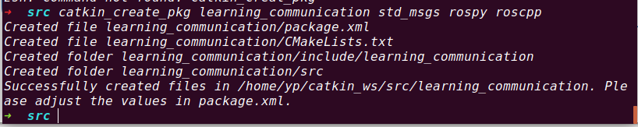

打开src文件：出现了新建的功能包文件

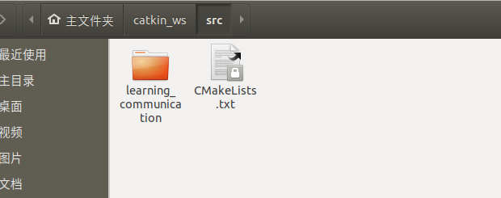

功能包文件里面出现了一些默认文件：

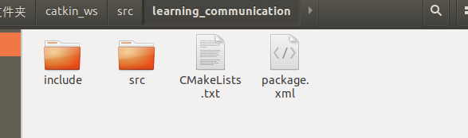

在package.xml文件里如下图：

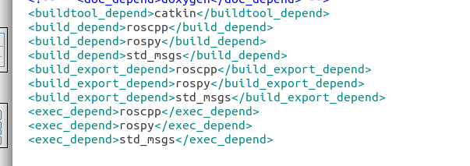

如果后面需要添加新的依赖文件，需要在上述文件中加上依赖文件

回到上级目录catkin_ws下，运行指令：catkin_make

因为src里面已经有一个功能包：learning_package

运行如下：

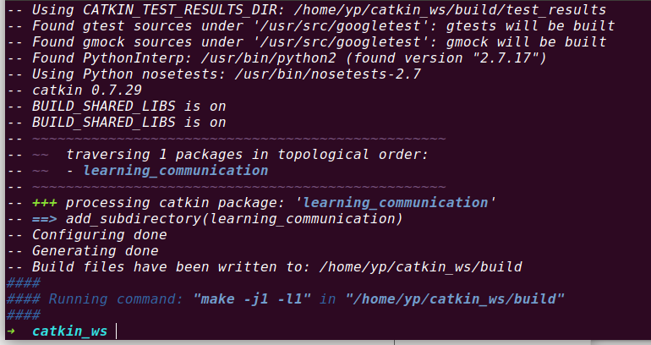

另外，在src中创建功能包时，不能出现同名功能包

那么问题来了，在ROS不同工作空间中出现了多个同名功能包，ROS是如何识别是哪一个功能包的，这依赖于ROS工作空间的Overlaying机制

使用指令：

env | grep ros

查找和ROS相关的指令，如下图：

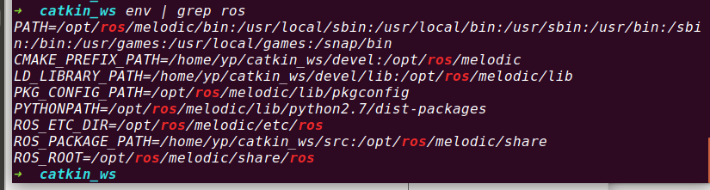

倒数第二行如下：

clipboard.png

可以查看ros功能包的所有路径，ros从前往后依次寻找

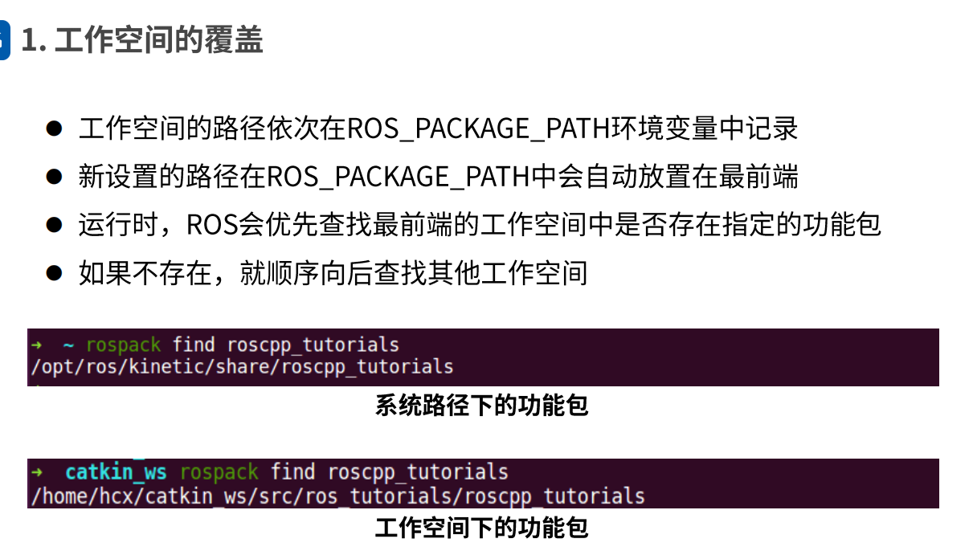

最后设置的环境变量往往最先被查找

安装c++功能包：

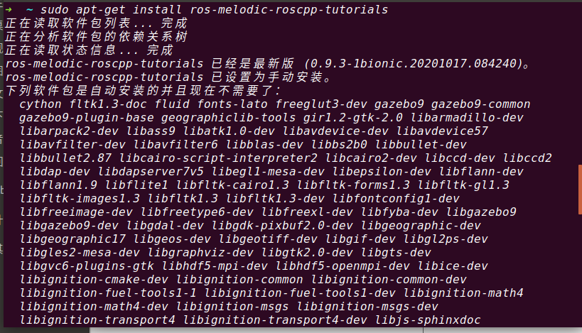

如果想要找到功能包的位置：

rospack find roscpp_tutorials

如下图所示：

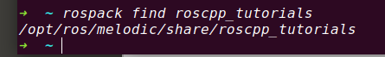

打开文件管理器查看：

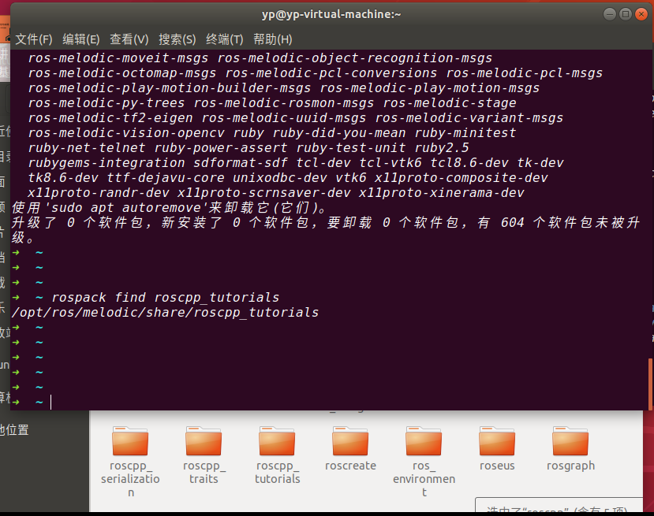

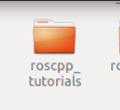

将roscpp_tutorials复制到创建的工作目录src下：

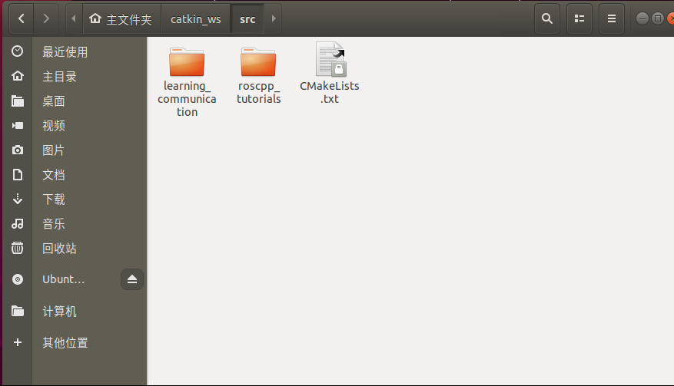

g++编译C++：

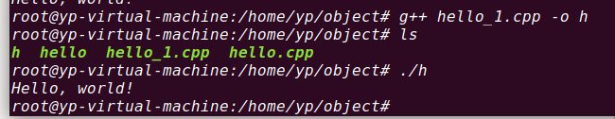

在learning_communication目录文件里面，进入src文件夹，创建talker.cpp文件

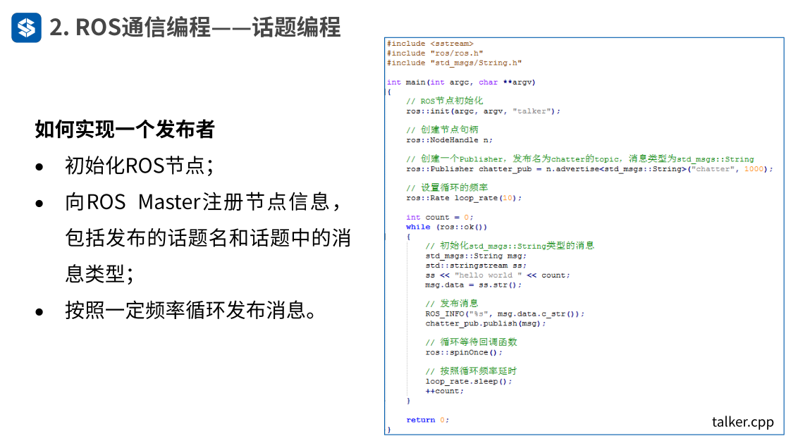

/**

* 该例程将发布chatter话题，消息类型String

*/

#include <sstream>

#include "ros/ros.h"

#include "std_msgs/String.h"

int main(int argc, char **argv)

{

// ROS节点初始化

ros::init(argc, argv, "talker");

//talker是定义整个节点运行起来的名称

// 创建节点句柄

ros::NodeHandle n;

// 创建一个Publisher，发布名为chatter的topic，消息类型为std_msgs::String

ros::Publisher chatter_pub = n.advertise<std_msgs::String>("chatter", 1000);

//1000是指发布者的队列长度，当发布的速度过快时，会把数据存放在这个队列中

//如果发布过快，会把一开始存入的数据覆盖，造成断帧的现象

// 设置循环的频率

ros::Rate loop_rate(10);

int count = 0;

while (ros::ok())

{

// 初始化std_msgs::String类型的消息

std_msgs::String msg;

std::stringstream ss;

ss << "hello world " << count;

msg.data = ss.str();

// 发布消息

ROS_INFO("%s", msg.data.c_str());

chatter_pub.publish(msg);

// 循环等待回调函数

ros::spinOnce();

//无论实现发布者还是订阅者，都要把这个函数放进来

// 按照循环频率延时

loop_rate.sleep();

++count;

}

return 0;

}

同样，在src目录下创建listener.cpp文件

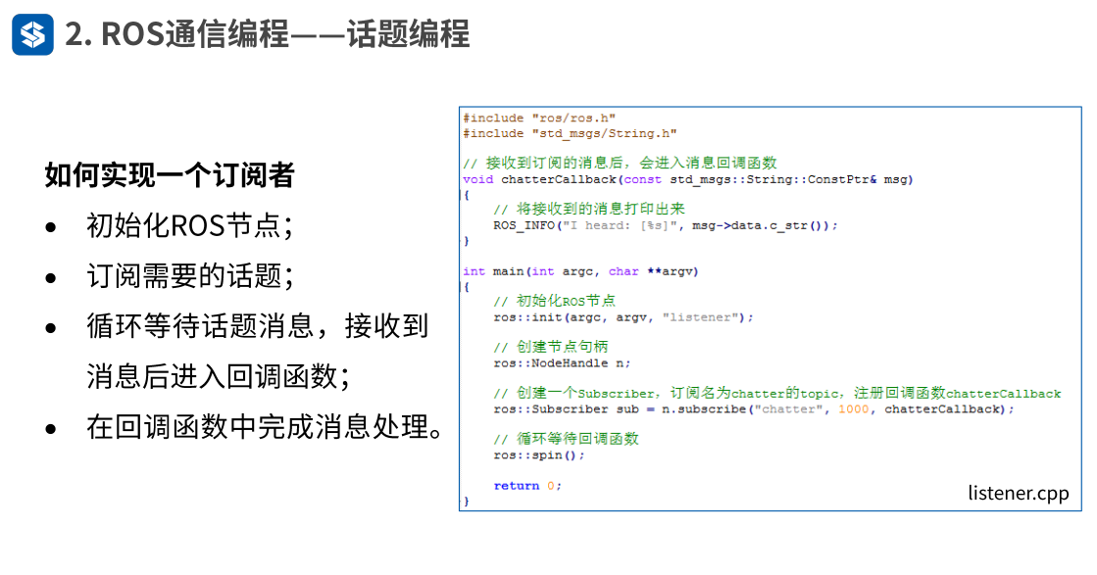

/**

* 该例程将订阅chatter话题，消息类型String

*/

#include "ros/ros.h"

#include "std_msgs/String.h"

// 接收到订阅的消息后，会进入消息回调函数

void chatterCallback(const std_msgs::String::ConstPtr& msg)

{

// 将接收到的消息打印出来

ROS_INFO("I heard: [%s]", msg->data.c_str());

}

int main(int argc, char **argv)

{

// 初始化ROS节点

ros::init(argc, argv, "listener");

// 创建节点句柄

ros::NodeHandle n;

// 创建一个Subscriber，订阅名为chatter的topic，注册回调函数chatterCallback

ros::Subscriber sub = n.subscribe("chatter", 1000, chatterCallback);

// 循环等待回调函数

ros::spin();

return 0;

}

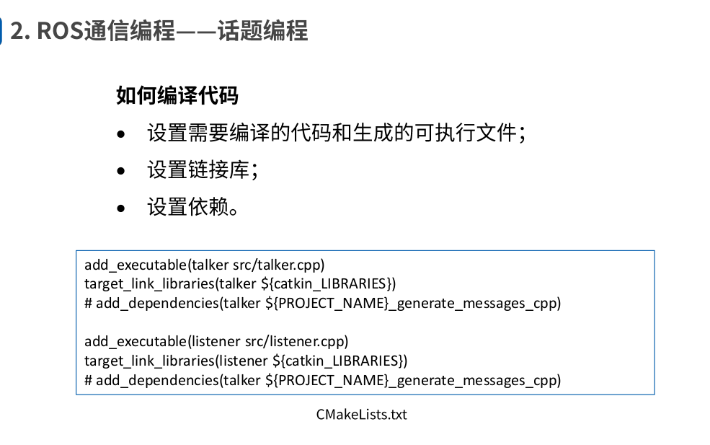

在CMakeList.txt文件里面执行下述操作：

add_executable(talker src/talker.cpp)

target_link_libraries(talker ${catkin_LIBRARIES})

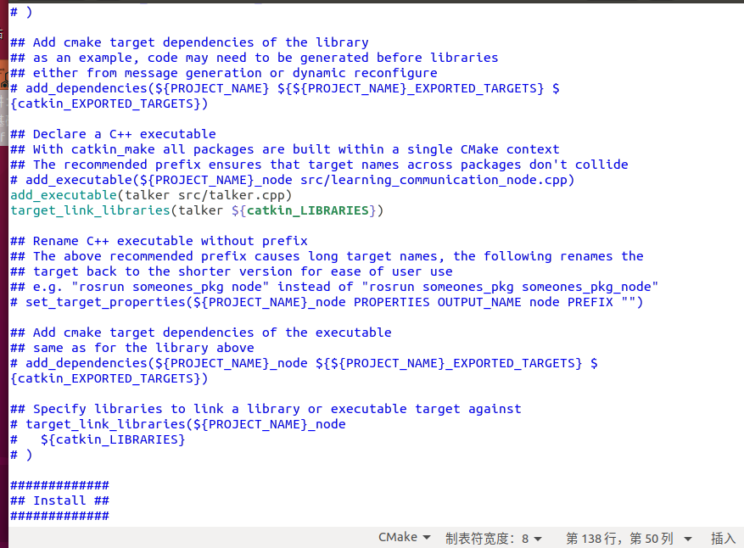

如有更多的可执行文件需要加入：

例如1.cpp，2.cpp

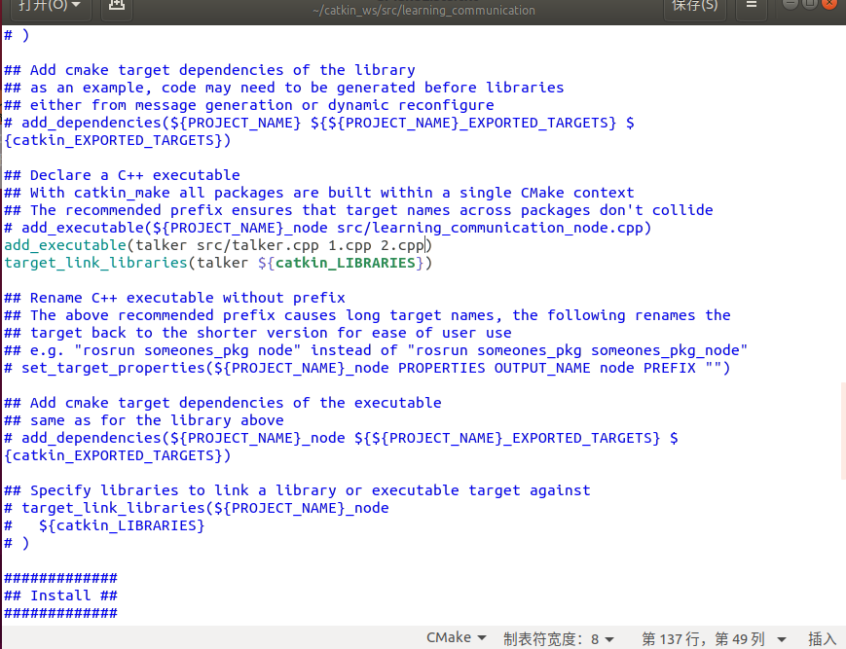

添加完talker.cpp，在添加listener.cpp

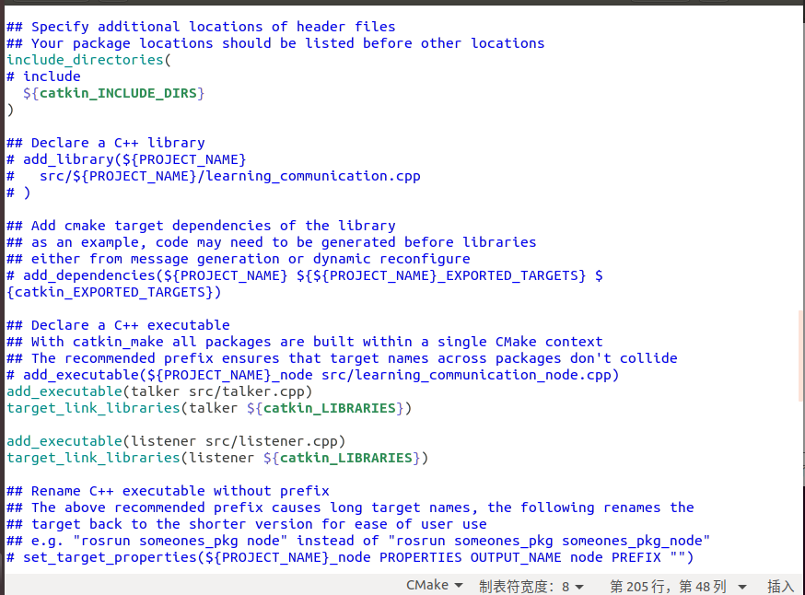

全部代码如下：

cmake_minimum_required(VERSION 3.0.2)

project(learning_communication)

## Compile as C++11, supported in ROS Kinetic and newer

# add_compile_options(-std=c++11)

## Find catkin macros and libraries

## if COMPONENTS list like find_package(catkin REQUIRED COMPONENTS xyz)

## is used, also find other catkin packages

find_package(catkin REQUIRED COMPONENTS

roscpp

rospy

std_msgs

)

## System dependencies are found with CMake's conventions

# find_package(Boost REQUIRED COMPONENTS system)

## Uncomment this if the package has a setup.py. This macro ensures

## modules and global scripts declared therein get installed

## See http://ros.org/doc/api/catkin/html/user_guide/setup_dot_py.html

# catkin_python_setup()

################################################

## Declare ROS messages, services and actions ##

################################################

## To declare and build messages, services or actions from within this

## package, follow these steps:

## * Let MSG_DEP_SET be the set of packages whose message types you use in

## your messages/services/actions (e.g. std_msgs, actionlib_msgs, ...).

## * In the file package.xml:

## * add a build_depend tag for "message_generation"

## * add a build_depend and a exec_depend tag for each package in MSG_DEP_SET

## * If MSG_DEP_SET isn't empty the following dependency has been pulled in

## but can be declared for certainty nonetheless:

## * add a exec_depend tag for "message_runtime"

## * In this file (CMakeLists.txt):

## * add "message_generation" and every package in MSG_DEP_SET to

## find_package(catkin REQUIRED COMPONENTS ...)

## * add "message_runtime" and every package in MSG_DEP_SET to

## catkin_package(CATKIN_DEPENDS ...)

## * uncomment the add_*_files sections below as needed

## and list every .msg/.srv/.action file to be processed

## * uncomment the generate_messages entry below

## * add every package in MSG_DEP_SET to generate_messages(DEPENDENCIES ...)

## Generate messages in the 'msg' folder

# add_message_files(

# FILES

# Message1.msg

# Message2.msg

# )

## Generate services in the 'srv' folder

# add_service_files(

# FILES

# Service1.srv

# Service2.srv

# )

## Generate actions in the 'action' folder

# add_action_files(

# FILES

# Action1.action

# Action2.action

# )

## Generate added messages and services with any dependencies listed here

# generate_messages(

# DEPENDENCIES

# std_msgs

# )

################################################

## Declare ROS dynamic reconfigure parameters ##

################################################

## To declare and build dynamic reconfigure parameters within this

## package, follow these steps:

## * In the file package.xml:

## * add a build_depend and a exec_depend tag for "dynamic_reconfigure"

## * In this file (CMakeLists.txt):

## * add "dynamic_reconfigure" to

## find_package(catkin REQUIRED COMPONENTS ...)

## * uncomment the "generate_dynamic_reconfigure_options" section below

## and list every .cfg file to be processed

## Generate dynamic reconfigure parameters in the 'cfg' folder

# generate_dynamic_reconfigure_options(

# cfg/DynReconf1.cfg

# cfg/DynReconf2.cfg

# )

###################################

## catkin specific configuration ##

###################################

## The catkin_package macro generates cmake config files for your package

## Declare things to be passed to dependent projects

## INCLUDE_DIRS: uncomment this if your package contains header files

## LIBRARIES: libraries you create in this project that dependent projects also need

## CATKIN_DEPENDS: catkin_packages dependent projects also need

## DEPENDS: system dependencies of this project that dependent projects also need

catkin_package(

# INCLUDE_DIRS include

# LIBRARIES learning_communication

# CATKIN_DEPENDS roscpp rospy std_msgs

# DEPENDS system_lib

)

###########

## Build ##

###########

## Specify additional locations of header files

## Your package locations should be listed before other locations

include_directories(

# include

${catkin_INCLUDE_DIRS}

)

## Declare a C++ library

# add_library(${PROJECT_NAME}

# src/${PROJECT_NAME}/learning_communication.cpp

# )

## Add cmake target dependencies of the library

## as an example, code may need to be generated before libraries

## either from message generation or dynamic reconfigure

# add_dependencies(${PROJECT_NAME} ${${PROJECT_NAME}_EXPORTED_TARGETS} ${catkin_EXPORTED_TARGETS})

## Declare a C++ executable

## With catkin_make all packages are built within a single CMake context

## The recommended prefix ensures that target names across packages don't collide

# add_executable(${PROJECT_NAME}_node src/learning_communication_node.cpp)

add_executable(talker src/talker.cpp)

target_link_libraries(talker ${catkin_LIBRARIES})

add_executable(listener src/listener.cpp)

target_link_libraries(listener ${catkin_LIBRARIES})

## Rename C++ executable without prefix

## The above recommended prefix causes long target names, the following renames the

## target back to the shorter version for ease of user use

## e.g. "rosrun someones_pkg node" instead of "rosrun someones_pkg someones_pkg_node"

# set_target_properties(${PROJECT_NAME}_node PROPERTIES OUTPUT_NAME node PREFIX "")

## Add cmake target dependencies of the executable

## same as for the library above

# add_dependencies(${PROJECT_NAME}_node ${${PROJECT_NAME}_EXPORTED_TARGETS} ${catkin_EXPORTED_TARGETS})

## Specify libraries to link a library or executable target against

# target_link_libraries(${PROJECT_NAME}_node

# ${catkin_LIBRARIES}

# )

#############

## Install ##

#############

# all install targets should use catkin DESTINATION variables

# See http://ros.org/doc/api/catkin/html/adv_user_guide/variables.html

## Mark executable scripts (Python etc.) for installation

## in contrast to setup.py, you can choose the destination

# catkin_install_python(PROGRAMS

# scripts/my_python_script

# DESTINATION ${CATKIN_PACKAGE_BIN_DESTINATION}

# )

## Mark executables for installation

## See http://docs.ros.org/melodic/api/catkin/html/howto/format1/building_executables.html

# install(TARGETS ${PROJECT_NAME}_node

# RUNTIME DESTINATION ${CATKIN_PACKAGE_BIN_DESTINATION}

# )

## Mark libraries for installation

## See http://docs.ros.org/melodic/api/catkin/html/howto/format1/building_libraries.html

# install(TARGETS ${PROJECT_NAME}

# ARCHIVE DESTINATION ${CATKIN_PACKAGE_LIB_DESTINATION}

# LIBRARY DESTINATION ${CATKIN_PACKAGE_LIB_DESTINATION}

# RUNTIME DESTINATION ${CATKIN_GLOBAL_BIN_DESTINATION}

# )

## Mark cpp header files for installation

# install(DIRECTORY include/${PROJECT_NAME}/

# DESTINATION ${CATKIN_PACKAGE_INCLUDE_DESTINATION}

# FILES_MATCHING PATTERN "*.h"

# PATTERN ".svn" EXCLUDE

# )

## Mark other files for installation (e.g. launch and bag files, etc.)

# install(FILES

# # myfile1

# # myfile2

# DESTINATION ${CATKIN_PACKAGE_SHARE_DESTINATION}

# )

#############

## Testing ##

#############

## Add gtest based cpp test target and link libraries

# catkin_add_gtest(${PROJECT_NAME}-test test/test_learning_communication.cpp)

# if(TARGET ${PROJECT_NAME}-test)

# target_link_libraries(${PROJECT_NAME}-test ${PROJECT_NAME})

# endif()

## Add folders to be run by python nosetests

# catkin_add_nosetests(test)

回到catkin_ws目录下，执行编译，运行catkin_make