Relative Centroid Index (RCI): A Novel Scale-Independent Metric for Assessing Hydrological Distributions across Hierarchical River Networks
Ziyun Yin¹, Peirong Lin^{1,*}, Dai Yamazaki², Haomei Lin¹, Fenghe Zhang¹
1 Institute of Remote Sensing and GIS, School of Earth and Space Sciences, Peking University
2 Institute of Industrial Science, The University of Tokyo
* Corresponding to: Peirong Lin (peironglinlin@pku.edu.cn)
Confidential manuscript revised at Water Resources Research, March XXXst, 2026

Key Points
- We propose a network-aware Relative Centroid Index (RCI) to enable consistent comparison of water mass balance locations across basins and spatial scales.
- We demonstrate the effectiveness of RCI in Poyang River Basin and cross-compare the RCI patterns for 40 global major river basins
- Runoff centroids systematically deviate from geometric midpoints with downstream bias in most basins, and exhibit pronounced seasonal variability in arid regions.
- Comparing RCI estimates from naturalized and human-perturbed datasets reveals that cross-dataset divergences diagnostically capture human water perturbation signatures.

Abstract
Climate change alters the terrestrial water cycle, but understanding runoff changes across river networks remains challenging due to the multi-scale nested nature of fluvial systems. Traditional assessments rely on gauge data or basin-averaged responses, overlooking internal spatial structure. Here we introduce a network-explicit framework for assessing hydrological centroids along river networks - the Relative Centroid Index (RCI). The RCI is defined as the relative distance from a basin’s outlet by casting the physical definition of centriods to river networks, which for the first time, enables cross-basin and multi-scale intercomparisons of the mass balance locations. We validate the framework in the Poyang Lake Basin, demonstrating that centroids align with known hydro-climatic and topographic gradients. Applying RCI to 40 major global rivers reveals that runoff centroids systematically deviate from geometric midpoints, with most basins exhibiting downstream bias due to network convergence, and arid basins show centroids with more seasonal variability. Multi-scale analysis across Pfafstetter Levels 1–5 shows runoff organization becomes increasingly outlet-concentrated and variable at finer scales. Long-term trend analysis (1985–2019) comparing naturalized and human-perturbed runoff reveals that cross-dataset centroid divergences diagnostically capture human water perturbation signatures, with over half of basins showing stronger decoupling of human-perturbed runoff from precipitation trends than naturalized conditions. The RCI framework transforms data uncertainty into process insight, offering a tool for understanding water distribution and migration from a continuous river-network perspective, with applications across data-rich and data-limited contexts.

Plain language summary
Understanding how river runoff responds to climate change is challenging because water flows from upstream to downstream through complex river networks. Traditional studies have focused on when water arrives at river mouths, but have overlooked where water is distributed along the entire river system. This study introduces the Runoff Centroid Index (RCI), a new metric that identifies the "balance point" of water distribution across a basin—the location where upstream and downstream contributions are equal. Crucially, the RCI enables for the first time consistent comparisons across basins of different sizes and across multiple spatial scales. We validated the RCI in China's Poyang Lake Basin and 40 major global river basins, confirming that centroid locations align with expected patterns of mountain topography, rainfall distribution, and tributary influences. Arid basins such as the Colorado and Nile exhibit upstream-displaced centroids, reflecting the dominance of headwater snowmelt and evaporative losses downstream. The multi-scale capability of the RCI revealed systematic patterns: smaller watersheds show greater variability and more outlet-focused runoff organization, while larger basins better integrate local heterogeneity. Beyond characterizing spatial patterns, we demonstrate that systematic comparison of RCI estimates derived from different datasets can diagnostically reveal human impacts. The RCI provides a transferable tool for quantifying and comparing water distribution across rivers and scales, offering new insights into how climate change and human interventions reshape water availability from headwaters to sea.

Introduction
Climate change is profoundly reshaping the terrestrial water cycle, altering precipitation, evapotranspiration, and river discharge worldwide (IPCC, 2021). Yet unlike temperature or precipitation (Asadieh & Krakauer, 2015), understanding runoff changes across river networks remains elusive, with existing studies often reporting complex and inconsistent spatial patterns (Blöschl et al., 2017, 2019; Hall et al., 2014; Zhang et al., 2022). The reason behind is partially due to the riverine processes organized by stream networks, with water flowing from upstream to downstream through directed and topologically-constrained branching structures. Therefore, changes in runoff manifest not only the local hydroclimatic changes, but also those propagate through the fluvial network (Huss et al., 2017). This makes it particularly difficult to parse the spatial patterns of runoff changes.
Traditional hydrological assessments often depend on sparse gauge data or basin-averaged responses, which inherently overlook the internal spatial structure of hydrological responses. For example, the most commonly used concept describing runoff distribution, the centroid of a hydrograph, also known as center of volume (COV), only represents the average time of runoff occurrence in a hydrological event (National Weather Service, 2005; Whitfield, 2013). This definition intrinsically focuses on time series, obsecuring the directional connectivity of fluvial systems and spatial heterogeneity of tributary contribution.
Recent advances in large-sample hydrology of dense gauge networks (Addor et al., 2017; Do et al., 2018; Kratzert et al., 2023), increasing satellite observations of rivers (Allen & Pavelsky, 2018; Hagemann et al., 2017; Wang et al., 2024) and global river network modeling (Feng et al., 2021a; Lin et al., 2019; Yang et al., 2021, 2025) have gradually shifted the paradigm of viewing rivers as disconnected segments to analyzing them as integrated, directed networks. With increasingly continuous data to construct “spatial hydrograph” (Cerbelaud et al., 2024; Thurman et al., 2025), or “space series” representing spatial discharge variation along a river, processes such as flood peak propagation can be studied. However, there still lacks a way to effectively describe the spatial distribution of hydrological variables across river networks. This conceptual update is essential for unraveling the complexity of runoff change, attributing drivers of water redistribution and guiding sustainable water management.
In fact, the concept of “spatial centroids” is not new to geospatial sciences, which effectively summarizes the spatial distribution of any variable into a single representative location. For instance, studies have analyzed the migration of cropland centroids (Wang et al., 2023) or urban centroids (Du et al., 2021; Hou et al., 2023) to understand economics and population changes. Other studies have focused on searching optimal locations (Farmer et al., 2011) in transportation or communication networks (Messina et al., 2006) based on the fact that centroids show high efficiencies for resource allocation. In hydrology, similar centroid-based studies have also been applied in quantifying terrestrial water storage changes, drought hazards, water resources regulations (LIU et al., 2022), precipitation (Wang et al., 2024) and snow cover changes (Brown et al., 2021). However, these geographical centroids are represented on planar maps rather than on the directional, constrained topology of a river network. Thus, existing studies remain non-river-network-resolved, which do not capture how water is distributed and transmitted within a branching, flow-dependent system. Moreover, the spatial distribution of runoff across basins of different sizes or nested level cannot be directly compared.
A notable step toward a network-aware spatial index is the Longitudinal Hydrologic Distribution Index (LHDI), developed using the Global River Discharge Reanalysis (GRDR) dataset (Feng & Gleason, 2024), which aimed to identify spatial changes in runoff. While LHDI borrows the form of centroid calculation, the authors themselves note that LHDI carries an “abstract physical meaning” as it does not represent an exact position in a continuous river network system (Feng & Gleason, 2024). Consequently, till now, there is a lack of runoff centroid defined along the river networks, limiting its interpretability for characterizing the true center of mass of runoff within a network.
Based on the importance of river-network-explicit spatial hydrological centroids, our study focuses on the following questions:
- How to explicitly represent spatial centroids of hydrological variables along multi-level nested river networks using a unified framework?
- Where are the long-term mean centroids located and what are their spatial-temporal variations?
- What advantages does the RCI framework offer for such comparative analysis?
To address the questions, we propose a novel Relative Centroid Index (RCI) that quantifies the spatial distribution of hydrological fluxes within river networks. Unlike conventional centroid measures, the RCI is designed to be extensible to nested, multi-scale river networks, allowing for consistent comparison across all levels and scales of river systems. It is also designed to represent the balancing point for any hydrological variable (e.g., runoff, precipitation, water storage, etc.), explicitly projected onto their intrinsic flow pathways of the system. Shifting from traditional latitude/longitude averaging, the cumulative length of river reaches is adopted as the spatial coordinate, thereby preserving the topological continuity and facilitating the analysis of directional changes of hydrological distribution alongside the river networks.
The paper is organized as follows. We first introduce the generic framework of the RCI, followed by the experimental design and datasets utilized in this study (Section 2). Then, we map the RCI with a case study to demonstrate its effectiveness, followed by results across 40 global major river basins, aiming to show how the RCI can allow for cross-basin comparisons (Section 3.1). We also examine the different behaviors of the RCI seasonality, and correlate this with climatic features of the basins (Section 3.2). Finally, we discuss the potential limitation and utility of this newly proposed metric to inspire new studies (Section 4). Eventually, we expect the newly proposed RCI to facilitate large scale water distribution and redistribution assessment from a river-networ-explicit perspective, casting the hydrological insights into a geospatial domain to complement traditional studies focusing on the time series analysis.

Materials and methods

2.1 Definition of the RCI across river networks
We first introduce how the RCI can be obtained (Fig. 1) following the physical definition of centroid. As shown in Fig. 1a, the mass center of any object (here an two-dimensional object is given as an example) is calculated by integrating mass density function ($ρ_{(x,y)}$) over position (x, y), which is normalized by the total mass of the object over the domain to get the centroid location C(X, Y). Unlike traditional geographical centroids in the form of an exact location calculated from 2-D planar variables (Fig. 1b), we map this definition to river networks by dividing a basin into sub-basin slices with river reach divides (Fig. 1c), where the mass of any hydrological variable-of-interest is calculated for each slice ($M_{i}$). Then the centroids can be calculated by integrating $M_{i}$ over the cumulative length of the river reaches ($L_{i}$)_to obtain $C_{intg}$ (Eq. 1) (referred to as integrated C). Lastly, as $L_{i}$ is accumulated from headwaters, we use the maximum length of the mainstem ($L_{max}$) minus the integrated C to get centroid distance ($L_{c}$) relative to the outlet (Eq. 2). Thus, $L_{c}$ has a specific location (represented as kilometers relative to the outlet), above and below which point the hydrological variable is considered to be balanced in mass.
$$C_{intg}=\frac{\sum{\left(M_{i}*L_{i}\right)}}{\sum{M_{i}}}$$ | (1)
$$L_{c}=L_{max}-C_{intg}$$ | (2)
To ensure the index is comparable across basins of different sizes, we further define the RCI (Eq. 3), which normalizes $L_{c}$ by $L_{max}$, represent the relative distance of the centroid to the river outlet. By definition, $RCI$ <0.5 means the centroid is closer to outlet, while $RCI>$0.5 means closer to headwater. $RCI$ normally ranges betwen 0 to 1, but like the center of mass for an irregularly shaped object, it can sometimes fall outside the boundaries of the river network itself. By design, the RCI allows for comparing centroid locations across rivers of different sizes, and is considered as an effective tool for summarizing data, comparing systems, and identifying trends in both natural and human-managed environments.
$RCI=\frac{L_{c}}{L_{max}}$ (3)
To allow for comparisons across scales in the nested river network, we calculate multi-level centroids by following a three-step workflow (Fig. 1d). First, the Pfafstetter hierarchical coding system (Pfafstetter, 1989) is applied to partition each major basin into nested sub‑basins. Second, the mainstream reach is delineated for each identified sub‑basin to disaggregate sub-basins. Finally, the runoff centroid position is computed using the same mass‑based algorithm shown in Fig. 1c. This tiered approach enables a consistent, comparable quantification of runoff centroids across different levels of the watershed hierarchy, from the entire basin down to its major sub‑basins.
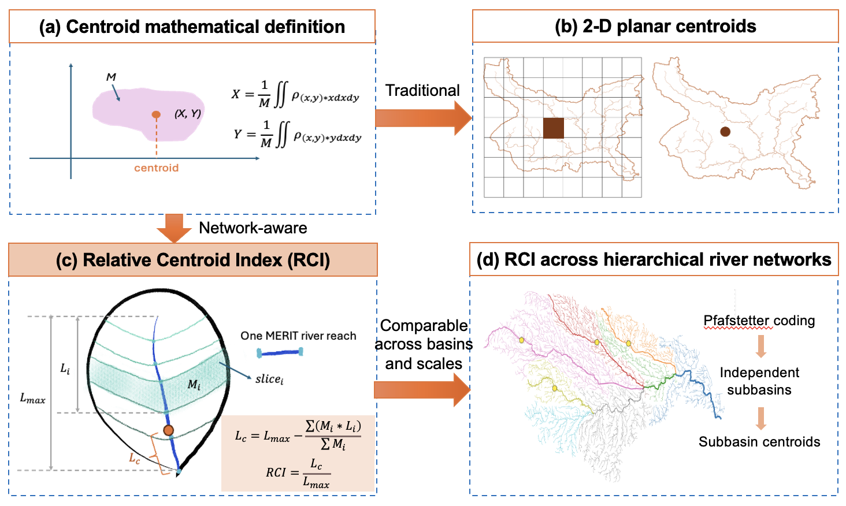
Figure 1 Definition of relative centroid index (RCI) for river network-based hydrological centroid analysis. (a) shows the general definition of centroid for any object. (b) shows the traditional spatial centroid calculation of gridded data or polygon data on a 2-D geographical object. (c) shows the sliced sub-watersheds to represent the differential elements. (d) shows the framework for hierarchical river network delineation and multi-level centroid extraction.
It is important to note that the RCI framework can be used to identify the mass balancing point across hydrological variables and data types, including 2D gridded hydrological varaiables as well as river network-based discharge data (Fig. 2). For example, for precipitation, runoff, and snow that often come in the form of gridded data, the mean value of the variable for each subbasin slice is used to derive $M_{i}$; for lakes that come in the form of polygon data, $M_{i}$ will be decided by intersecting the data with the subbasin slice (Fig. 2a). To derive centroids based on observed or simulated discharge data along river reaches, the incremental runoff contribution for the i^{th} river reach ($M_{i}$) is defined as the difference between the discharge at the downstream node and that at its upstream node ($Q_{i+1}$-$Q_{i}$) (Fig. 2b). Although runoff mass is a state variable and Q is a flux, the runoff centroid can be calculated from Q (as flux) because Q is linearly proportional to mass over a fixed Δt. Note that the RCI calculated from river network-based discharge data (Fig. 2b) should not be interpreted as the river storage balancing points, but instead the transformation recovers the discrete runoff contribution for a particular reach, effectively summarizing the runoff mass concentration location or the balancing point alongside the networks.
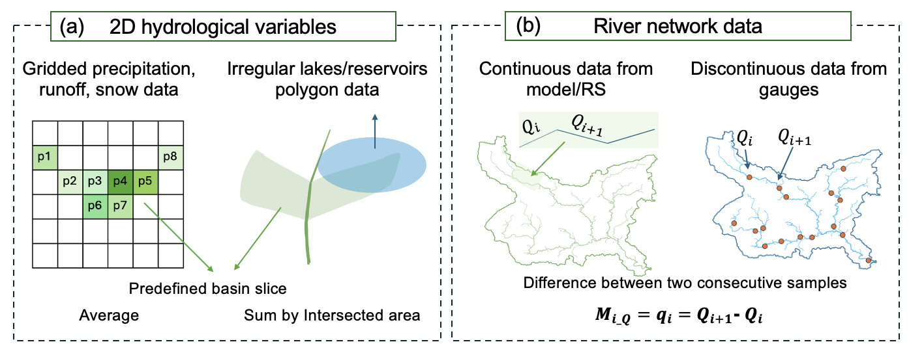Figure 2 The calculation of $M_{i}$ (the equivalent mass index of any unit) using 2D data (a) and river reach data (b) separately.

2.2 Experimental design
After defining the RCI, we first validated the centroid framework over the Poyang Lake Basin, China. The case study is adopted to evaluate whether the resulting RCIs demonstrated clear physical meaning aligned with the key hydrological and geomorphic features of the region (Section 3.1.1).
To extend these insights to broader scales, we then applied the framework to the networks of 40 major global basins (Fig. S1). Runoff centroids were computed for both naturalized and human-perturbed network-based discharge datasets (see Section 2.3), with the naturalized data serving as the baseline for analyses in Sections 3.1–3.2. Focusing on large-scale mainstems ensures that the seasonal and anthropogenic signals are sufficiently pronounced and spatially integrated, as larger basins exhibit more systematic convergence of tributary flows and more detectable human modifications, compared to smaller catchments where local variability and stochasticity may dominate.
For each basin, the mainstem was first delineated from the outlet to the headwaters based on the topological information provided by the MERIT Basins dataset (Lin et al., 2019). To assess the physical meaningfulness of the derived centroids, we analyzed human activity features within a defined buffer around each centroid, including urban areas, dams, and agricultural land (the latter identified by overlaying irrigation zones with the buffer). Furthermore, the locations of runoff (Q) and precipitation (P) centroids were compared to examine key drivers of runoff centroid placement, such as the average slope between P and Q (calculated as the elevation difference divided by the river distance) and the total lake volume within the river segment connecting the two centroids.
Seasonal centroid variability was examined by mapping centroid positions across four climatic seasons (Section 3.2). Long-term trends (1985–2019) were analyzed using annual discharge time series (Section 3.3), with corresponding precipitation centroid trends also evaluated to explore their coupling with runoff centroids. We hypothesized that human-perturbed runoff centroids may exhibit divergent trends relative to precipitation when compared to naturalized centroids; both were analyzed jointly to evaluate the sensitivity and utility of the runoff centroid index (RCI).
A core component of our experimental design is the multi‑scale analysis of centroid distributions (Section 3.1.3). To systematically examine how runoff organization varies across spatial scales, we applied the Pfafstetter hierarchical coding system to divide each of the 40 major basins into nested sub‑basins at Levels 1 to 5. Using the same centroid‑calculation workflow implemented for the mainstems, we then derived precipitation and runoff centroids for each sub‑basin unit. This approach allows for a consistent, comparable investigation of centroid spatial patterns across different basin sizes and topological levels, offering new insights into the scale‑dependent behavior of runoff spatial distribution within river networks.
2.3 Data and preprocessing

(1) River network-based discharge data
We first employ a naturalized discharge dataset to implement the RCI framework, enabling a baseline characterization of runoff centroid behavior under naturalized conditions. For this purpose, we use model derived Global Reach-scale A priori Discharge Estimates for SWOT (GRADES) (Lin et al., 2019) data for its wide applicability for studying naturalized runoff processes (Rocher-Ros et al., 2023; Yao et al., 2023). It is derived from a hydrological model chain, with biases adjusted against machine learning-derived runoff characteristics to enhance its quality. This dataset provides the foundation for our initial demonstration and application of the RCI across multiple basins and temporal scales.
To then test whether the RCI can detect additional process information through its sensitivity to input data, we introduce an observation-informed dataset as a human‑perturbed counterpart. For human-perturbed runoff, we chose the latest GRDR dataset (Feng & Gleason, 2024) which has assimilated satellite river width observations to improve modeled runoff estimates. Although GRDR is not specifically designed to represent human interventions, studies have proven the presence of anthropogenic signals in river widths (Feng et al., 2022; Lin et al., 2020) as well as in the resulting runoff dataset (Feng et al., 2021b; Feng & Gleason, 2024). We note that the two datasets have slightly different underlying routing model and runoff forcing, thus to prove their major difference is in human-pertubations rather than other areas, we compared them in highly regulated vs. natural gauges (Fig. S2 and Text S2), which shows an R² difference of 0.75 (GRADES) vs 0.78 (GRDR) only at regulated gauges. This justifies the usage of these two datasets in representing naturalized and human-perturbed conditions. Eventually, the Multi-Error-Removed Improved-Terrain Hydrography (MERIT) Basins river network and sub-watershed datasets (Lin et al., 2021) are used to represent the directional flow and interconnectedness of a river network.

Precipitation data
To examine the relationship between precipitation and runoff centroid locations, we extracted precipitation centroids using gridded reanalysis data. We use Multi-Source Weighted-Ensemble Precipitation (MSWEP) (Beck et al., 2017) combining gauge observations, satellite products, and reanalysis results as precipitation data. The precipitation data is also used to identify monsoon basins, which are defined as basins with mean winter-summer precipitation difference exceeding 180 mm and local summer precipitation exceeding 35% of annual rainfall (Wang & Ding, 2006).

Urban, dams, cropland, elevation, and lake
To verify the physical relevance or importance of the centroid locations, we combine multi-source data to automatically locate important geographic features near the centroids. We use Global Urban Boundary (GUB) data generated from Global Artificial Impervious Area (GAIA) dataset to represent urban areas (Li et al., 2020). Polygons over 500 km² are considered as major cities, and those intersecting 20 km buffers of the mainstem river reaches were identified as the major cities located near the centroid location. Dams from GeoDAR (Georeferenced global Dams And Reservoirs) dataset (Wang et al., 2022) are used, and points within 10 km buffers of the mainstem river reaches were identified as the dam near the centroid. We also extracted cropland within 150 km buffers of the centroids using the Global Irrigated Area Mapping (GIAM) data (Thenkabail et al., 2008) to identify centroids overlapping with irrigation activities. We also extracted the reprocessed MERIT DEM data, upscaled from 90 m to 1 km (Zheng et al., 2024), for each river reach, with the goal to obtain the topographic profiles of each river mainstem. HydroLAKES, which is a comprehensive global dataset that provides detailed spatial and attribute information on over 1.4 million lakes worldwide, including their geographic location, surface area, volume, and hydrological characteristics (Messager et al., 2016).

Results

3.1 Spatial patterns of network river centroids

3.1.1 Spatial explicit centroids on a river network: A case in Poyang Lake basin
We first validate the proposed RCI by examining whether the spatially explicit placement of runoff centroids aligns with known hydro-climatic and topographic gradients across different stream orders within the Poyang Lake Basin. Fig. 3 illustrates the runoff centroids of the Poyang Lake Basin precisely located along its four major tributary networks. We find the mainstream centroid of the basin yields an RCI value of approximately 0.3 (yellow dot in Fig. 3.a). This is because the major tributaries converge in the lower reaches, bringing the centroid downstream of the geometrical center of the mainstem. The centroid of its largest subbasin, Fu River, is located further downstream, at approximately 0.2, which can be explained through similar mechanism. The centroids of the Xiu River, Jin River, and Lu River are positioned further upstream compared to the mainstream centroid. This shift is attributable to the combined influence of the basin's climatic and topographic gradients. Specifically, higher precipitation in the mountainous headwaters increases upper‑basin runoff generation (Zhang et al., 2014), while higher evapotranspiration in the downstream lowlands near Poyang Lake reduces net water yield in the lower reaches (Z. Wang et al., 2023). Notably, smaller tributaries exhibit runoff centroids located progressively closer to the basin outlet (Fig. 3.b). This pattern can be attributed to two factors. First, smaller basins are typically situated in steeper mountainous headwaters, where rapid runoff generation and limited storage capacity hinder the concentration of flow in upstream reaches, shifting the centroid downstream. Second, as illustrated in Fig. 3.a, these smaller streams ultimately converge into higher-order tributaries, a configuration that inherently positions their centroids nearer to the point of confluence—consistent with the conceptual understanding of tributary convergence.
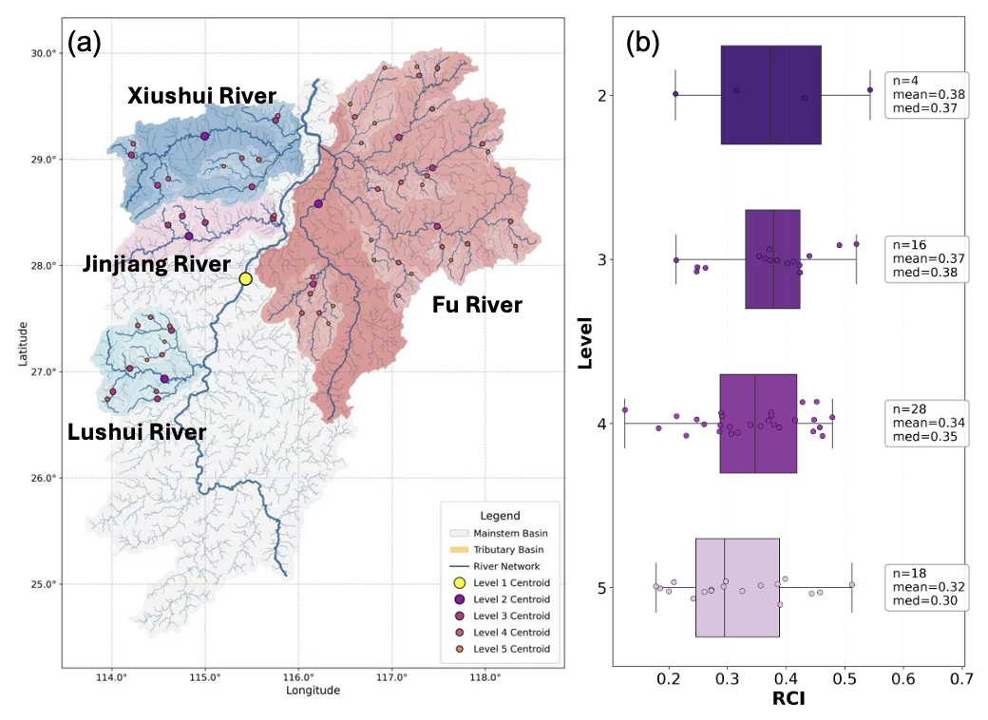
Figure 3 Multi-scale runoff centroids of Poyang Lake Basin, China. (a) Spatial distribution of runoff centroid casted on the mainstem (yellow circle) and subbasin runoff centroids casted on the subbasin mainstem rivers. Circles at different sizes represent centroids on multi-level sub-watershed mainstreams. The four major basins are represented using different colors. (b) Distributions and boxplot of the RCIs at different levels. For each level, it breaks out into four major tributary subbasins and the runoff centroid is calculated if it satisfies the data criteria.

3.1.2 Runoff centroids across 40 major global rivers
We further validate the generalizability of the RCI framework by applying it to the long-term mean runoff centroids of the mainstems of 40 major rivers globally (Fig. 4). The red dots denote the locations where upstream and downstream runoff mass are balanced along each network (Fig. 4a). Notably, these balance points are generally offset from the midpoints of the mainstems, with a prevalent downstream tendency. For example, the centroid of the Yangtze River is situated 2536 km from the outlet, while the total mainstem length is 6443 km.
Because these basins vary substantially in size, network geometry, and branching complexity, direct comparison of absolute centroid positions is not meaningful. We demonstrate that the RCI serves as a normalized, scale‑independent metric that enables consistent inter‑basin comparison. Using RCI, we further examine the drivers behind the observed spatial patterns. The downstream tendency seen in most basins (Fig. 4c) can be largely attributed to network topology. In highly convergent systems such as the Haihe and Pearl Rivers, strong tributary contributions naturally concentrate flow toward the outlet, shifting the centroid downstream—a pattern consistent with classical understanding of flow accumulation in dendritic networks. In contrast, several basins deviate from this general trend. Rivers including the Syr Darya, Amu Darya, Yellow, São Francisco, Nile, and Colorado are primarily fed by upstream snowmelt, glacial melt, or lake storage, yet experience substantial evaporative losses along their middle and lower reaches. This combination of upstream‑dominated supply and downstream losses reduces the effective downstream accumulation of runoff, resulting in centroid positions that are comparatively farther upstream.
Interestingly, we identified notable spatial coincidences with key anthropogenic features. For instance, approximately 18% (7 out of 40) of the centroids are located near major cities, over 75% are situated close to significant agricultural regions, and nearly half lie in proximity to dams or reservoirs (Fig. 4b, c). Detailed case illustrations of these spatial relationships are provided in the Supplementary Materials (Text S3 and Figs. S3–S7). However, these spatial overlaps do not imply a direct causal relationship. Rather, they highlight that centroid locations—as integrative points of hydrological mass balance along the network—tend to fall within zones where water, land use, and human activity naturally intersect. The RCI thus provides a spatially explicit reference that can help identify areas where water resources are centrally concentrated and where integrated water management may be particularly relevant.
The application of the RCI across this broad set of rivers demonstrates its capacity to distill complex, basin-specific hydrological signatures into a comparable network-based metric. By enabling consistent localization of runoff centroids across different geographical and climatic settings, the framework supports large‑scale comparative analyses and reinforces its utility as a general tool for hydrological characterization.
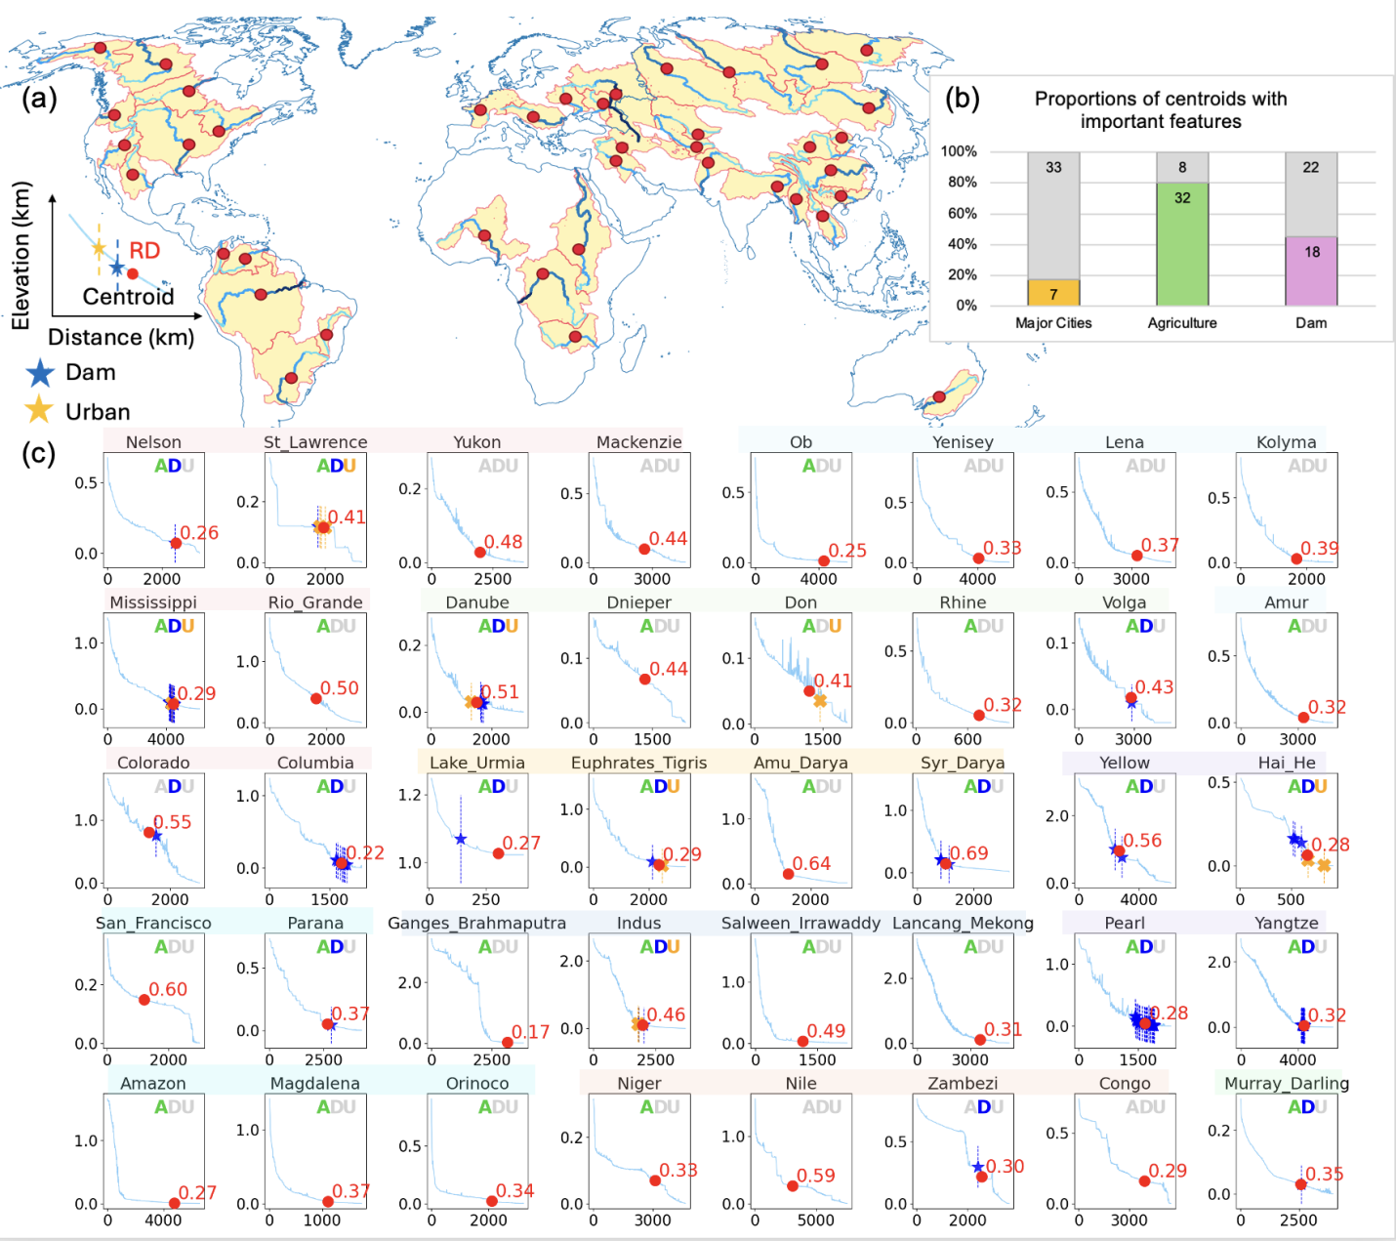
Figure 4 Runoff centroids for the world’s major 40 river basins and their nearby geographical features. (a) shows the spatial map of where the centroids are located. (b) shows the proportion of basins whose centroids are within ±150 km of major cities, agriculture, and dams along the mainstems. (c) shows the locations of runoff centroids and the features on the longitudinal profile of the rivers, with the legend shown at the bottom left of subfigure (a). Different colored patches at the subtitles represent different continents. The Asian continent is divided into North Asia, Middle Asia, East Asia, South and Southeast Asia. In each subplot, the blue line represents the profile of the river, the red dot is the Q centroid, and the surrounding dams and urban are illustrated in the legend. The RCI are also labeled in red decimal numbers. Letters on the right top of each subfigure refers to the existence of agriculture activities (A), dams (D) or urban areas (U). If no such attribute exists around the centroid, the corresponding letter will be grey; otherwise, the letter will be highlighted using the same color as the legend.
To examine if the runoff centroid location is determined by precipitation, the primary driver of runoff process, we mapped both precipitation (P) and runoff (Q) centroids onto river longitudinal profiles and compared their relative positions across basins. We found that when the basin slope and natural storage (e.g., mainly lake volume) are low between P and Q centroids, the two centroids tend to be aligning well with each other (Fig. 5b). By contrast, for basins with either high slope (Fig. 5a) or lake volume (Fig. 5c) between the centroids, Q centroid tend to appear further from P centroids. These highlight that in addition to underlying network structures, the joint controls of precipitation, topography, and basin storages,are also important in determining the Q centroid locations.
To verify this pattern, we divided all 40 rivers into two groups by their relative P-Q centroid distances and compared the distributions of their slopes and relative lake volumes (Fig. 5d). The group with shorter P–Q centroid distances consistently shows lower median values for both slope and relative lake volume, with the latter showing a more pronounced difference. This pattern supports the mechanism that (1) considering the velocity of water flowing in the steep mountains, water will confluence further downstream, thus the centroid will be appearing farther from the precipitation centroid compared to the opposite case; (2) natural storages such as lakes introduce hydrological buffering effects, attenuating and delaying runoff responses to precipitation, which consequently leads to greater spatial divergence between the centroids of precipitation input and runoff output due to the storage and gradual release of water.
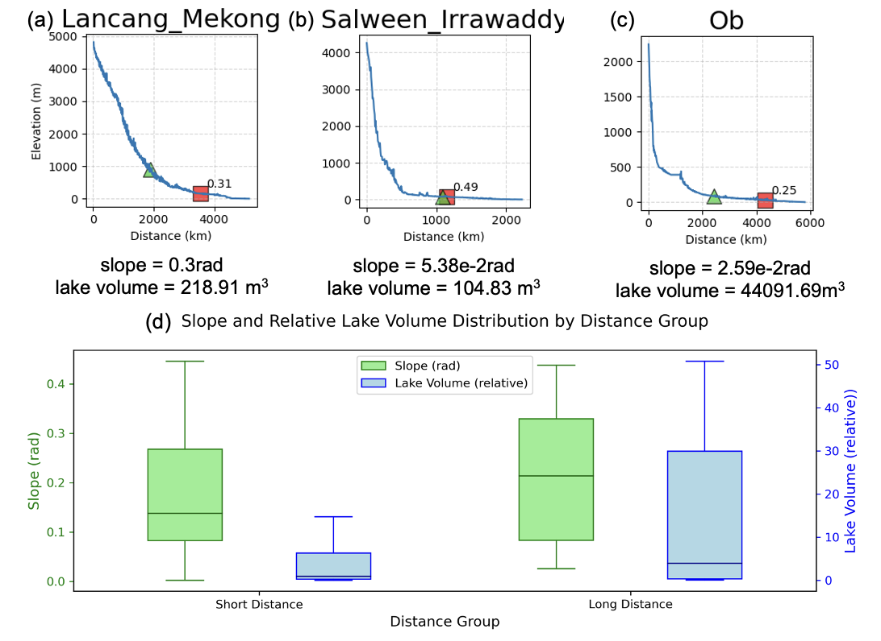
Figure 5 Slope and relative lake volume between precipitation and runoff centroids by P-Q centroid distance groups. Normalized lake volume is calculated as the total lake volume along the river segment between precipitation (P) and runoff (Q) centroids, divided by the long-term mean annual discharge at the centroid segment. Three individual cases illustrating different P-Q distances are shown in subfigures (a) Lancang-Mekong river, representing high slope and low lake volume between P and Q centroids, (b) Salween-Irrawaddy river, representing low slope and low lake volume between P and Q centroids, and (c) Ob river, representing low slope and high lake volume between P and Q centroids. We divided all 40 rivers into two groups by their P-Q centroid distances to total river lengths, and the threshold is set as the mean of all cases. Boxplots of slope and lake volume for each group are shown in subfigure (d).

3.1.3 Multi-level patterns of spatial centroids
To assess the consistency and interpretability of the RCI across spatial scales, we examine its behavior across watersheds spanning multiple orders of magnitude. Fig.6 presents the long-term mean centroids of precipitation and natural runoff across watersheds covering multiple orders of magnitude (level 1-5 represents large to small subwatersheds). Fig.6 reveals distinct scale-dependent patterns in the spatial organization of precipitation and runoff centroids. Runoff and precipitation centroids are generally positioned further downstream in smaller watersheds (Fig. 6a, 6b), while exhibiting wider distribution ranges and higher spatial variability at finer scales. For example, for watersheds at level 5, runoff centroid distances from the outlet range from 0 to 0.75 of mainstem length, whereas in basins directly pouring into the mainstems, this range narrows to 0.35–0.65. For level 1 and level 2 subwatersheds, the mean RCIs are very close to the geometric centres of the basins, while for level 5 basins, runoff is more likely to concentroate towards the outlets (approximately at 0.3). This pattern likely arises because small watersheds possess shorter, less integrated flow paths and are more sensitive to local heterogeneities in topography and rainfall distribution, leading to faster downstream routing of runoff and greater scatter in centroid locations. Runoff centroids are consistently located farther downstream than precipitation centroids across all watershed levels, yet the positional difference between them diminishes at coarser scales. This suggests that larger, higher-order basins integrate local variability more effectively, resulting in a more stable spatial coupling between precipitation input and runoff output.
These scale-dependent patterns demonstrate that the RCI captures robust, transferable signatures of hydrological organization across nested watershed scales. The framework thus enables meaningful intercomparison of centroid behavior both within and across basins, supporting its application to comparative hydrological analysis.
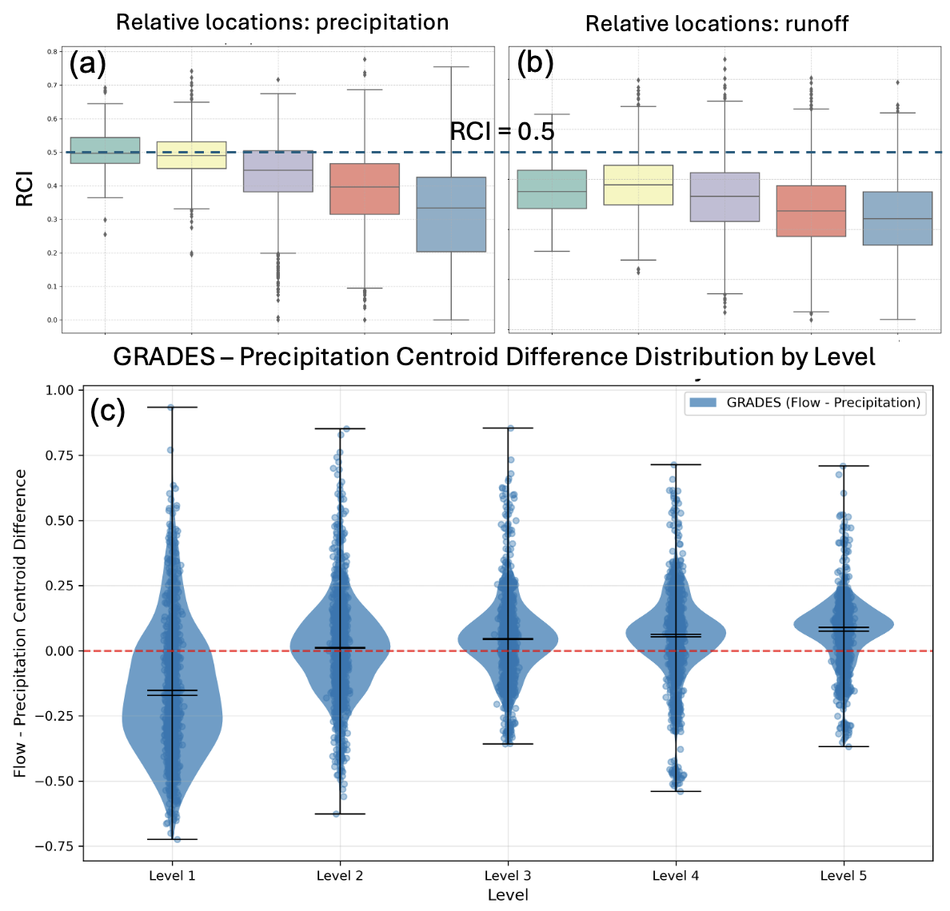
Figure 6 Spatial Patterns of Precipitation and Runoff Centroids Across Multi‑level River Networks. (a) and (b) show the RCI of precipitation (P) and runoff (Q), respectively, across nested Pfafstetter sub‑basins from Level 1 to Level 5. Each point represents one sub‑basin in a given year, using long‑term mean annual data from the GRADES dataset. The horizontal axis progresses from higher to lower Pfafstetter levels (i.e., from larger to smaller sub‑basin scales), highlighting how centroid offset varies with basin size and network complexity.

3.2 Seasonal variability of runoff centroids
We also analyzed the seasonal variations of the centroids (Figs. 7a, 7b) by calculating the maximum difference of centroid locations among four seasons. Generally, we find arid basins show more apparent fluctuation of runoff centroid location across seasons. For example, in the middle Asian basins, as well as Nile, Colorado, and Rio Grande river basins, we found the seasonal variations of the centroid can reach 1100 to 1300 km. By contrast, in humid regions such as Yangtze and Pearl, their centroids remain relatively stable (within 10 % of change). This finding is supported by Fig. 7c that with the increase of river basin aridity, seasonality of runoff centroid locations show a decreasing trend. Interestingly, precipitation centroids show no clear seasonal trend across aridity gradients (Fig. 7c). In humid regions, runoff centroids remain largely decoupled from the seasonal movement of precipitation centroids, likely due to the buffering effects of abundant baseflow and dense tributary networks that sustain stable runoff patterns despite seasonal precipitation shifts. In arid basins, where precipitation is the dominant water source along the mainstem, runoff centroids more closely track seasonal precipitation shifts, leading to pronounced centroid displacement.
For Syr Darya, Amu Darya, and Yellow River Basins, RCI can even become less than 0, likely due to their arid conditions, and runoff not increasing from headwater to outlet. This unusual positioning can also indicate a significant alteration of the natural flow patterns within a basin. For example, if there is a disproportional decrease in downstream flow relative to the upstream contributions, it can point to water loss upstream, resulting in the centroid to move further upward to the river network. These water losses effectively "move" water out of the natural river system, disrupting the expected progression of runoff from headwaters to outlets and thus causing the calculated centroid to lie outside the physical confines of the river network where the natural flow would otherwise occur.
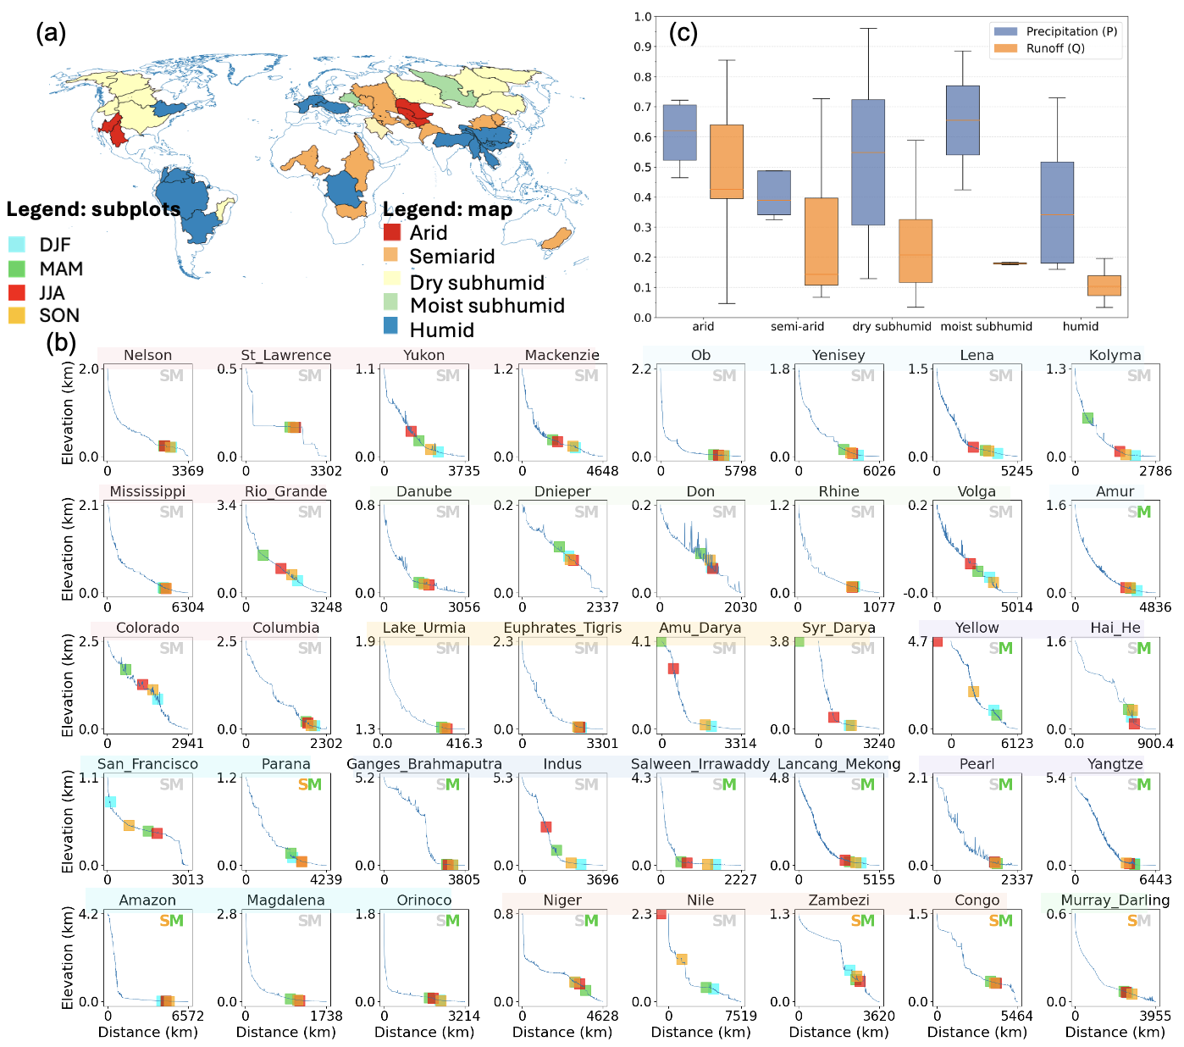

Figure 7 Seasonal variation of runoff centroids and its magnitudes in different aridity groups and monsoon regions. (a) shows the map of basins and their aridity index. (b) Subplots show the runoff centroid of each season (DJF, MAM, JJA, SON) on the river profile. The letters on the right top of each subfigure represent whether the watershed is in the monsoon area or in southern hemisphere. If the letter S is highlighted in orange, the watershed (or the main part of the watershed) is in southern hemisphere; if the letter M is highlighted in green, the watershed is in monsoon area; otherwise, the corresponding letter is shown in grey. (c) Maximum difference between seasonal runoff and precipitation centroid locations grouped by aridity types. Aridity index (AI) groups: arid: AI < 0.05, semi-arid: 0.05 ≤ AI < 0.5, dry subhumid: 0.5 ≤ AI <0.65, moist subhumid: 0.65 ≤ AI <0.75, humid: AI ≥0.75.

Discussions

Data sensitivity and framework transferability
A critical consideration for any diagnostic metric is its dependence on input data. While absolute centroid coordinates inevitably vary with data resolution, accuracy, and modeling assumptions, the relative spatial patterns and scale-independent behaviors of RCIs remain robust across datasets. For instance, the systematic downstream shift of centroids in convergent networks and the upstream displacement in arid, evaporation-dominated basins are consistently reproduced regardless of whether GRADES (natural flow from model) or GRDR (observation-informed) runoff estimates are used. This stability suggests that the RCI captures intrinsic hydrological organization rather than dataset-specific artifacts.
Beyond mere robustness, however, we find that differences between centroid estimates derived from alternative datasets can themselves be diagnostically valuable. Rather than treating such discrepancies as noise, the RCI framework enables their systematic interpretation as signatures of distinct hydrological processes differentially represented in each dataset. Specifically, by comparing long-term trends (1985–2019) of runoff centroids from naturalized GRADES (Q_nat), human-perturbed GRDR (Q_hum), and precipitation centroids (P), we demonstrate that cross-dataset centroid divergences reveal the spatial footprint of human water perturbations—information that would remain latent in conventional basin-aggregated metrics.
Fig. 8 presents this comparative trend analysis across 40 major global basins. We systematically compared the trends of Q_nat and Q_hum centroids against the trend of the P centroid, to shed light on how a basin's natural and human-perturbed runoff responses are evolving. Notably, we found a clear divergence in Q_hum trends from P trends, as noted by the Q_nat centroid trends aligning more closely with P trends than Q_hum as shown by their proximity to the 1:1 line (Fig. 8a). Over half of the basins (24/40) demonstrate stronger diverging trends of Q_hum to P than Q_nat to P.
The 40 major basins can be categorized into four groups (Figs. 8b to 8e) based on the statistics of migration trends of individual basins (Fig. S8). Among them, 16 basins show consistent direction of trends in Q_nat and P centroids, but Q_hum shows a more obvious trend than both Q_nat and P (Fig. 8b). These include Yellow River basin, Haihe River basin, Pearl River basin, Colorado River basin, Danube River basin, indicating that together with climate change-induced water redistribution, these basins were also undergoing severe human disturbance, causing further decoupling of runoff and precipitation. The other eight basins, including Yangtze River basin, Lancang-Mekong River basin, Rhine River basin, Columbia River basin, do not show apparent trends in Q_nat and P centroids, yet their Q_hum centroids are migrating apparently (Fig. 8c), suggesting that human activities other than climate change are significantly redistributing their water resources. Approximately a quarter of the rivers do not show consistent trends between Q_nat and P (Fig. 8d). This is because natural land surface storage or evaporation terms such as large lakes (including Saint Lawrence River basin, Lake Urmia basin), glaciers and snowpack (including Ganges-Bramaputra River basin, Salween Irrawady River basin) are causing natural divergence of runoff from precipitation centroids. There are also five basins demonstrating closer migration trends of Q_hum to P than Q_nat. Fig. 8e shows special cases where Q_nat trend is more divergent to P trend than Q_hum, which are not considered for our analysis, and is discussed in Text S4. Further looking into the cases based on Fig. S8, Rio Grande River basin, Congo River basin, and Mackenzie River basin only show very mild differences in Q_nat-P and Q_hum-P migrations. The rest cases, including Nile River basin and Euphrates-Tigris Rivre basin are both located in arid areas, where GRADES data comes with larger uncertainty compared to GRDR. Altogether, the results suggest human perturbations are causing the decreasing connection of P-Q processes, reinforcing the assumption that human regulations are causing spatial migrations in water distribution centers.
These results demonstrate that the RCI functions not merely as a summary statistic but as a comparative diagnostic metric. The framework transforms data uncertainty—conventionally viewed as a limitation—into a source of process insight. The systematic decoupling of Q_hum centroids from P and Q_nat centroids across diverse climatic and geographic settings confirms that human regulations are materially shifting the spatial centers of water mass in river networks worldwide. More broadly, this exercise illustrates the transferability of the RCI framework: it is equally applicable to observed, modeled, or reanalyzed runoff fields, and its cross-dataset comparison provides a generalizable strategy for detecting and attributing the spatial signatures of hydrological change.
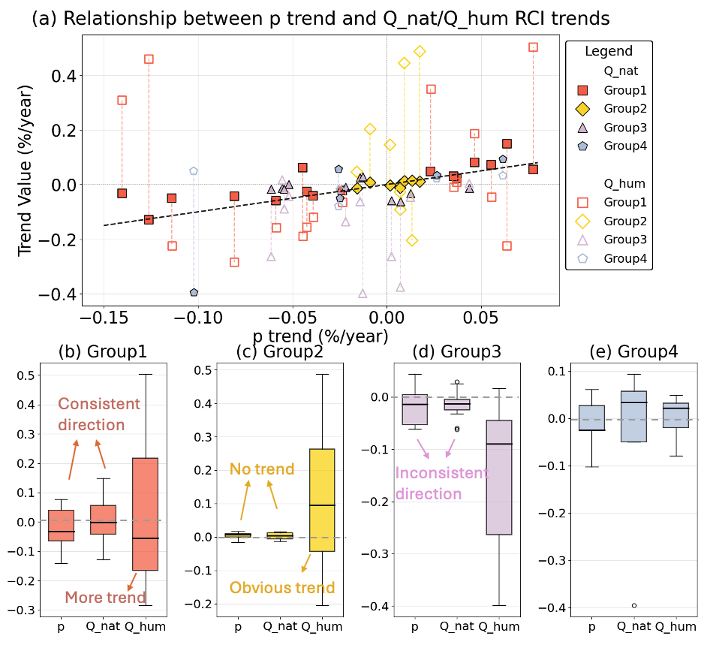
Figure 8 Migration trends of RCI (%/year) of naturalized (Q_nat) and human-impacted runoff (Q_hum) relative to precipitation (p) centroids across 40 global river basins. (a) shows the scatter plot of trends in Q_nat RCI (solid symbols, y-axis) and Q_hum (hollow symbols, y-axis) compared against the p centroids (x-axis). Black dashed line shows the 1:1 line. (b–e) show the boxplots of the centroid trends in different basin groups, respectively, with the dashed line showing trend = 0: (b) Group1: p and Q_nat show significant trend in the same direction (Sen's slope > 0.02%), but Q_hum shows stronger divergence from p trend than Q_nat. (c) Group2: p and Q_nat show almost no trend (Sen's slope < 0.02%), but Q_hum show apparent trend. (d) Group 3, p and Q_nat do not show consistent trend. (e) Group 4: Q_nat and p show trends in the same direction, but Q_hum shows closer trends to p compared to Q_nat.

Potential utility of the network-explicit RCI framework
Beyond its diagnostic utility, the RCI carries deeper conceptual significance rooted in both mechanics and network theory. In classical mechanics, the centroid denotes the center of mass—the unique point at which the weighted average position of a distributed mass is balanced. In network theory, centroids identify nodes that minimize aggregate distance to all other nodes, serving as optimal locations for resource distribution or facility locations (Wuchty & Stadler, 2003). A hydrological network centroid, by analogy, pinpoints the location along the river network where the mass of actively contributing runoff is effectively balanced within the branching topology.
This conceptual framing offers a shift in perspective: rather than treating runoff as a unidirectional flux to be integrated at an outlet, the RCI treats the river network as a spatial structure across which water mass is distributed, and this distribution has a measurable center of balance. That point is not arbitrary, nor is it simply a function of channel length or network geometry. Instead, it emerges from the combined effects of climate, topography, landscape storage, and human intervention. Its location and how it moves over time thus integrate—into a single, spatially explicit coordinate—multiple interacting processes that have often been studied in isolation. By making this balance point quantifiable and comparable across basins, spatial scales, and data sources, the RCI provides a new perspective for understanding hydrological organization. It connects physical hydrology, water management, and network science, and offers a practical entry point for comparative studies of river systems worldwide.

Conclusions
This study introduces a novel, network‑explicit framework for calculating spatially explicit runoff centroids that adhere strictly to the mathematical definition of a center of mass. By integrating continuous hydrological data with river network topology, we derived the Runoff Centroid Index (RCI), a scale‑independent metric that enables multi‑level and cross‑basin comparisons of runoff spatial organization. Generally, RCI effectively captures the spatia-temporal characteristics of the centroids along the global major rivers. Thus, it fills in the gap of the lack of spatial perspective in the centroid of runoff processes, especially the analysis of hydrological response and water distribution alongside river networks.
Our analysis reveals that runoff centroids frequently coincide spatially with zones of concentrated human activity—including major cities, agricultural regions, dams, and critical infrastructure. It is important to emphasize that these overlaps represent spatial correlation, not causation; they highlight that centroid locations—as integrative points of hydrological mass balance—often fall within areas where water, land use, and human activity naturally intersect. Seasonal centroid variability is strongly modulated by precipitation dynamics, with more pronounced oscillations in arid basins. Long‑term trend analysis further indicates that human activities are progressively decoupling runoff centroids from precipitation centroids, underscoring the growing anthropogenic signature in the spatial distribution of river runoff.
RCI is expected to facilitate the understandings of water distribution and migrations from a perspective of continuous river network and geospatial analysis of runoff processes.
We note that the RCI framework is conceptually independent of any specific data product. Its formulation is based on the principle of mass distribution along a topologically explicit network, and it can be applied consistently to any spatially distributed hydrological variable—whether derived from models, remote sensing, or in-situ networks. This transferability suggests that the RCI can support comparative analyses across regions, scales, and data availabilities, enhancing its utility in both data-rich and data-limited contexts.

Acknowledgement
This research receives funding support from the National Natural Science Foundation of China (42371481), the Beijing Nova Program (20230484302), the Beijing Nova Interdisciplinary Program (20240484647), and the Yunnan Provincial Science and Technology Project at Southwest United Graduate School (202302AO370012).

Data and Code Availability
All datasets from this study are obtained from publicly available respositories. GRADES is obtained from https://www.reachhydro.org/home/records/grades. GRDR is obtained from https://zenodo.org/records/13951712. MERIT basins is obtained from https://www.reachhydro.org/home/params/merit-basins. MSWEP is obtained from https://www.gloh2o.org/mswep/. GeoDAR is obtained from https://zenodo.org/records/6163413. Aridity index is obtained from Global Aridity Index and Potential Evapotranspiration Database is obtained from https://figshare.com/articles/dataset/Global_Aridity_Index_and_Potential_Evapotranspiration_ET0_Climate_Database_v2/7504448. GUB is obtained from https://data.ess.tsinghua.edu.cn. GIAM is obtained from https://waterdata.iwmi.org/Applications/GIAM2000/. GSHA is obtained from https://zenodo.org/records/8090704. HydroLAKES is obtained from https://www.hydrosheds.org/products/hydrolakes. The code for RCI will be made publicly available upon acceptance of this paper.

Author Contribution
Conceptualization: PL, DY, ZY. Data curation: ZY, PL. Investigation: ZY, PL. Writing - Initial: ZY, PL. Writing - Review & Edit: ZY, PL, DY. The authors declare no conflict of interests.

Reference
Addor, N., Newman, A. J., Mizukami, N., & Clark, M. P. (2017). The CAMELS data set: Catchment attributes and meteorology for large-sample studies. Hydrology and Earth System Sciences, 21(10), 5293–5313. https://doi.org/10.5194/hess-21-5293-2017
Allen, G. H., & Pavelsky, T. M. (2018). Global extent of rivers and streams. Science, 361(6402), 585–588. https://doi.org/10.1126/science.aat0636
Asadieh, B., & Krakauer, N. Y. (2015). Global trends in extreme precipitation: Climate models versus observations. Hydrology and Earth System Sciences, 19(2), 877–891. https://doi.org/10.5194/hess-19-877-2015
Beck, H. E., Van Dijk, A. I. J. M., Levizzani, V., Schellekens, J., Miralles, D. G., Martens, B., & De Roo, A. (2017). MSWEP: 3-hourly 0.25° global gridded precipitation (1979–2015) by merging gauge, satellite, and reanalysis data. Hydrology and Earth System Sciences, 21(1), 589–615. https://doi.org/10.5194/hess-21-589-2017
Blöschl, G., Hall, J., Parajka, J., Perdigão, R. A. P., Merz, B., Arheimer, B., Aronica, G. T., Bilibashi, A., Bonacci, O., Borga, M., Čanjevac, I., Castellarin, A., Chirico, G. B., Claps, P., Fiala, K., Frolova, N., Gorbachova, L., Gül, A., Hannaford, J., … Živković, N. (2017). Changing climate shifts timing of European floods. Science, 357(6351), 588–590. https://doi.org/10.1126/science.aan2506
Blöschl, G., Hall, J., Viglione, A., Perdigão, R. A. P., Parajka, J., Merz, B., Lun, D., Arheimer, B., Aronica, G. T., Bilibashi, A., Boháč, M., Bonacci, O., Borga, M., Čanjevac, I., Castellarin, A., Chirico, G. B., Claps, P., Frolova, N., Ganora, D., … Živković, N. (2019). Changing climate both increases and decreases European river floods. Nature, 573(7772), 108–111. https://doi.org/10.1038/s41586-019-1495-6
Brown, R. D., Smith, C., Derksen, C., & Mudryk, L. (2021). Canadian In Situ Snow Cover Trends for 1955–2017 Including an Assessment of the Impact of Automation. Atmosphere-Ocean, 59(2), 77–92. https://doi.org/10.1080/07055900.2021.1911781
Cerbelaud, A., David, C. H., Biancamaria, S., Wade, J., Tom, M., Frasson, R. P. D. M., Allen, G. H., Thurman, H. R., & Blumstein, D. (2024). Spatial Hydrographs of River Flow and their Analysis for Peak Event Detection in the Context of Satellite Sampling. Preprints. https://doi.org/10.22541/au.172228543.36697092/v1
Do, H. X., Gudmundsson, L., Leonard, M., & Westra, S. (2018). The Global Streamflow Indices and Metadata Archive (GSIM) – Part 1: The production of a daily streamflow archive and metadata. Earth System Science Data, 10(2), 765–785. https://doi.org/10.5194/essd-10-765-2018
Du, L., Peng, X., Zhao, Y., Lyu, J., & Pan, M. (2021). From nature-based to engineering-based: The interaction process and turning point of the city-water system relationship in the North China plain. Applied Geography, 135, 102556. https://doi.org/10.1016/j.apgeog.2021.102556
Farmer, E., Jones, S. D., & Deakin, R. E. (2011). Derivation of a resilient polygon centroid for natural resource management applications. International Journal of Geographical Information Science, 25(9), 1545–1558. https://doi.org/10.1080/13658816.2011.554837
Feng, D., & Gleason, C. J. (2024). More flow upstream and less flow downstream: The changing form and function of global rivers. Science, 386(6727), 1305–1311. https://doi.org/10.1126/science.adl5728
Feng, D., Gleason, C. J., Lin, P., Yang, X., Pan, M., & Ishitsuka, Y. (2021a). Recent changes to Arctic river discharge. Nature Communications, 12(1), 6917. https://doi.org/10.1038/s41467-021-27228-1
Feng, D., Gleason, C. J., Lin, P., Yang, X., Pan, M., & Ishitsuka, Y. (2021b). Recent changes to Arctic river discharge. Nature Communications, 12(1). https://doi.org/10.1038/s41467-021-27228-1
Feng, D., Gleason, C. J., Yang, X., Allen, G. H., & Pavelsky, T. M. (2022). How Have Global River Widths Changed Over Time? Water Resources Research, 58(8). https://doi.org/10.1029/2021wr031712
Hagemann, M. W., Gleason, C. J., & Durand, M. T. (2017). BAM: Bayesian AMHG‐Manning Inference of Discharge Using Remotely Sensed Stream Width, Slope, and Height. Water Resources Research, 53(11), 9692–9707. https://doi.org/10.1002/2017WR021626
Hall, J., Arheimer, B., Borga, M., Brázdil, R., Claps, P., Kiss, A., Kjeldsen, T. R., Kriaučiūnienė, J., Kundzewicz, Z. W., Lang, M., Llasat, M. C., Macdonald, N., McIntyre, N., Mediero, L., Merz, B., Merz, R., Molnar, P., Montanari, A., Neuhold, C., … Blöschl, G. (2014). Understanding flood regime changes in Europe: A state-of-the-art assessment. Hydrology and Earth System Sciences, 18(7), 2735–2772. https://doi.org/10.5194/hess-18-2735-2014
Hou, Y., Chen, Y., Li, Z., & Wang, Y. (2023). Changes in Land Use Pattern and Structure under the Rapid Urbanization of the Tarim River Basin. Land, 12(3), 693. https://doi.org/10.3390/land12030693
Huss, M., Bookhagen, B., Huggel, C., Jacobsen, D., Bradley, R. S., Clague, J. J., Vuille, M., Buytaert, W., Cayan, D. R., Greenwood, G., Mark, B. G., Milner, A. M., Weingartner, R., & Winder, M. (2017). Toward mountains without permanent snow and ice. Earth’s Future, 5(5), 418–435. https://doi.org/10.1002/2016EF000514
Kratzert, F., Nearing, G., Addor, N., Erickson, T., Gauch, M., Gilon, O., Gudmundsson, L., Hassidim, A., Klotz, D., Nevo, S., Shalev, G., & Matias, Y. (2023). Caravan—A global community dataset for large-sample hydrology. Scientific Data, 10(1), 61. https://doi.org/10.1038/s41597-023-01975-w
Li, Xuecao, Gong, P., Zhou, Y., Wang, J., Bai, Y., Chen, B., Hu, T., Xiao, Y., Xu, B., Yang, J., Liu, X., Cai, W., Huang, H., Wu, T., Wang, X., Lin, P., Li, Xun, Chen, J., He, C., … Zhu, Zhiliang. (2020). Mapping global urban boundaries from the global artificial impervious area (GAIA) data. Environmental Research Letters, 15(9), 094044. https://doi.org/10.1088/1748-9326/ab9be3
Lin, P., Pan, M., Allen, G. H., De Frasson, R. P., Zeng, Z., Yamazaki, D., & Wood, E. F. (2020). Global Estimates of Reach‐Level Bankfull River Width Leveraging Big Data Geospatial Analysis. Geophysical Research Letters, 47(7). https://doi.org/10.1029/2019gl086405
Lin, P., Pan, M., Beck, H. E., Yang, Y., Yamazaki, D., Frasson, R., David, C. H., Durand, M., Pavelsky, T. M., Allen, G. H., Gleason, C. J., & Wood, E. F. (2019). Global Reconstruction of Naturalized River Flows at 2.94 Million Reaches. Water Resources Research, 55(8), 6499–6516. https://doi.org/10.1029/2019WR025287
Lin, P., Pan, M., Wood, E. F., Yamazaki, D., & Allen, G. H. (2021). A new vector-based global river network dataset accounting for variable drainage density. Scientific Data, 8(1), 28. https://doi.org/10.1038/s41597-021-00819-9
Messager, M. L., Lehner, B., Grill, G., Nedeva, I., & Schmitt, O. (2016). Estimating the volume and age of water stored in global lakes using a geo-statistical approach. Nature Communications, 7(1). https://doi.org/10.1038/ncomms13603
Messina, J. P., Shortridge, A. M., Groop, R. E., Varnakovida, P., & Finn, M. J. (2006). Evaluating Michigan’s community hospital access: Spatial methods for decision support. International Journal of Health Geographics, 5(1), 42. https://doi.org/10.1186/1476-072X-5-42
National Weather Service. (2005). Unit Hydrograph Technical Manual—NOHRSC - The ultimate source for snow information. NOAA’s National Weather Service. https://www.nohrsc.noaa.gov/technology/gis/uhg_manual.html
Pfafstetter, O. (1989). Classification of Hydrographic Basins: Coding Methodology. Departamento Nacional de Obras de Saneamento (DNOS).
Rocher-Ros, G., Stanley, E. H., Loken, L. C., Casson, N. J., Raymond, P. A., Liu, S., Amatulli, G., & Sponseller, R. A. (2023). Global methane emissions from rivers and streams. Nature, 621(7979), 530–535. https://doi.org/10.1038/s41586-023-06344-6
Thenkabail, P. S., Biradar, C. M., Noojipady, P., Dheeravath, V., Li, Y. J., Velpuri, M., Reddy, G. P. O., Cai, X., Gumma, M. K., Turral, H., Vithanage, J., Schull, M., & Dutta, R. (2008). A Global Irrigated Area Map (GIAM) using remote sensing at the end of the last millennium. International Water Management Institute (IWMI). https://doi.org/10.5337/2011.0024
Thurman, H. R., Allen, G. H., Williams, B. A., Cerbelaud, A., & David, C. H. (2025). SWOT Captures Hydrologic Waves Traveling Down Rivers. Geophysical Research Letters, 52(10), e2024GL113875. https://doi.org/10.1029/2024GL113875
Wang, & Ding, Q. (2006). Changes in global monsoon precipitation over the past 56 years. Geophysical Research Letters, 33(6). https://doi.org/10.1029/2005gl025347
Wang, Walter, B. A., Yao, F., Song, C., Ding, M., Maroof, A. S., Zhu, J., Fan, C., McAlister, J. M., Sikder, S., Sheng, Y., Allen, G. H., Crétaux, J.-F., & Wada, Y. (2022). GeoDAR: Georeferenced global dams and reservoirs dataset for bridging attributes and geolocations. Earth System Science Data, 14(4), 1869–1899. https://doi.org/10.5194/essd-14-1869-2022
Wang, Y., Bai, H., Yang, X., Wen, Z., Zhang, Y., & Li, B. (2024). Detecting Spatiotemporal Shifts in Precipitation Core Regions Using a Centroid-Based Identification Method and Its Application in China. In Review. https://doi.org/10.21203/rs.3.rs-4924856/v1
Wang, Z., Zhang, R., & Zhang, Y. (2023). Temporal and Spatial Variation Characteristics and Impact Analysis of Evapotranspiration and Its Components in Poyang Lake Basin Based on SWH Dual-Source Model. China Rural Water and Hydropower, (11), 52–63. https://doi.org/10.12396/znsd.222412
Wang, Zhang, E., & Chen, G. (2023). Spatiotemporal Variation and Influencing Factors of Grain Yield in Major Grain-Producing Counties: A Comparative Study of Two Provinces from China. Land, 12(9), 1810. https://doi.org/10.3390/land12091810
Whitfield, P. H. (2013). Is ‘Centre of Volume’ a robust indicator of changes in snowmelt timing? Hydrological Processes, 27(18), 2691–2698. https://doi.org/10.1002/hyp.9817
Yang, Y., Feng, D., Beck, H. E., Hu, W., Abbas, A., Sengupta, A., Delle Monache, L., Hartman, R., Lin, P., Shen, C., & Pan, M. (2025). Global Daily Discharge Estimation Based on Grid Long Short‐Term Memory (LSTM) Model and River Routing. Water Resources Research, 61(6), e2024WR039764. https://doi.org/10.1029/2024WR039764
Yang, Y., Pan, M., Lin, P., Beck, H. E., Zeng, Z., Yamazaki, D., David, C. H., Lu, H., Yang, K., Hong, Y., & Wood, E. F. (2021). Global Reach-Level 3-Hourly River Flood Reanalysis (1980–2019). Bulletin of the American Meteorological Society, 102(11), E2086–E2105. https://doi.org/10.1175/BAMS-D-20-0057.1
Yao, F., Livneh, B., Rajagopalan, B., Wang, J., Crétaux, J.-F., Wada, Y., & Berge-Nguyen, M. (2023). Satellites reveal widespread decline in global lake water storage. Science, 380(6646), 743–749. https://doi.org/10.1126/science.abo2812
Zhang, R., Kong, P., Jiang, Y., Dai, N., & Yin, J. (2014). Research on Precipitation Characteristics and Drivers of the Hydrological Processes in Poyang Lake Basin in Recent 50 Years. Journal of Nanchang University (Natural Science), 38(3). https://doi.org/10.13764/j.cnki.ncdl.2014.03.013
Zhang, S., Zhou, L., Zhang, L., Yang, Y., Wei, Z., Zhou, S., Yang, D., Yang, X., Wu, X., Zhang, Y., Li, X., & Dai, Y. (2022). Reconciling disagreement on global river flood changes in a warming climate. Nature Climate Change, 12(12), 1160–1167. https://doi.org/10.1038/s41558-022-01539-7
Zheng, K., Lin, P., & Yin, Z. (2024). SHIFT: A spatial-heterogeneity improvement in DEM-based mapping of global geomorphic floodplains. Earth System Science Data, 16(8), 3873–3891. https://doi.org/10.5194/essd-16-3873-2024

SI Reference
Thenkabail, P. S., Biradar, C. M., Noojipady, P., Dheeravath, V., Li, Y. J., Velpuri, M., Reddy, G. P. O., Cai, X., Gumma, M. K., Turral, H., Vithanage, J., Schull, M., & Dutta, R. (2008). A Global Irrigated Area Map (GIAM) using remote sensing at the end of the last millennium. International Water Management Institute (IWMI). https://doi.org/10.5337/2011.0024
Tian, Tx., & Zhao, W. (2006). Research on the Three Gorges Reservoir District’s Human Settlements Construction in Recent 10 Years—Master’s thesis—Dissertation (115) [Master’s thesis, Chongqing University]. TU984. https://www.dissertationtopic.net/doc/1063071
Yin, Z., Lin, P., Riggs, R., Allen, G. H., Lei, X., Zheng, Z., & Cai, S. (2024). A synthesis of Global Runoff Characteristics, Hydrometeorology, and Catchment Attributes (GSHA) for large sample river-centric studies. Earth System Science Data, 16(3), 1559–1587. https://doi.org/10.5194/essd-16-1559-2024

