Intelligent IoT’s Influence on Personalization, Emotional Attachment, and Cognitive Flow in Cinematic Viewing Experiences
ABSTRACT
With the evolution of Intelligent Internet of Things (IIoT) technology, the relationship between viewers and content has undergone a total transformation. The aim of this study is to test the impact of IIoT technology on psychological functions and visual experience of film and television (F&T) audiences to examine the possibilities of virtual reality and individual cinematic experience. The influences on the psychology and scene usage of F&T audiences on the premise of the IIoT have been identified through a mixed-methods research that took a combination of quantitative and qualitative methodologies. The data collection procedure was conducted between the period of May and June 2025. The survey involved analysis of the responses of 250 respondents and 50 were interviewed. SPSS was used to analyze quantitative data and NVivo qualitative data. The research finding indicates that the IoT technology is deeply influencing the psychological experience and use of visualization of the F&T users. This novelty provides a new angle toward the psychological involvement of television and film viewers and their visual experiences leveraged through the IoT mobile technology. In this research, the efficiency of IoT technology in maximizing the emotional engagement of the viewers, and their cognitive processing are pointed out.
KEYWORDS: Psychology and Scene Application, Intelligent Internet of Things, Emotional Engagement, Immersive Scene Application, Realism and Viewer Satisfaction.
- INTRODUCTION
The adoption of Intelligent Internet of Things (IIoT) in the film and television (F&T) production is transforming the experience and interactions between viewers and the content. The traditions of cultural studies in the objectively suspicious of the form of media effects research that seduces media psychology. The experience and communication among viewers and the content are also altering due to the adoption of IIoT in the F&T production (Litherland, 2025). It is linked to the sense of being engulfed and immersed in the virtual world of consumption that the streamer generates and which will instead predispose the action of acquiring products (Bai et al., 2025).The basis on which one could comprehend the core of film communication and the audience's psychological needs (Han et al., 2024). The paper seeks to examine the value of IoT technologies in transforming the F&T content experience, such as through the psychological state of the viewers through the analysis of live data, so as to enhance the experience.
  - Importance of Psychology in IIOT
In the IoT technology, psychology serves an important purpose since it influences the design, development, and arrangement of IoT systems to fit human needs. The users embrace an IoT device, and the psychological emotions of trust, fear, and worry of losing personal information. IoT technology is preconditioned by psychological knowledge that ensures its success (Ladeira et al., 2025). Through the IIoT technology, a more psychological experience can be created when the services are being offered based on the emotional state of the user (Shuwei, 2025). Towards the end of enhancing the safety of passengers using IIoT-based public transportation systems, explainable safety standards are becoming significant with regard to the use of explainable deep learning techniques. This is an element of creating user trust and psychological intimacy (Wazid et al., 2025).
  - Overview of Film and Television in Audience Analysis
In F&T, audience analysis is carried out to understand who consumes the media content and the reasons, which is then used in production, marketing, and distribution strategies. This technology is capable of understanding viewers’ previous viewing habits and providing them with personalized storytelling content not only enhances the viewer’s satisfaction but also their engagement. (Yang et al., 2024). High-speed data transmission via 5G increases the ability to deliver content to viewers in an instant and personalized form. It enables one to track down the immediate reaction and the psychological influence on the viewer (Zhang & Shao, 2025). In F&T, visuals, text, sound, and staging work together to form a total experience. The main idea of this study is that all of these must be integrated, considering the language, culture, and psychological context of the viewer (Valdeón, 2024)
  - Factors Affecting Scene Application on IIOT
The scenario of the Internet of Things is usually divided into three broad categories: technology, security, and environmental. Security threats involve device, data security, and network division. One will find that this kind of article highlights that an effective scene design requires such important features as live data collection, proper situational cognition, and adaptive scene planning solutions (Zhang et al., 2024). The reasonableness of data orchestration and the precision of the virtual scene are reasons provided by them. The paper also refers to the issues and the answers related to automatically generated scenes depending on the context and actions of the user (El Ghati et al., 2024).
  - Contributions and Novelty
The current research goes into detail about how the psychological experience and visual implementations of F&T spectators are influenced by the IoT in psychological & scene implementations, with multiple contributions and insights to offer the discipline.
- The research is devoted to psychological effects on emotions and proves the correlation between the emotional involvement, emotional change, intensity of the memory, and satisfaction created by IIoT.
- This paper discusses the effects of technological innovations to improve content encounters in a home setting through the use of recognition devices, contextual intelligence, and audio-visual combinations.
- The given research proves by empirical evidence that IIoT technologies improve visual experiences, particularly immersive visuals, understanding of the narrative, and viewer engagement.
- This paper combines the previously discussed results of direct interaction, personalization, and cognitive recommendations offered by IIoT technology into the psychological functioning of the viewers with linguistic and numerical statistics.
One of the major novelties to the study of viewer psychology and visual use in the F&T setting, the present paper will look into the effects of the IoT technologies on emotional, cognitive, and immersive viewer experiences.
  - Research Objectives
The research has the following aims:
RO1: To study how IoT products will improve visual input to home screen experiences.
RO2: To assess how the coherent audiovisual design of IIoT platforms can make the visual continuity stronger.
RO3: To examine the effect of data-driven content suggestion on viewers' psychological satisfaction and entertainment ratings.
- LITERATURE REVIEW
  - Intelligent Internet of Things (Iot)
IIoT can be used to obtain knowledge in the viewing process of the F&T viewers, intelligent monitoring of information, autonomous computing-real-time acting, and complicated environments. Chen and colleagues (2025) attempted to add Synaptic Intelligent Convolutional Neural Networks that would promote the ability to detect intrusion in dynamic IoT systems. It was concluded that the relevance of the SICNN model to enhance the security of IoT products and the performance of this model made it an ideal solution for the real-time detection of intrusion in dynamic IoT systems. The paper by Rehman et al. (2025) explored the engineering practice of edge computing systems in providing real-time decisions for the IIoT. The study's results determined that AI edge nodes reduce the load on the network and increase the speed of response. The research conducted by Wazid et al. (2025) aimed to evaluate an explainable malware attack classification model, which is deep learning-based and can be implemented into intelligent IoT environments, more specifically into the intelligent transportation system network. The results of the research indicated that explaining ability practices can increase trustworthiness and disclosure to the point where the operators can know about certain threats.
  - Psychology and the Scene Application of Film and Television
IoT is such a technology that separates devices to connect and communicate with one another and exchange information. Hornik and Rachamim (2024) aimed to explore how the preview and testing processes can be improved by using intelligent tools. The study concluded that the program and its output were predicted to have a high impact on F&T viewing applications. Prokopic and Sayer (2025) examined how virtual reality and spatialized cinematic experiences explain how viewers participate in the structure of the story. The result concluded by confirming that VR and spatial films have great potential to create new types of interactive relationships with audiences. These are seen as revolutionary advances in filmmaking through technology. Li (2025) tried to explore the system of forecasting, which is used in the area of managing peatland fires and technologies of possible IoT. The study concluded that early detection of encroachment risk through soil fertility and adequate monitoring systems, and improved mangrove forest fire management.
  - The Role Of IIOT in Audience Analysis
One of the primary goals of Assaad and Sadek Kanaan (2025) was to contribute to the ideas of supply chain integration, big data, market intelligence, and knowledge sharing in major ways. The investigations conducted in this research paper showed that the flow of information and technology has resulted in audience-centric marketing. This finding was that there has been an increase in the integration of IoT and the accuracy of the audience analysis. Gulzar et al. (2025) discussed the way to enhance user experiences through combining smart IoT and social connectivity. According to the research results, self-awareness, communication, and social connectedness of the users improved. Qureshi et al. (2024) considered the solutions in the form of deep learning to the issues of malware effects and forensics in IoT systems. It has been stipulated that IoT intelligence will become an important instrument toward enhanced audience-based security analysis and an instrument to develop audience-based security architectures.
  - Research Gap
Based on the past literature, the research on the psychology and use of the F&T viewers and the viewership on the visual use of the IoT is considerable. The use of Smart technologies that are connected to the Internet can facilitate the increased involvement and experience of viewers. There is little consistent statistical evidence on how these IoT technologies directly affect viewer emotions, mood, and visual perception. The efficiency and efficacy of the technology that provides content have been the basis of the centre of attention, mostly in previous studies. Nevertheless, it can be more about individual experiences delivered with the help of IoT, the visual alteration in accordance with the perceptual response, or the realization of the psychological condition regarding the viewer. There is little research on how IoT affects such viewer behaviors as trust, clarity, and social interactions. In particular, challenges such as multi-level management systems, departmental integration, and changes in content experiences under stressful situations have been addressed in previous studies. Furthermore, current studies have mostly examined technical aspects in isolation. Therefore, this study highlights the need to deeply examine the role, challenges, and opportunities of IoT technology in viewers’ psychological reactions and visual perception.
  - Research Questions
The following research questions are proposed to address the gaps identified in the literature review:
RQ1: What are the possible enhancements to the quality of visual experience through the use of IoT vis-à-vis home screen viewing environment?
RQ2: How does personalized content (in case delivered through IoT) affect the mood of the audience, as well as the cognitive abilities of the audience?
RQ3: What effects do synchronization of audiovisual integration between IoT platforms have on distracting viewers and providing the perception of visual continuity?
- THEORETICAL FRAMEWORK
  - Cognitive Load (CL) Theory
CL Theory is a psychological theory that describes how the human brain is able to perceive and process information, pictures, and sounds at the same time. The cognitive load theory concerning IIoT has been found to deliver major gains in terms of student participation and cognitive load, thereby resulting in general gains in academic performance. Similar strategies are a matter of vivid visibility in numerous studies (Spaho et al., 2025). According to this theory, the human brain is highly constrained in the size of its information processing capabilities; in other words, it can only attract a certain level of cognitive resources that the individual can apply. This may go as far as causing decreased work efficiency (Bilderback, 2025). This will ensure that the learning issues are introduced at controlled periods, hence leading to a consistent flow of processing information in the long-term memory. This will enhance IoT experiences too (Ongoro et al., 2024).
  - Gratification Theory
Gratification Theory (GT) may be described as a manner in which users implement the technologies of the IIoT to an end of meeting needs. The capability of using smart equipment that runs on artificial intelligence to treat or prevent stroke disease in aged patients. The latter may also be applied during research of patterns of online health information seeking behaviour by means of individual, technological, and sociocultural integration by employing GT (Adewojo et al., 2025). The theory presumes that the decisions that people make on the media are based on their needs and personal preferences, media of different forms and the awareness of their needs and preferences (Lim, 2025). It implies that the theory also investigates the indirect relationships between stimuli, including the dimensions of functionality, similarity of communication styles, and aesthetics, and result variables, including customer satisfaction and intentions to re-use (Nguyen et al., 2025).
  - Technology Acceptance Model (TAM) Theory
The TAM is one of the main theories proving the adoption and usage of new technologies, including IoT. The adaptability, inclusiveness, and scalability are the main strengths that have led to the widespread adoption of the TAM-based model to be used in the study of software systems and technology-in-use. TAM can also be regarded as a very powerful theory as far as analyzing and determining how people may accept information systems and information and communication systems end up (Wang et al., 2025). It has been the most common influential theory so far to explain the intention in an individual to adopt information systems (Su et al., 2025). TAM determines the intention to implement modern technologies by determining its influential factors. TAM and subsequent adjustments have offered articulate empirical evidence regarding the conditions under which the technologies of Industry 4.0 are embraced (Zou et al., 2025).
- CONCEPTUAL FRAMEWORK
The conceptual framework of the study is constructed to assess the factors affecting psychology and scene application.
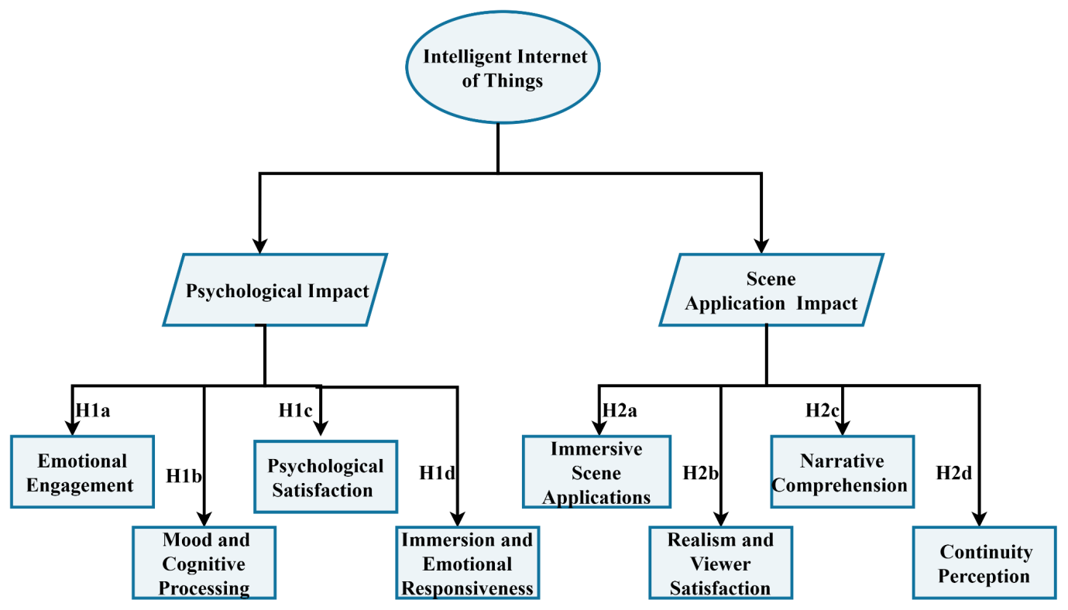
Figure 1: Hypothesized Conceptual Framework
Figure 1 illustrates the conceptual framework developed to study the psychological state and visual application of film and television viewers based on the IoT.
  - Factors Affecting the Psychology of Film and Television Audiences Based on IIoT
- Emotional Engagement
The IIoT gives fresh approaches to learning and optimizing how audience members interact with cinemas and television shows in regard to their emotions. The theme of animated movies reveals that audiences tend to attach more importance to short-term sentiments of an emotional nature rather than to long-term cultural principles. The multicultural nature of interactive stories and their complicated structures make the public connection and sensitivity of the films exciting and more intimate (Yu et al., 2025). The feelings and continuous interaction with the user provide additional of pleasure in the viewing experience through emotions. That is why user engagement should be carefully preserved, and the researcher should guarantee that the audience is thoroughly connected to the story (Wu et al., 2024). IoT predicts audience reactions, engagement, and the time spent engaging with the characters. Based on analytics provided by the number of views of the trailer, audience reactions in social networks, and reviews of the movie, machine learning will identify emotional appeal and determine how viewers might react to various visual elements and editing (Ardjomandi et al., 2025).
H1a: Real-time interactive feedback through IIoT significantly enhances audience emotional engagement with film and television content.
- Mood and Cognitive Processing
Monitoring of the physiology and environmental data may be used to personalize the experience and potentially fight stress and mental health problems. IoT shapes personal cognitive behaviors. In the meantime, the professional insight possessed by people can serve as a vital factor impacting the alterations of a comment context. The differences in the intrinsic characteristics of users and their thinking patterns are also more or less constant, and these aspects make them very subjective and indifferent to being influenced by information recommendation technologies (Wang & Kim, 2024). The creation of IOT audio productions is based on binaural sound, and little research on the impact it has on cognitive processing is available (Rodero & Rodríguez-de-Dios, 2024). The affective responses, in turn, are influenced twice by the cognitive processes. Information asymmetry can be decreased from the perspective of IoT interactivity because it provides the opportunity to engage in real-time (Zhao et al., 2024).
H1b: Personalized content delivery using IIoT significantly influences audience mood and cognitive processing.
- Psychological Satisfaction
The emotional experience and acceptance of a film or media content are connected to it. Understanding this, it is necessary to propose new technologies that integrate technical, psychological, and behavioral principles (Hornik et al., 2025). The use of IoT technology plays a key role in creating robust recommendation systems that can collect data on users’ behavior, preferences, and interfaces of communication devices. The IIoT suggestions elevate the attention of the viewer and their satisfaction by enhancing the individual connection users have towards the content (Kim, 2025). IoT devices collect data about the user, body language, and interaction. Combined with such technological dimensions, content recommendations generated especially with IIoT-driven data have a greater impact on improving users’ moods and perspectives (Kourtesis, 2024).
H1c: Data-driven content recommendations via IIoT significantly affect audience psychological satisfaction and entertainment value perception.
- Immersion and Emotional Responsiveness
The F&T shows draw viewers into stories. This connection affects how they feel. The psychological experience of viewers is highly affected by the incorporation of AI-based maintenance and integration and integration of art, especially the interactive type of installation art, which elicits emotional attraction. It increases the entertainment score and experience of a conversation for the viewers (Chen & Ibrahim, 2023). Sustaining sensory input enhances immersion, since the virtual world will seem alive and feel to the user. The implementations also depend on fixed emotional reactions instead of adapting to the behavior of the users on the fly (Rahimi et al., 2025). It enables seamless streaming, instant communication, and a higher level of immersion. Technologies provide brief moments of immersion; they often need to be capped accurately (Alsamh et al., 2024).
H1d: Continuous sensory stimulation enabled by IIoT significantly increases audience immersion and emotional responsiveness.
  - Factors Affecting the Scene Application of Film and Television Audiences Based on IIoT
- Immersive Scene Application
Immersive screen applications for F&T audiences are emerging based on the IoT to completely transform the content experience of viewers. IIoT is able to detect the environment of a user, combine real and virtual information, and customize it. Emotional engagement and understanding are among the areas extensive use of immersive experiences can improve significantly. This technology has huge potential of evolving to immersive scene application (Zhang et al., 2025). VR has recently proved to be one of the wonderful design tools when it comes to designing cities. It shows even the visualized way of thinking, scales out and analyzes spaces, and is interactive as well as immersive (Ehab et al., 2025). The information gathered by IIoT devices includes shooting conditions, lighting, sound, and actor movement in real-time. Such integrative interactive scene technology supported by IIoT is bringing a fresh era of the entertainment value and attractiveness of the audience as witnessed in films and television production (Berrezueta-Guzman & Wagner, 2025).
H2a: IIoT-enabled smart devices significantly improve the quality of immersive scene applications in home viewing environments.
- Realism and Viewer Satisfaction
IIoT can perceive the surrounding conditions like light, sound, temperature, and movement as real-time information and it can alter the arrangement of the setup really on its own. It customizes the illumination and advances in the time of day based on actual geographical and environmental information. This technique is a vital step for improving urban visualizations (Ehab et al., 2025). One of the aspects that helps grasp IoT is the perception and interaction mechanism. The emergence of the IoT,s where processing is done at a low latency and high speed, has resulted in the consideration of edge computing (Kamdjou et al., 2024). Now add the improvement of user experience in the third axis by real-time data processing. Spatial computing is closely related to AI applications. It aims at processing data dynamically and interactively, which can be adjusted fast according to changing environmental signals and user interests (Wang et al., 2025).
H2b: Real-time environment adaptation through IIoT significantly increases scene realism and viewer satisfaction.
- Narrative Comprehension and Participation
The process called Narrative Comprehension is through which the viewers comprehend the events occurring on the screen better, the character of the story, the motives, and the emotions of the characters. The technology allows IoT to detect movement, moods, environment, and actions of the user and adjust and change the scenes, sounds, and dialogues depending on the data. The virtual reality also offers something new as well as something familiar. It gives a powerful feeling and experience of being here and there, and it affects our senses and behaviors (Patil et al., 2025). The technology applies in virtual decision-making and planning. We can do simulations and observe how the protection measures affect the power system (Tightiz et al., 2024).
H2c: Integrating IIoT with augmented or virtual reality significantly enhances scene-based narrative comprehension and audience participation.
- Continuity Perception
In continuity perception, the IoT can be defined as the perception that users feel with regard to the interconnectedness and seamless interaction of devices and systems in an IoT setting. We contribute to retargeting with knowledge of visual perception by professional photographers. Our convolutional neural network (CNN) model is aimed at reducing multimodal human interactive-visual perception under dynamic and immersive environments (Zhao et al., 2025). The visual information processes the speech and the visual information as it is of high power in producing our hearing and sound. The use of digital twins in the field of ports is explained by referring to the IoT perception and the entirety of elements digital expression, intergalactic images visualization rendering, and data combination (Bi et al., 2024).
H2d: Seamless synchronization of audiovisual elements across IIoT platforms significantly reduces viewer distraction and increases scene continuity perception.
Overall, the hypothesized conceptual model of the IIoT-based study of factors influencing the psychology and visual applications of film and television viewers.
- METHODOLOGY
  - Research Design
The study implemented the mixed-method research design wherein it integrated the qualitative and quantitative research methods and whose purpose is to assess the psychological and visual effect of F&T watchers in the high-IQ IoT world. To conduct an interview with the target audience of the media, F&T, those people who watch them and recipients of their messages, and the creators of products, it has been planned to use the qualitative research method.
  - Target Population
The F&T viewers and the creators were the target population of the study because both of these groups could undergo and cause supervised changes directly in the IIoT environment and all its psychological and visual usage implications.
  - Sampling Technique & Sample Size
The sample size and the sampling method in the study are the joint combination of the Lake and qualitative sample methods. The quantitative study is done using stratified random sampling, where the number of respondents is 250. The method in the qualitative research is the purposive sampling technique, and 50 subjects will be used.
  - Data Collection Tool
This study's data collection tool and procedure combine qualitative and quantitative data collection in affecting the psychology and scene application of F&T audiences based on the IIoT. The data were collected during 8 weeks.
- Quantitative Data Collection
The quantitative data collection was conducted using a questionnaire from two different groups: F&T viewers and content creators. Data were obtained quantitatively using structured questionnaires. The questionnaires were sent to the viewers of F&T face-to-face and through the internet. May 1, 2025, through June 26, 2025 (8 weeks). The participants were requested to provide their rating with regard on the use of IoT devices and the visual and psychological effects, according to a 5-point Likert scale.
- Qualitative Data Collection
Through semi-structured interviews qualitative data were collected. The participants in the study were the film/TV audiences and the film/TV content makers. The qualitative data collection period was carried out between May 1, 2025, and June 26, 2025 (8 weeks). 50 interviewees accepted the offer. The interviews were done in person and through video conferencing depending with the availability of the participants. The participants were interviewed taking around 15-20 minutes each. The interview questions sought to point out the visual perceptions, psychological impacts, content experience, and technical issues of the IoT environment.
  - Demographic Details
The demographic details of the study included 250 participants on the factors affecting the psychology and scene application of F&T audiences based on the IIoT, are shown in Table 1.
Table 1: Demographic Profile of the Respondent
Demographics | Category | Frequency(n=250) | Percentage (%)
Gender | Male | 135 | 54
 | Female | 115 | 46
Age Group | 18–24 | 83 | 33.2
 | 25–34 | 100 | 40
 | 35–44 | 44 | 17.6
 | 45 and above | 23 | 9.2
Educational Level | High School | 30 | 12
 | Undergraduate | 130 | 52
 | Postgraduate | 80 | 32
 | Other | 10 | 4
IoT Device Usage | Rarely | 120 | 48
 | Frequently | 90 | 36
 | Daily | 40 | 16
Primary Viewing Device | Smart TV | 140 | 56
 | Laptop | 60 | 24
 | Home Theatre | 50 | 20
Viewing Setting | Alone | 100 | 40
 | With Friends | 80 | 32
 | With Family | 70 | 28
Overall, the insights of the demographic parameters give a complete concept on the profile of the participant, and this aspect acts as a base for an insight into the later study results.
  - Data Analysis
This section of the study is a mixed-methods study since quantitative and qualitative data are used to identify the psychological and visual consumption of the audience of film and television in a smart IoT environment.
- Quantitative Data Analysis
The quantitative data analysis was made with the assistance of SPSS software. The regularity of using the devices, the viewing trend, and the psychological response of the respondents were to be attended to in the statistical analysis.
- Qualitative Data Analysis
Qualitative data was collected through interviews with the viewers of the films and the TV, and other content producers. The data was analysed by using the NVivo software.
- RESULTS
  - Quantitative Results
The quantitative results form an analysis of the influences behind the psychology and scene application of the F&T audiences on the basis of the IIoT. Based on a variety of statistical tests, such as descriptive statistics, reliability & validity tests, the analysis of correlation between heat, discrimination validity, and regression analysis.
6.1.1. Result for the Descriptive Statistics
Table 2 presents the result of the descriptive analysis of the study variables regarding the factors influencing the psychology and the scene application of the F&T audiences according to the IIoT.
Table 2: Descriptive Statistics
Variable | N | Mean | Standard Deviation | Minimum | Maximum
Emotional Engagement | 250 | 4.50 | 0.78 | 1.80 | 4.50
Mood and Cognitive Processing | 250 | 3.67 | 0.90 | 2.30 | 4.90
Psychological Satisfaction | 250 | 4.06 | 0.70 | 1.90 | 5.00
Immersion and Emotional Responsiveness | 250 | 3.45 | 0.92 | 2.20 | 4.80
Immersive Scene Application | 250 | 3.88 | 0.85 | 2.50 | 4.70
Realism and Viewer Satisfaction | 250 | 4.01 | 0.75 | 2.20 | 4.90
Narrative Comprehension | 250 | 3.95 | 0.81 | 1.80 | 5.00
Continuity Perception | 250 | 4.12 | 0.73 | 2.20 | 4.70
Overall, the table reveals the representation of mean and standard deviation, on psychology and scene application of F&T on IoT.
6.1.2. Result for Reliability and Validity Analysis
Table 3 presents the reliability and validity of the constructs revealed by Cronbach's alpha.
Table 3: Cronbach’s Alpha Reliability and Validity Test
Component | Cronbach’s α | CR(>0.7) | AVE(>0.5)
Emotional Engagement | 0.81 | 0.89 | 0.60
Mood and Cognitive Processing | 0.88 | 0.91 | 0.68
Psychological Satisfaction | 0.82 | 0.88 | 0.59
Immersion and Emotional Responsiveness | 0.84 | 0.87 | 0.62
Immersive Scene Application | 0.87 | 0.91 | 0.63
Realism and Viewer Satisfaction | 0.83 | 0.86 | 0.67
Narrative Comprehension | 0.86 | 0.88 | 0.61
Continuity Perception | 0.85 | 0.90 | 0.65
Overall, the findings suggest that there are strong factors in most of the components with a higher value of CR and AVE.
6.1.3. Result of Heat Correlation Analysis
Based on the new IIoT, the heat correlation matrix for reflecting the psychological and visual characteristics of F&T viewers as described above is built up.

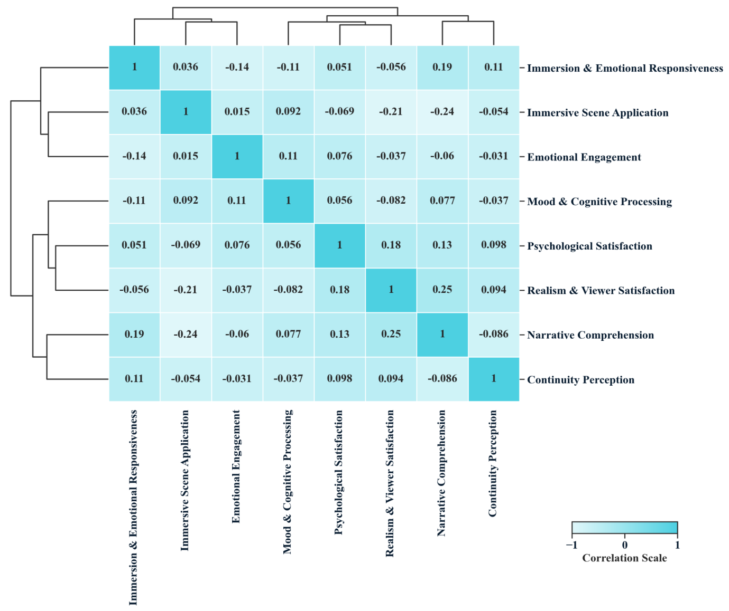
Figure 2: Correlation Analysis
Figure 2 represents the spontaneous relations between the experience of F&T offered by IIoT to viewers in their emotional reactions, gratification, and perception of storytelling.
  - Qualitative Results
Qualitative results are researched on a thematic basis. The psychological effect of IIoT on the audience involvement, and the arising themes and representative quotes by the participants on IIoT
6.2.1. Thematic Analysis
Table 4 shows the thematic analysis of the factors that influence the psychology and scene implementation of F&T audiences according to the IIoT and points out 8 important themes on the basis of 50 observations.
Table 4: Thematic analysis
Themes | Frequency  (n = 50) | Observation
Emotional Engagement | 38 | Synchronized effect, responsive audio or ambient lighting being IIoT sensitive elements provided weaker participants with a greater level of emotional engagement.
Mood and Cognitive Processing | 48 | The individualization of presentation of the texts, the participants described themselves to have been more mood congruent, and their cognitive load was lower.
Psychological Satisfaction | 41 | The pairing of preferences with the content was achieved with the use of intelligent suggestions and made viewers feel more satisfied.
Immersion and Emotional Responsiveness | 39 | The members mentioned the feeling of being attracted to the multisensory stimulation with IoT devices.
Immersive Scene Application | 44 | The use of smart home technologies (smart TVs, lights, and speakers) allowed a very immersive watching experience.
Realism and Viewer Satisfaction | 47 | The real-time change of environment made it more realistic and believable in content.
Narrative Comprehension | 43 | IIoT and AR/VR technologies allowed people to participate in the engagement process and also enabled them to learn more about those stories.
Continuity Perception | 49 | The respondents were also satisfied with the ease of synchronization of the devices and insisted that this prevented distraction and narrative interruptions.
Overall, the thematic analysis table indicates that the findings underscore the multifaceted factors affecting the psychology and scene application of F&T audiences based on the IIoT.
6.2.2. Result for Psychological Impact of Intelligent IOT on Audience Engagement
The F&T industry is changing the audience experience due to the IIoT technology. IIoT also has the potential to directly track the emotional dispositions, viewing patterns, and mood swings of the audience and adjust their media content accordingly, with personalized and customized solutions being delivered.
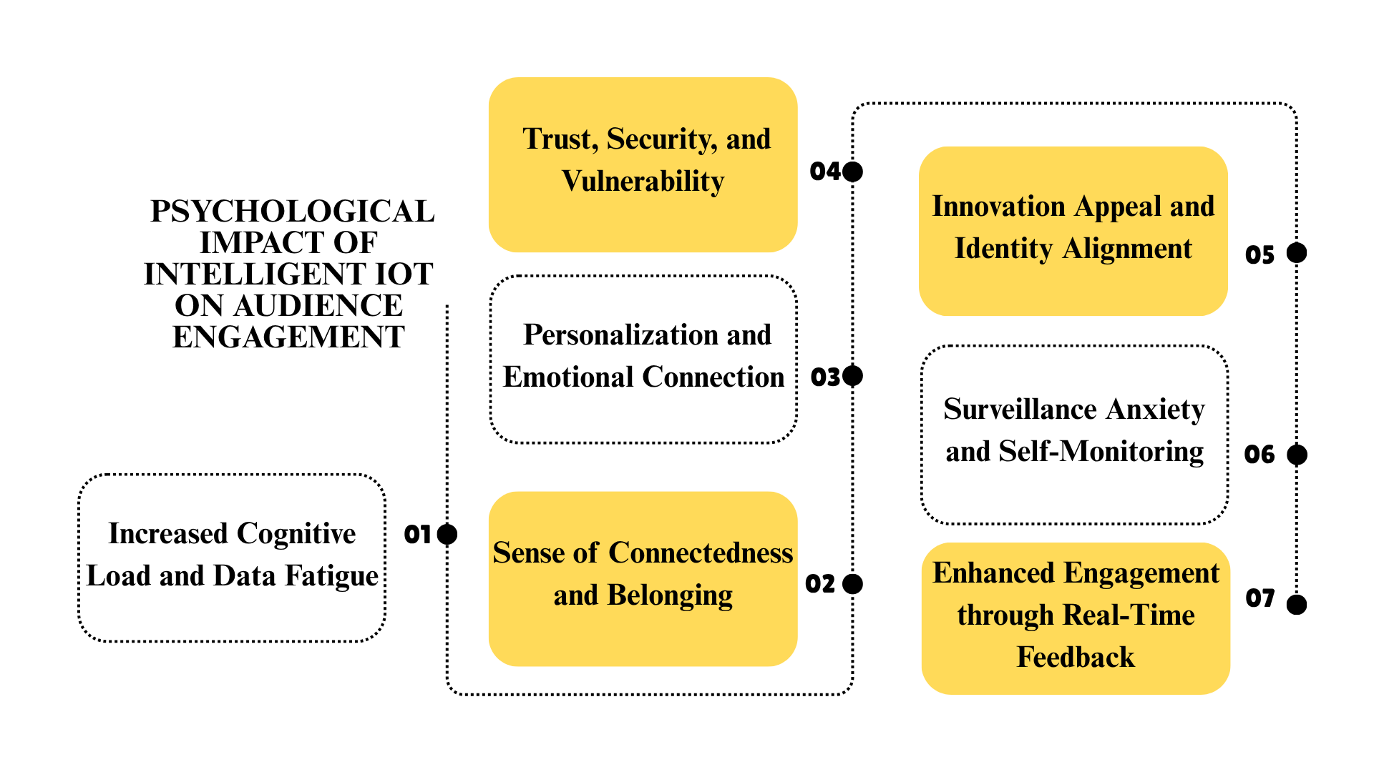
Figure 3: Psychological Impact of IOT
Figure 3 explains the psychological impacts of the IIoT technology on the emotional engagement of F&T viewers in seven key areas. Overall, all the information presented in this figure clearly shows that IoT technology is changing the psychological experience and visual consumption of F&T viewers.
6.2.3. Emergent Themes and Representative Participant Quotes on IIoT-Affected Audience Experience
Psychological and visual effects that IIoT technology has on F&T viewers. The first theme is direct interaction and feedback in the content.
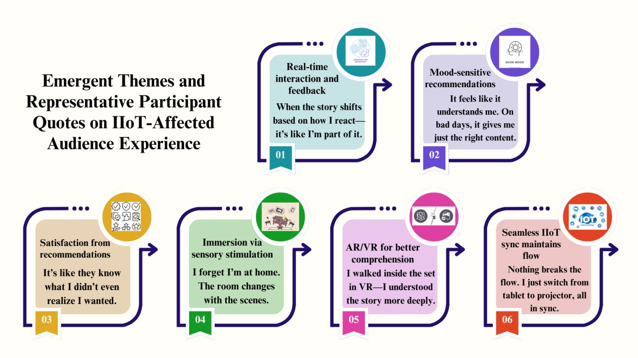Figure 4: Emergent Themes and Representative Participant Quotes on IIoT
Overall, Figure 4 underscores the emergent themes and representation of participants in psychology and the scene application of F&T in IoT.
- DISCUSSION
This paper measures the effects of the technology of IoT in the context of psychological response and visual perceptions of F&T viewers. The support of H1a was due to the influence of IIoT, creating emotion in the viewers to engage them emotionally. Another study by Hornik and Rachamim (2025) proved the possibility of IIoT instruments to provide a prediction of the emotions and preferences of the users. H1b: Personalized experience affects sub-paralleous and/or cognitive states of the viewer. According to Prokopic and Sayer (2025), VR and IIoT allow specific experiences, where witnesses are involved in the story construction. In H1c, recommendations based on data help to improve viewer satisfaction and content evaluation. Incorporation of the requirements of the audience and promotion through the market in IIoT was investigated (Assaad & Sadek Kanaan, 2025) by discovering new channels. In H1d, there will be an uninterrupted sensory experience where viewers will have a complete visual experience. (Gulzar et al., 2025), they explored how IIoT is a key tool for creating emotional understanding and social engagement. H2a significantly improves the immersive scene application of IoT smart devices. Wazid et al. (2025) aimed to evaluate a deep learning-based, explainable malware attack detection model for an IoT environment. H2b increases scene realism and viewer satisfaction through the real-time environment. To increase the intrusion detection of an IoT environment, Chen et al. (2025) designed Synaptic Intelligent Convolutional Neural Networks (SICNN). This correspondence is with H2c because it enhances the visual storyline understanding and attention of a viewer. As a solution to malware attacks, the research conducted by Qureshi et al. (2024) and Li (2025) reviewed the use of deep learning approaches. They observed that IoT technologies are vital in giving proper anticipation and live checks.. In this work, it was confirmed that the IoT technologies play a significant role in the provision of accurate and correct expectations, as well as live monitoring. H2d decreases distractions among the viewers and enhances the perception of scene continuity. According to (Rehman et al., 2025), it was investigated that computing systems under real-time methods enhance trust and transparency.
Overall, researchers investigate the changes in the mental engagement and visual experiences of movie and TV audiences. In particular, the study suggests that viewers’ emotional engagement is enhanced through personalized content has effects on viewers’ mood and cognitive processing. Talking of the causes of the IIoT-induced changes in the visual experience, the IIoT equipment in the domestic setting enhances the quality of the visual experience. This paper examines the recent works on IIoT to facilitate an insight into the psychological involvement, experience quality, and changes in technology in the experiences of F&T.
- CONCLUSION
The research examines the impact of IIoT technology on two key dimensions of F&T viewers’ psychological states and visual usability. Moreover, the research IIoT-connected smart devices further enhance immersive scene quality in home screen experiences; real-time environment adaptation significantly enhances scene realism & viewer satisfaction; The current study underscores that the IIoT-AR/VR integration enhances narrative comprehension & participation; audiovisual synchronization reduces distraction and improves continuity perception. The present study findings are expected to guide psychological and visual quality reconstructions in the IIoT environment and provide the foundation for creating media experiences that are superior, commercially viable, and entertaining. Overall, IIoT technologies bring significant improvements in psychological aspects such as audience emotional engagement, mood processing, psychological satisfaction, and immersion, as well as experiential aspects such as visual quality, realism, narrative comprehension, and continuity in bringing personalized, immersive, and sensory-based experiences to F&T.
REFERENCES
Adewojo, A.A., Olatunji, M.O., Adewojo, A. and Olalere, P.M., 2025. Patterns of Online Health Information Seeking Among Gen Z Nigerians: A Behavioral Analysis.
Alsamh, M.H., Hawbani, A., Kumar, S. and Alsamhi, S.H., 2024. Multisensory metaverse-6G: A new paradigm of commerce and education. IEEE Access, 12, pp.75657-75677.
Ardjomandi, A., 2025. The role of narrative and storytelling in designing for long-term emotional engagement in product design.
Assaad, A.S. and Sadek Kanaan, S., 2025, June. Supply chain integration based on big data, Internet of Things, marketing intelligence and knowledge sharing. Study SNOWA company in Iran. In Supply Chain Forum: An International Journal (pp. 1-17). Taylor & Francis.
Bai, S., Jiang, F., Li, Q., Yu, D. and Tan, Y., 2025. Harnessing Empathy: The Power of Emotional Resonance in Live Streaming Sales and the Moderating Magic of Product Type. Journal of Theoretical and Applied Electronic Commerce Research, 20(1), p.30.
Berrezueta-Guzman, S. and Wagner, S., 2025. Immersive Multiplayer VR: Unreal Engine’s Strengths, Limitations, and Future Prospects. IEEE Access.
Bi, J., Wang, P., Zhang, W., Bao, K. and Qin, L., 2024. Research on the construction of a digital twin system for the long-term service monitoring of port terminals. Journal of Marine Science and Engineering, 12(7), p.1215.
Bilderback, S., 2025. Why they rot: a global epidemic impacting employees. Strategic HR Review, 24(1), pp.36-41.
Chen, H., Wang, Z., Yang, S., Luo, X., He, D. and Chan, S., 2025. Intrusion detection using synaptic intelligent convolutional neural networks for dynamic Internet of Things environments. Alexandria Engineering Journal, 111, pp.78-91.
Chen, X. and Ibrahim, Z., 2023. A comprehensive study of emotional responses in AI-enhanced interactive installation art. Sustainability, 15(22), p.15830.
Ehab, A., Aladawi, A. and Burnett, G., 2025. Exploring AI-Integrated VR Systems: A Methodological Approach to Inclusive Digital Urban Design. Urban Science, 9(6), p.196.
El Ghati, O., Alaoui-Fdili, O., Chahbouni, O., Alioua, N. and Bouarifi, W., 2024. Artificial intelligence-powered visual internet of things in smart cities: A comprehensive review. Sustainable computing: informatics and systems, 43, p.101004.
Gulzar, B., Sofi, S. A., & Sholla, S. (2025). Convergence of personal internet of things into social internet of things. Cluster Computing, 28(4), 277. https://doi.org/10.1007/s10586-024-04997-0
Han, D., Xu, J. and Zhou, P., 2024. Optimization of Chinese film and television communication technology in Portuguese-speaking areas under the application of digital Internet of Things. Heliyon, 10(18).
Hornik, J. and Rachamim, M., 2024. Television shows ideation, and testing with smart digital twins to advance ratings. Electronic Commerce Research, pp.1-32.
Hornik, J., Rachamim, M. and Ofir, C., 2025. Leveraging real-time digital twins for smart livestreaming platforms to enhance consumers’ experience. The Journal of Supercomputing, 81(8), p.887.
Kamdjou, H.M., Baudry, D., Havard, V. and Ouchani, S., 2024. Resource-constrained extended reality operated with digital twin in industrial internet of things. IEEE Open Journal of the Communications Society, 5, pp.928-950.
Kim, Y.L., 2025. Urban vitality measurement through big data and Internet of things technologies. ISPRS International Journal of Geo-Information, 14(1), p.14.
Kourtesis, P., 2024. A comprehensive review of multimodal XR applications, risks, and ethical challenges in the metaverse. Multimodal Technologies and Interaction, 8(11), p.98.
Ladeira, W.J., Lim, W.M., de Oliveira Santini, F., Rasul, T., Frantz, B., de Oliveira Rosa, J.C. and Azhar, M., 2025. Consumer adoption of internet of things. Journal of Consumer Behaviour, 24(2), pp.673-693.
Li, L., 2025. A Comprehensive Survey of Fire Weather Index (FWI) Systems and IoT Applications in Peatland Fire Management. IEEE Access, 13, pp.33579-33599.
Lim, C.T.N., 2025. Controller to Console: Tracing the Footsteps of Video Game Media Evolution in the Filipino Gaming Experience. Review of Integrative Business and Economics Research, 14(1), pp.72-87.
Litherland, B., 2025. Smarter, better, faster, kinder? The problems with claiming that media and popular culture has positive effects. International Journal of Cultural Studies, p.13678779251337761.
Nguyen, T.H., Trivedi, R.H., Fukukawa, K. and Adomako, S., 2025. Investigating Drivers of Customer Experience with Virtual Conversational Agents. Information Systems Frontiers, pp.1-27.
Ongoro, C.A., FanJiang, Y.Y., Hung, C.H., Lin, B.J. and Guo, J., 2024. Tares: A game-based tangible augmented reality English spelling mastery system with minimal cognitive load. IEEE Access, 12, pp.61163-61184.
Patil, K.P., Bharathi S, V. and Pramod, D., 2025. Examining the impact of consumption values and hedonic motivation on metaverse adoption in Ayurveda health tourism. Cogent Social Sciences, 11(1), p.2519932.
Prokopic, P. and Sayer, J., 2025. Expanding Interactivity in Film: Emergent Narratives through VR and Spatialized Cinematic Experiences. Interactive Film & Media Journal, 5(1-2), pp.29-42.
Qureshi, S. A., Hussain, L., Sadiq, T., Shah, S. T. H., Mir, A. A., Nadim, M. A., & Shah, S. A. H. (2024). Breast Cancer Detection using Mammography: Image Processing to Deep Learning. IEEE Access. https://doi.org/10.1109/ACCESS.2024.3523745
Rahimi, F., Sadeghi-Niaraki, A. and Choi, S.M., 2025. Generative AI Meets Virtual Reality: A Comprehensive Survey on Applications, Challenges, and Future Direction. IEEE Access.
Rehman, A.U., Lu, S., Bin Heyat, M.B., Iqbal, M.S., Parveen, S., Bin Hayat, M.A., Akhtar, F., Ashraf, M.A., Khan, O., Pomary, D. and Sawan, M., 2025. Internet of Things in Healthcare Research: Trends, Innovations, Security Considerations, Challenges and Future Strategy. International Journal of Intelligent Systems, 2025(1), p.8546245.
Rodero, E. and Rodríguez-de-Dios, I., 2024. The 3D sound power of immersion processing and psychophysiological effects of binaural versus stereo audio stories. Media Psychology, 27(5), pp.715-736.
Shuwei, L., 2025. Indoor energy conservation and intelligent elderly care rehabilitation based on ambient light sensing in the Internet of Things. Thermal Science and Engineering Progress, 59, p.103289.
Spaho, E., Çiço, B. and Shabani, I., 2025. IoT Integration Approaches into Personalized Online Learning: Systematic Review. Computers, 14(2), p.63.
Su, J., Wang, Y. and Li, Z., 2025. Investigating user acceptance of mobile cultural applications in China: an expanded technology acceptance model (TAM). International Journal of Human–Computer Interaction, 41(5), pp.2920-2935.
Tightiz, L., Dang, L.M., Padmanaban, S. and Hur, K., 2024. Metaverse-driven smart grid architecture. Energy Reports, 12, pp.2014-2025.
Valdeón, R.A., 2024. The translation of multimodal texts: challenges and theoretical approaches. Perspectives, 32(1), pp.1-13.
Wang, J., Mo, F., Qiao, S., Feng, H. and Lyu, Z., 2025. Spatial computing in digital twins. Digital Twin, p.2508268.
Wang, L. and Kim, K., 2024. Analyzing group polarization through text emotion measurement and time series prediction: A comparative study across three online platforms. Measurement: Sensors, 33, p.101216.
Wang, Z., Wang, Y., Zeng, Y., Su, J. and Li, Z., 2025. An investigation into the acceptance of intelligent care systems: an extended technology acceptance model (TAM). Scientific Reports, 15(1), p.17912.
Wazid, M., Singh, J., Pandey, C., Sherratt, R.S., Das, A.K., Giri, D. and Park, Y., 2025. Explainable deep Learning-Enabled malware attack detection for IoT-Enabled intelligent transportation systems. IEEE Transactions on Intelligent Transportation Systems.
Wu, T., Jiang, N., Kumar, T.B.J. and Chen, M., 2024. The role of cognitive factors in consumers’ perceived value and subscription intention of video streaming platforms: a systematic literature review. Cogent Business & Management, 11(1), p.2329247.
Yang, H., Li, J. and Jahng, S., 2024. The Application of Knowledge Graph Convolutional Network-Based Film and Television Interaction Under Artificial Intelligence. IEEE Access.
Yu, T., Yang, W., Wu, R., Xu, J. and Yang, J., 2025. A multidimensional exploration based on Hofstede’s Cultural Theory: An empirical study on Chinese audience acceptance of American animated films. Behavioral Sciences, 15(2), p.164.
Zhang, B. and Shao, L., 2025. Production and dissemination path of new media film and television content based on 5G technology. Entertainment Computing, 52, p.100852.
Zhang, H., Gao, K., Hou, Y., Domaneschi, M., & Noori, M. (2025). Portable IoT device for tire text code identification via integrated computer vision system. Computer‐Aided Civil and Infrastructure Engineering.
Zhang, Z., Tan, L. and Tiong, R.L., 2024. Fire emergency management of large shopping malls: IoT-based evacuee tracking and dynamic path optimization. Alexandria Engineering Journal, 107, pp.652-664.
Zhao, D., Yang, J. and Zhao, C., 2024. Exploring how the application of live-streaming in E-commerce influences consumers’ trust-building. IEEE Access.
Zhao, J., Shi, X., Yezhova, O., Zhan, Q., & Zhang, X. (2025). An Advanced Recomposition-Based Displaying Technique: Maximizing Image Reconstruction for Virtual Museum Applications. IEEE Access, 13, 96277-96289.
Zou, W., Man, S.S., Hu, W., Zhou, S. and Chan, H.S., 2025. Factors Influencing the Acceptance of Industry 4.0 Technologies in Various Sectors: A Systematic Review and Meta-Analysis. Applied Sciences, 15(9), p.4866.

