Disclaimer:
The National Cooperative Research Program (NCHRP) produces ready-to-implement solutions to the challenges facing transportation professionals. NCHRP is sponsored by the individual state departments of transportation of the American Association of State Highway and Transportation Officials. NCHRP is administered by the Transportation Research Board (TRB), part of the National Academies of Sciences, Engineering, and Medicine, under a Cooperative Agreement with the Federal Highway Administration (FHWA). Any opinions and conclusions expressed or implied in resulting research products are those of the individuals and organizations who performed the research and are not necessarily those of TRB; the National Academies of Sciences, Engineering, and Medicine; FHWA; or NCHRP sponsors.

Quantitative Risk Assessment GIS Tool User Manual
The Quantitative Risk Assessment GIS Tool was developed as part of the NCHRP 23-24 project, Methods to Allow Agencies to Incorporate Quantitative Risk Assessment at Project and Network Level. This tool enables users to view risks associated with various types of transportation assets under different natural threats. See below for instructions on how to use the tool. Please note that the tool is intended for research and planning purposes only.
The input for this GIS tool comes from risk assessment results generated by the QRA Spreadsheet Tool. These results were visualized using ArcGIS Pro and shared via ArcGIS Online. To make the risk information more accessible, the results were also presented through an ArcGIS StoryMap, which constitutes the Quantitative Risk Assessment GIS Tool. The current version of the tool is based on a case study in Utah.
- Instruction: Click the buttons to view the maps
This tool includes multiple maps that display the risk assessment results. To view the map or visualization for a specific calculation, click the corresponding button located on the left side of the map area.

- Asset Category
This section lists the primary transportation assets included in the risk assessment.

- Threat Category
This section lists the main natural threats considered in the risk assessment.

- View Asset Risk Information

- Map Area: Maps are displayed in the map area on the right side of the webpage. When you click a button, the corresponding map will appear. Each map includes a legend for reference. You can zoom in and out to explore the map in more detail. Right-clicking on a feature will activate a pop-up window with additional information about the selected asset.

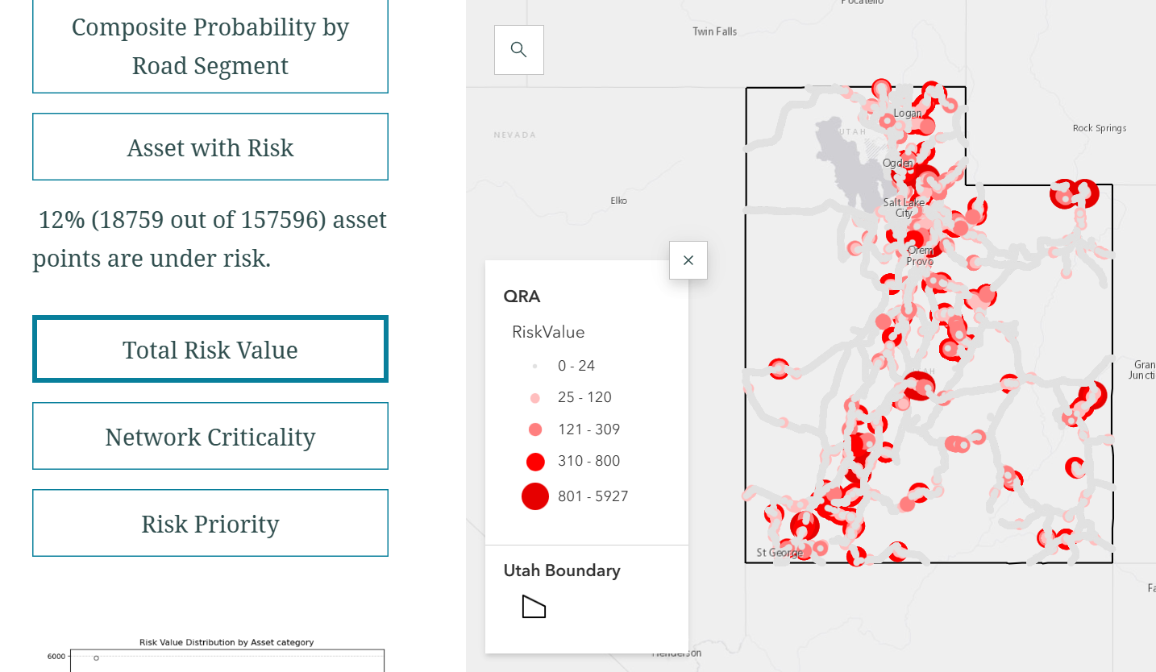
Map Area
Legend
Calculation Buttons

- Pop-Up Windows: Right-click on a specific asset on the map to view a pop-up window displaying the asset's attributes and risk assessment results. These include the risk value, risk priority, network criticality, vulnerability, probability of threat, and consequence.

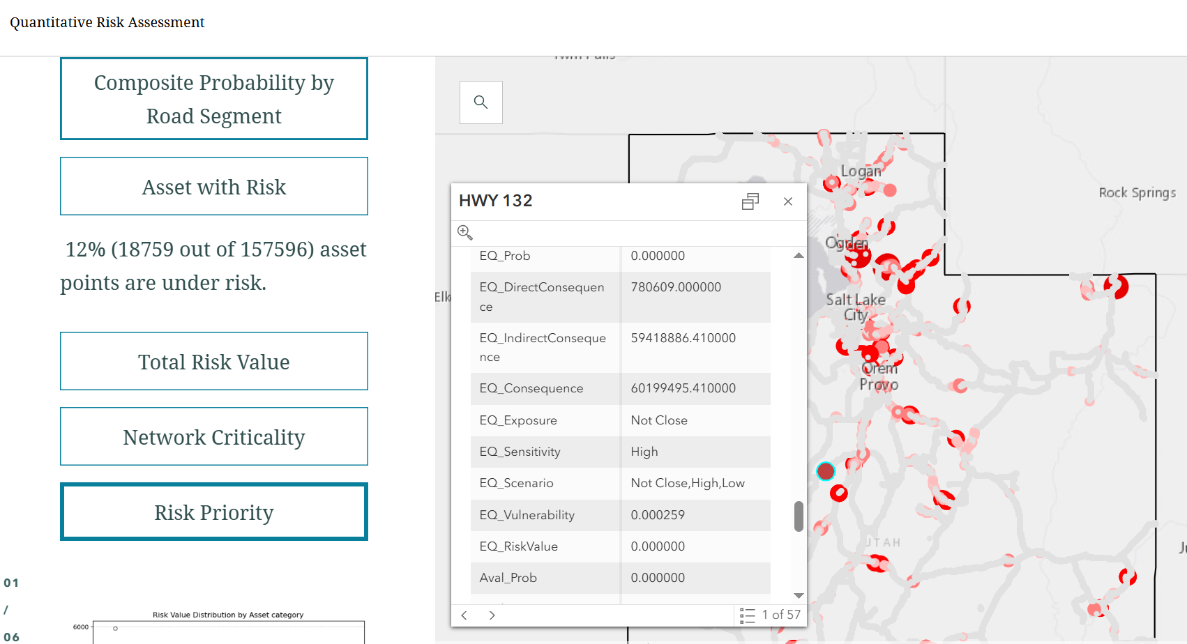
Pop-up window

- Summary Statistics: This tool also includes several figures and tables that present descriptive statistics for risk values and risk priorities. These visualizations help users understand overall trends and the distribution of risk across different assets and threat categories.

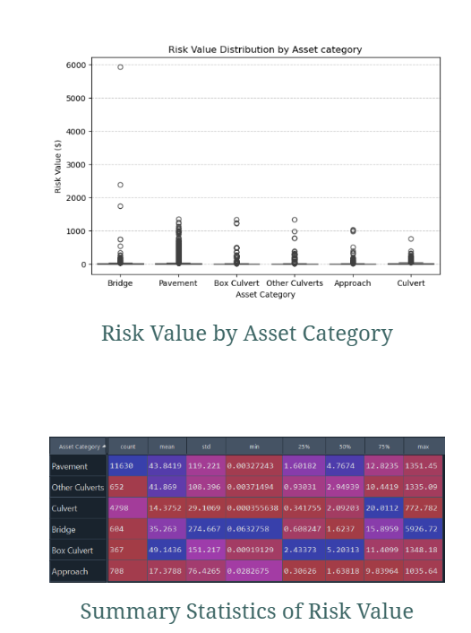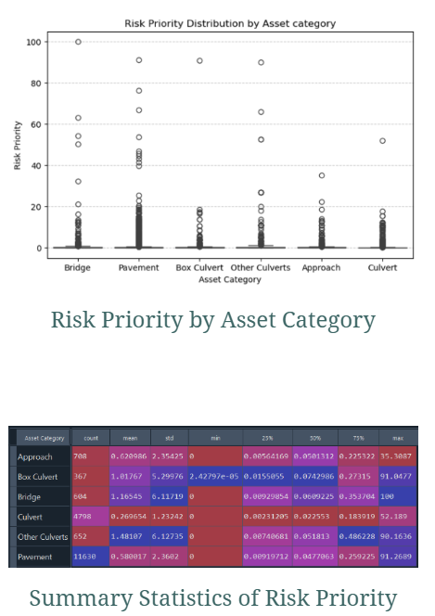

- Risk Assessment Groups
This tool includes both the total risk values and risk priorities aggregated across all threat types, as well as detailed risk assessment results for each individual threat. The results for each threat type include the consequence, probability, vulnerability under that specific threat, and the resulting risk value.

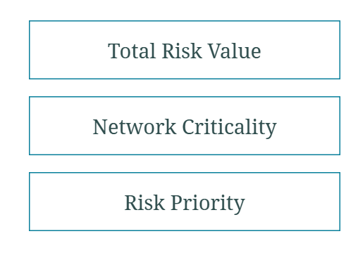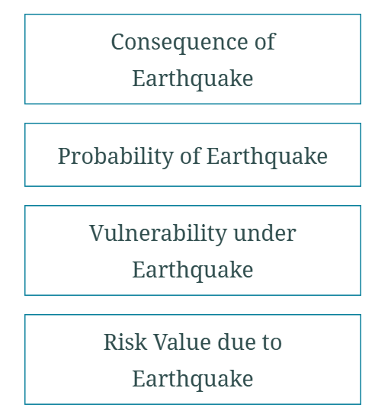
- Network Criticality
This tool also provides detailed information on network criticality, including the formula and calculation steps used. The map visualizes network criticality and highlights key contributing factors such as AADT (Annual Average Daily Traffic), TADT (Truck Annual Daily Traffic), and delay time.

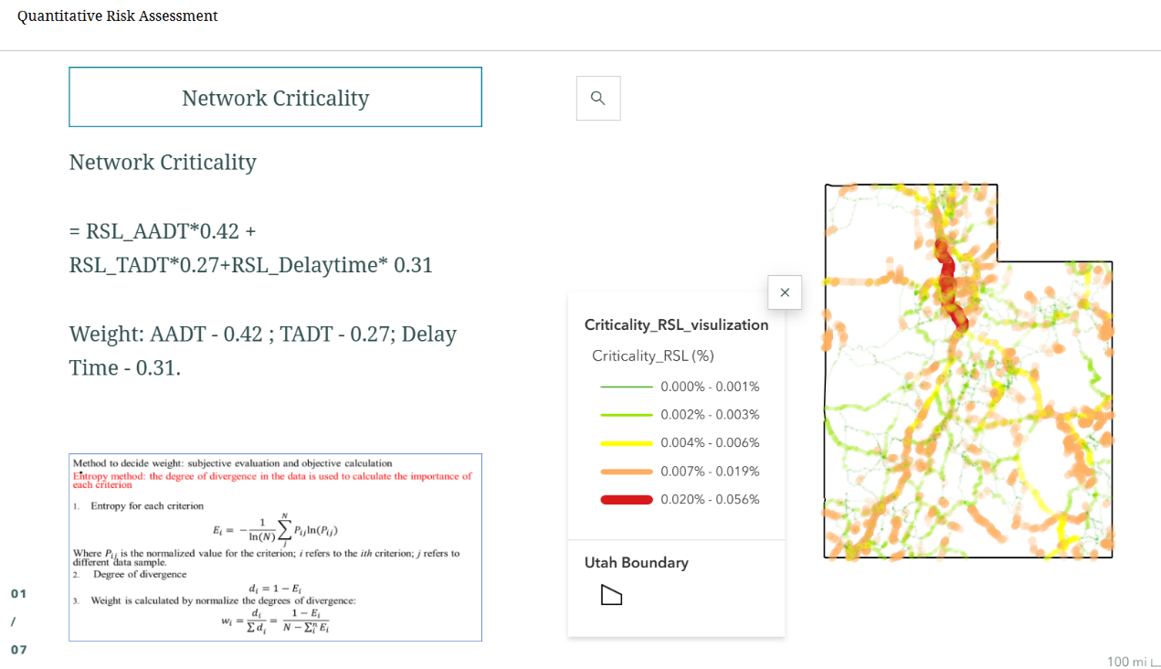

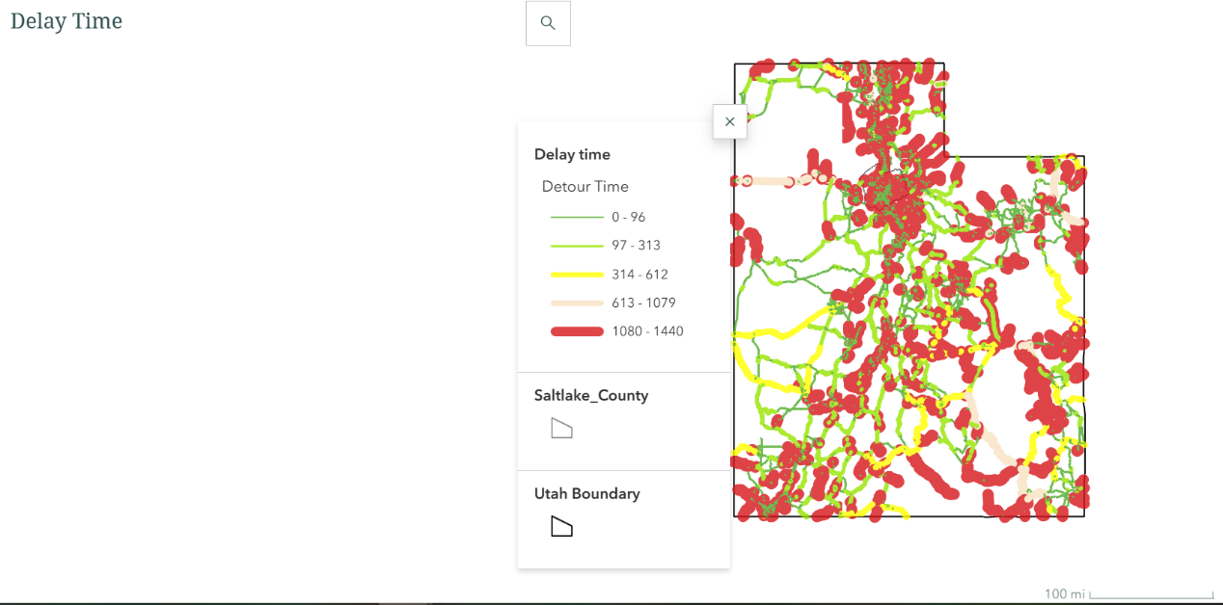

Contact Information:
Junmei Cheng | UCLA Mobility Lab | junmeicheng@ucla.edu

