Credit Default Prediction: A Cost-Sensitive Classification Approach with SHAP Interpretability

Introduction and Motivation
In consumer finance, credit default prediction balances expected return against non-payment risk. Misclassifying a risky customer causes direct credit loss, while rejecting creditworthy customers reduces income opportunities. Traditional models optimize accuracy or F1-score, ignoring the asymmetric business costs: approving a defaulter (False Negative) typically costs 10× more than rejecting a good borrower (False Positive) due to Loss-Given-Default (45%) versus foregone profit margin (4.5%). Moreover, default events are rare (25.6% in our dataset), customer behavior evolves over time, and regulators demand transparent, explainable scoring systems.
This study addresses these challenges by developing cost-sensitive credit models for small-amount loans (≤200,000 NT$) suitable for automated decisions. We compare five models—three glassbox (Ridge, Logistic Regression, Linear SVM) and two blackbox (LightGBM with L2/Cross-Entropy loss)—to examine how learning objectives affect predictive performance and business outcomes. Our final model (LightGBM with Cross-Entropy) achieves 0.7642 validation AUC and reduces business cost by 40% through threshold optimization (0.10 vs. F1-optimal 0.30). Using SHAP analysis, we demonstrate that payment behavior features dominate predictions while demographics show minimal impact, enabling focused data collection and regulatory compliance.

Data and Methods

Dataset
We use the UCI Credit Card Default dataset (30,000 Taiwanese cardholders, April–September 2005, binary target for October 2005 default). Filtering to credit limits ≤200,000 NT$ yields 20,378 observations (25.6% default rate). Features include demographics (SEX, EDUCATION, MARRIAGE, AGE), credit limit, repayment status (PAY_1–PAY_6: -2=no consumption, -1=paid full, 0=revolving, 1-9=months late), bill amounts (BILL_AMT1–BILL_AMT6), and payment amounts (PAY_AMT1–PAY_AMT6). Data split: 60% training (12,226), 20% validation (4,076), 20% test (4,076), stratified by default rate.

Data Cleaning
Quality checks confirmed no missing values and unique IDs. We consolidated invalid EDUCATION codes (0,5,6→4:others) and MARRIAGE code (0→3:others). Negative bills (2.25%, refunds) were retained. All payment statuses validated within [-2,9] range.

Feature Engineering
We created eight behavioral features from 6-month history using OLS slopes and statistical aggregations: BILL_SLOPE (bill trend), PAY_SLOPE (payment trend), DELINQUENCY_PERSISTENCE (max consecutive late months), MAX_DELINQUENCY (worst delay), REPAYMENT_RATIO (total pay/bills), REPAYMENT_STABILITY (payment std dev), UTILIZATION_RATE (avg bills/credit limit), UTILIZATION_TREND (utilization change). Total: 31 features (23 original + 8 engineered).

Model Development and Comparison

Model Specifications
Glassbox Models: (1) Ridge Regression uses L2-penalized least squares (GridSearchCV: α=1, best), providing a baseline for classification-via-regression. (2) Logistic Regression links predictors to default probability via logistic function (C=10, class_weight=balanced), offering transparent log-odds coefficients. (3) Linear SVM applies margin-based classification with squared hinge loss (C=1, class_weight=balanced), calibrated via CalibratedClassifierCV for probability outputs.
Blackbox Models: (1) LightGBM Regressor (L2) uses gradient-boosted trees with squared error, capturing non-linear interactions without heavy feature engineering. (2) LightGBM Classifier (Cross-Entropy) optimizes binary cross-entropy for probability outputs, combined with SHAP TreeExplainer for post-hoc interpretability.

Performance Comparison
Model | Type | Loss | Validation AUC
Ridge Regression | Glassbox | L2 | 0.7385
Logistic Regression | Glassbox | Log Loss | 0.7449
Linear SVM | Glassbox | Hinge | 0.7442
LightGBM (L2) | Blackbox | L2 | 0.7599
LightGBM (CE) | Blackbox | Cross-Entropy | 0.7642
All models achieved AUC 0.74–0.77, effectively separating defaulters. Logistic Regression and Linear SVM perform similarly (0.7449 vs. 0.7442), showing minimal effect of surrogate loss changes. LightGBM models outperform linear models by ~2%, with Cross-Entropy achieving highest AUC (0.7642), confirming tree-based models better capture non-linear payment behavior patterns. LightGBM with Cross-Entropy is selected as final model.

Cost-Sensitive Threshold Optimization

Cost Function Design
Threshold | Precision | Recall | F1 | Cost | Approval Rate
F1-Optimal (0.30) | 51% | 58% | 0.55 | 4,928 | 72%
Cost-Optimal (0.10) | 32% | 91% | 0.48 | 2,950 | 28%
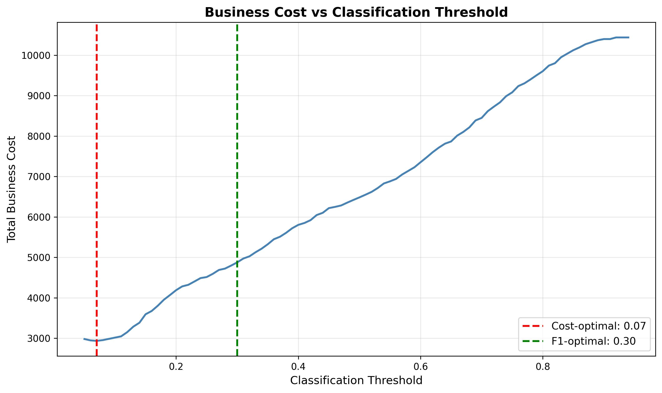
Switching to cost-optimal threshold achieves 40% cost reduction (4,928→2,950) and 91% recall (vs. 58%). The trade-off—higher false positives—is financially justified given 10:1 cost asymmetry. Figure 1 shows cost minimization at threshold=0.10.

Figure 1: Total cost minimizes at threshold 0.10 (red), reducing cost 40% vs. F1-optimal 0.30 (green).

Model Interpretation Using SHAP

SHAP Methodology
SHAP (SHapley Additive exPlanations) quantifies each feature's contribution to predictions using Shapley values from game theory. Since SHAP only requires model inputs and outputs, it explains any blackbox model. As Gafsi (2025) notes, SHAP is widely accepted in banking for reconciling ML performance with regulatory transparency requirements.

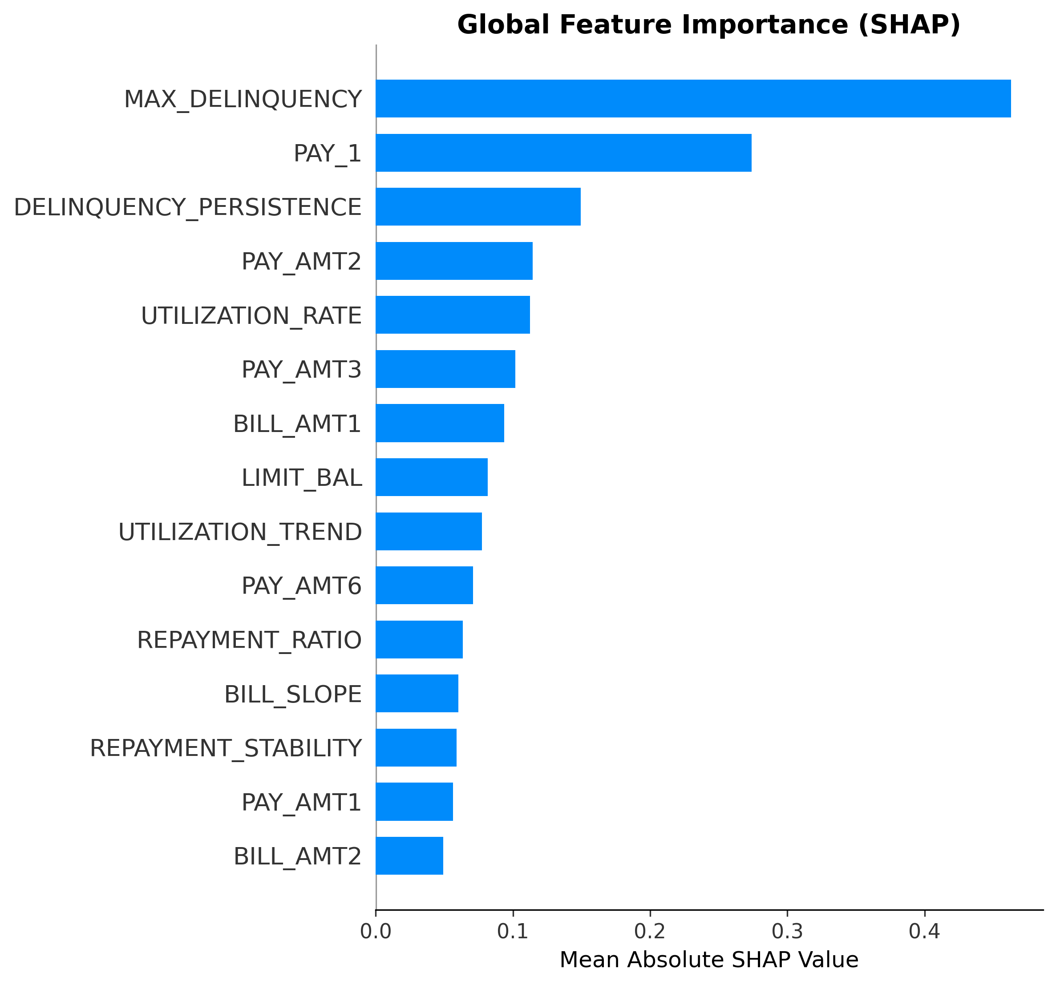
Global Feature Importance
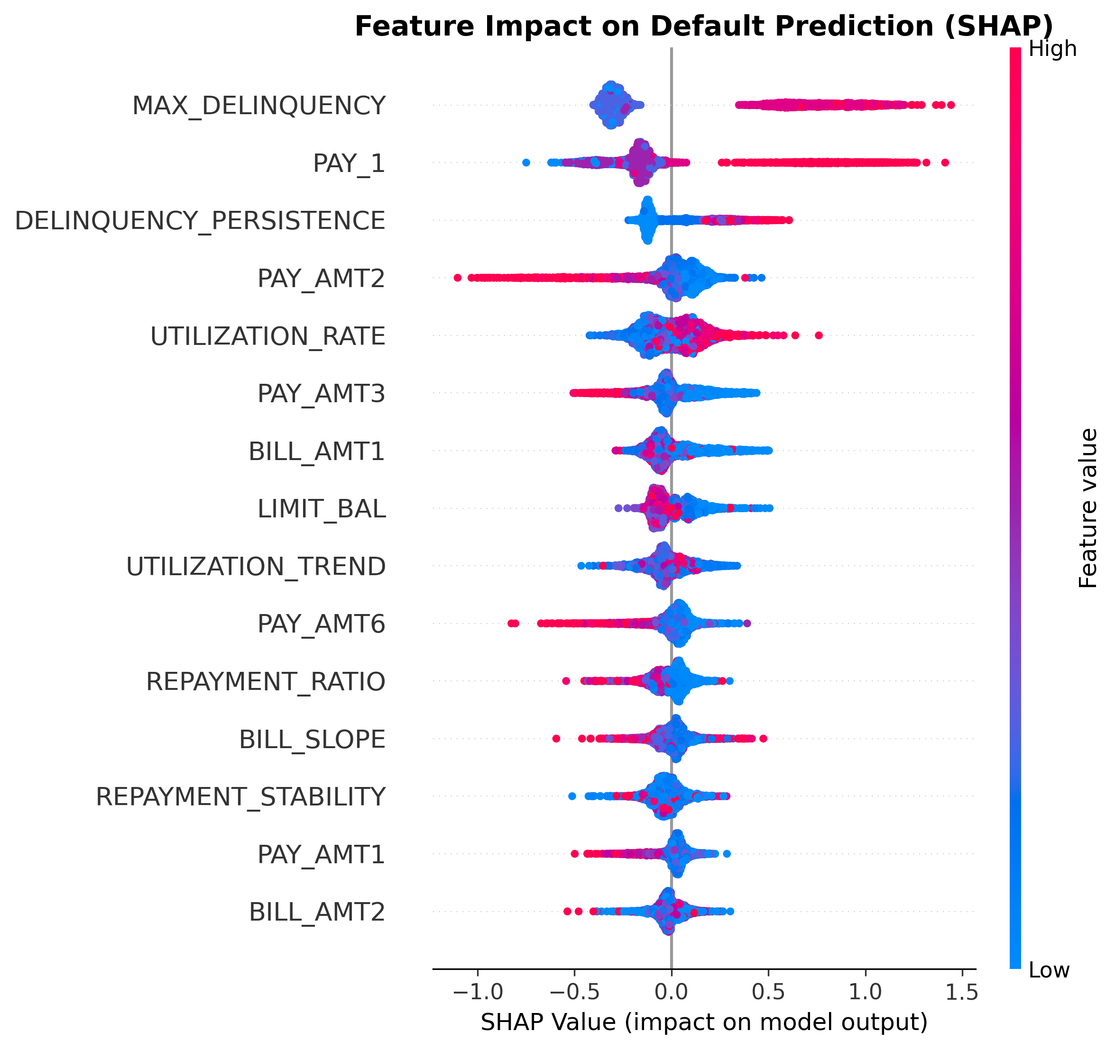

Figure 2: Payment behavior dominates feature importance (SHAP values).
Figure 3: High MAX_DELINQUENCY (red dots, right) increases default risk; paid-in-full status (blue, left) decreases risk.

Local Case Studies
True Positive (predicted 0.78, actual default): MAX_DELINQUENCY=8 (+0.95 SHAP), PAY_1=4 (+0.42), UTILIZATION_RATE=1.2 (+0.28, over limit). Clear high-risk profile.
False Positive (predicted 0.71, actual non-default): MAX_DELINQUENCY=6 (+0.72), PAY_1=2 (+0.31), but REPAYMENT_RATIO=0.9 (-0.22). Model flagged past late history; client was recovering—acceptable trade-off of conservative threshold.
False Negative (predicted 0.22, actual default): PAY_1=0 (-0.31, revolving), MAX_DELINQUENCY=2 (+0.15), low bills (-0.18). Sudden default without warning—9% slip-through acceptable given cost-benefit.

Final Model and Business Recommendations

Model Selection
LightGBM with Cross-Entropy is selected based on: (1) Highest validation AUC (0.7642 vs. 0.7449 for best glassbox), (2) Lowest cost (2,950 vs. 2,987 for Logistic Regression), (3) Practical approval rate (28% vs. 5%), (4) SHAP interpretability, (5) 91% recall. While glassbox models offer intrinsic interpretability, LightGBM's 2% AUC gain and 23% higher approval rate justify blackbox+SHAP. SHAP provides actionable insights comparable to coefficients while capturing non-linear interactions.

Deployment Strategy
Threshold policy: Use 0.10 to minimize cost and detect 91% of defaulters. Implement three-tier system: (1) Auto-approve <0.05 (safest 5%), (2) Auto-reject >0.10 (risky 72%), (3) Manual review 0.05–0.10 (borderline 23%). Monitor actual FN/FP costs monthly, recalibrate if recovery rates change, retrain quarterly.

Conclusion

References
Bank for International Settlements. (2005). Studies on the validation of internal rating systems (Working Paper No. 14). BIS. https://www.bis.org/publ/bcbs_wp14.htm
Gafsi, N. (2025). Machine Learning Approaches to Credit Risk: Comparative Evidence from Participation and Conventional Banks in the UK. Journal of Risk and Financial Management, 18(7), 345. https://doi.org/10.3390/jrfm18070345
Lessmann, S., Baesens, B., Seow, H. V., & Thomas, L. C. (2015). Benchmarking state-of-the-art classification algorithms for credit scoring: A ten-year update. European Journal of Operational Research, 247(1), 124–136. https://doi.org/10.1016/j.ejor.2015.05.030

