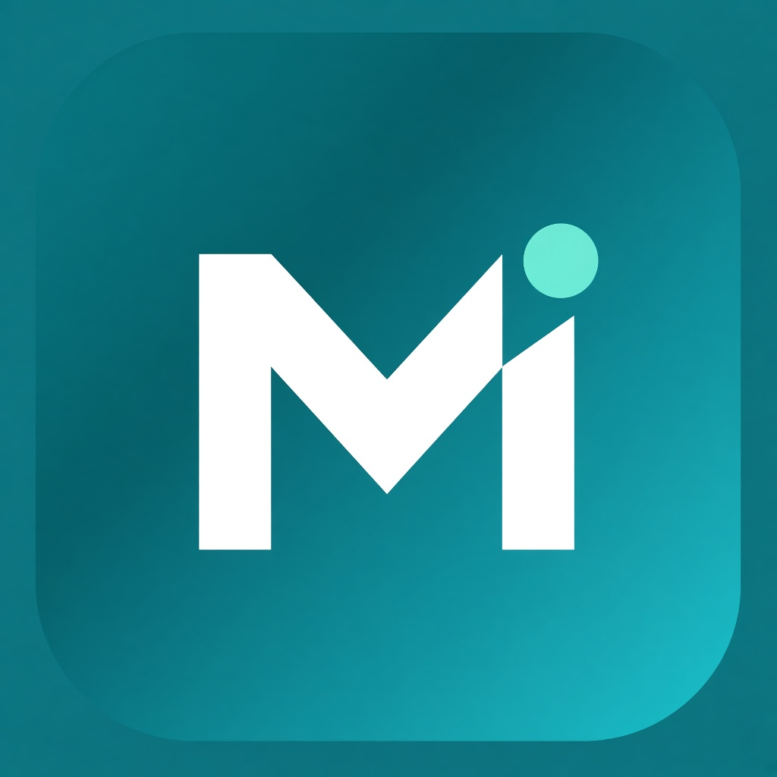
HEALTHCARE CHAT BOT
Medical Bot Console
User Manual
A complete operating guide for clinic administrators and front-desk staff.
Learn how to configure, monitor, and use Medical Bot Console as your AI-assisted clinic front desk.
Document type: Clinic operations manual
Audience: Clinic Admin & Clinic Staff
Product: Medical Bot Console
Version: 1.0

Medical Bot Console is a clinic-facing AI front desk. It answers patient questions from your clinic knowledge,
handles inbound phone calls, books appointments, runs outbound outreach campaigns, and gives your
team a secure console to review conversations, calls, and schedules — day or night.
Contents
- Introduction & what Medical Bot Console does
- How patients reach the bot
- Signing in & user roles
- Recommended go-live checklist
- Dashboard & conversation inbox
- Clinics
- Agents (bot profiles)
- Knowledge (training content)
- Conversation flows
- Appointments & doctors
- Outbound campaigns
- Calling history
- Users & audit logs
- Testing with Agent Test Lab
- Safety, privacy & clinical boundaries
- Day-to-day staff workflows
- Troubleshooting
- Glossary
- Support & document control

1. Introduction & what Medical Bot Console does
Medical Bot Console (product name: Healthcare Chat Bot) acts as an always-available digital
front desk for your medical practice. It is designed to reduce missed calls, standardize patient
intake, and keep appointment booking consistent — while keeping clinical decision-making with
licensed staff.
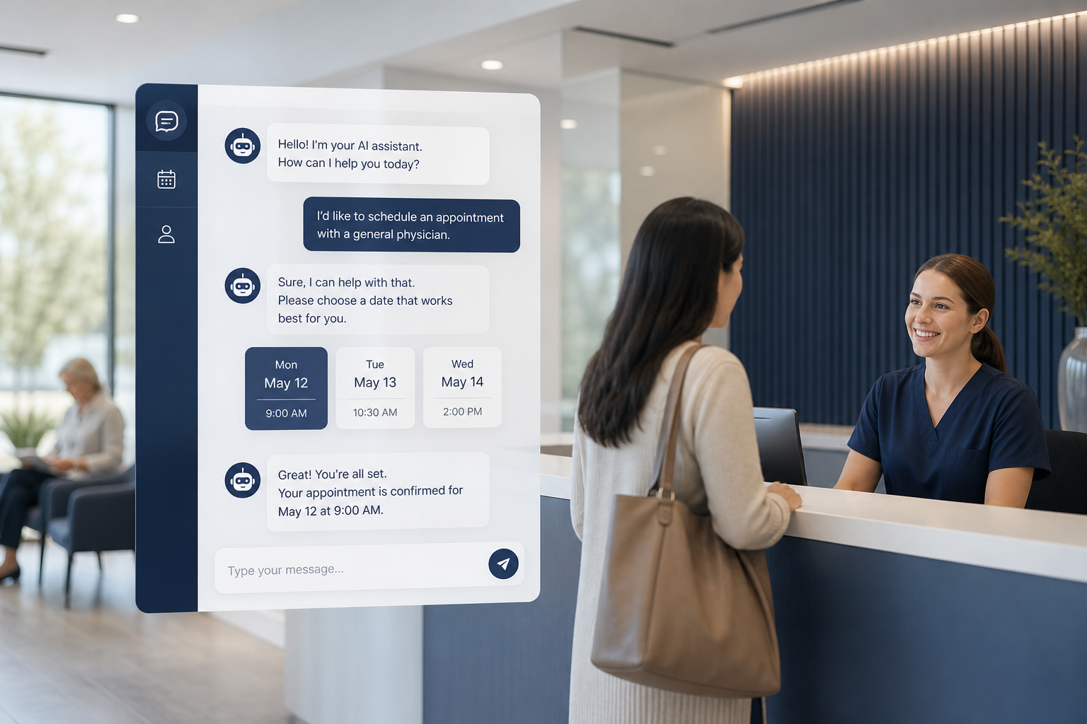
Figure 1. Medical Bot Console supports clinic operations across chat, phone, and scheduling.
1.1 Core capabilities
Capability | What it means for your clinic
Web chat | Patients message your clinic assistant in the browser. Answers are based on your clinic knowledge and safety rules.
Inbound phone (voice AI) | When patients call your clinic number, Medical Bot Console can greet them, answer questions, and collect booking details using natural conversation.
Appointment booking | The bot collects required intake fields, confirms the visit, and creates an appointment visible in the Appointments calendar.
Knowledge base | You control what the bot says — FAQs, clinic policies, hours, directions, and safety prompts.
Conversation flows | Visual call/chat scripts (Start → questions/actions → End) so conversations follow your clinic process.
Campaigns | Outbound dialing to patient lists for reminders, follow-ups, or outreach — with status tracking per contact.
Operations console | Dashboard KPIs, inbox, call transcripts, doctor roster, user management, and audit logs.

1.2 What Medical Bot Console is not
IMPORTANT CLINICAL BOUNDARY — Medical Bot Console is an informational and operational assistant . It does not diagnose conditions,
prescribe treatment, or replace a licensed clinician. Emergency situations should be directed to 911 or urgent care according to your clinic policy.
2. How patients reach the bot
Patients interact with Medical Bot Console through these channels:
Web chat
A clinic web chat widget (connected to Medical Bot Console) lets patients type questions or use voice
in the browser. Theme colors and clinic identity can match your clinic branding.
Inbound phone
Calls to your Twilio-connected clinic number are answered by the assigned Agent.
The assistant greets the caller, follows your flow/knowledge, and can book appointments.
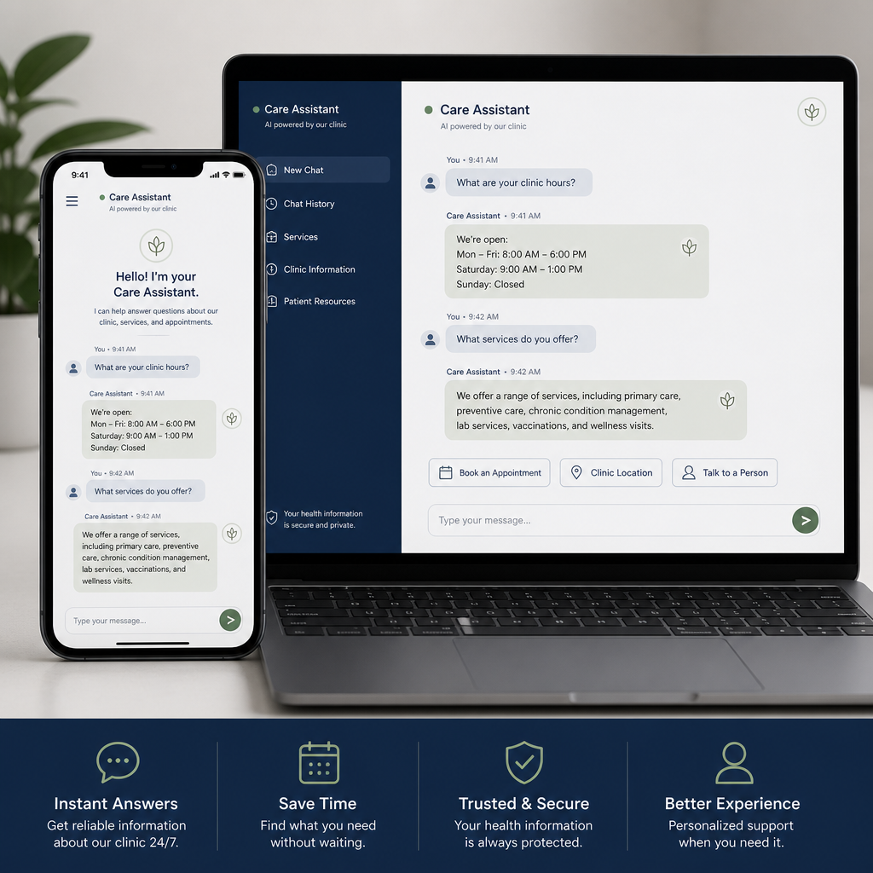
Figure 2. Web chat — patients ask questions and book visits from the browser.

Figure 3. Inbound voice — Medical Bot Console handles phone conversations with natural speech.
2.1 Typical patient journey
- Welcome & intent. The bot greets the patient and identifies why they are contacting the clinic (information, booking, existing appointment, etc.).
- Knowledge-aware answers. For FAQs and clinic information, Medical Bot Console answers from your Knowledge content and safety prompts.
- Structured booking (when requested). The bot collects required intake fields and confirms the appointment.
- Handoff / continuity. Staff can review the conversation or call transcript in Medical Bot Console and follow up as needed.

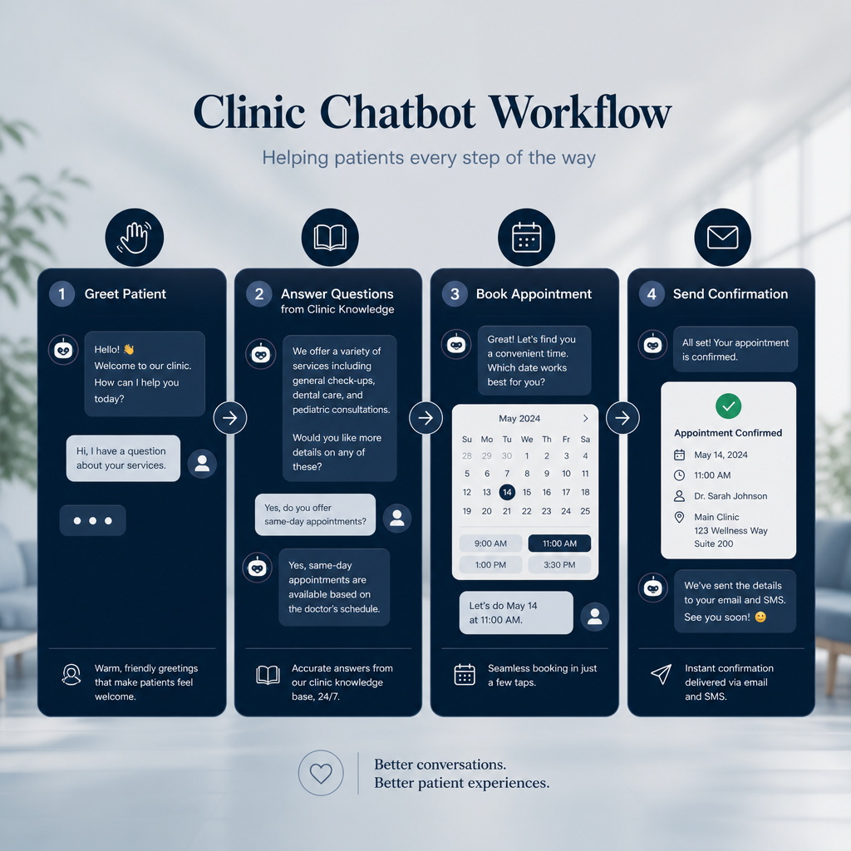
Figure 4. High-level patient conversation workflow.
3. Signing in & user roles
3.1 Accessing Medical Bot Console
Medical Bot Console
Look for this admin logo on the sign-in page and in the left sidebar after you log in.
It identifies the official Medical Bot Console used by your clinic.
- Open your clinic’s Medical Bot Console URL (typically ending with /admin).
- Confirm you see the Medical Bot Console logo on the login screen.
- Sign in with the email and password provided by your administrator.
- After a successful login you land on the Dashboard. The same logo appears at the top of the sidebar.

SESSION SECURITY — Sessions expire after 60 minutes of use. When the session expires, sign in again.
Do not share login credentials. Always sign out on shared workstations.
3.2 Roles and permissions
Role | Can access | Typical use
Admin | Dashboard, Clinics, Appointments, Users, Doctors, Agents, Knowledge, Flows,  Campaigns, Calls, Audit logs | Full platform configuration and oversight across clinics
Clinic Staff | Dashboard, Appointments, Doctors, Agents, Knowledge, Flows, Campaigns, Calls  (not Clinics, Users, or Audit logs) | Day-to-day operations for assigned clinic(s)

Clinic Staff accounts are limited to the clinics assigned to them. Admins can manage all clinics
and user accounts.
3.3 Navigation overview
The left sidebar lists the modules available to your role:
Menu item | Purpose
Dashboard | Operations overview, KPIs, and conversation inbox
Clinics | Clinic profiles, branding, and agent assignment (Admin)
Appointments | Calendar of booked visits (Eastern Time)
Users | Create and manage Admin / Clinic Staff accounts (Admin)
Doctors | Provider roster used by the clinic
Agents | Bot profiles (AI, voice, phone, meeting, flow, knowledge)
Knowledge | Prompts and uploaded clinic documents / FAQs
Flows | Visual conversation graphs
Campaigns | Outbound calling programs and patient lists
Calls | Inbound call history and transcripts
Audit logs | Who accessed what, when, and from where (Admin)

4. Recommended go-live checklist
Use this sequence when bringing a new clinic onto Medical Bot Console. Complete each step before going live
with patients.
- Create users. In Users, create Admin and Clinic Staff
accounts. Assign Clinic Staff to the correct clinic(s).
- Prepare Knowledge. In Knowledge, review the default
safety prompts and add clinic-specific FAQs, hours, insurance notes, and policies.
- Build or select a Flow. In Flows, design the
conversation path (greeting → questions → booking actions → End).
- Configure an Agent. In Agents, complete the wizard:
General → OpenAI → Voice → Twilio → Meeting → Flow & knowledge.
- Register the Clinic. In Clinics, enter profile details,
upload an avatar, choose a theme color, and assign the Agent.
- Add Doctors. In Doctors, maintain the provider roster
patients and staff will reference.
- Connect telephony. Ensure the clinic’s Twilio voice number points to the Medical Bot Console
inbound webhook (configured by your technical team).
- Test thoroughly. Use Agent Test Lab (flask icon on Agents / Clinics)
for Webchat, Inbound, and Campaign simulations before enabling live traffic.

BEST PRACTICE — Go live with Knowledge and Test Lab validated first. Outbound Campaigns should be enabled only
after inbound chat/phone behavior is approved by clinic leadership.
5. Dashboard & conversation inbox
The Dashboard is the home screen for daily operations. It summarizes activity and
gives quick access to recent conversations.
5.1 What you will see
- KPI cards — conversations, messages, calls, and appointments at a glance.
- Daily channel volume chart — switch between 7 / 30 / 60 day views to spot trends.
- Today’s appointments — visits scheduled for the current day.
- Clinic performance — comparative activity across clinics (when applicable).
- Inbox — recent patient conversation threads for review.

5.2 Using the inbox
- Open Dashboard.
- Select a conversation in the inbox panel.
- Review the message history to understand patient intent and what the bot already collected.
- Follow up by phone or in person if the conversation needs human attention.

STAFF TIP — Check the inbox at the start of each shift and after busy periods. Flag incomplete bookings
(missing phone/email/DOB) and complete them manually if needed.
6. Clinics
Clinics (Admin only) stores each practice location’s identity and
which Agent serves that location.

Figure 5. Medical Bot Console supports one or many clinic locations under a shared console.
6.1 Clinic profile fields
Field | Description
Name | Full clinic name shown to staff and used in greetings
Acronym | Short code used in templates (e.g. greeting placeholders)
Clinic ID | External or internal identifier for the location
Address / phone / email / website / portal | Contact and location details
Avatar | Clinic image used in the console and patient-facing branding
Theme color | Brand color passed to the web chat experience
Assigned agent | Which bot profile answers for this clinic

6.2 Assigning an agent
- Open the clinic record.
- Select an active Agent from the assignment control.
- Save. New chat and phone sessions for that clinic use the assigned Agent.

Admins may also use Import from API to sync clinic records from an external source
when that integration is enabled for your organization.
6.3 Greeting placeholders
Greetings can include dynamic clinic values:
- $clinic_name$ — full clinic name
- $clinic_acronym$ — short name
- $clinic_city$ — city from the clinic address

7. Agents (bot profiles)
An Agent is the complete bot configuration for how Medical Bot Console speaks, thinks, dials,
and books. One Agent is typically assigned to one Clinic, though you may maintain multiple Agents
(for example, inbound vs. campaign).
7.1 Creating or editing an Agent
Open Agents and use the setup wizard. Steps:
Step | What you configure
1. General | Title, status (active/inactive), description of the agent’s purpose
2. OpenAI | API key and models for chat, realtime voice, transcription, and TTS
3. Voice | Realtime voice selection and preview so the phone experience matches your brand tone
4. Twilio | Telephony credentials used for inbound/outbound calling for this agent
5. Meeting | Meeting/calendar provider:  Google (Meet + OAuth fields),  ECW, or  Azul (API endpoint)
6. Flow & knowledge | Link the conversation flow and knowledge documents this agent should use

7.2 Duplicating an Agent
Use Duplicate to copy an existing Agent into a prefilled create form. This is useful
when opening a second location with similar settings — then adjust clinic-specific Twilio, meeting,
or knowledge links before saving.
CREDENTIAL CARE — OpenAI and Twilio credentials are sensitive. Only Admins or authorized staff should enter them.
Rotate keys if a staff member with access leaves the organization.
8. Knowledge (training content)
Knowledge controls what the bot is allowed to say. Keeping this section
accurate is the single most important quality factor for patient experience.
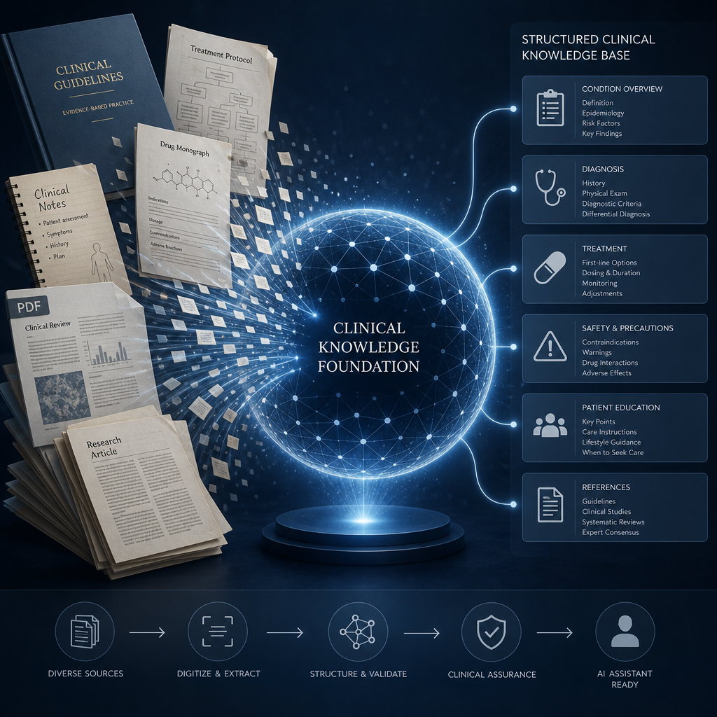
Figure 6. Knowledge content trains Medical Bot Console on your clinic’s information and policies.
8.1 Built-in prompt categories
Prompt | Purpose
Assistant & safety | Core behavioral rules: no diagnosis, HIPAA-aware handling, off-topic deflection,  OTC-only medication mentions, red-flag escalation, multilingual warm tone.
Voice style | Keeps phone replies short, natural, and free of markdown or lists.
Appointment booking | Guides how booking language and confirmation should work for your clinic.

8.2 Adding clinic documents
- Go to Knowledge.
- Create or edit a knowledge item and attach documents as needed.
- Supported uploads include .txt, .md, .csv,
.pdf, and .docx.
- Assign the knowledge to the relevant clinic(s) and set it Active.
- Link the knowledge from the Agent’s Flow & knowledge step.

8.3 What to put in Knowledge
- Office hours, holiday closures, parking, and directions
- Accepted insurance plans and referral requirements
- New patient vs. established patient instructions
- Preparation notes (fasting, bring ID/insurance card, arrive early)
- Clinic phone numbers and when to call vs. use the bot
- Approved FAQ answers reviewed by clinical leadership

DO NOT UPLOAD — Do not place protected health information (PHI) from real patients into Knowledge documents.
Knowledge is for general clinic information and approved educational content only.
9. Conversation flows
Flows is a visual builder for structured conversations. Flows tell the
bot how to move from greeting to questions, actions, and ending the call.
9.1 Node types
Node | Behavior
Start | Entry point of the conversation
Message | Says a fixed or templated message to the patient
Question | Asks for information and waits for a reply
Function | Runs a clinic action (book, cancel, SMS, transfer, etc.)
Branch | Routes the path based on the patient’s answer
End | Ends the conversation / hangs up the call

9.2 Available function actions
- Book appointment
- Cancel appointment
- Reschedule appointment
- Send appointment reminder
- Send voicemail
- Send text message
- Send email
- Transfer to human
- Collect payment
- Update patient info

You can Duplicate a flow to create a deep copy of the graph for another clinic or
campaign variant.
DESIGN TIP — Keep flows short. Collect only what staff need. Always provide a path to transfer to a human
for clinical concerns, billing disputes, or frustrated callers.
10. Appointments & doctors
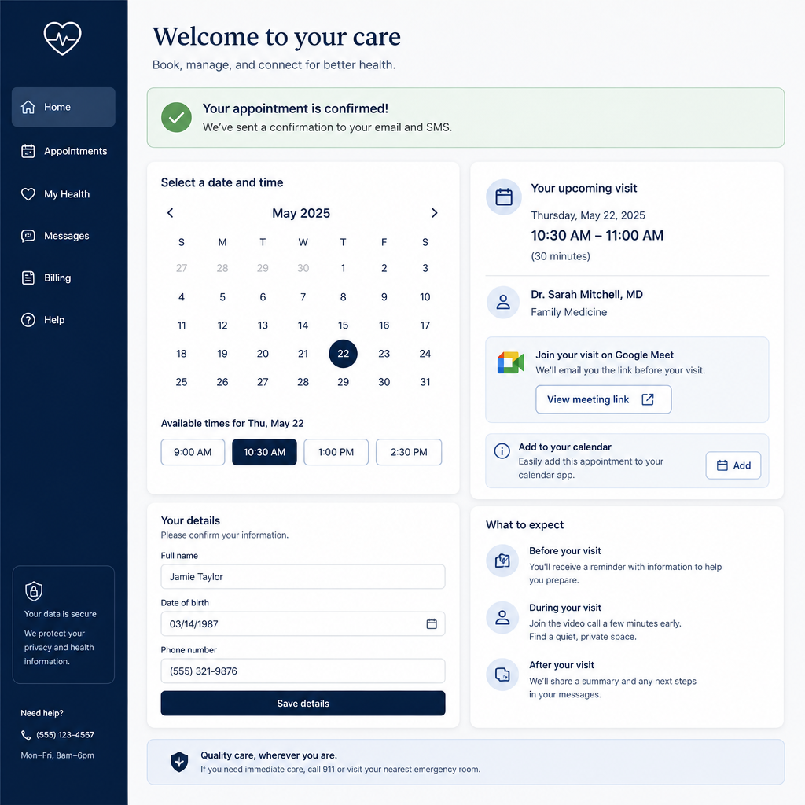
Figure 7. Appointments booked by Medical Bot Console appear on the clinic calendar.
10.1 Appointment calendar
Open Appointments to view the schedule in month or week views.
All appointment times are managed in Eastern Time (America/New_York).
- Review today’s and upcoming visits from the Dashboard and Appointments pages.
- Cancel appointments from the calendar when a visit should not proceed.
- After cancellation, notify the patient through your normal clinic process if needed.

10.2 What the bot collects during booking
When a patient requests an appointment, Medical Bot Console gathers these required fields:
# | Field | Example prompt to patient
1 | Full name | What is your full name?
2 | Phone number | What is the best phone number to reach you?
3 | Email address | What is your email address?
4 | Date of birth | What is your date of birth?
5 | New or existing patient | Are you a new patient or an existing patient?
6 | Preferred date & time | What date and time would you like for the appointment?

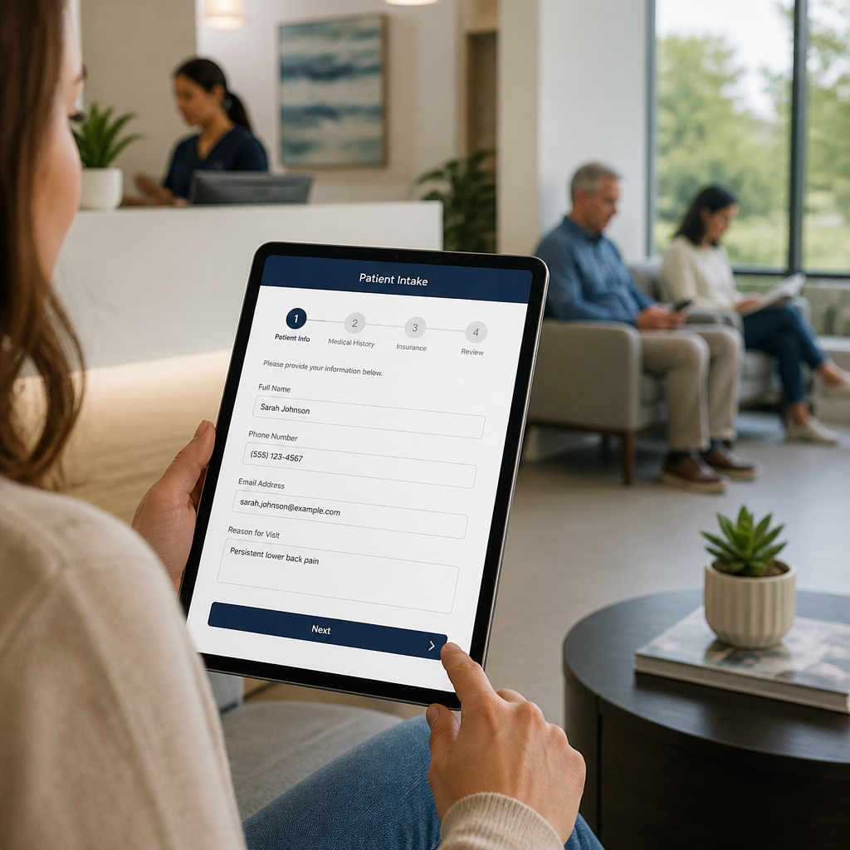
Figure 8. Structured intake ensures bookings arrive complete for front-desk staff.
After intake is complete, Medical Bot Console confirms the visit, creates the appointment record, and may
generate a meeting link (for example Google Meet) when the Agent’s meeting provider is configured.
Staff notification emails can also be sent when email alerts are enabled.
10.3 Doctors
Use Doctors to maintain provider profiles (name, photo, and related
details). Keep this roster current so patients and staff see the correct providers.
11. Outbound campaigns
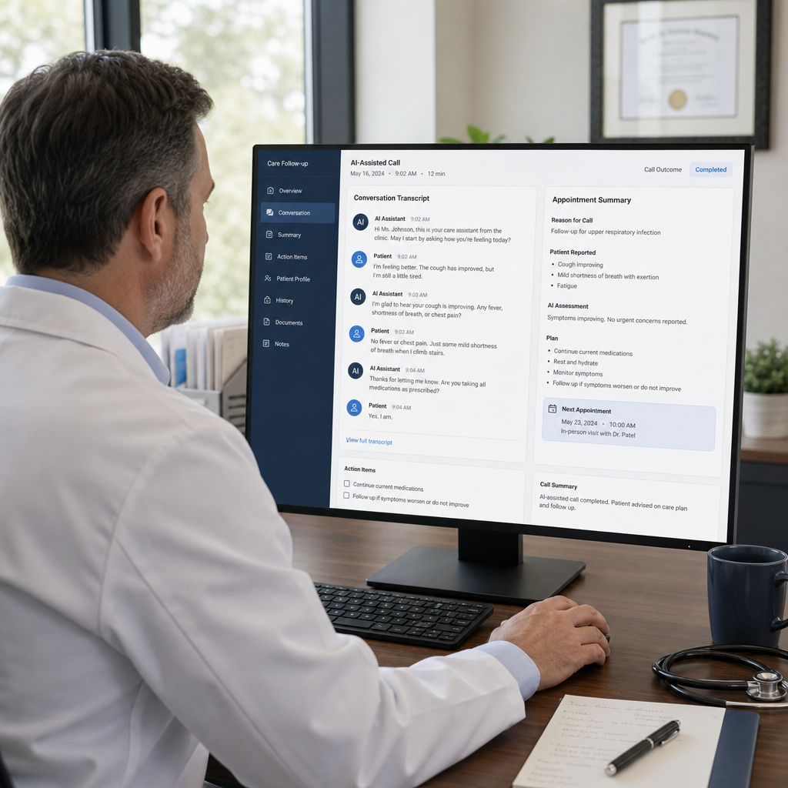
Figure 9. Campaigns support outbound reminders and patient follow-up calls.
11.1 Campaign lifecycle
Status | Meaning
Draft | Being configured; not ready to dial
Ready | Configured and awaiting schedule / start
Running | Actively placing outbound calls
Paused | Temporarily stopped by staff
Completed | Finished dialing the list

11.2 Creating a campaign
- Open Campaigns and create a new campaign (or duplicate an existing one).
- Select the clinic, active Agent, and conversation Flow.
- Set the schedule window and retry behavior according to clinic policy.
- Save as Draft, then move to Ready when configuration is complete.
- Open the campaign detail page to manage the patient list.

11.3 Importing patients
- On the campaign detail page, upload an Excel (.xlsx / .xls) or CSV file.
- Map columns (name, phone, and other fields) in the import dialog.
- Confirm the import and review the contact list.
- Optionally sync patients from an external API if your organization uses that integration.

11.4 Contact outcome statuses
Status | Meaning
Pending | Not yet called
Calling | Call in progress
Success | Completed successfully per campaign criteria
Reject | Declined or unsuccessful
Interesting | Engaged / needs follow-up (positive interest)
Not interesting | No interest expressed

COMPLIANCE NOTE — Only call patients who have consented to outreach under your clinic’s policies and applicable
regulations. Respect quiet hours and do-not-call preferences.
Duplicate campaign copies campaign configuration only — patient lists are not copied.
Re-import or re-sync contacts for the new campaign.
12. Calling history
Calls stores inbound phone sessions for quality review and continuity of care coordination.
- Open a call record to review the transcript.
- Listen to recorded audio when available (waveform player).
- Delete records only when authorized by your clinic’s retention policy.

QUALITY ASSURANCE — Spot-check several calls each week. Confirm greetings, booking accuracy, escalation language,
and whether Knowledge answers match current clinic policy.
13. Users & audit logs
13.1 User management (Admin)
- Open Users.
- Create a user with email, password, and role (Admin or Clinic Staff).
- For Clinic Staff, assign one or more clinics.
- Update or deactivate accounts when staff change roles.

13.2 Audit logs (Admin)
Audit logs provide a HIPAA-oriented access trail showing
who performed what action, when, and from
where. Use filters and page size controls to investigate activity. Clearing logs
should follow your organization’s compliance policy.

Figure 10. Access controls and audit logging support accountable clinic operations.
14. Testing with Agent Test Lab
Before exposing patients to a new Agent, Flow, or Knowledge change, validate behavior in
Agent Test Lab (flask / test icon from Agents or Clinics).
14.1 Test modes
Tab | Use it to verify
Webchat | Browser chat answers, tone, booking intake, and knowledge accuracy
Inbound | Phone-style conversation, greeting, and voice flow behavior
Campaign | Outbound script behavior before launching a live campaign

14.2 Suggested test script
- Ask an on-topic FAQ (hours, parking, insurance).
- Ask an off-topic question — confirm polite deflection.
- Request an appointment and complete all intake fields.
- Provide incomplete or invalid details — confirm the bot asks again.
- Describe an emergency symptom — confirm 911 / urgent care guidance.
- Ask for a diagnosis — confirm the bot refuses and redirects appropriately.
- Verify the appointment appears on the Appointments calendar.

15. Safety, privacy & clinical boundaries
Medical Bot Console ships with mandatory safety behavior in the Assistant & safety knowledge
prompt. Clinic leadership should review these rules and keep them enabled.
15.1 Built-in safety principles
- No diagnosis — the bot must not say or imply “you have X.”
- No clinical replacement — it is a support tool, not a clinician.
- Limited medication guidance — OTC mentions only; no personalized dosing.
- Red-flag escalation — directs callers to urgent care or 911 when warranted.
- Privacy awareness — avoid collecting unnecessary identifiers in Knowledge or free-form chat.
- Off-topic deflection — stays focused on clinic services and general health information.
- Multilingual replies — answers in the patient’s language when possible, in a warm, clear style.

15.2 Recommended clinic policies
- Designate a clinical reviewer for Knowledge content changes.
- Train staff on when to take over from the bot (complex clinical questions, angry callers, emergencies).
- Define retention periods for call recordings and transcripts.
- Use unique staff accounts — never share passwords.
- Review Audit logs periodically.

16. Day-to-day staff workflows
16.1 Opening checklist (each morning)
- Sign in to Medical Bot Console.
- Review Dashboard KPIs and today’s appointments.
- Scan the inbox for overnight conversations needing follow-up.
- Check Calls for any incomplete or escalated overnight phone sessions.
- Confirm any Running campaigns are behaving as expected.

16.2 During the day
- Monitor new appointments created by the bot; complete chart prep as usual.
- Update Knowledge immediately when hours, providers, or policies change.
- Pause campaigns during unexpected clinic closures.
- Transfer complex callers to human staff per clinic protocol.

16.3 Closing checklist
- Reconcile same-day bot bookings against the practice management / EHR schedule.
- Note any Knowledge corrections for the next business day.
- Sign out of shared workstations.

17. Troubleshooting
Symptom | Likely cause | What to try
Cannot sign in | Wrong password or expired/disabled account | Verify email; ask Admin to reset credentials; confirm role is active
Session ends unexpectedly | 60-minute session timeout | Sign in again; avoid leaving the console idle mid-task
Bot gives outdated answers | Stale Knowledge content | Update Knowledge; confirm Agent still links to the correct knowledge items; re-test in Test Lab
Phone not answered by Medical Bot Console | Twilio / Agent / clinic assignment issue | Confirm clinic has an active assigned Agent; verify Twilio settings with your technical team
Appointments not appearing | Incomplete intake or timezone confusion | Check Calls/Inbox for missing fields; remember calendar uses Eastern Time
Campaign not dialing | Status not Running, empty list, or inactive Agent | Confirm status, patient import, schedule window, and active Agent/Flow
Menu items missing | Role permissions | Clinic Staff cannot open Clinics, Users, or Audit logs — ask an Admin
Web chat theme wrong | Clinic theme color not set | Update Theme color on the Clinics page and re-test the widget

18. Glossary
Term | Definition
Healthcare Chat Bot | Public product name of the platform
Medical Bot Console | Brand name of the clinical operations console
Agent | Full bot behavior profile (AI, voice, phone, meeting, flow, knowledge)
Clinic | A practice location with its own profile and assigned Agent
Knowledge | Training content and safety prompts that shape bot answers
Flow | Visual conversation graph from Start to End
Campaign | Scheduled outbound calling program with a patient list
Webchat | Browser-based patient chat channel
Inbound | Patient calls the clinic phone number
Appointment intake | Structured collection of booking fields
Meeting provider | Google / ECW / Azul integration used when creating visits
Clinic Staff | Role with clinic-scoped operational access
Audit log | Record of administrative access and actions
Eastern Time (ET) | System timezone for appointment scheduling

19. Support & document control
19.1 Getting help
- Check this manual’s Troubleshooting section.
- Escalate configuration issues (Twilio, OpenAI keys, server URL) to your technical administrator.
- Escalate clinical content questions to your clinic’s designated Knowledge reviewer.

19.2 Document information
Item | Detail
Document title | Medical Bot Console User Manual
Product | Healthcare Chat Bot (Medical Bot Console)
Version | 1.0
Audience | Medical clinic administrators and front-desk staff
Classification | Internal clinic operations — do not include patient PHI in printed copies beyond operational need

© Healthcare Chat Bot / Medical Bot Console. This manual describes the Medical Bot Console for clinic operations.
Screen labels and features reflect the current product. For a printable PDF, open this file in a browser
and use Print → Save as PDF.

