Community Services - May 2024 –

1. In central we need to change Dashboard to Communication Dashboard

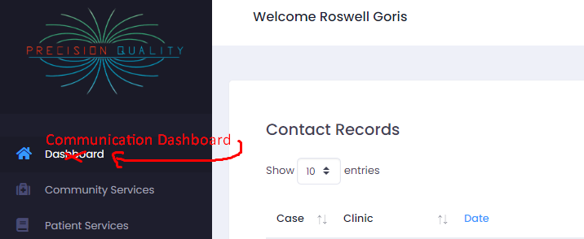

1. In central to put an alert when we try to delete and item we added to category or do Clinic. IN fact I would like a different method to manage this list the way it is not the best or a efficient layout.

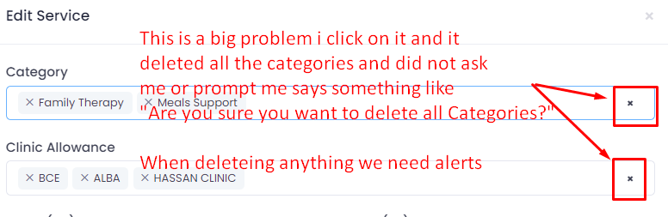

1. We add categories and when we try to select them in the community services the categoes do not come up. Only old categories are showing. We categories do not appear or show to be selected this is quite a problem I am entering new community services but I am not able to add the category. I am able to create a new category but it will not show when adding the new community service.

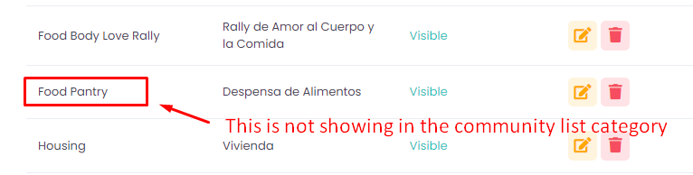

Since I made these screen images I added more category and these new categories will not show in the category lsit then creating new community services. Please make sure if these issues are fix not to delete the data already enter into the community services.

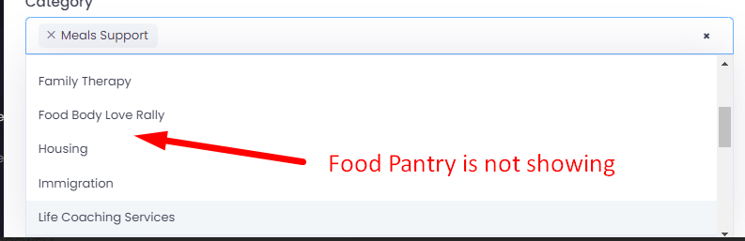

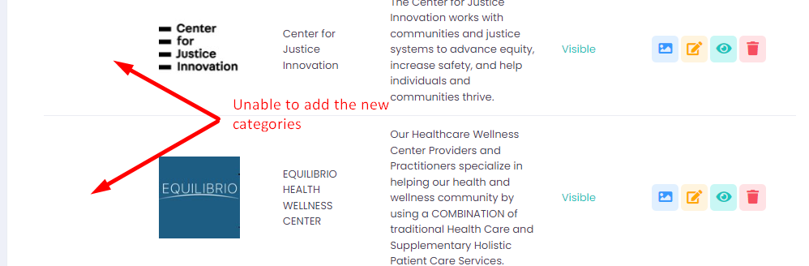

1. We do not need to show the description it is better is we show the address, city, state and zip

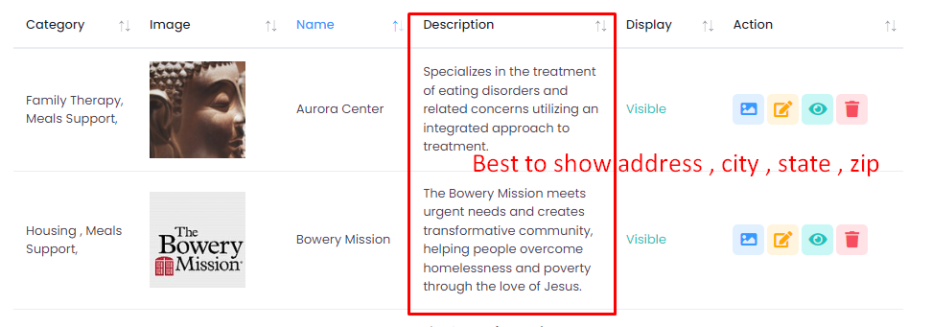

1. Some settings we can make them default, we can change them but at first the can the set as default

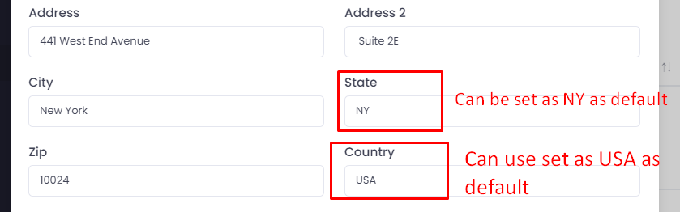

1. When we clinic eye we need to display a page with the information we can use a basic responsive template we can show the information, this temple will be the same the patient will get to see the community resource information when they visit the web site and want to read community services resources orinformatin

