Best Care Ever Updates Mar 2022:
- IT WILL BE GOOD IS WE HAVE A LIST OF DIFFETENT ICONS IN SYSTEM THAT WE CAN SELECT IS CASE WE WANT TO ADD A NEW AREA THERE TO SELECT WITH ICON IS GOOD THIS IS A PROBLEM BECAUSE SOME STAFF MADE A MESS OF THE SITE SO NOW WE NEED TO REMAKE THEM I CAN DO THAT NOW

- THERE ARE SOME MISSING AREAS AND PICTURES THAT WE NEED TO REVIEW WHAT HAPPEN I AM NOT SURE IF NOT ACTIVE OR DELETED BUT THERE WHERE MORE PEOPLE IN THE STAFF AREA NOW IT ONLY SHOWS 3 we need to check what happened to rest

- WE NEED TO LOAD THE CORRECT DOCUMENT TO THIS AREA I TRIED TO DO IT ON MY OWN I WAS NOT ABLE TO DO IT I NEED YOUR HELP AS WELL, when I tried I was not able to load or update new documents this is the same for the entire site we need to be able to update all documents on the site – Delete – Edit – Add
https://bestcareever.com/orientation

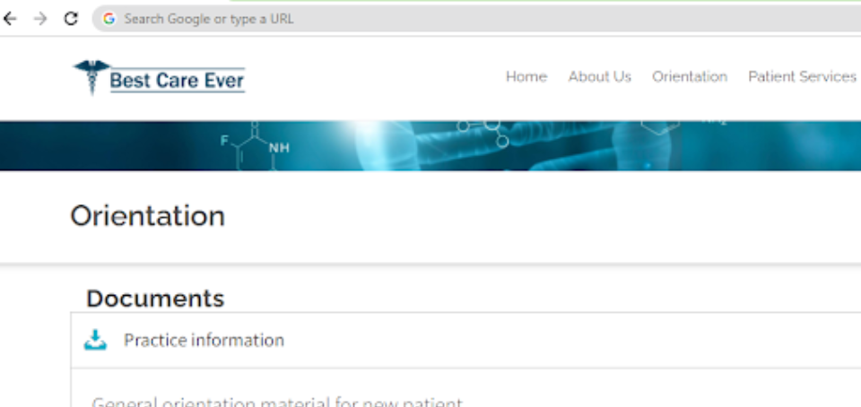

- WE NEED TO TEST USER AND SEE WHAT ACCESS LEVEL USERS HAVE WE NEED TO ALLOW TO USEE SOME ITEMS PER USER OTHERS NOT BUT I THINK MANY THEY CAN LOGIN AND NOT ABLE TO UPDATE OR MAKE SOME CHANGES WE NEED TO CHECK WHAT IS GOING ONE BECAUSE I HAVE MY ACCOUNT TO LIKE 5 STAFF AND KNOW I THINK THIS IS WHY SITE WAS DELETED IN SOME AREAS

EVERONE USE MY ACCOUNT BCE HAS IMPORTANT SYSTEMS LIKE MISSED CALLS AND DASHBOARD OF CALLS AND OTHER ITEMS THERE THAT ARE IMPORTANT, We need to also develop some access right at least for some areas of the system so that not every user has the same access.

- I NOTICED THAT THIS AREA ALSO LOOKS EMPTY AND IT WAS NOT I AM NOT SURE YOU HAVE A OLD BACK UP BUT THE TEXT HERE IS GONE TERRIBLE
https://bestcareever.com/primarycare

- Survey System update: we need to update the questionnaire, right now we present all the questions into one screen. The system is working well right now but for the user lots of questions is a little too much. When we had more complex question and longer survey is too much into one screen. We need to improve user survey interaction as follows:
  - One question per page
  - Bar onto that show how many questions and how many already answered or passed
  - After select answer click next to move to next question
  - Have << Back and Next >> button where user can update if they wish to do so·
WE will use nice smooth ajax function to go from question to question see bellow sample
HERE A SAMPLE
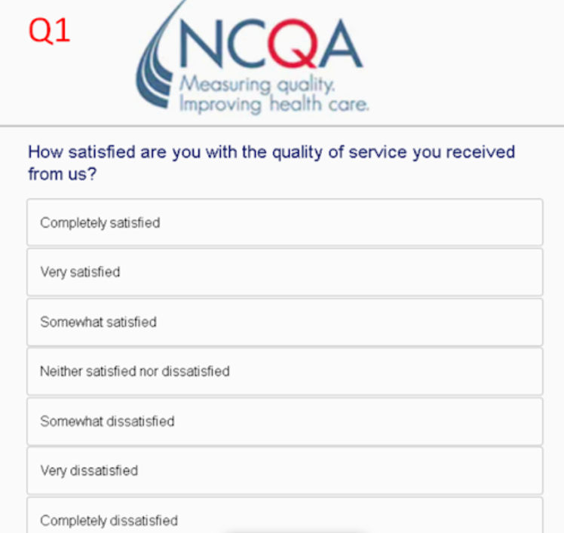

- CALCULATIONS IS TERRIBLE WE CAN NOT USE I HAVE SAMPLE CALCULATIONS NOW IN A DOCUMETN WE NEED TO REMAKE CALCULATIONS THIS DOES NOT TELL US RESPONSE LEVEL PER PATIENT PER QUESTION WE NEED TO RE MAKE much BETTER CALCULATIONS. THERE IS a FORMULA FOR EACH QUESTION STE and TYPE. WE NEEd maybe to see questions types so we can calculate them correctly.
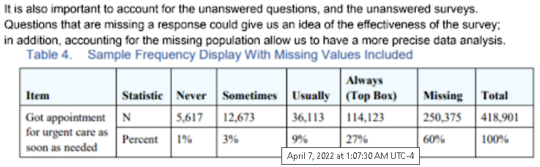 I WILL SEND YOU DOCUMENT

- We need to add some more functionally after we have taken results
  - Action to Print survey
  - Action to Reset Survey
  - Dates Range People Answered Survey
  - Name of the clinic
  - Name of the Survey

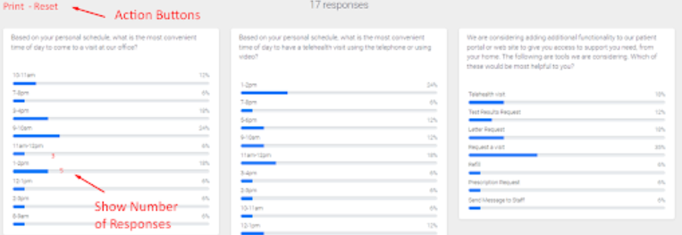
- It will be good to make a survey results reports we can email the team in the clinic we are working with. I think we can implement sys system in connector but we need to make it know professional so it is easy manage and can run survey much better so where are a new items we need
  - WE need to develop some report about a survey we can email to click doctor or management but this report we need to look at it simple is best.
  - We need to allow to load a list like we did for sms system can we can send via text or email the survey right now we can enter manually each one each oen it all takes times. We have these system already made in conector php for sms where we have data load and send sms, email is missing but the system loading and sending is the same exact idea infact we can use the same exact query https://conectorhealth.com/smsmanage
Is a problem to enter manually one by one it takes us time look we are not repeating emails, and it is more difficult if we run a query for 3 days get all the and load them to send them and email or sms or both we can send to unique patient email and phones and it will help on getting responses
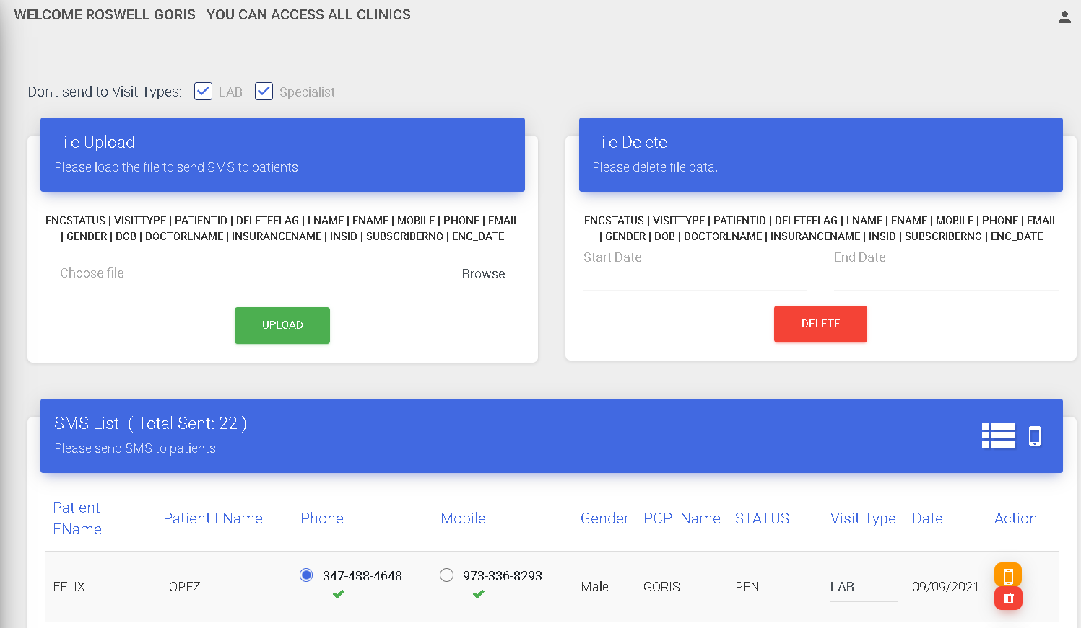

- We need way to look at what patient enter manual as text here is an idea, and we can talk about his but we need to look at manual responses is very important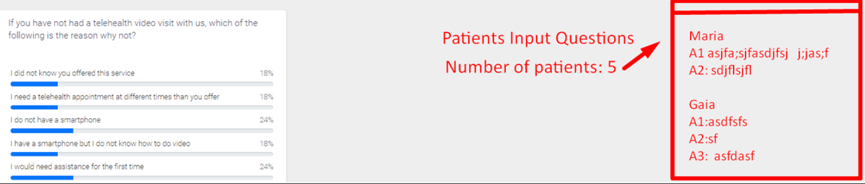

- News letter web site
We need internal and for patients SENT YOU A TEMPLATE WE BUY FOR THIS PORPUSE
I THINK THAT IS ALL FOR NOW WE CAN START WITH WHAT WE CAN RIGHT NOW
New letter is simple idea, the clinic can post a message news and email it to patients or sms link to patients and we can have this posted on the site.

The other part is for internal messages we can post something for the staff and email them with news or business communication, I think is good to make this system modular that we can transfers one systems some data table one folder we can take and use easily in for other site system, we have to think each as separate systems for example
- Survey system
- Missing Calls
- Communication tiket
- News letter

We can make with code in one location we can see it I think is better for us.

