**第七周作业**

**姓名：李英**

**学号：2017051611007**

**最终代码：**

import tensorflow as tf

import matplotlib.pyplot as plt

import numpy as np

bsdh = tf.keras.datasets.boston_housing

(x,y),(test_x,test_y) = bsdh.load_data()

x = x.astype(np.float32)

y = y.astype(np.float32)

for i in range(13):

    x[:,i] = (x[:,i]-np.min(x[:,i]))/(np.max(x[:,i])-np.min(x[:,i]))

def model(x,w,b):

    return tf.matmul(x,w) + b

w = tf.Variable(tf.random.normal([13,1],mean=0,stddev=1.0,dtype=tf.float32))

b = tf.Variable(tf.zeros(1),dtype=tf.float32)

training_epochs = 50 #迭代次数

learning_rate = 0.001 #学习率

batch_size = 10 #批量训练一次的样本数

def loss(x,y,w,b):

    err = model(x,w,b) - y

    squared_err = tf.square(err)

    return tf.reduce_mean(squared_err)

def grad(x,y,w,b):

    with tf.GradientTape() as tape:

        loss_ = loss(x,y,w,b)

    return tape.gradient(loss_,[w,b])

optimizer = tf.keras.optimizers.SGD(learning_rate)

loss_list = []

total_step = int(len(y)/batch_size)

x1 = x.astype(np.float32)

print(tf.matmul(x1,w))

for epoch in range(training_epochs):

    for step in range(total_step):

        xs = x[step*batch_size:(step+1)*batch_size,:]

        ys = y[step*batch_size:(step+1)*batch_size]

        grads = grad(xs,ys,w,b)

        optimizer.apply_gradients(zip(grads,[w,b]))

    loss_train = loss(x,y,w,b).numpy()

    loss_list.append(loss_train)

    print("epoch={:3d},train_loss={:.4f}".format(epoch+1,loss_train))

print("w:",w)

print("b:",b)

plt.figure()

plt.rcParams["font.sans-serif"]="SimHei"

plt.plot(loss_list,label="loss")

plt.legend()

plt.suptitle("迭代次数:"+str(training_epochs)+" 学习率:"+str(learning_rate))

plt.show()

**不同超参数分别运行结果：**

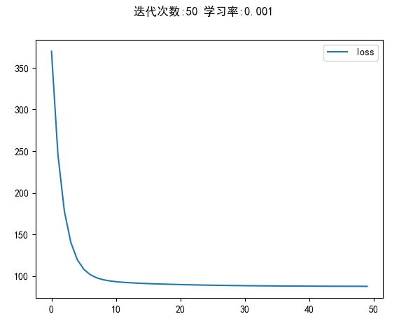

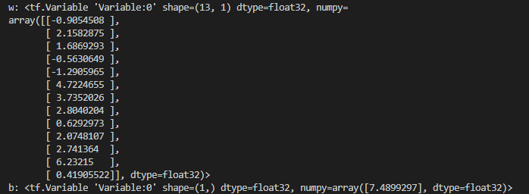

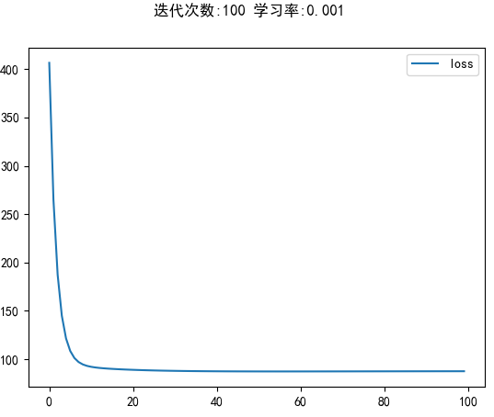

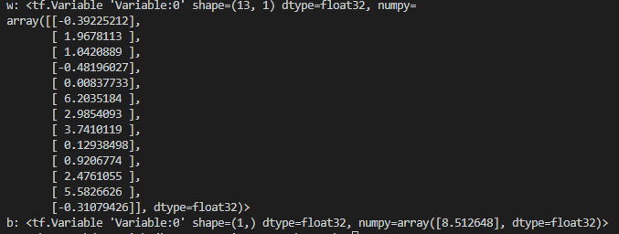

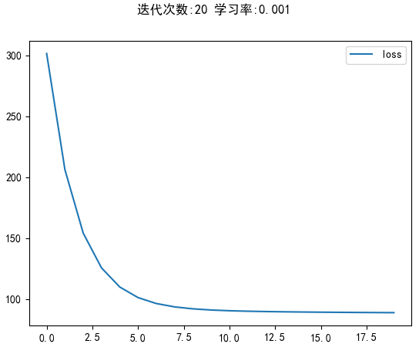

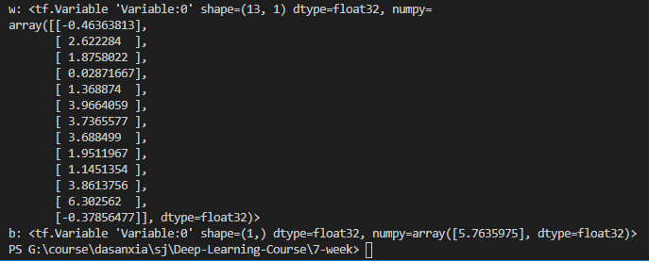

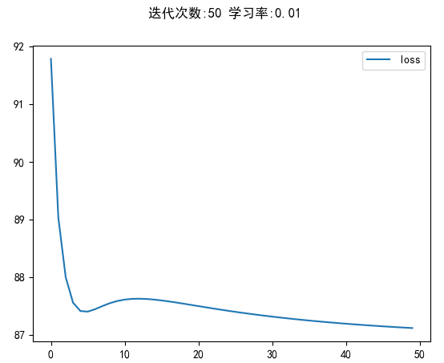

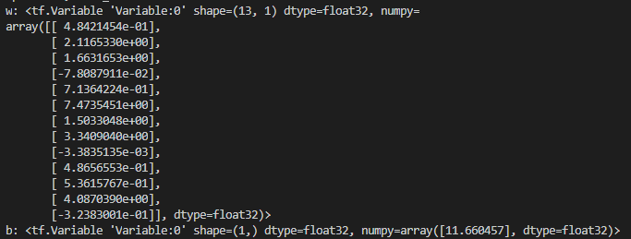

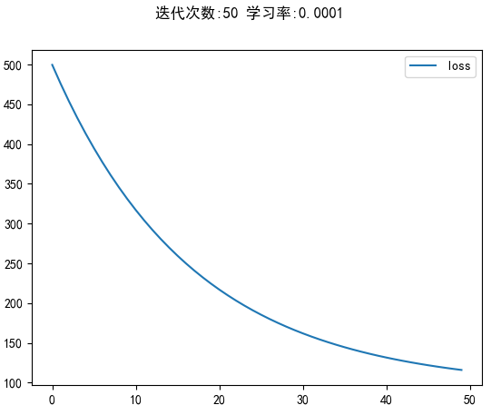

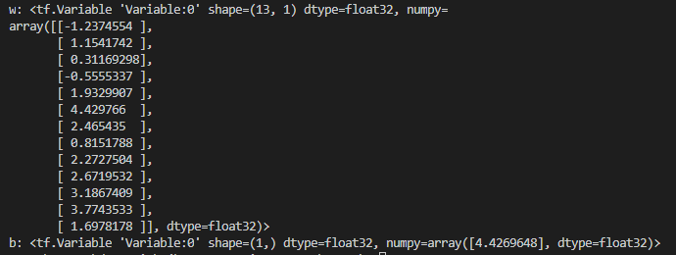

**GitHub地址：**[**https://github.com/ying1024/Deep-Learning-Course.git**](https://github.com/ying1024/Deep-Learning-Course.git)