# MultiThread Handling:

I make all get and update methods in Automobile class synchronized

synchronized void updateOpt(String setName, String optname, float price)

synchronized void updateOptSet(String setName,String newName)

synchronized void updateOpt(String setName, String optname, String price)

public synchronized void addOpt(String setName, String name, float price)

synchronized void print()

EditOption implements Runnable to start new thread, and run method is overwritted to update option price.

# Package Scale:

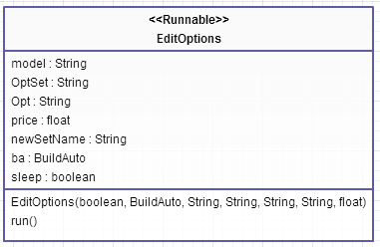

# Package Adaper:

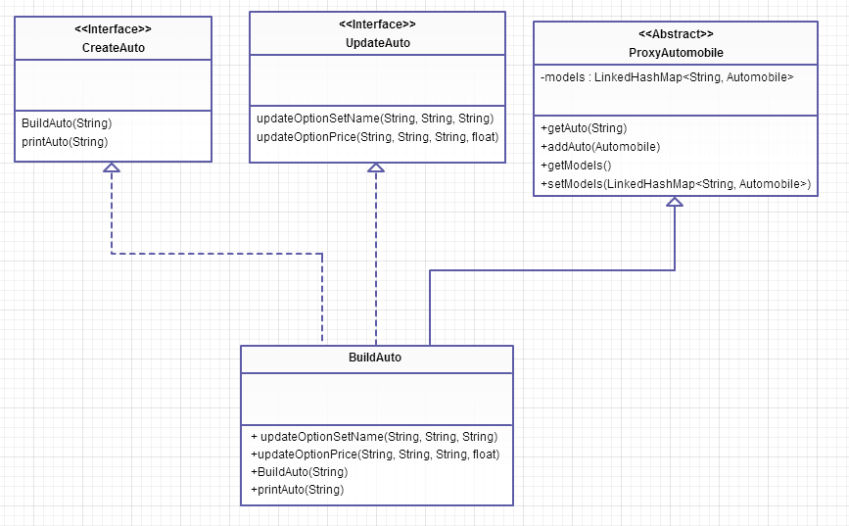

I have two Interfaces: CreateAuto and UpdateAuto who defines the following methods:

1. public void BuildAuto(String filename);

//Given a text file name a method called BuildAuto can be

written to build an instance of Automobile. This method

does not have to return the Auto instance.

2. public void printAuto(String Modelname);

//This function searches and prints the properties of a

Given

given Automodel.

3. public void updateOptionSetName(String Modelname,

String OptionSetname, String newName);

//This function searches the Model for a given OptionSet

and sets the name of OptionSet to newName.

4. public void updateOptionPrice(String Modelname, String

Optionname, String Option, float newprice);

//This function searches the Model for a given OptionSet

and Option name, and sets the price to newPrice.

Alos an abstract class called proxyAutomobile in Adapter package which has a static linkedhashmap as a lookup table for automobile models;

# Exception Package:

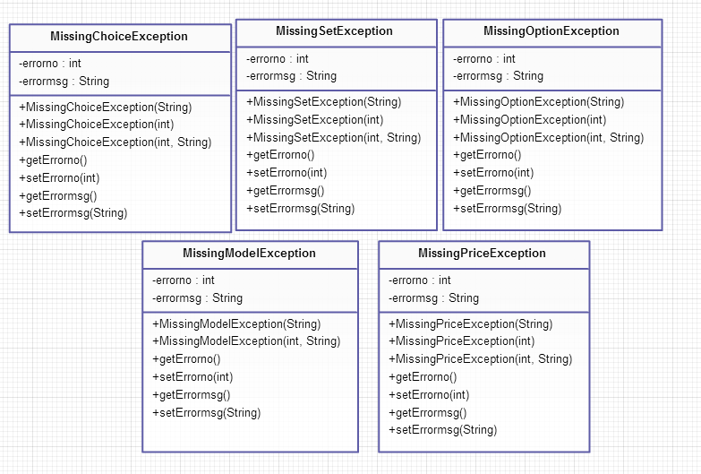

I have 5 customized exceptions to handle missing choice, missing set missing option, missing model and missing price situations.

# Model Package:

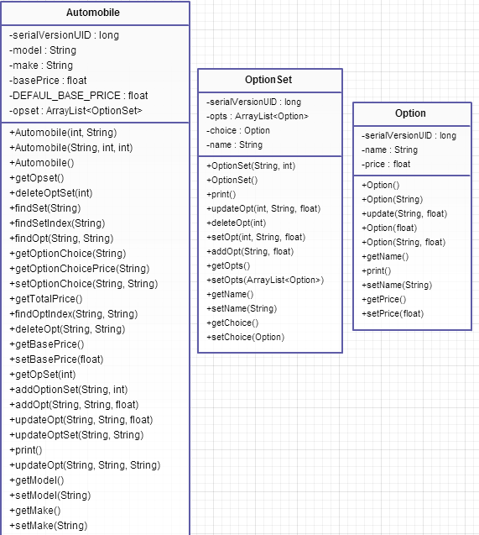

In model package, option is an inner class of OptionSet. Each Automobile has an ArrayList of Optionset, and each OptionSet has an ArrayList of Options.

# FileUtil Package

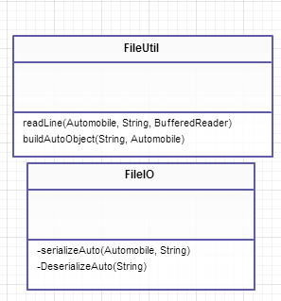

This package is for File IO interactions.