1. With more than 40 student records

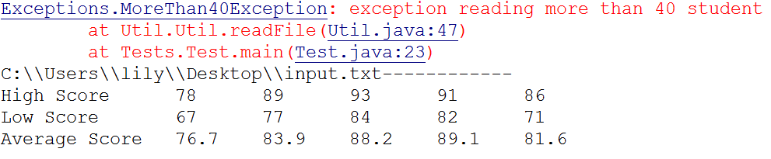

1. With exact 40 students

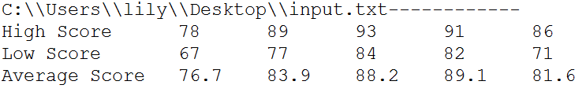

1. Incorrect input file



1. Zero student record

