## 一 Elasticsearch widows10下载安装

官网<https://www.elastic.co/cn/start>

下载Elasticsearch,Kibana安装包

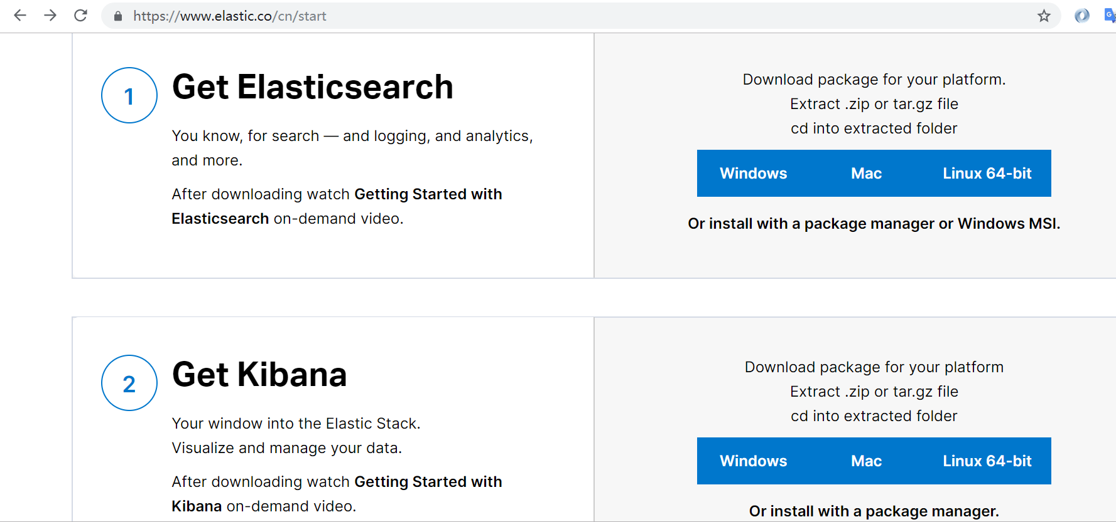

解压缩后

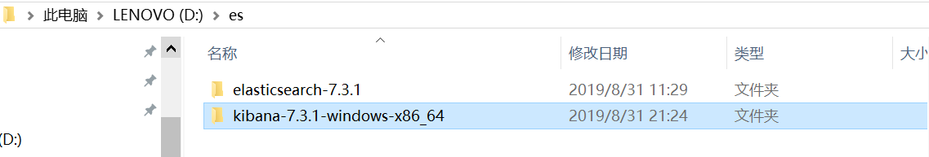

分别启动elasticsearch、Kibana

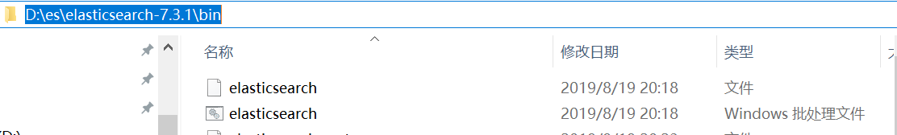

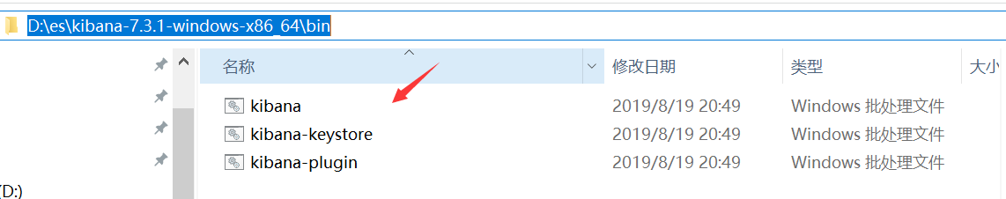

浏览器访问<http://localhost:9200/?pretty>

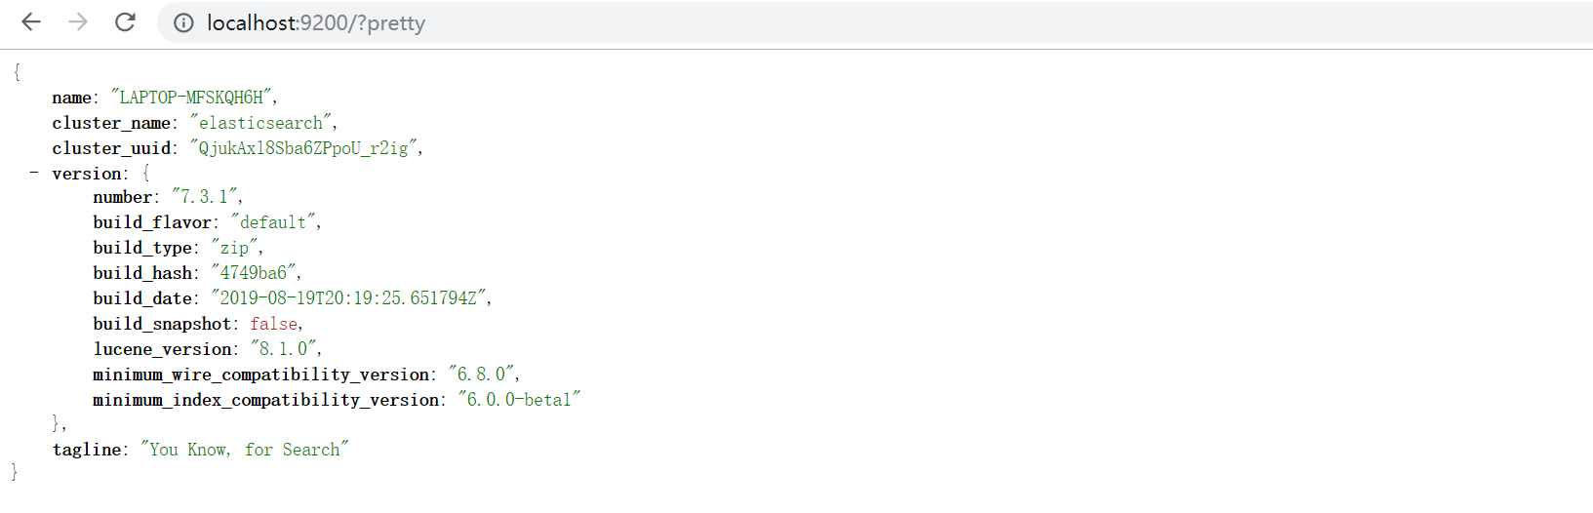

访问Kibana控制台:localhost:5601

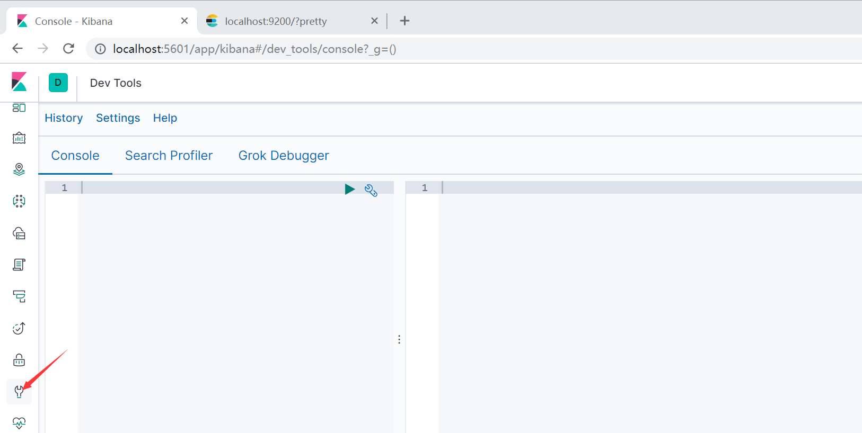

## 二 Elasticsearch集群健康检查、文档CRUD

1. 快速检查集群健康状况

GET /_cat/indices?v

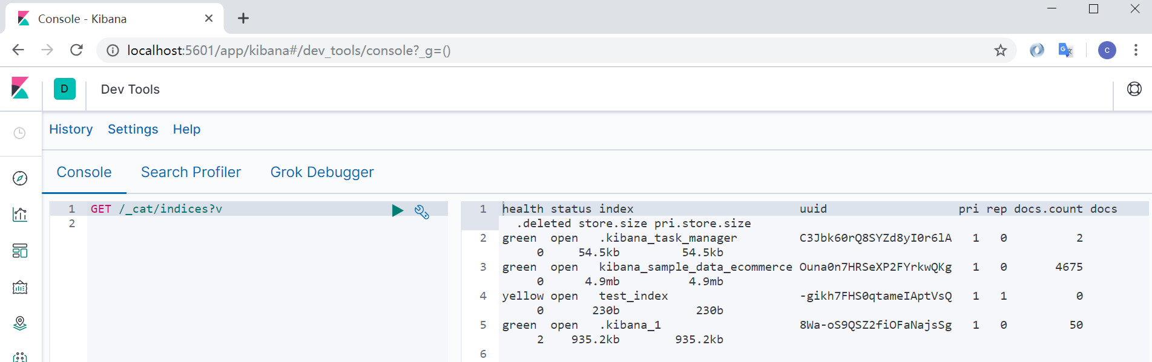

2.创建索引

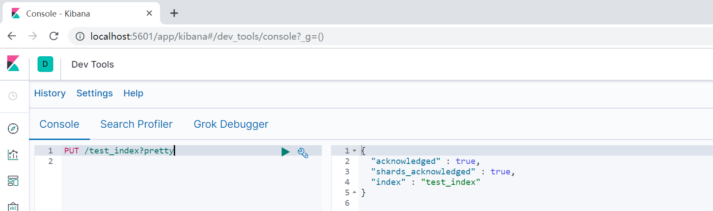

删除索引

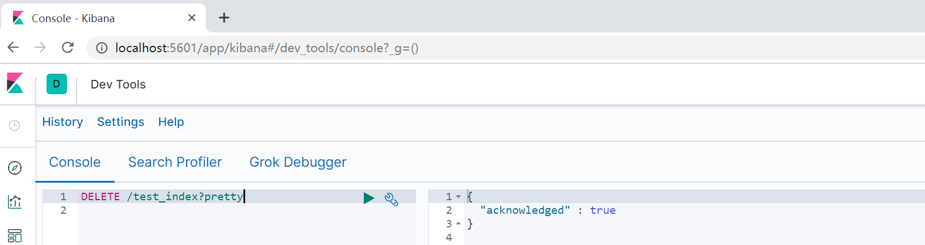

3.商品的crud

1)创建商品

返回结果

{ PUT /ecommerce/product/3

{

"name":"heirenyajao",

"desc":"meibai",

"price":20,

"producter":"gaolujie",

"tags":["meibai","fanzhu"]

}

"_index" : "ecommerce",

"_type" : "product",

"_id" : "3",

"_version" : 1,

"result" : "created",

"_shards" : {

"total" : 2,

"successful" : 1,

"failed" : 0

},

"_seq_no" : 4,

"_primary_term" : 1

}

2）查询商品

GET /ecommerce/product/3

返回

{

"_index" : "ecommerce",

"_type" : "product",

"_id" : "3",

"_version" : 1,

"_seq_no" : 4,

"_primary_term" : 1,

"found" : true,

"_source" : {

"name" : "heirenyajao",

"desc" : "meibai",

"price" : 20,

"producter" : "gaolujie",

"tags" : [

"meibai",

"fanzhu"

]

}

}

3）修改商品

POST /ecommerce/product/3/_update

{

"doc":{

"name":"heiranyagao2"

}

}

返回

{

"_index" : "ecommerce",

"_type" : "product",

"_id" : "3",

"_version" : 2,

"result" : "updated",

"_shards" : {

"total" : 2,

## 七 Elasticsearch多种搜索方式

查询所有

GET /ecommerce/product/_search

返回

{

"took" : 9,

"timed_out" : false,

"_shards" : {

"total" : 1,

"successful" : 1,

"skipped" : 0,

"failed" : 0

},

"hits" : {

"total" : {

"value" : 2,

"relation" : "eq"

},

"max_score" : 1.0,

"hits" : [

{

"_index" : "ecommerce",

"_type" : "product",

"_id" : "1",

"_score" : 1.0,

"_source" : {

"name" : "yunnanbaiyao3",

"desc" : "meibai",

"price" : 30,

"producter" : "yuannan",

"tags" : [

"meibai",

"fanzhu"

]

}

},

{

"_index" : "ecommerce",

"_type" : "product",

"_id" : "2",

"_score" : 1.0,

"_source" : {

"name" : "gaolujie",

"desc" : "meibai",

"price" : 20,

"producter" : "gaolujie",

"tags" : [

"meibai",

"fanzhu"

]

}

}

]

}

}